**HOMEWORK ASSIGNMENT: Art / Not Art / Art?**

1) Find an object that you think is art, label it “ART.” Either bring the object in to class or bring a printed photo of the labelled object to class. Write 3-5 sentences explaining why you think this is art on a separate piece of paper.

2) Find an object that you think is not art, label it “NOT ART.” Either bring the object in to class or bring a printed photo of the labelled object to class. Write 3-5 sentences explaining why you think this is not art.

3) Find an object that you think might be art, label it “ART?” Either bring the object in to class or bring a printed photo of the labelled object to class. Write 3-5 sentences explaining why you aren’t sure if this is / isn’t art.

**EXAMPLES:**

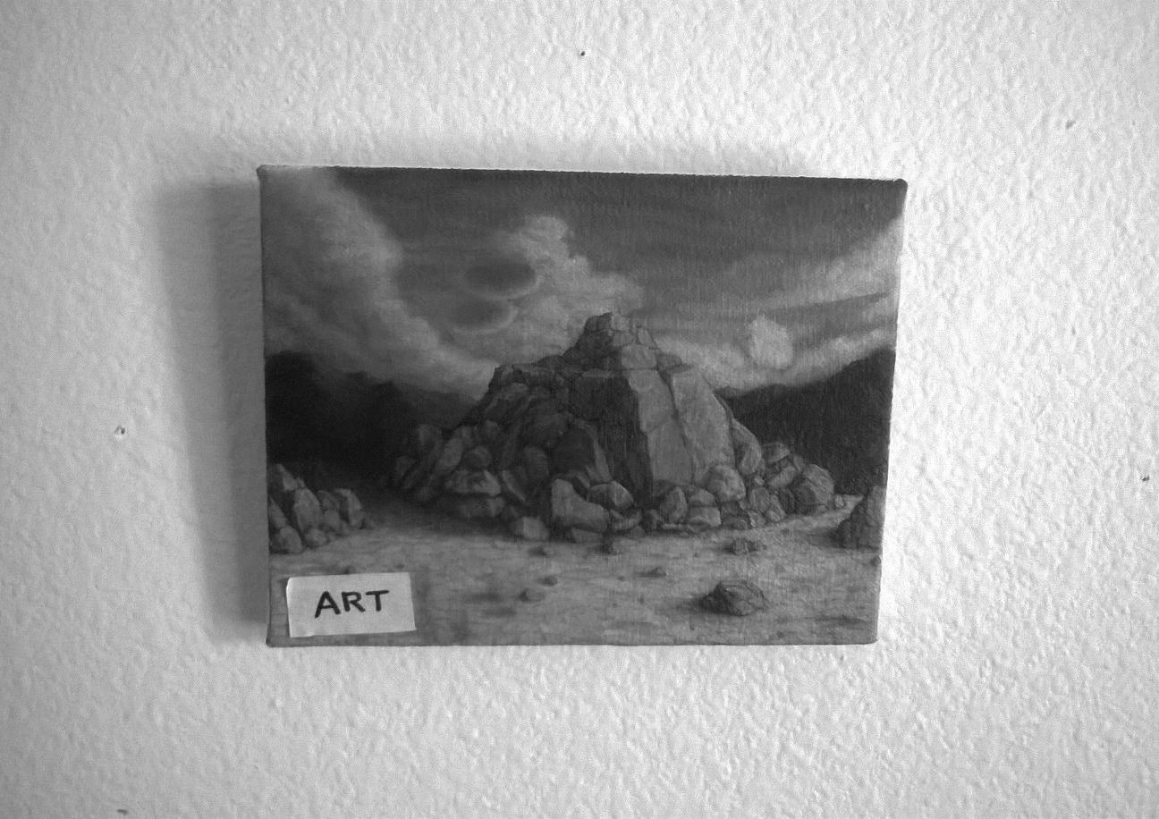

**ART** – This is art. A person made it with the specific intention of making a painting in the historical tradition of painting as fine art. They stretched canvas over a panel because that is what *artists* do. They used oil paints and a brush because that is what *artists* do. They hung it on a wall when they were done because that is what *artists* do with *art.* Beyond this, it is art because it is a non-functional image, made with only one discernible purpose, to paint something (a pile of rocks) that had personal inarticulable meaning.

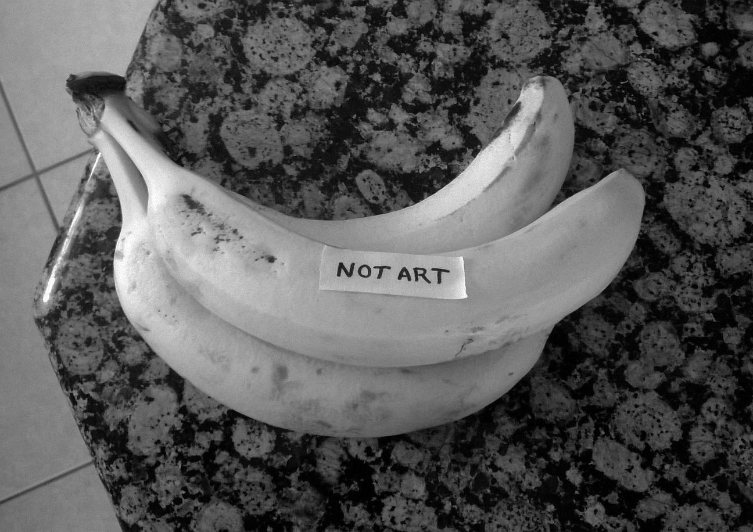

**NOT ART** – This is not art. It was not made by a human being, although human beings did have a hand in growing it, picking it, selling it, buying it, arranging it on this table, putting a sticker on it and photographing it. In spite of all this its most important aesthetic qualities were determined by natural forces, human beings only made decisions that edited those original qualities, so in a conservative traditional sense it is not art.

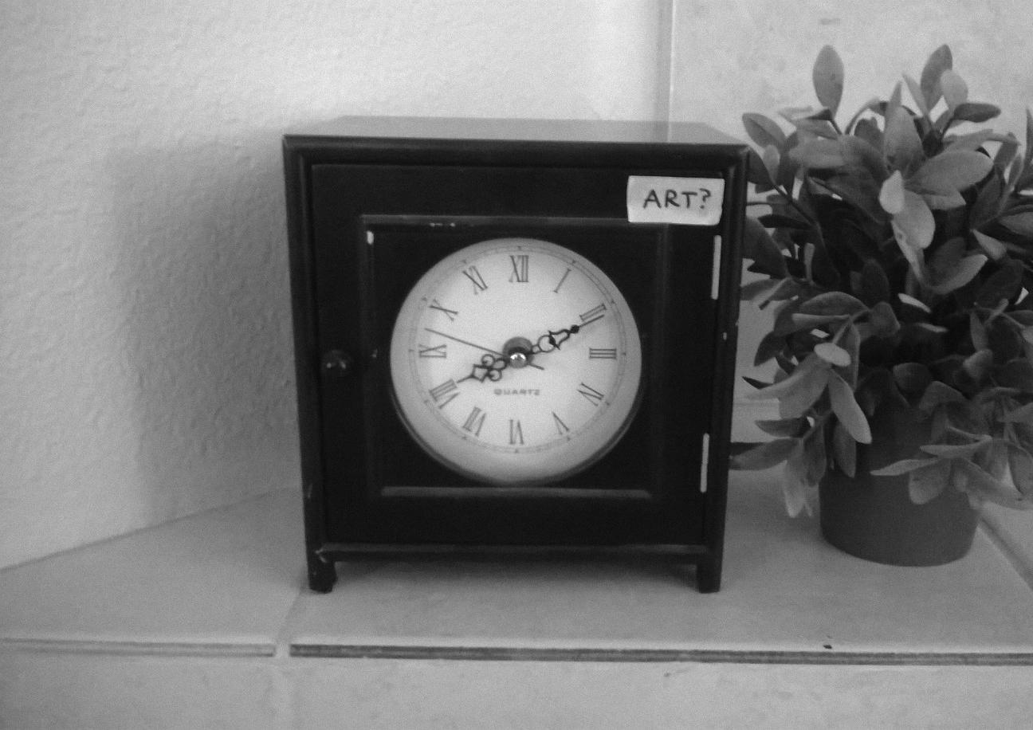

**ART?** – This might be art. It was definately made by human beings, its most important aesthetic qualities were definitely the result of intentional decisions on the part of human beings and it has qualities that could definitely be considered aesthetically beautiful. In spite of this its primary purpose seems to be telling time, which might make it more of a tool than a work of art. This is questionable however because it is broken and does not tell time, and the person who owns the clock acquired it knowing this, so they do not use it as a tool.