**HOW TO PAINT GEORGE WASHINGTON**

ICA or TCA - First Used 2014

**WHO WAS GEORGE WASHINGTON:**

George Washington was the first *President* of the United States of America. He dropped out of school at 15 because his parents were poor. At 26, he married a widow who already had two children. He was six feet, two inches tall and 200 pounds, he was one of America’s largest presidents. He loved cream of peanut soup. He let his dogs eat at the table with him, one of them was named Sweet Lips. He had terrible teeth, so when he was 57 he had all his teeth pulled out so they would never hurt him again. He replaced his teeth with ivory and silver teeth, which were stronger and prettier than his old teeth. Although he his name was Washington, he never lived in Washington. George Washington owned 10 slaves by the time he was 11, and he owned over 300 by the end of his life. No one knows why he died. There are more paintings of George Washington than any other person.

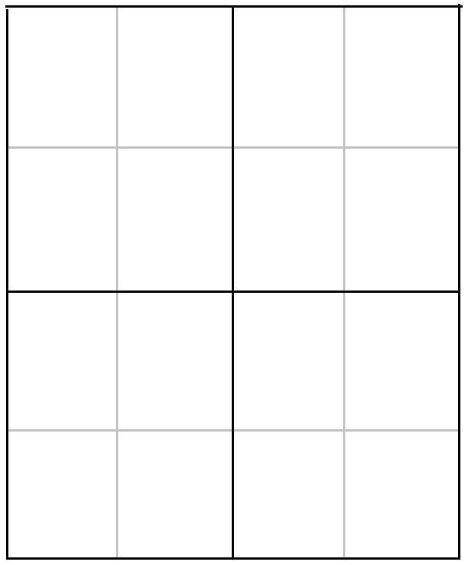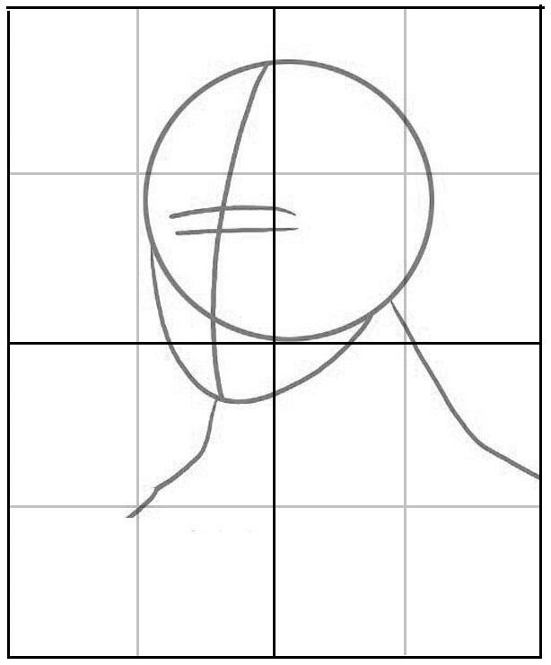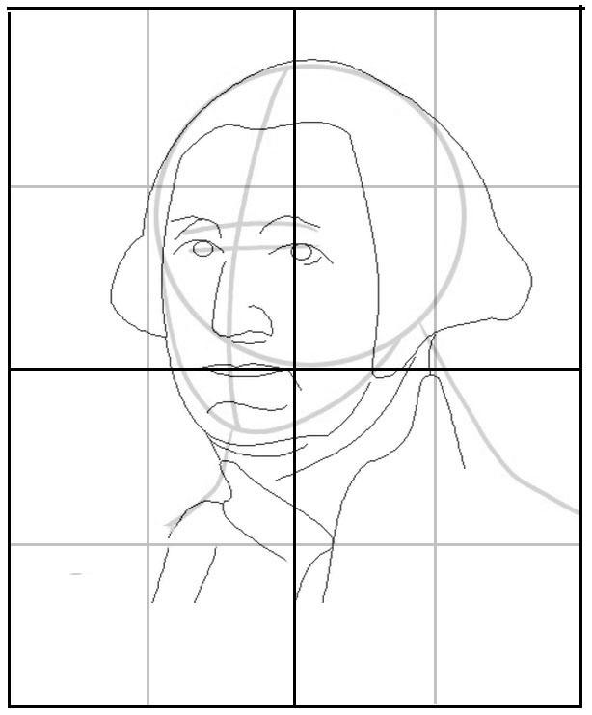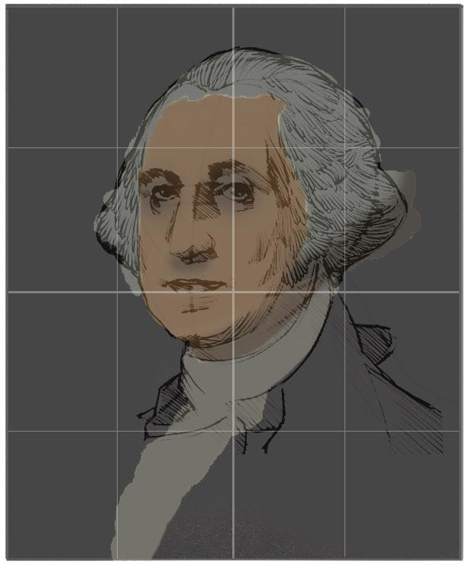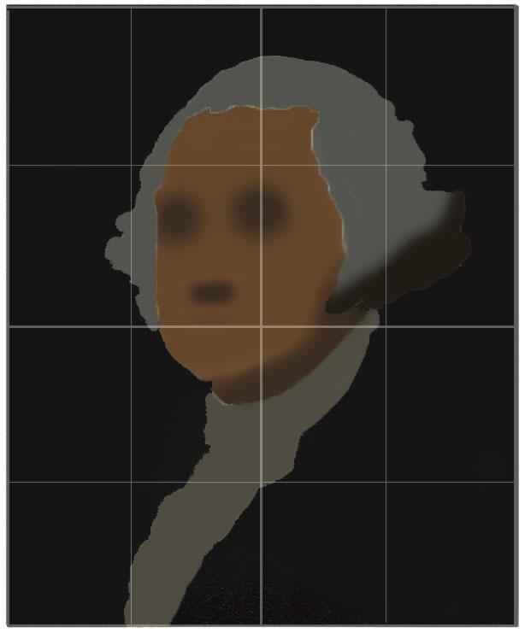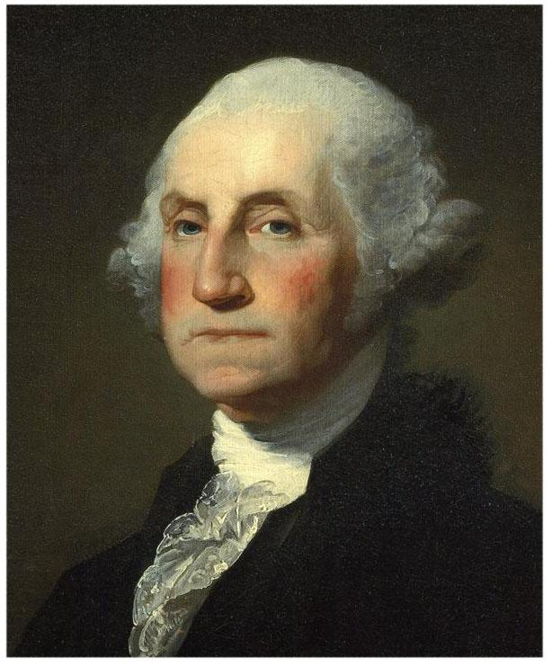

**PAINTING GEORGE WASHINGTON:**

To make this painting we will break our process down into 6 steps. The first step is to create a basic grid of vertical and horizontal guidelines in pencil. The next two steps will be to build a preliminary sketch and the last 3 steps will be to paint over this sketch first in large swatches of dark color and then working in details.

**MATERIALS YOU WILL NEED:**

- A Surface (Canvas paper, stretched & gessoed canvas or board)

- A Ruler

- A Pencil (non-mechanical)

- An Eraser

- Paint (Acrylic or Oil, at least Red, Yellow, Blue, White, Black & a Dark Brown)

- Brushes (Large & Small)

**STEP 1: GRID & BASIC SKETCH:** To make this painting we will break our process down into 6 steps. The first step is to create a basic grid of vertical and horizontal guidelines in pencil. The next two steps.

**STEP 2: OUTLINE SKETCH:** To make this painting we will break our process down into 6 steps. 



**STEP 3: BLOCK IN DARK COLORS:** To make this painting we will break our process down into 6 steps.



**STEP 4: DETAIL SKETCH:** To make this painting we will break our process down into 6 steps.

**STEP 5: PAINT HIGHLIGHTS & DETAILS:** To make this painting we will break our process down into 6 steps. 