**PAREIDOLIA & THE RORSCHACH TEST**

INA or THA - First Used at GLC SP-2014

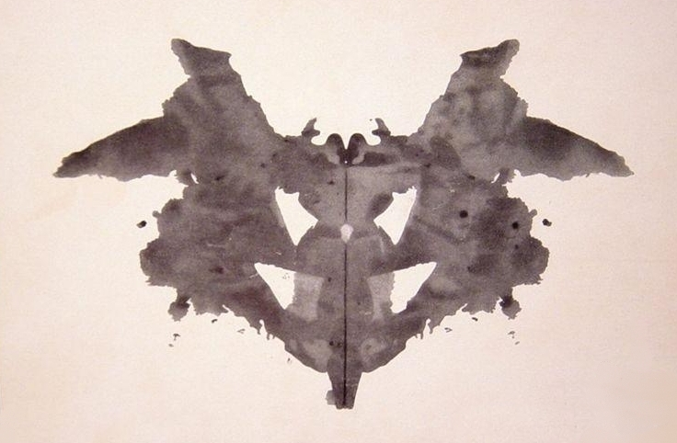

**STEP ONE:** Starting with a standard 8.5” x 11” sheet of paper, fold this paper in half and then unfold it leaving a crease down the center.

**STEP TWO:** beginning with only black paint / ink and white paper, apply your chosen medium to the paper in any way you choose in large enough quantity that it will be able to transfer when folded.

**STEP THREE:** Along your previously formed crease, refold the paper carefully, then press gently so that all the areas with ink or paint are made to transfer their pattern to the opposite side.

**STEP FOUR:** Unfold your paper immediately after pressing and allow to dry. Repeat this step several times, then try adding different colors, using different sizes / shapes of paper and making different kinds of folds.

**STEP FIVE:** Hang your most successful pieces up. Try not to identify them immediately as being a face, or an elephant etc. Instead attempt to allow them to remain abstract in your mind and choose the one you are naturally most drawn to. Take this shape and develop it into a medium sized painting (abstract or representational). The only requirements are that this painting be significantly larger than 8.5” x 11” and that you fill the entire space.

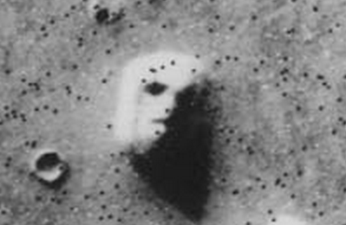

**THE RORSCHACH TEST & PAREIDOLIA:**

In the early 20th century Hermann Rorschach, a German psychologist created a system by which individual patient’s personalities could be interpreted and analyzed based on their reactions to shapes created by applying ink drops to a paper, then folding that paper in half to produce a symmetrical essentially random design. This was the first historical attempt at using such shapes in the service of quantifiable scientific goals, but the relationship between human beings and abstract naturally occurring shape interpretation appears to be as old as behavioral modernity itself (approx. 50 kya).

Human beings seem to be able to instinctively form connections with inanimate objects and shapes through this phenomena referred to as **pareidolia** (pair-eye-dole-ya). In its simplest definition, this phenomena is the process by which a human being may recognise people, places or things in natural abstract and often inanimate forms. Humans often experience pareidolia when looking at clouds, smoke, shadows, rock faces, puddles of water, the face of the moon, non-patterned textures on walls or floors and an infinite number of other similar examples. These visions can be experienced in any state of mind but take on special potency when the individual is experiencing any form of naturally occurring or artificially induced altered consciousness state (for more information refer to *The Sign of All Times, 1988*).

It is important to note that the Rorschach Test as it was used popularly in the the mid 1900’s is largely debunked and not often used today, which is key because it marks a failure to impose logic and rationality to pareidolic phenomena and the emotional / spiritual relationship that human beings can form with inanimate shapes and objects. In fact the most lasting use of pareidolic interpretation is found in cross-cultural religious divination rituals and in the creative artistic process, regardless of any possible scientific or medical explanation pareidolia is an foundational and ultimately enigmatic experience common to all human life.