# Database layer

I use h2 database.

Schema will be auto generated from domain model.

Test data will be inserted when application starts up using sql – resources/db/data.sql

Db console can be accessed from <http://localhost:8080/h2-console> using sa/sa

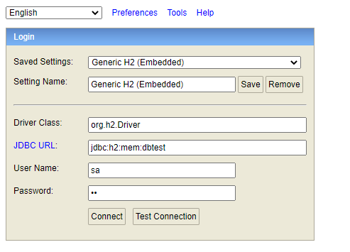

I have 3 tables

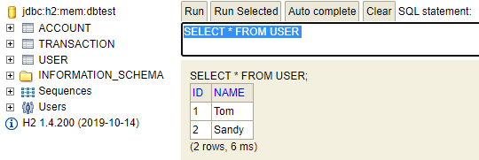

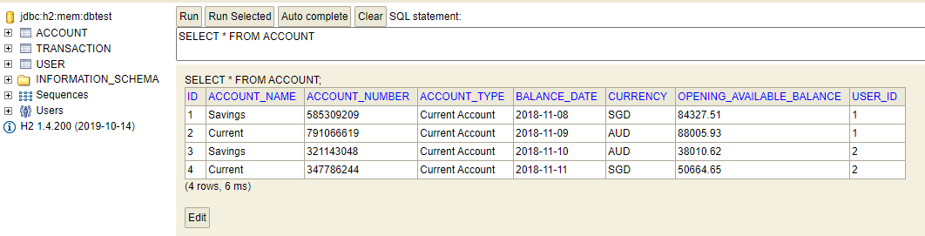

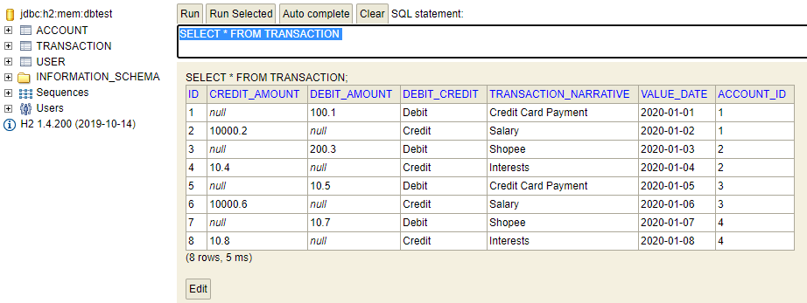

# Java Layer

I use spring boot to design the application.

## Domain layer

I use hibernate to do the OR mapping. 3 domain classes have been added.

Account.java

Transaction.java

User.java

## Dao layer

I use JPA to define the dao layer. 3 repository classes have been added.

AccountRepository.java

TransactionRepository.java

UserRepository.java

## Service layer

I use plain spring bean to define 2 spring services.

AccountService.java

TransactionService.java

## Unit Testing

Spring Boot Test library is used. I test accountService and transactionService.

AccountServiceTest.java

TransactionServiceTest.java

## RestFul layer

The client has 2 choice, either he can directly autowire the service bean, or call my RestFul service.

I define 3 restFul services.

1. UserController

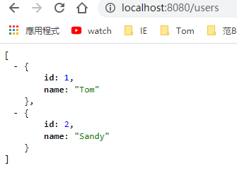

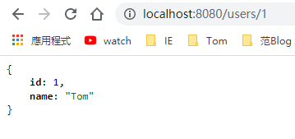

1. AccountController

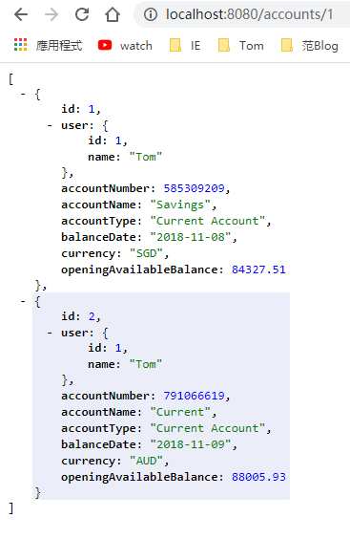

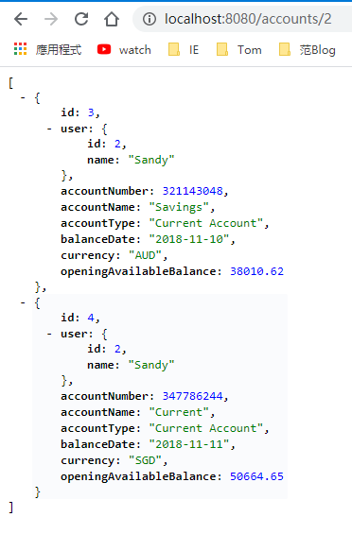

1. TransactionController

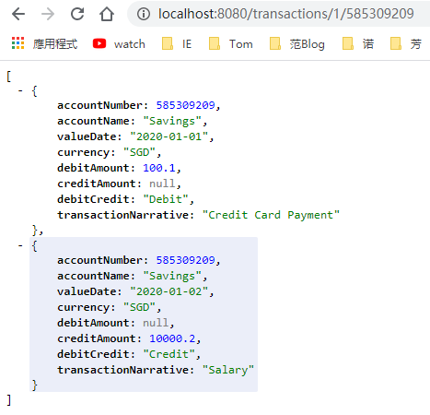

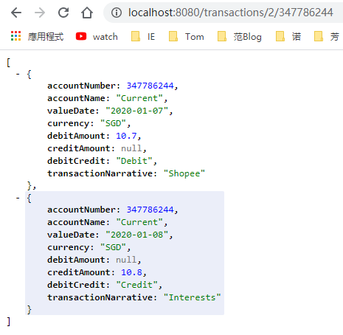

If you query an accountNumber which doesn’t belong to the userId, you see nothing.

