Concrete5 Manuals
Explaining the workings of Concrete5



Subject: Concrete5’s manuals.
For: Users with access to the Concrete5 Dashboard.
Date: 2009-05-25
Author: Tom de Bruijn

Contents
Introduction 5
About these manuals 5
Issues? 6
Revisions of this document 6
Termonology 7
Read and edit pages 7
Dashboard 8
Developing for Concrete5 8
Login and forgot password 9
Forgot password? 9
Dashboard interface 10
Sitemap 12
Editing pages 15
Creating pages 15
Editing pages 16
Adding blocks 16
Editing blocks 17
Saving pages 17
Versions 18
(Event) forms 19
Creating forms 19
Adding questions 19
Editing 20
Preview 20
Options 20
File manager 21
Uploading files 21
Single file 21
Multiple files 21
Downloading 23
Sets 23
Rescanning files 24
Deleting files 25
Search engine 26
Permissions 27
reports 29
Surveys 29
User manager 30
Users 30
Creating new user accounts 30
Editing user accounts 30
User groups 30
Creating new user group(s) 31
Editing user groups 31
User attributes 31
Settings 32
Maintenance 32
Pages and themes 34
Page Types 34
Page attributes 34
Single pages 34
Add functionality 35
Sitewide settings 35
Scrapbook 37
Global scrapbook 38
Permissions 38
Extra information (Difference between Administrators) 38
Page permissies 38
Reachable through: 38
Description 38
Set permissions (pop-up box) 39
Block permissions 41
Reachable through: 41
Description 41
Permissions (tab) 41

Introduction
These manuals are meant to describe the workings of the Concrete5 CMS. These manuals are only about the Concrete5 interface.
While writing these manuals the latest version of Concrete5, version 5.3.1.1, is used. This version was available on 2009-04-28.
Not all default features of Concrete5 will be explained, because there is official Concrete5 documentation available for these features. In the official documentation the most basic workings are explained and some have screen casts available. These screens casts are small movies that show how the Concrete5 interface works.
Manuals and screen casts are available at http://www.concrete5.org. Currently (27-04-2009) they can be reached directly at: http://www.concrete5.org/help/editing. (This link may change over time.)
The website and interface of Concrete5 is currently only available in English, but some local groups are busy with translations and communities.
Some groups (per country) which are present at the moment:
- Japan
  - The Japanese Concrete5 community is available at: http://concrete5-japan.org
- Switzerland
  - The Swiss Concrete5 community is available at: http://www.concrete5.ch/
- France
  - The French Concrete5 community is available at: http://concrete5.fr
- Dutch
  - The Dutch group should be available at http://www.concretecms.nl/, but this currently only shows the “Coming Back Soon” message.
More groups will be added to this page: http://www.concrete5.org/community/members/.
There are also groups listed here that have no (known) website.
Another good site with lots of links and downloads is http://c5mix.com/ which is run by a community member of Concrete5.

About these manuals
These manuals are written by Tom de Bruijn of Newanz.com. The manuals were a part of his internship that he did from January till mid June in 2009. The document was released as it might benefit the community, but no claims can be made upon it.
The only thing I request is that, when asked, you admit this document is written by the original author. My school might be a pain about this one. Besides, I have the original Dutch version of this document and my English translations might be a little stiff now and then. Also, I removed all manuals for custom blocks, logos and names from the document and images.
It is allowed to modify/change the contents of this document to improve the documentation for the Concrete5 community.

Issues?
Is something not working in the interface of Concrete5? Are you using a version of Microsoft Internet Explorer lower than version 8? That is you problem.
Internet Explorer has never actually followed the guidelines of HTML, CSS, JavaScript and other languages. This is why some applications, were developers are following the W3C http://w3.org guidelines, don’t work like they were intended.
Version 8 of Internet Explorer is on its way to follow those guidelines, but this still means that older versions of the browser don’t. The Concrete5 development team doesn’t try to make it work on older versions, but does for version 8.
When other issues arise, you should report this to your local Concrete5 Administrator. If you are experiencing a reproducible problem they are able to find the origin of the problem sooner, so please try to find out why it occurs.

Revisions of this document
2009-05-13: Added manual for the Form block.
2009-05-25: More communities added to the introduction section.

Termonology
Concrete5 has some terms that aren’t familiar with everyone. That is why all the terms that Concrete5 uses are put explained below. This is useful when you run into one or more of these terms as they are used throughout the manuals.

Read and edit pages
- View mode
  - Reading pages when the user is not logged in, doesn’t have rights to edit the page or when the page is not open in edit mode.
- Edit mode
  - When a user is logged in, and has rights to edit a page, they can open the page in edit mode. The page will reload and edit functions will be available.
  - In edit mode it’s possible to change the content of a page using block editors.
- Editor
  - An editor is a window that opens when a block in a page is opened for editing. In this editor the contents of a block can be changed.
- Publishing
  - Publishing is a term used for approving the page to go live. Making it visible for visitors.
  - Pages that are edited don’t necessarily have to be published; they can also be saved as a preview version. This is useful when more people are working on a page or when the new version of the page shouldn’t go live yet.
- Versions
  - When a page is edited and saved a new version is created. The old version is saved so you can always return the page to a previous version. When a page is saved for preview a new version is also created. This new version will be visible for everyone that is allowed to edit that page. When a version is ready to be published the person that is able to publish pages should be informed so he or she can publish the page. This depends on your local permissions scheme.
- Design
  - A design is a sub-theme that you can select for a page. This design is then used to create the basic layout of the page. It gives you more or less areas to place blocks and some other default layout styles.
- Blocks
  - Standard installed or additional plug-ins that contain and show your page’s actual content. Without blocks your page wouldn’t have content.

Dashboard
- The dashboard is the Administrator side of Concrete5. More is explained about this in the “Dashboard interface” section.

Developing for Concrete5
- Events
  - Events are scripts that are called when a certain action occurs in Concrete5.
Events that occur in Concrete5 (and are documented) are:
    - Before loading of a page.
    - After loading of a page.
    - When making, editing, moving, deleting, duplicating and reading of:
      - Pages
      - User accounts
      - User groups.
    - Uploading files.
- Packages (previously known as applications)
  - Packages are combined features. Blocks, page controllers and events are combined to create a package. This package should then be placed in the “packages” directory. Page controllers are scripts that run in the background and can be activated by a certain action.
- Single pages
  - Single pages are pages that only occur only once on the website. Login pages or register pages are simple examples of these pages. These pages should only have to occur once and they usually present a special function.
- Areas
  - Areas are locations to which you can add blocks. Without areas no blocks could be added and no content would exist. To areas permissions can be linked, these are dependant of user groups.

Login and forgot password
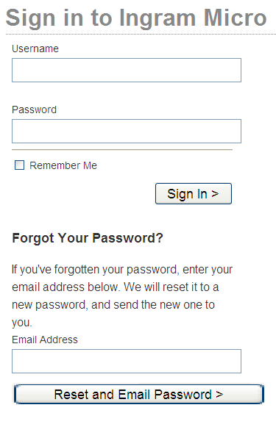
When you visit a page that you can only read when you are logged in or when you are trying to reach the Dashboard you will get this login screen. (See the image on the right).
The login screen also features a couple of options. The default option is to login and that’s just why you get this screen. Enter you username and password and then press “sign in”. When ticking the “Remember me” checkbox Concrete5 will remember your login for the next time you need to login.

Forgot password?
Forgot your password? Can’t login? Enter your (registered) email address in the email address form field below the login form. Press the button “Reset and Email Password” and you get an email send to your address containing your new password. However, it is recommended to change your password after this feature.

Dashboard interface
Below here you will see an image with the interface of the Dashboard. You can only see this when you have a Concrete5 user account and when you permission to view the dashboard.
Not every user will be able to see all the features that are available in Concrete5. This depends on the permissions that are set to the group(s) which the user is added to. 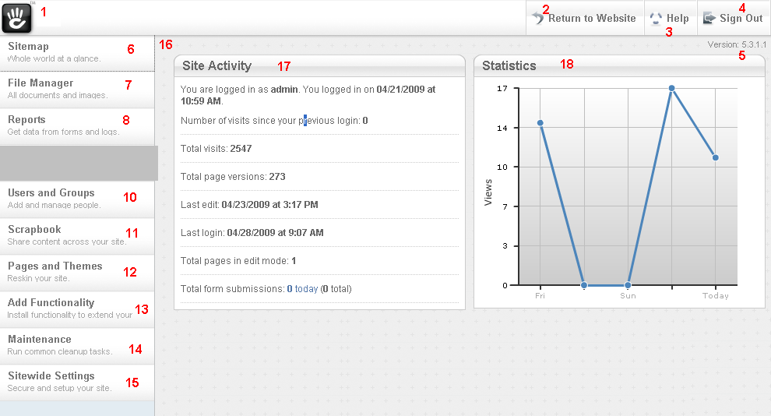
Interface parts numbers:
- Click on the image to go back to the root of the dashboard (currently shown page).
- Press here to return to the first page of the website.
- Are you having problems with something? Press here to go the help page of Concrete5 on the Concrete5 website, http://concrete5.org/help. The inbuilt search function will make it easier to find solutions to the issues that you currently experiencing.
- Sign out. You will log out from Concrete5 and will be able to enter the dashboard only when you are logged in again. The remember me function will forget you as well.
- Version number. Since version 5.3 the version number of Concrete5 is visible here unless tabs are available.
- Navigation of the dashboard. The first is the Sitemap. This feature will be described in detail in the section.
- File manager. In this manager you will be able to see uploaded files and manage them. Files are able to be placed in “Sets”. These are a kind of group which makes searching for files easier.
- Reports. View all filled in form results on the website.
- Non-standard functionality. Not explained in this version of the manuals.
- Users and Groups. User and group managers.
- Scrapbook. Scrapbook which you can use to copy blocks over the entire website.
- Pages and Themes. Manage page types, theme’s and single pages.
- Add functionality. Inspect currently installed blocks and install new ones.
- Maintenance. Run tasks that will improve the website’s search engine, generate a sitemap and import customer information.
- Change settings that apply for the entire website.
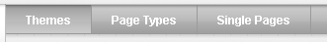
- The actual content of the dashboard. Here forms are shown to perform search and edit actions. This is shown in blocks like 17 and 18. When a page contains subpages there will be tabs available like in the image on the right. The most left page “Themes” is currently active.
- Look at some global statistics of the website and the user itself.
- Statistics graph which shows the number of visits of an entire week. Move over with your move to see the actual amount.
Numbers 1 through 15 are always available with exceptions by permissions.

Sitemap
The sitemap is a list of all the pages that are available in the Concrete5 CMS. All pages, even when the user can’t edit them, are displayed in the sitemap. The ”Home” page is the first page where visitors will see when the go the direct URL of the website. On the home page a script is added to redirect users to the “Public” page. The home page is only page that is “stuck” in the system, which means it cannot be deleted from the system.
When a page has sub pages the icon for this page will be displayed as a directory. This system should remind people to the explorer, in Microsoft Windows (XP), which looks similar. By pressing the plus (+) sign in front of the icon you will be able to expand the page to show all its subpages. Press the minus (-) sign to hide all subpages.
The number that appears behind some pages their titles is the amount of subpages that are added directly below them. Subpages of subpages are not counted.
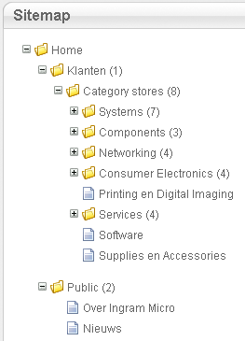
By pressing on the title of a page with the left mouse button a menu will appear. This menu will contain several options that are described in the list below.
- Visit
  - Visit the page you just selected. When visiting a page you can switch to edit mode and edit the page.
- Properties
  - Change properties of the page. Name, description, URL’s of the page and additional information can be added here.
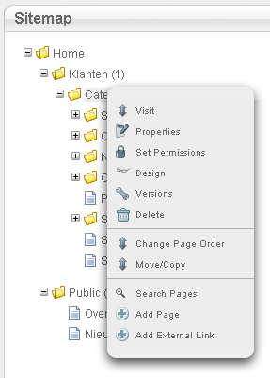
- Set permissions
  - This is only available for Administrators, but here the permissions per page can be set. Read more about this in the “Permissions” section later on in this document.
- Design
  - Change the design of the page. The design is the page type selected when creating the page.
- Versions
  - Version manager of the page. Look at older versions of the page and compare them with each other.
- Delete
  - Delete the selected page and all subpages that are added to it.
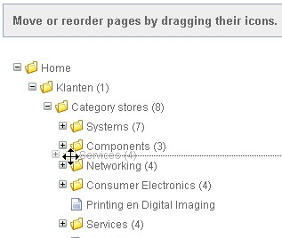
  - When a page is deleted it is deleted permanently.
- Change Page Order
  - Change the order of the pages as they occur in the sitemap. Drag an icon to another location to move it there.
- Move/Copy
  - Move or copy the page to another location. Drag the icon of the page to another page where it should be added to. Three options will appear: Move, Create Alias and Copy. Move will move the page under the selected page. Create Alias will make it look like the page is added under that page when it actually remains in its current position. Copy will copy the entire page under the other page. From that point on multiple versions of that page exist and editing one will not affect the other page, this is however the case with Create Alias.
- Search pages
  - Search through the subpages with a keyword.
- Add page
  - Add another subpage to the selected page.
- Add External Link
  - Add an URL redirection instead of a page as subpage. When a user clicks on this page he/she will be redirected to the saved URL.
In the sitemap it’s not only possible to search through subpages of a page, but through all pages at the same time. On the right side of the sitemap a very complete search filter is available to search for the page(s) you need.
There is also a checkbox “Show System Pages” available. When this is checked all Dashboard pages will be visible in the sitemap as well. Their details can be edited, but not their functionality.
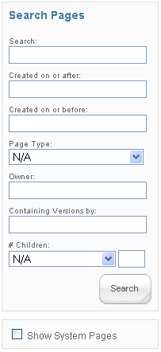

Editing pages

Creating pages
To create a page you should first know where to add it under. When a location is chosen the page has to be opened, if it hasn’t already, and press the “Add page” button.
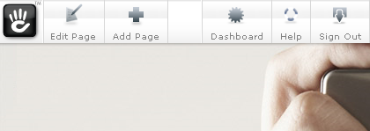
Next a box will open where you can add the information about the new page. After choosing a “Page type”/”Design” this options will hide. After correctly entering information about the page press the “Add” button at the bottom.
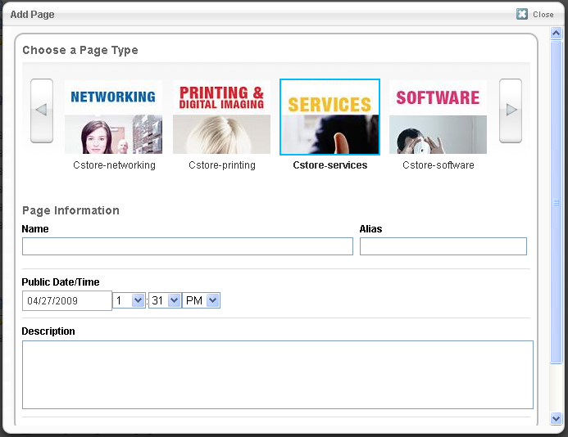
After creating a page this will turn up in the sitemap, but will only be visible for the visitors when it is published.

Editing pages
Through the sitemap or by browsing on the website, in view mode, pages can be opened. When a user, that has the permission to edit the page, views the page the “Edit bar” will be visible on top of the page.
When a user is in view mode the bar will look like this:
When a user is in edit mode, by pressing in the image above on “Edit page”, the edit bar will look like in the image below.
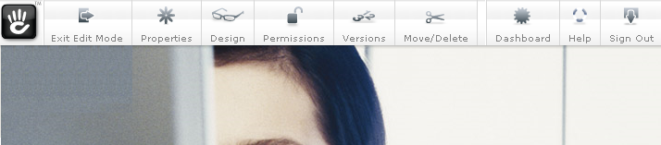
In edit mode more options are available. Leave edit mode by clicking on “Exit edit mode”. Next a box will appear that asks you to save the discard changes, preview the new version or publish the version.
Other settings of the page like “Properties”, ”Design”, “Permissions”, ”Versions” en ”Move/Delete” don’t have to be present. Whether or not these options available will depend on the permissions given to the user group you are currently in.

Adding blocks
Add a new block to a page by clicking on a link like in the image below. The “Add to [Area]” links give the option to add blocks to that area.
After clicking on the link like the one in the image above, the “Add Block” window will open. Here it’s possible to add new blocks to the area. Choose a block and click on the name or the plus (+) sign, the editor of that block will now open.
Block editors change per block, almost none are the same.
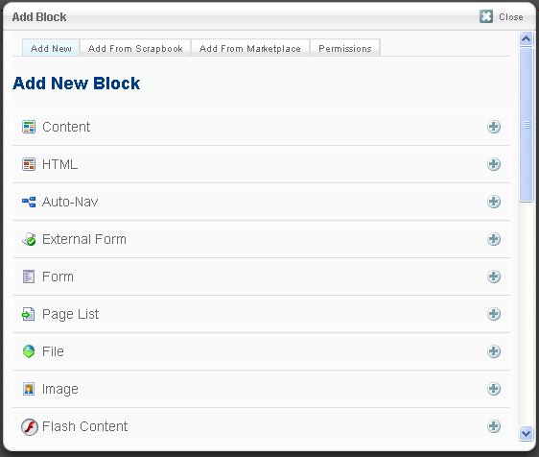
“Add Block” window with all the blocks available.

Editing blocks
In edit mode all blocks, that are added, will have a border, which is a red dotted line. When you move your mouse over the block it will highlight, even though the color of the highlight is darker.
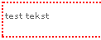 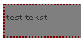
Normal (inactive) Active (highlighted)
After opening the block, the block editor will appear.

Saving pages
After editing a page you want to save the changes. Press the “Exit edit mode” button and the window in the image below will appear. You can name the version and then select the option you want.
- Discard My Edits
  - Undo all changes and return to the latest saved version.
- Preview My Edits
  - Save all changes, but don’t publish the page yet.
  - When a page is opened in view mode, by a user that can edit the page, the latest saved version, also preview versions, is displayed. The link “This version is waiting approval. Approve this version.” will be shown to quickly publish the page.
  - When another user edits the page he/she will continue in the latest saved version, even when it is saved by another user.
- Publish My Edits
  - Save all changes and publish the page on the website. This option is not available when you have no rights to publish the page.
  - When a page is published you only publish that page and not its subpages. 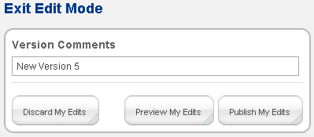

Versions
Like described above there can be multiple versions of a page. Every time you save a page a new version is created. This is useful, because you can always return to an earlier state of the page.
The button “versions” in the edit bar (when available) will show a list with all the versions of the page and options to compare, delete and publish versions.

(Event) forms

Creating forms
Creating a form is done by adding the Form block to a page. The form block shows a normal form which the user can fill in and send to the system and the Klant Form+ block shows a similar form only it already fills the question with a known answer using customer recognition. More information about the customer recognition is explained later on.

Adding questions
When adding a question to the form 3 options have to be entered:
- Question
  - Name of the question. Enter the question which the user will see here.
- Answer Type
  - The following options are possible:
    - Text Field
    - Text Area – Bigger Text Field
      - Here 2 more options are available:
        - Width – Width of the text area in pixels
        - Height – Height of the text area in pixels
    - Radio button
      - Here more options are available:
        - A text area will appear where on every line a possible answer can be entered.
    - Select box – Dropdown box
      - Here more options are available:
        - A text area will appear where on every line a possible answer can be entered.
    - Checkbox list
      - Here more options are available:
        - A text area will appear where on every line a possible answer can be entered.
    - File upload – Select a file which will be uploaded.
- This question is required
  - When this checkbox is ticked this question has to be answered in order to submit the form.
It is possible to save the form at any time by pressing the “Update” button. Clicking on the “Cancel” button will discard any changes made to the form.

Editing
Open the form for editing, by clicking on it while in edit mode. The same editor will appear and can be used to change the questions in the form. Use the edit tab to edit or delete existing questions. While editing the question you will get to a similar editor as the create question screen.
It is possible to save the form at any time by pressing the “Update” button. Clicking on the “Cancel” button will discard any changes made to the form.

Preview
In this tab it is possible to preview the form as it will appear on the page. You cannot perform any other actions here.

Options
In the options tab it’s possible to set a number of options that matter for how the form reacts to the user.
- Form name
  - Name of the form how it appears in the reports section in the dashboard. Use an easy recognizable name.
- Message to display when completed
  - What will the user see as a “Thank you” message after he submits the form?
- Notify me by email when people submit this form
  - Enter email addresses here where the confirmations messages will be send to. Multiple addresses can be entered in the text field that appears after ticking the checkbox. Use a comma, to separate the addresses.
- Solving a CAPTCHA Required to Post?
  - Does the user have to complete a CAPTCHA text/word to be able to submit a form? This way the system will know it’s not entered by a computer, but by a real human being.

File manager
The file manager in Concrete5 has recently been rewritten. In version 5.3 the file manager’s options has been expanded and improved. First off the file manager was an simple manager which had no real support for a single location to save files. Blocks and add-ons had to handle files on their own.
This has changed and now there is a single location to save files and search for them. These functions will be explained below.
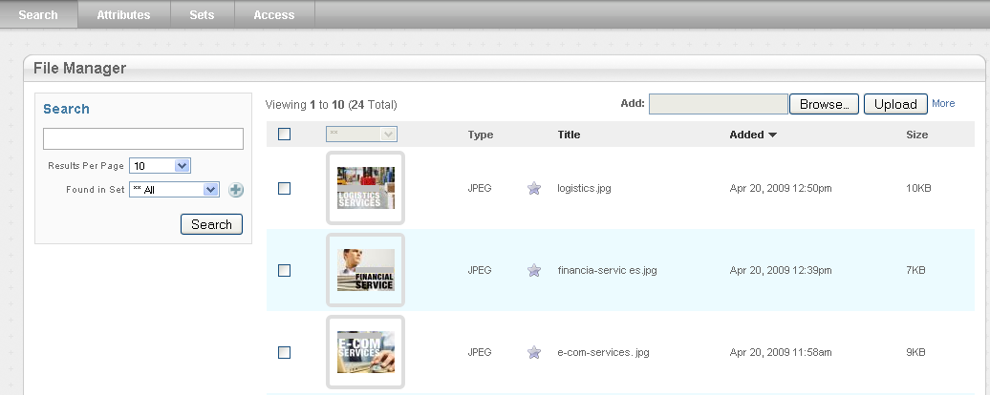

Uploading files
The file manger is working with uploaded files. These files should first be uploaded and added to the system. That’s why there are more than one ways to do this.

Single file
Uploading a single file can be done through the form that is in the image below. Choose a with the browse button and then press “Upload”. The file will now be added to the system.

Multiple files
It’s also possible to upload multiple files at the same time. This can be very useful when uploading large amount of files. In the image below there is a link “More”, click it and a new window will appear.

Uploading files from the computer
In the new window, the image below, you have to press “Add files” to be able to select multiple files in through the interface of your operating system. After that, press the “Start uploads” button to upload the files, when the uploading is complete the results will be shown in the same window.
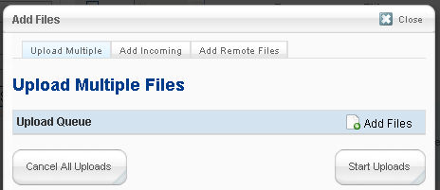
Files selected:
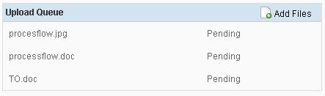
Files uploaded:
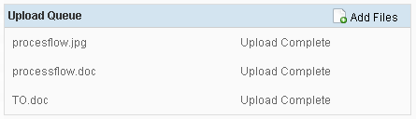
When you are done uploading files you can close the window by clicking on the “Close” link on the top right corner. Your uploaded files will then become visible in the file manager.

Uploading files from the internet
There are more ways to upload files then from your computer. You can also upload files directly from the internet. Open the “Add Remote Files” tab to enter URL’s from files on the internet that you want to upload.
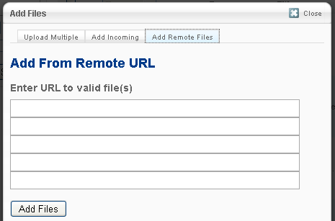
When you are done uploading files you can close the window by clicking on the “Close” link on the top right corner. Your uploaded files will then become visible in the file manager.

Downloading
It’s also possible to download one or multiple files at the same time from the file manager. The selected files will become available in a downloadable archive.
Select the files you want to download using the checkboxes and then select “Download” from the dropdown box.
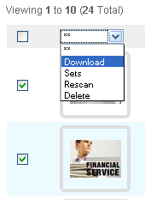

Sets
There is no option to create directories in the file manager, but there is a similar function available. “Sets” are sets of files combined to a type of group. Select the files you want to add to a set using the checkboxes and then select “Sets” from the dropdown box.
After clicking on the sets option in the dropdown box, the window from the image below will appear. Sets that are already present in the file manager will be displayed along with an indicator if the file(s) have already been added to a set. A file can be added to multiple sets.
To add the file(s) to a new set you can use the text field under the already present sets and enter a name for the new set. Click update to add the files to the selected sets.
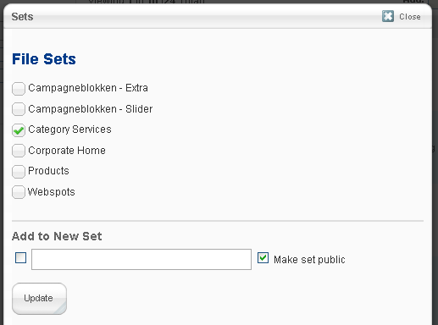
Sets can be used to make archiving and searching a lot easier, but they also have a use in, for example, the standard slideshow block. When adding slides to the slideshow you can select a whole set at once to be added to the slideshow instead of adding every image separately.
Sets can be individually edited in the “Sets” tab in the file manager.

Rescanning files
When an upload is changed by someone with direct access to the server or when a new version of the file is uploaded the registered information no longer matches with the actual upload. To update this information use the “Rescan” function from the dropdown box. This will rescan all selected files, update all known details and create new thumbnails.
Select the files you want to rescan and select the rescan option from the dropdown box.
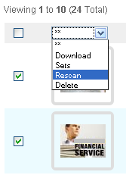

Deleting files
Files can also be deleted from the file manager. Select the files you want to delete and select the “Delete” option from the dropdown box.
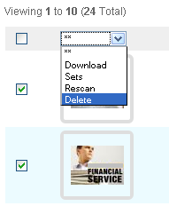
After selecting the “Delete” option a new window will appear with a confirmation message.
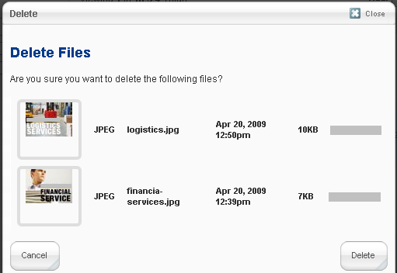
Press “Delete” to delete the shown files.
Press “Cancel” to abort the current operation and keep the shown files.

Search engine
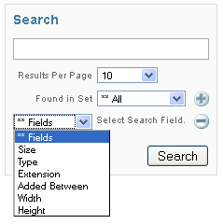
The search engine in the file manger makes possible to search for files using multiple filters. You can search on:
- Filename
- File size
- File type (image)
- File extension (.jpg, .gif, .doc, .xls, .ppt)
- Upload date
- Width of an image
- Height of an image.
The sets can come to use here as it is possible to search in sets, but this is also the way to see all files in a set. The “Found in Set” dropdown box shows all sets and when selected (and pressed the search button) all files in the selected set are displayed.
Add a new filter using the plus (+) image and remove a filter using the minus (-) image.
Press “Search” when you have configured the search engine and you want to get the results.

Permissions
For the file manager there is a separate permissions page. This page is under the “Access” tab. On this page you can set which user groups have access to which files and what they are able to do with them. You can also distinguish users by only allowing them to perform action on their own uploaded files. There is also an option to restrict uploading of certain file types.
It’s recommend to secure this page through the sitemap to only allow access from users in the “Administrators” group.
For each group you can set the following permissions, displayed in the image below:
- “View Site Files”
  - View uploaded files on the website.
  - It’s recommended to put this on “Yes” for every group.
- “Search Files”
  - Search for files in the file manager.
  - The group has to have access to the file manager itself.
  - “Mine” will only give users access to search in its own uploaded files.
- “Edit Files”
  - Allow users to edit files in the file manager.
  - The group has to have access to the file manager itself.
  - “Mine” will only give users access to edit their own uploaded files.
- “Admin Files”
  - Delete files
  - Change information of the files.
  - The group has to have access to the file manager itself.
  - “Mine” will only give the users access to perform these actions on their own uploaded files.
- “Add Files”
  - Allow users to upload new files to the file manager.
  - “Custom” allows you to set only specific file types to be uploaded to the file manager for that selected group.
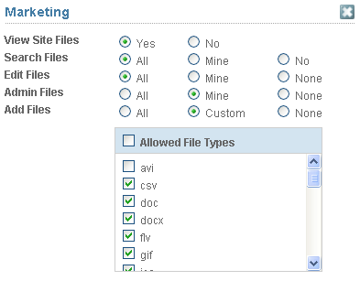

reports
When a visitors submits a form on the website this is saved in the Concrete5 database. In the dashboard you can look through these results at any time.
On default the Form results tab will be opened when you click on reports on the left side of the navigation. Here you can look through submitted form results.
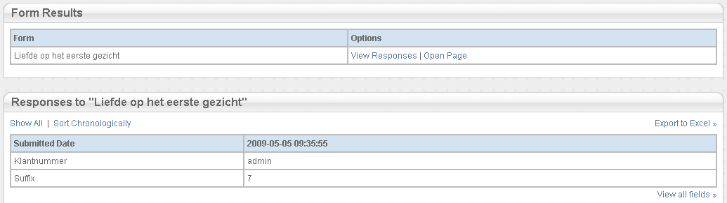
All the known forms are displayed in the top block in the image above. “View Responses” will make the lower box appear with the results of that form. “Open page” will open the page on which the form is added. The bottom box will show the results of the selected form. “View all fields” will show all the answers to all the questions instead of only the first two that are shown on default. “Export to Excel” allows users to download an excel sheet with all the form results.

Surveys
The surveys tab will shows information about surveys that are added to the website. All surveys will be listed on the page. Press the name of the survey to see the results of the survey.
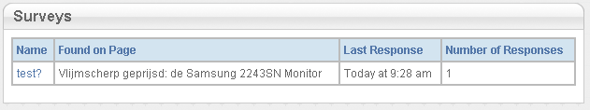
In the Logs tab all the important logs are saved of actions that the Concrete5 system performs, for example when a user forgets its password and when Concrete5 finds an unexpected error or exception. The database tab will show all the queries that are performed by the system. These logs can grow quite large and that is why it’s recommended to clean these logs from time to time when they are set to active.
All logs can be disabled in the Sitewide settings section in the tab “Debug”.

User manager

Users

Creating new user accounts
The following fields are available on default when creating user accounts, these fields cannot be deleted:
- Username
- Password (2x – confirmation)
- Avatar – not required
  - Because Concrete5 can also be used for communities this feature is available on default.
Press after entering all the required fields on the “Create user” button. The user will be created and can login with the login details you just entered.

Editing user accounts
First you will have to find a user on the “Find users” page to be able to edit a user. Use words or characters that are used in the username or password of the user account you want to edit.
After searching you will get a result list with users that match the words you entered. Press on the name, not the email address, of the user account you want to edit. The profile page will now open and press on the edit button to start editing. Which fields are available depends on the amount of additional fields there are created in the “User Attributes” section. The fields from the user creation screen are also available.

Adding users to groups
In the user editor there is an option to add users to user groups. The advantages of this option is managing user accounts and managing permissions set for an entire group of users instead of applying permissions to every single user account.
The option is available under the “Add Group” link. A list with all available user groups will appear. Select the group(s) you want to add the user and save the user profile.

User groups
Users can be added to user groups which makes managing users easier. All settings and permissions are handled on user group level and will apply to every user that is added to these groups. When a user is not added to any group(s) the user will have the permissions from the “Registered users” group. Visitors, not logged in users, will have the permissions from the “Guests” group.
How permissions can be set to user groups is explained in the permissions section.

Creating new user group(s)
On the bottom of the “Groups” page there is a small form present which allows you to create new user groups. You can enter a name and description for the group. No other information is needed.

Editing user groups
Press on a name of a user group to edit the information about that group. Here you can change the name and description of the group. Save changes by clicking on the “Update” button.

User attributes
In the “User attributes” tab it is possible to add additional fields to user profiles. First a list is displayed with all the already present user attributes; these can also be edited here.
The values of these attributes can be set by the user itself or by an Administrator. There is also an option to show these attributes on registration of the user account when registration is enabled.
- Handle
  - Is used in the database and can be used to call the information in PHP.
- Type
  - What type of field will be used to enter the information? Options: text field, large text area, checkbox, dropdown box, radio buttons and HTML text.
- Name
  - The name of the question the user will see in the user profile editor.
- Values
  - Only used with radio buttons and the dropdown box. The options the user will see have to be entered here. One option per rule.
- Hidden
  - Will hide the field from the user.
- Required
  - Is the question required to save the profile or complete the registration?
- Private
  - This value will or will not be shown in the public profile.
- Registration Q
  - Is this question available on the registration page?
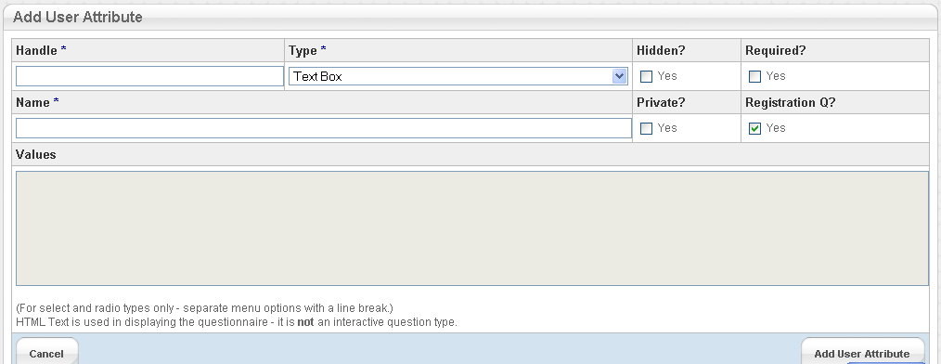

Settings
There are a number of global settings that apply for all users. This can be found under the “User Registration” tab.
- Registration
  - Registration is disabled
  - Registrations need to be verified with an email.
  - Registrations have to be manually approved by an Administrator.
  - Registration is enabled.
  - Allow users to use their OpenID.
  - Use the email address as username.
- Profiles
  - Activate publicly available profile pages for user accounts..

Maintenance
On the Maintenance page you can add scripts, called Jobs, to be run at a specific time and date through cronjobs. In the image below the jobs are not running.
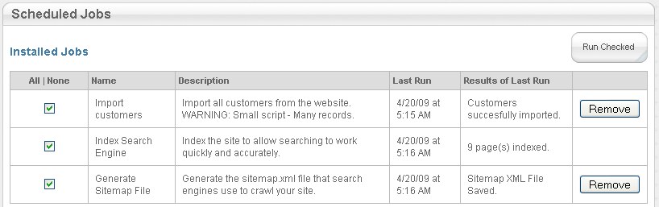
When the script is running there will be a JavaScript “progress” animation visible. This is handled by Concrete5. When the script has successfully run a green icon will be visible.
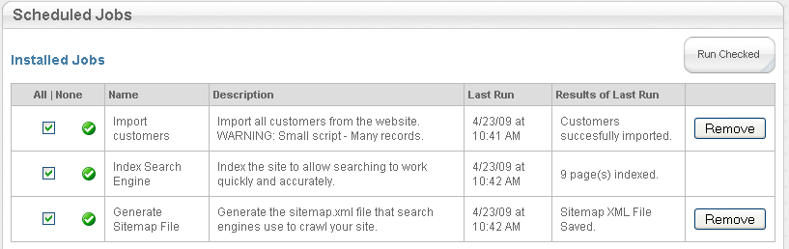
When something has gone wrong while running the script there will be a yellow icon visible for the Job that has returned the error and in the “Results of Last Run” column an error message will appear.
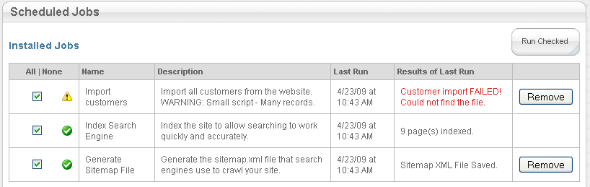
By pressing remove you can remove jobs from Concrete5. The script will be visible on the page as a “Not installed job” which can be installed at any time by clicking on the name. To remove the job entirely you have to remove the job file from the jobs directory in your installation.
By using the link at the bottom of the page the scripts can be put in a schedule system like the cronjobs. Then the server will run those (selected) scripts at a specific time and day.

Pages and themes
On the “Pages and Themes” page it’s possible to change settings of the website that are for the design, theme/layout, of the website. You can select a default theme and install new themes when they are uploaded to the web server. There is an option “Customize” where you can change a number of simple settings of the theme, but I don’t recommend it, because they are too simple and some themes no longer use this option. You can however use this on the default themes “Plain Yogurt” and “Green Salad Theme” with less risk involved.

Page Types
In the tab “Page Types” new page types can be added and the default blocks can be set for page types. A page type is used to select a layout inside the design of a theme. For example: Full width, left sidebar, right sidebar, no header page types.
There can be default blocks added to the page type. These default blocks will be atomically added to every new page created with this page type. The already existing pages will not contain the default blocks when they are added to the default settings.

Page attributes
In the same tab you can add “Page Attributes”. These page attributes are additional values that can be added to every page. They work in the same way as User Attributes.
They can be entered in the properties window of the page when this is opened for editing.

Single pages
Single pages are pages that only occur once in the website and usually feature an unique function. These kinds of pages are login pages, profile pages, special forms, etc. Single pages are visible in the sitemap and can be treated like a normal Concrete5 page.
The single pages have to be added through the single pages manager under the “Single pages” tab in the “Pages and Themes” section. The manager does not allow more options than adding a page because the rest of the properties and settings can be managed through the sitemap.
While adding a single page you have to enter an URL. Here you should take in account how the page is called as a PHP file in the “single_pages” directory on the web server.
When the single page is placed on the web server like this: “concrete/single_pages/newpage.php”
This has to be entered as URL: “newpage”
When the single page is placed on the web server like this: “concrete/single_pages/adirectory/newpage.php”
This has to be entered as URL: “adirectory/newpage”
View.php is seen as the default page and won’t have to be entered; this is very useful in sub directories.

Add functionality
On the “Add functionality” page there is a list of all the installed blocks. These blocks can be on default installed blocks or additional blocks. There is no indicator which is which. All the non-installed blocks are displayed on the right side of the page and can be installed by pressing on their names.
Opening an installed block will give the possibility to remove the block from the installation, when this is no longer used on the website. It can also be refreshed which will update all the information and tables about the block to the information found in the blocks installation directory.

Sitewide settings
These global website settings will apply to the entire website. On the “Sitewide settings” page and its tabs these settings can be found:
- Global
  - Website name
    - Name of the website as it appears in the title bar of the browser and in search results.
  - Editor preferences
    - Display breadcrumb navigation bar.
      - Shows a breadcrumb from the edit bar when you mouse over it. It shows you current location on the website.
      - User depended setting.
  - Tracking code
    - Option to add a code to the end of each page which can be used to load a more advanced tracking program.
  - Linking
    - Enable Pretty URLs
      - Automatically translates your path-based Concrete5 URLs so that they don't include 'index.php'.
  - Marketplace integration
    - Option to show plug-ins from the marketplace when users add blocks or change themes. They can be installed from the dashboard when they are downloaded from the marketplace and uploaded to the installation.
  - Content toolbars
    - Choose the level of advanced-ness for the content block. The more advanced option you select the more options users will get in the content block WYSIWYG editor.
      - There is also an option to add a custom code. You will be able to determine yourself which options are available and which are not.
  - Upload bookmark icon
    - Upload an icon which will be used in the bookmarks of the user’s browser and will appear in the address bar of the browser.
- Access
  - Site permissions
    - This option is unavailable because there is chosen for the advanced permissions model.
    - Here it is possible to set for each user group if they are able to edit pages. This setting will apply to all pages on the website.
  - Maintenance mode
    - Put the website in “Maintenance mode”. With this the website will be closed off for non-Administrators. Users that will visit the website will get the message that the page is closed for maintenance.
  - IP black list
    - Add an IP address or an IP address series to the list of banned IP addresses. People with computers that match those IP addresses will no longer be able to access the Concrete5 driven part of your website.
    - You can also use a smart filter that will block a user after a certain amount of failed login attempts in a certain amount of time.
- Debug
  - Debug Level
    - Here you can choose to put the website in “Production” or “Development” mode. When production mode is active no PHP errors will be displayed, while in the development mode this is displayed.
  - Logging
    - To keep track of what’s going on, on the website you can enable logging.
      - Log Application Exceptions
        - When Concrete5 has found something it didn’t expected it can make an exception and when this happens it will log this exception to be able to inform the administrators. These logs can be used to track down a problem.
      - Log Database Activity
        - Saves all queries executed on the website. Can be used to track down any issues that might have arisen.
      - Log Emails Sent
        - Saves all emails that are being sent from the website to the database. They can be reviewed later.
      - When all logs are saved the database can become full and slower, you don’t want this. That is why it’s recommended to clean these logs from time to time when they are enabled.
  - Caching
    - Delete cache
      - To make the loading of the website faster some parts of the website are cached so that they can be loaded faster next time a user visits the page. Sometimes the cache can be outdated and it will be needed to delete the current ache. Next time a page loads the loading will take longer than with an already cached page.

Scrapbook
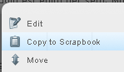
The scrapbook is a type of clipboard for Concrete5. This scrapbook allows you to copy blocks easily from one page to another, which is easier than recreating the block on another page.
Open a page in edit mode and click on a block (left mouse button) and click on “Copy to scrapbook”. A confirmation message will appear.
To place this block on another page you will have to open that one in edit mode and click on the “Add to [area]” link. Open the “Add from Scrapbook” tab and select the block you want to add. The block will now be copied to the selected area on the page. The block will remain added to the scrapbook.
In the Dashboard there is a scrapbook page present. On this page you can see your scrapbook and all the blocks that are added to it. You can also remove blocks from your scrapbook from there.

Global scrapbook
The global scrapbook is also available. This page is a tab on the Scrapbook page.
The global scrapbook allows you to add blocks, rename, delete and edit them. Blocks that are used a lot can be added here.
The real advantage of the global scrapbook lies in that you can only edit the block from the dashboard in the global scrapbook page. This block is page independent and when a change is made it’s changed throughout the site where the block is used.
Editing a block from the global scrapbook is not possible from the page where it’s added only from the dashboard itself.

Permissions

Extra information (Difference between Administrators)
The first user account, the Root Administrator/Super User/admin, can do everything at any time in the system. This account is not bound to the permissions that are set. Users in the same user group (Administrators for example) do not have the same permissions as the super user. This means that you have to create a new user group (Administrators) and allow this group to do everything.
Because there are still some minor differences even then it’s recommended that the daily administrator of the website uses the super user account.

Page permissies

Reachable through:
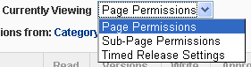
Sitemap -> select a page -> Set permissions
Or
Visit a page -> Edit mode -> Set permissions
Options in the set permissions popup

Description
Permissions are set to available user groups. On default a new user group has access to nothing and has the same rights as the “Guests” group.
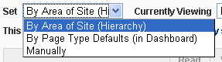
Permissions work per page and they are also set to every page that is added beneath it (inheriting). When a subpage gets other permissions set to it all the pages that are beneath that page will get the same permission model when this is selected with the option: “Sub-pages added beneath this page inherit permissions of this page”.
Warning!: Permissions can be set for subpages and then they will no longer inherit the permission model from their parent pages. A new tree with another permission model will start here. To revert this set the “By Area of Site (Hierarchy)” option to the page permission model.

Set permissions (pop-up box)
- Page permissions
  - Read
    - Reading a page.
  - Versions
    - Manage versions of the page.
  - Write
    - Edit pages and blocks.
  - Approve
    - Publish pages.
  - Delete
    - Delete pages and subpages.
  - Admin
    - All rights for editing a page.
      - All the above.
      - Change designs of a page.
      - Change permissions of a page.
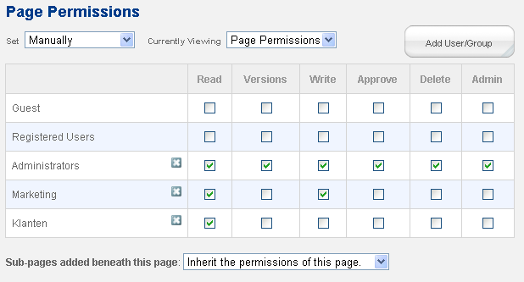
- Sub-page permissions
  - You can set for every user group here which designs/page types they can use when creating a new page.
  - When nothing is added here users won’t be able to add pages.
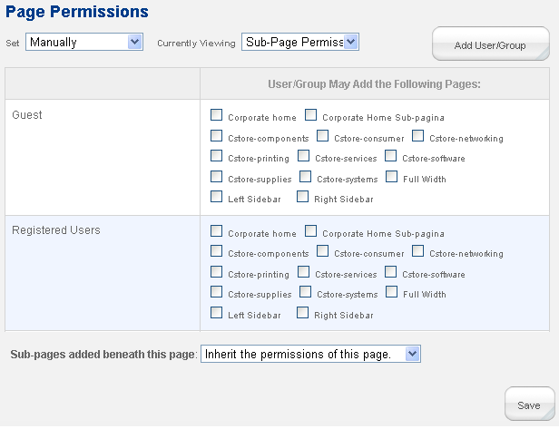
- Timed released settings
  - Set the time when a user group is able to see this page.
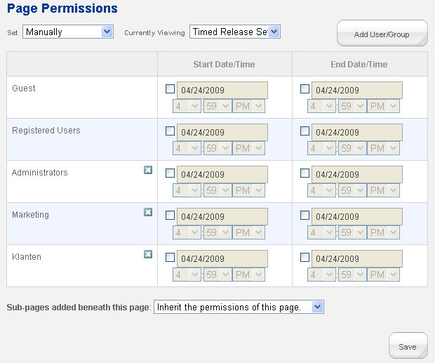

Block permissions

Reachable through:
Sitemap -> select a page -> visit page -> Edit mode -> Add new block -> Permissions
Or
Visit a page -> Edit mode -> Add new block -> Permissions

Description
The same description here applies as for the page permissions, but also the following:
For every page multiple areas can be available (like: main, header, sidebar). Every area can have other permissions for every page. This gives you more freedom in setting permissions, but is also more difficult to maintain.

Permissions (tab)
Here you can set which blocks are users able to use while editing pages.
Inheriting applies here again and WARNING! This is more difficult to control. All subpages will get the same permission model as their parent page and then only get a small message (in red) about the version permission model it inherits.
Open a page in edit mode and click on the “Add to [area]” link. A new window will appear and will contain the “Permissions” tab. In this tab you can set for every group which blocks they can add, edit and delete..
.