Thomas Tingey

CS 462

Lab 6

Part 1

1. Urls:
   1. <https://raw.githubusercontent.com/tomcat90/cs462_lab6/master/echo.krl>
   2. <https://raw.githubusercontent.com/tomcat90/cs462_lab6/master/track_trips.krl>
2. RIDs:
   1. Echo: b507769x1.prod
   2. Track_Trips: b507769x2.prod
3. ECI:
   1. 9F23A2A8-ED86-11E5-BB47-4890E71C24E1
4. Questions:
   1. I used sublime plugin to validate the KRL
   2. 1 Directives. At least 1 rule ran:
5. "directives": [{
6. "options": {
7. "something": ""
8. },
9. "name": "say",
10. "meta": {
11. "rule_name": "message",
12. "txn_id": "3314AC9E-ED8E-11E5-8DE5-D6A4647AB95A",
13. "rid": "b507769x1",
14. "eid": "81761703699"
15. }
16. }

c. 2 directives. At least 2 rules ran

{

"directives": [{

"options": {

"something": ""

},

"name": "say",

"meta": {

"rule_name": "message",

"txn_id": "3314AC9E-ED8E-11E5-8DE5-D6A4647AB95A",

"rid": "b507769x1",

"eid": "81761703699"

}

}, {

"options": {

"trip_length": "1000"

},

"name": "trip",

"meta": {

"rule_name": "process_trip",

"txn_id": "3314AC9E-ED8E-11E5-8DE5-D6A4647AB95A",

"rid": "b507769x2",

"eid": "81761703699"

}

}]

}

d. The difference is that every rule that matches the event gets fired. So when I added the second ruleset with the same rules both rules ran.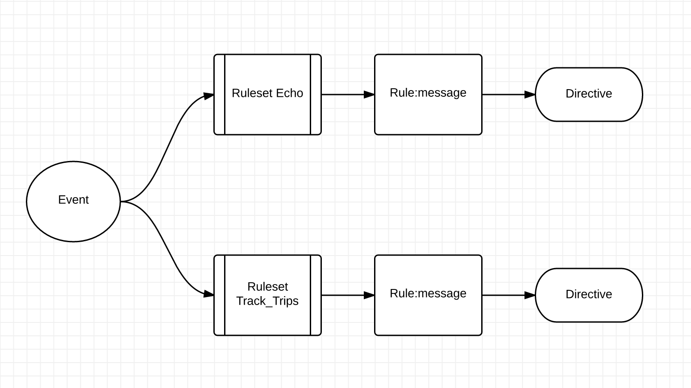

Part 2

1. <https://raw.githubusercontent.com/tomcat90/cs462_lab6/master/track_trips_2.krl>
2. b507769x3.prod
3. 9F23A2A8-ED86-11E5-BB47-4890E71C24E1
4. Questions:
   1. I noticed your specs are wrong. This question should probably ask what did you notice in (3) not (2) above. In (3) the event still fired even if the mileage wasn’t supplied
   2. Yes it is an intermediary. Intermediary rules are rules that trigger another rule and then passes that data along. My rule is a logging rule and logs the mileage sent in.
   3. raise explicit event 'found_long_trip' attributes event:attrs(); since this is in a fired based on a conditional the logs let me know whether or not it was fired. Just to double check it though I defined a rule that listens for explicit found_long_trip and that sends a directive letting me know it was fired as well.
   4. You could pass it in as an attribute, call an api with the information, use a randomly assigned number ;)

Part 3

1. <https://raw.githubusercontent.com/tomcat90/cs462_lab6/master/trip_store.krl>
2. b507769x4.prod
3. 9F23A2A8-ED86-11E5-BB47-4890E71C24E1

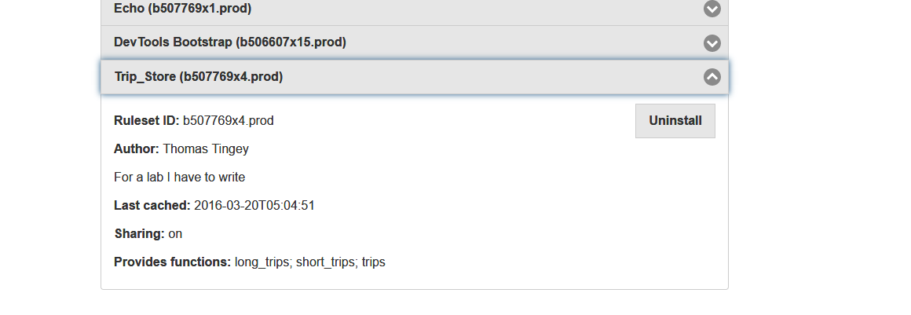

1. Questions:
   1. It’s an event api because it listens to events and responds to those events. By providing the provides meta you can also query my endpoint and it will tell you what functions it has.
   2. I had to look this up, but basically it gets all of the trips and then runs them through a filter returning only those that are not in long_trips
   3. Then when you query you don’t get that function in the query.
   4. Sharing allows others to install the rule. So sharing off would mean nobody else could install the rule on their picos.