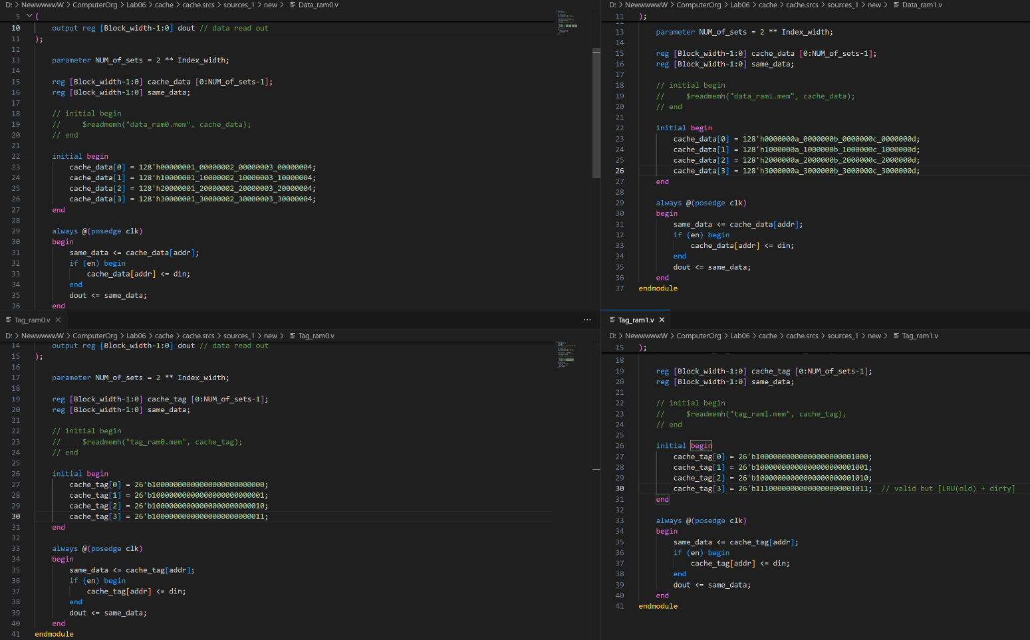

对cache中的data+tag进行初始化，左上角为Data0（Way0），左下角为Tag0（Way0）；
右上角为Data1（Way1），右下角为Tag1（Way1）.

·仿真代码
`timescale 1ns / 1ps
module Cache_tb();
reg clk;
reg rst;
reg [31:0] addr_cpu;
reg rd_cpu;
reg wr_cpu;
reg ready_mem;

// Outputs
wire [31:0] addr_mem;
wire rd_mem;
wire wr_mem;

// Bidirs
reg [31:0] data_cpu_write;
reg [127:0] data_mem_read;
wire [127:0] data_mem_write;
wire [31:0] data_cpu_read;

// Instantiate the Unit Under Test (UUT)
Cache uut (
.clk(clk),
.rst(rst),
.data_cpu_write(data_cpu_write),
.data_mem_read(data_mem_read),
.addr_cpu(addr_cpu),
.addr_mem(addr_mem),
.rd_cpu(rd_cpu),
.wr_cpu(wr_cpu),
.rd_mem(rd_mem),
.wr_mem(wr_mem),
.data_cpu_read(data_cpu_read),
.data_mem_write(data_mem_write),
.ready_mem(ready_mem)
);
//Clock generator block
initial begin
clk = 1'd0;
forever
#10 clk = ~clk;
end
initial begin
// Initialize Inputs
rst = 1;
addr_cpu = 0;
rd_cpu = 0;
wr_cpu = 0;
ready_mem = 1;
data_cpu_write = 0;
data_mem_read = 0;
rst = 0;
#120;

// Read from location
rd_cpu = 1'd1;
addr_cpu = 32'b0000_0000_0000_0000_0000_0010_0000_0111;
#40;
rd_cpu = 1'd0;

// Write to same location
#40;
wr_cpu = 1'd1;
data_cpu_write = 32'habababab;
addr_cpu = 32'b0000_0000_0000_0000_0000_0010_0000_0111;
#40;
wr_cpu = 1'd0;
// Read from same location to check updated data
#40;
rd_cpu = 1'd1;
addr_cpu = 32'b0000_0000_0000_0000_0000_0010_0000_0111;
#40;
rd_cpu = 1'd0;

// // Read Miss with dirty bit 0 policy check, reads data from Main Memory

#40;
rd_cpu = 1'd1;
addr_cpu = 32'b0000_0000_0000_0000_0000_0010_0000_1010; // read miss
#40;
ready_mem = 1;
data_mem_read = 128'h54088666_54088666_54088666_54088666; // miss

#40;
rd_cpu = 1'd0;
#40;
rd_cpu = 1'd1;
addr_cpu = 32'b0000_0000_0000_0000_0000_0010_0000_1010;
#40;
rd_cpu = 1'd0;

// //////////////////////////////////////////////////////
// // write Miss with dirty bit 1 policy check
#80;
rd_cpu = 1'd0;
wr_cpu = 1'd1;
data_cpu_write = 32'h5a5a5a5a;
addr_cpu = 32'b0000_0000_0000_0000_0000_0010_0000_1101;
#40;

ready_mem = 1;
data_mem_read = 128'h11451450_11451451_11451452_11451453;

#40;
wr_cpu = 1'd0;
#40;
wr_cpu = 1'd1;
data_cpu_write = 32'h5a5a5a5a;
addr_cpu = 32'b0000_0000_0000_0000_0000_0010_0000_1101;
#40;
wr_cpu = 1'd0;

#300 $finish;

end

endmodule

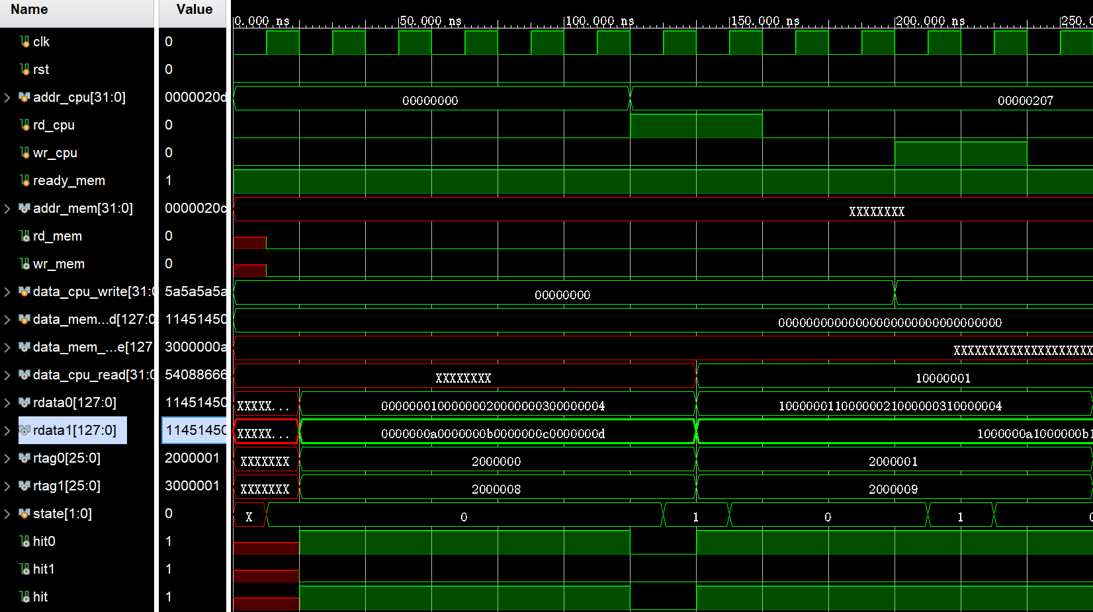
（1）Read Hit

addr_cpu = 32'b0000_0000_0000_0000_0000_001_0000001_11; = 207

Index = 0000001第一组 ——> Tag = 000001和rtag0相等（hit） ——> 读出rdata0的第b11 = d3个字的数据（10000001）。

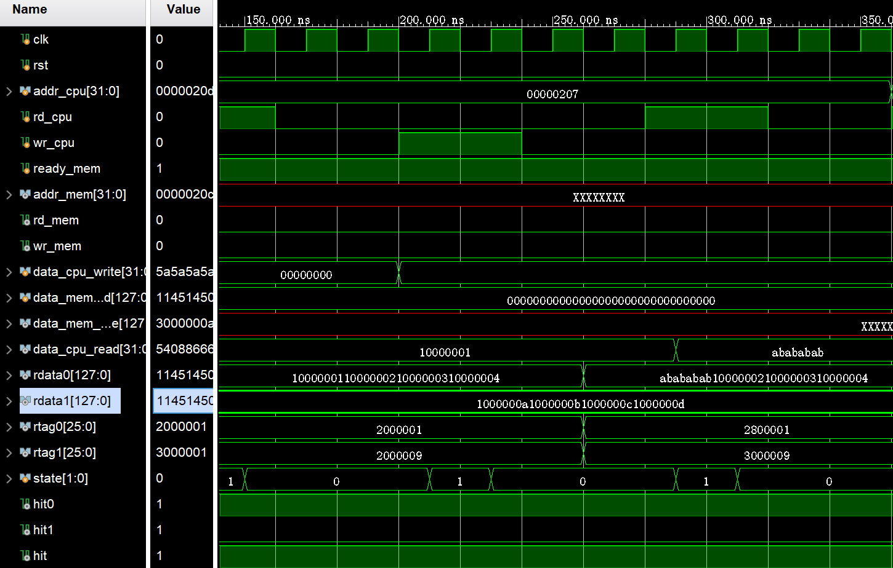
（2）Write hit
abababab
同一个addr_cpu，现在想要写入h’abababab，可以看到rdata0中的数据被修改（Write hit），But（data_cpu_write没被截进来）。
随后对同一地址进行Read，可以看到data_cpu_red成功读出abababab，即Read hit。

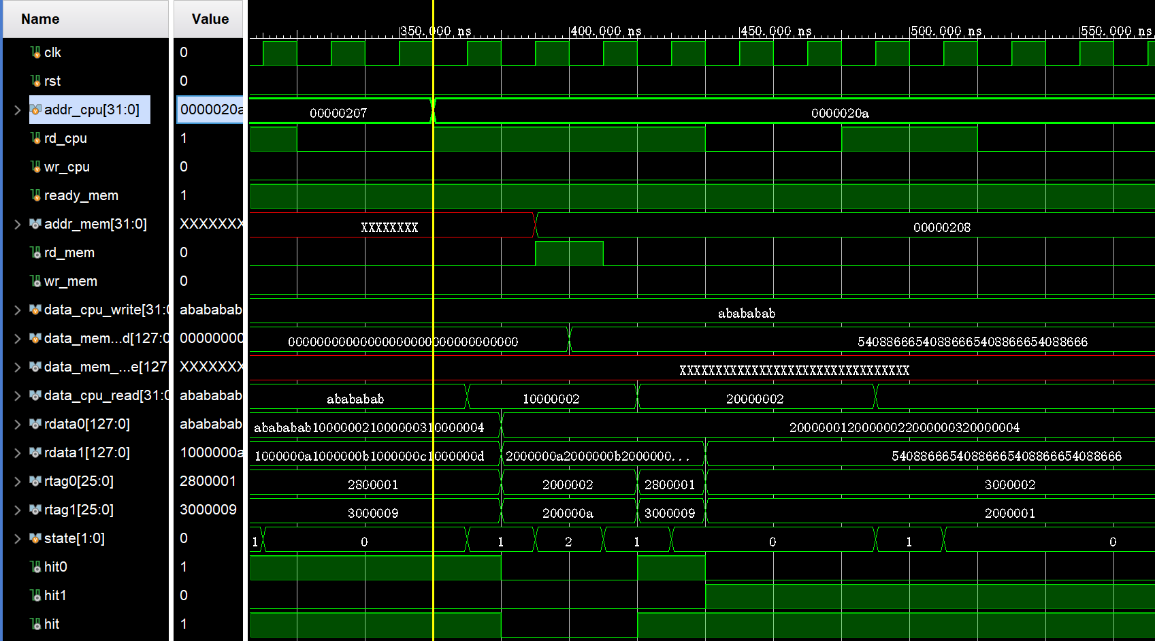
（3）Read Miss （No dirty）：采用allocate从内存中读取块
54088666540……88666
addr_cpu = 32'b0000_0000_0000_0000_0000_001_0000010_10; = 20a
Index = 0000010第二组 ——> Tag = 000001不与cache中相应块中的tag相等（miss） ——> 从CompareTag(state = 1) 进入 Allocate（state=2），因为块not dirty（rtag的第23位）不用写回。
——> 随后rdata1中修改，且rtag0设为LRU=1（old）——> 随后Read hit

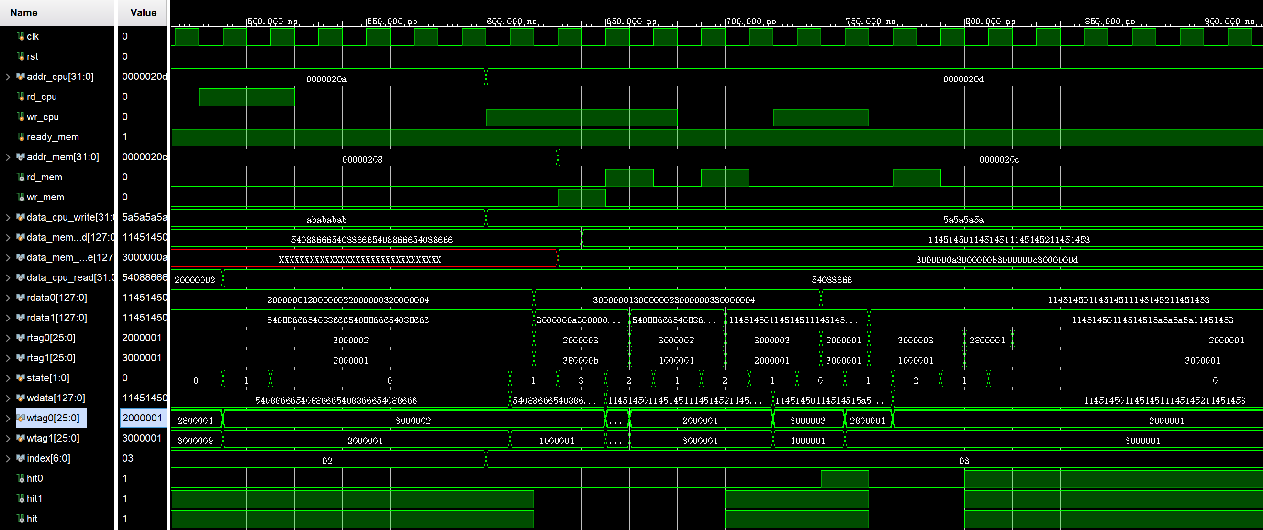
（4）Write Miss （Dirty）（图有点大）：先WriteBack写回，随后Allocate从内存中读取块
addr_cpu = 32'b0000_0000_0000_0000_0000_001_0000011_01; = 20a
Index = 0000011第三组 ——> Tag = 000001不与cache相应块的tag相等（writemiss） ——> 从CompareTag(state = 1) 进入 WB（state=3）（rtag1块dirty）写回。
——> 进入Allocate(state = 2) ，并修改rtag1，并且rdata1写入
——> 然后在同一位置写入5a5a5a5a，可以看到被修改（write hit）
`timescale 1ns / 1ps // 原代码
module Cache(
input wire clk, // clock
input wire rst, // reset
input wire [31:0] data_cpu_write, // data write in
input wire [127:0] data_mem_read, // data read in
input wire [31:0] addr_cpu, // cpu addr
input wire wr_cpu, // cpu write enable
input wire rd_cpu, // cpu read enable
input wire ready_mem, // memory ready

output reg wr_mem, // memory write enable
output reg rd_mem, // memory read enable
output reg [127:0] data_mem_write, // data to mem
output reg [31:0] data_cpu_read, // data to cpu
output reg [31:0] addr_mem // memory addr
);

reg [1:0] state, next_state;
parameter [1:0] IDLE = 2'b00, CompareTag = 2'b01, Allocate = 2'b10 , WriteBack = 2'b11;
reg en0,en1,ent0,ent1; // input enable
reg [127:0] wdata; // input din for Data_ram
reg [25:0] wtag0, wtag1; // input din for Tag_ram
wire [6:0] index; // input addr for ram
wire [22:0] cpu_tag; // Tag in addr_cpu
wire [1:0] cpu_offset;

wire [127:0] rdata0, rdata1;
wire [25:0] rtag0, rtag1;

wire cpu_req_valid;
wire hit0, hit1, hit;

wire valid0, valid1, valid;
wire LRU0, LRU1;
wire dirty0, dirty1;

assign cpu_req_valid = wr_cpu | rd_cpu;
assign index = addr_cpu[8:2];
assign cpu_tag = addr_cpu[31:9];
assign cpu_offset = addr_cpu[1:0];
assign valid0 = rtag0[25];
assign LRU0 = rtag0[24];
assign dirty0 = rtag0[23];

assign valid1 = rtag1[25];
assign LRU1 = rtag1[24];
assign dirty1 = rtag1[23];

assign hit0 = (cpu_tag == rtag0[22:0]) & valid0;
assign hit1 = (cpu_tag == rtag1[22:0]) & valid1;
assign hit = hit0 | hit1;
assign valid = valid0 | valid1;
assign dirty = dirty0 | dirty1;

always@(posedge clk or posedge rst) begin
if(rst) begin
state <= IDLE;
end
else begin
state <= next_state;
end
end

always@(*) begin
case(state)
IDLE: begin
en0 = 1'b0;
en1 = 1'b0;
ent0 = 1'b0;
ent1 = 1'b0;
wr_mem = 1'b0;
rd_mem = 1'b0;

if(cpu_req_valid)
next_state = CompareTag;
else
next_state = IDLE;
end

CompareTag: begin
en0 = 1'b0;
en1 = 1'b0;
ent0 = 1'b0;
ent1 = 1'b0;
wr_mem = 1'b0;
rd_mem = 1'b0;

if(hit) begin
next_state = IDLE;
ent0 = 1'b1;
ent1 = 1'b1;
if(rd_cpu) begin
if(hit0) begin
wtag0 = {rtag0[25],1'b0,rtag0[23:0]}; // change LRU (0 for new)
wtag1 = {rtag1[25],1'b1,rtag1[23:0]}; // change LRU (1 for old)

case(cpu_offset)
2'b00: data_cpu_read = rdata0[31:0];
2'b01: data_cpu_read = rdata0[63:32];
2'b10: data_cpu_read = rdata0[95:64];
2'b11: data_cpu_read = rdata0[127:96];
endcase
end

if(hit1) begin
wtag0 = {rtag0[25],1'b1,rtag0[23:0]}; // change LRU (0 for old)
wtag1 = {rtag1[25],1'b0,rtag1[23:0]}; // change LRU (1 for new)

case(cpu_offset)
2'b00: data_cpu_read = rdata1[31:0];
2'b01: data_cpu_read = rdata1[63:32];
2'b10: data_cpu_read = rdata1[95:64];
2'b11: data_cpu_read = rdata1[127:96];
endcase
end
end

if(wr_cpu) begin
if(hit0) begin
en0 = 1'b1;
wtag0 = {rtag0[25],1'b0,1'b1,rtag0[22:0]}; // change LRU (0 for new), change dirty (1 for only in cache)
wtag1 = {rtag1[25],1'b1,rtag1[23:0]}; // change LRU (1 for old)

case(cpu_offset)
2'b00: wdata = {rdata0[127:32],data_cpu_write};
2'b01: wdata = {rdata0[127:64],data_cpu_write,rdata0[31:0]};
2'b10: wdata = {rdata0[127:96],data_cpu_write,rdata0[63:0]};
2'b11: wdata = {data_cpu_write,rdata0[95:0]};
endcase
end
else if(hit1) begin
en1 = 1'b1;
wtag0 = {rtag0[25],1'b1,rtag0[23:0]}; // change LRU (1 for old)
wtag1 = {rtag1[25],1'b0,1'b1,rtag1[23:0]}; // change LRU (0 for new), change dirty (1 for only in cache)

case(cpu_offset)
2'b00: wdata = {rdata1[127:32],data_cpu_write};
2'b01: wdata = {rdata1[127:64],data_cpu_write,rdata1[31:0]};
2'b10: wdata = {rdata1[127:96],data_cpu_write,rdata1[63:0]};
2'b11: wdata = {data_cpu_write,rdata1[95:0]};
endcase
end
end
end

else begin
if(dirty)
next_state = WriteBack;
else
next_state = Allocate;
end
end

Allocate: begin
en0 = 1'b0;
en1 = 1'b0;
ent0 = 1'b0;
ent1 = 1'b0;
rd_mem = 1'b0;
wr_mem = 1'b0;

addr_mem = {addr_cpu[31:2],2'b00};
wdata = data_mem_read;

if(ready_mem) begin
next_state = CompareTag;
rd_mem = 1'b1; // memory read enable
ent0 = 1'b1;
ent1 = 1'b1;

if(LRU0) begin
en0 = 1'b1;
wtag0 = {1'b1,1'b0,1'b0,cpu_tag}; // valid , LRU (0 for new), dirty (0 for both in cache and memory)
wtag1 = {1'b1,1'b1,rtag1[23:0]}; // valid, LRU (1 for old)
end

else begin
en1 = 1'b1;
wtag0 = {1'b1,1'b1,rtag0[23:0]};
wtag1 = {1'b1,1'b0,1'b0,cpu_tag};
end

end

else
next_state = Allocate;
end

WriteBack: begin
en0 = 1'b0;
en1 = 1'b0;
ent0 = 1'b0;
ent1 = 1'b0;
rd_mem = 1'b0;
wr_mem = 1'b0;
addr_mem = {addr_cpu[31:2],2'b00};

if(ready_mem) begin
next_state = Allocate;
wr_mem = 1'b1;// memory write enable

if(dirty0)
data_mem_write = rdata0;
else if(dirty1)
data_mem_write = rdata1;
end

else
next_state = WriteBack;
end

default: next_state = IDLE;
endcase
end
Data_ram0 data_ram0(
.clk(~clk),
.en(en0),//
.din(wdata),//
.addr(index),
.dout(rdata0)//
);
Data_ram1 data_ram1(
.clk(~clk),
.en(en1),//
.din(wdata),//
.addr(index),
.dout(rdata1)//
);
Tag_ram0 tag_ram0(
.clk(~clk),
.en(ent0),//
.din(wtag0),//
.addr(index),
.dout(rtag0)//
);
Tag_ram1 tag_ram1(
.clk(~clk),
.en(ent1),//
.din(wtag1),//
.addr(index),
.dout(rtag1)//
);
endmodule

