Electric Vehicle Mobility as-a-Service: Exploring the ‘Tri-Opt’ of Novel Private Transport Business Models

Peter Cooper1, Theo Tryfonas[1]*2, Tom Crick3 and Alex Marsh4

1Faculty of Engineering, University of Bristol, UK  
2Faculty of Engineering, University of Bristol, UK  
3Department of Computer Science, Swansea University, UK  
4School for Policy Studies, University of Bristol, UK  
1 peter.cooper@bristol.ac.uk  
2 theo.tryfonas@bristol.ac.uk  
3 thomas.crick@swansea.ac.uk  
4 alex.marsh@bristol.ac.uk

**Abstract**

*Three distinct trends have emerged that have disrupted the dominance of privately- owned, combustion-powered car transport in the UK. First, the electric powertrain has emerged as an affordable means of transport, with the potential to address many pump- to-tire shortcomings, especially CO2 emissions, air and noise pollution. Second, new models of car ownership are developing: hiring a car for single journeys, addressing systematic impacts such as residential parking, purchase-justifying-use and social division. Third, the growth of ‘smart city’ thinking emphasises capitalising on increased connectivity and data availability to create value. We define the combination of these three trends as the ‘tri-opt’ of private transport – three disruptors that should not be considered in isolation but as interacting – an inflection of the ‘Energy Trilemma’.*

*This paper applies systems thinking and a mixed methodology of workshops, interviews and systems modelling to the UK city of Bristol’s Smart EV Transport Hub project to identify concepts that positively combine two or more of these three ‘opts’. Subsequently, the use cases are evaluated qualitatively for their perceived value. Segmentation is subsequently undertaken to characterise and generalise groups of concepts to inform recommended stakeholder actions. We demonstrate that there are many synergistic overlaps and that combinations potentially create significant value. Those use cases that the current literature has explored the least are of the greatest perceived value. They can be characterised as requiring significant public and private sector collaboration. We thus recommend that public-private sector collaboration in private transport – particularly at the intersection of electric vehicles, smart cities and mobility-as-a-service – is prioritised for further investigation.*

**Keywords:** Electric Vehicles, Vehicle Hire Models, Smart Monitoring, Business Models, Mobility-as-a-Service

**1 Introduction**

**1.1 Problem Space**

There is a growing research and policy consensus that the prevailing private transport paradigm of developed nations has a finite lifespan: a mobility culture focused primarily on privately-owned internal combustion engine (ICE) automobiles is unlikely to survive the next thirty years in its current form, in the face of economic, social, and environmental pressures (Black et al., 2016; Lerner, 2011; Van Audenhove et al., 2014). Several distinct trends have emerged as potential disruptors; three in particular are identified and analysed here. First, electrical motors have emerged as the primary alternate powertrain for private automobiles (Gnann et al., 2015; Paffumi et al., 2015). Second, there is a trend, albeit in its infancy, for transitions to new car use models, which is frequently captured by the term ‘Mobility-as-a-Service’ (Transport Systems Catapult, 2016). Third, the broader rise of ’smart city’ thinking to create value emphasises increased system connectivity and the collection and curation of data to provide value (Cosgrave et al., 2013; IBM, 2014; Townsend, 2013).

However, disruption to private transport in the UK – even with recent wide-ranging policy pronouncements (BBC News, 2017) – assessed in terms of any one of these trends individually is, at present, limited. Electric cars only comprise a small share of the UK car market, with limited charging infrastructure outside of major urban areas and motor- ways (Brook Lyndhurst, 2015); short-term hire transport models have yet to be proved at a significant scale in the UK, beyond simpler modes such as cycling (Kamargianni et al., 2016). Furthermore, smart cities are, in many cases, little more than a long term strategic aspiration for governments and policymakers. While there are a few significant demonstrators (including Bristol, Glasgow and Manchester in the UK), many are too early in their lifetime to be able to provide substantial conclusions about the value they produce from data (Ojo et al., 2015; Sta, 2017).

Some of the most successful recent disruptive private transport initiatives can however be observed capitalising on the opportunities created by combining two or three of these trends. AutoLib, the Paris-based EV car hire scheme that has offered single leg trips around the city since 2011, has already grown to over 500,000 members and 4,000 cars across an extensive array of car nodes. Tesla Motors in the USA have also heavily emphasised new business models enabled by data and the role of new ownership models in their corporate strategy (Musk, 2016). While the existing literature has extensively examined each trend in isolation there has been less exploration of combinations of two or more trends (see Figure 1), with even less focus on the notion of synergy between the three trends as a principle. The need to consider three significant issues in conjunction is hardly a radical concept, however, as seen in the inverse, but principally similar, ‘energy trilemma’ (World Energy Council, 2015). This paper builds upon previous work (Cooper et al., 2015a) and substantially extends the literature and analysis. It investigates the manifestations of the opportunities created by the overlaps of these three trends in the context of the city of Bristol in the UK.

**1.2 Electric Vehicles**

Electric vehicles (EVs), driven by electric motors powered by a battery, have emerged as an environmentally sustainable alternative to ICEs. As well as reducing carbon emissions, EVs typically have lower noise and air pollution, can be cheaper to run per mile and reduce transport’s dependency on fossil fuels (Parliamentary Office of Science and Technology, 2010). It is widely accepted that an alternate (and scalable) energy source is necessary for the UK transport network in the future, with electrification considered the most likely choice. Furthermore, the UK Government’s aspiration is that by 2040 every new car in the UK will be an ultra-low emission vehicle (ULEV): it is facilitating this through a range of measures including financial support to help consumers meet the upfront purchase costs of ULEVs, through a “Plug-in Car Grant” scheme, and investment in the creation of a national charge point network (Brook Lyndhurst, 2015).

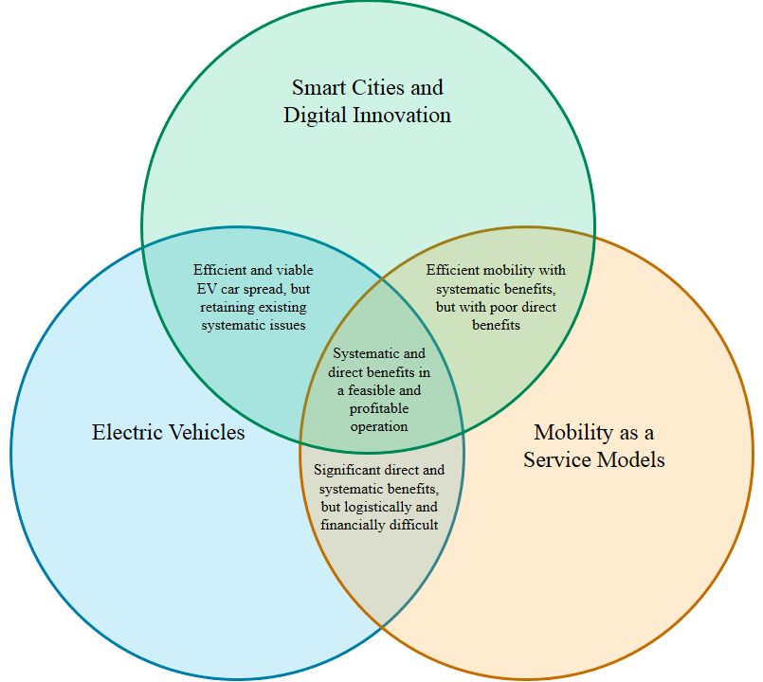

Figure 1: The proposed 'tri-opt' of positive opportunities to disrupt the private sector transport paradigm in developed countries.

Most of the world’s major automotive manufacturers have released purpose-designed electric cars (different from ICEs that have a substituted EV powertrain). Some have gone so far as to make significant strategic investment in the concept by releasing entire electric car ranges, such as BMW’s i Series. Personal cars and small commercial vehicles account for 13% of all UK carbon emissions (Lumsden, 2012) so the direct ‘pump-to-tire’ benefits of electric cars are highly significant. Legislation in many countries is double- edged: penalising ICE users and incentivising the purchase of EVs. EVs bring with them several challenges, however: the purchase price of EVs, predominantly due to current battery technology, is yet to be comparable to an equivalent ICE; the embodied carbon of EVs, again due to the battery component, is typically higher than an equivalent ICE; and the generation of electricity to meet charging patterns is theorised to bring with it considerable logistical difficulties on national grids (Akhavan-Rezai et al., 2015; Su et al., 2011). Furthermore, some of the benefits, such as CO2 savings, are dependent on the method of electricity generation used in the EV.

There are several barriers to the adoption of EVs; some of these are psychological for the end user. ICE owners have shown range anxiety – a concern over ‘running out of juice’ (Office for Low Emission Vehicles, 2011; Yilmaz and Krein, 2012). Evidence rarely supports such concerns: 95% of all private vehicles journeys in the UK are <25 miles (Brook Lyndhurst, 2015; Office for Low Emission Vehicles, 2011), a distance current EVs are easily able to service. Other user perceptions include concerns over battery lifetimes, the risk of obsolescence from investing in a product from a rapidly advancing technology, and the higher price of EV purchase. Many also criticise an absence of second-hand EVs for purchase. Fleet vehicles accounted for 63% of all new vehicle sales in the UK in 2011; as such they are a dominant influence on the cars that are subsequently available for sale in the secondary purchase markets (Transport for London et al., 2012). There is a growing trend for EVs in fleet vehicles due to reduced running costs, so it is likely a more substantial used EV market will start to emerge in the near future.

**1.3 Digital Innovation and Smart Technologies**

‘Smart’ as a mechanism is a contemporary and rapidly growing area of research and development (R&D); as such, a consensus on the concept’s definition has yet to be established. A review of the academic, policy and industrial practitioner literature in the field suggests a recurring fundamental theme is the use of increased data (in volume, quality and scope) and connectivity to create value (Arup, The Climate Group, Accenture and Horizon, University of Nottingham, 2011; Batty et al., 2012; Buscher, 2014; Harrison and Abbott Donnelly, 2011; Komninos, 2002). The rise of interest in data-based value creation within cities can be related to a number of trends:

1. *The rapid acceleration in the production of data*. Several key societal developments, including the rise of wide-spread internet connectivity (particularly high-speed mobile connectivity) and social networking, has caused an exponential increase in data production; rapidly growing datasets have spurred experimentation as to their potential new uses. ‘Big data’ is regularly used to refer to data available in such volumes, and is sometimes defined as a dataset big enough to be considered for use in smart value-producing systems (McKinsey Global Institute, 2018; Ojo et al., 2015; Sta, 2017).
2. *The rapid increase in the ability to collect more specific, higher-value data*. Improvements in sensor and transmission technology have resulted in data collection devices becoming more financially affordable and spatially practical (Townsend, 2013). The development of mesh networks, the mechanism of two-way communicating sensor nodes distributed over vast areas, can provide high resolution data facilitating accurate statements or the ability to reliably track and understand sensed activity. Furthermore, the internet of things (IoT) – defined as two-way connectivity integrated into everyday items – could enable transitions from machine-human-machine interaction to simply machine-machine.
3. *Improvements in data storage and processing*. Storing and processing data is becoming significantly cheaper, increasingly based in the cloud. This enables complex, intensive analytics on vast datasets – such as on the scale of a city – to be processed and presented for actioning fast enough to be deemed ‘live’.

Discussions increasingly refer to data as a raw material (sometimes going so far as to describe it as an emerging fifth ‘utility’), creating the notion that data can and should be used as a primary input to a business model (Arup, The Climate Group, Accenture and Horizon, University of Nottingham, 2011). This may involve aggregating or integrating data across traditional ‘silos’ (Shapiro, 2006; Tsoukalas, 2008). Increasingly, this also represents the pressing focus on whole-life environmental impacts of ICTs (Cooper et al., 2015b). ‘Creating value’ can be defined in many ways, for example:

* *Faster processes*: for example, using traffic data to pro-actively update signs in real-time, rather than the slow, reactive methods by which traffic is informally advised against taking certain routes.
* *Fairer*: for example, real-time demand-based tolls for motorways, charging higher rates for peak travel times, or when air quality is particularly poor in the city, and, conversely, lower rates at off-peak times.
* *At lower cost*: for example, water pipes containing flow sensors to identify the accurate location of leaks as they emerge, rather than expensive and time-consuming excavations and visual inspections (Cosgrave et al., 2014).
* *Without human interaction*: For example, when a first aid dispatch can be made at the detection of a heart attack in a public space, rather than requiring on-lookers to assess the situation and intervene. This can reduce the impact of human error, social boundaries and subjective judgement, although there is a discussion to be had of the shortcomings of overly objective assessment in processes.

It is acknowledged that a wide variety of big data applications are not without ethical and societal concerns (Bimber, 1990; Metcalf et al., 2016) – especially raising questions about civil liberties, privacy, mass surveillance and data retention (Goold, 2002; Oatley et al., 2015; Tryfonas et al., 2016), as well as wider concerns regarding technology dependency (perceived or real), and the education and skills needed for effective societal participation (Brown et al., 2014; Tryfonas and Crick, 2018).

However, there is an extensive literature documenting the potential impact of digital innovation, through these improvements, in the transport sector (Enoch, 2015). One trend absent from the current analysis is the issue of autonomous vehicles: if it were to be included it might be considered within this category or as a separate macro trend. While future extensions of this framework should seek to incorporate this consideration, it is out of scope for this paper.

**1.4 New Ownership Models**

‘Mobility-as-a-Service’ has grown to be a concept that is specifically recognised in modern transport dialogues (Transport Systems Catapult, 2016). It is best defined as a transition from a paradigm under which mobility functionality is accessed through purchasing a product, to a paradigm where mobility functionality is the outcome of a service moving users from one location to another, disassociated from any requirement for asset ownership, and typically arranged on a journey-by-journey basis.

In other modes of private transport in the UK, such as bike use, an increasing number of citizens are participating in short term hire models of use, particularly in urban contexts. Rather than bearing the capital and logistical cost of owning a bike, individuals rent the bike from a node near the origin of their journey, complete their journey, and return the bike to a node near their destination. As such they are purchasing the outcome of mobility from one destination to another, or ‘as-a-service’. Once seen as radical, examples such as London’s cycle hire scheme, or the spread of ride hailing services such as Uber and Lyft, have demonstrated not only the popularity of the operating model, but also the indirect benefits (for example, illustrated by the significant increase in cycling in the city, bringing wider health benefits). A range of drivers have been suggested for the emergence of this paradigm:

* *Changing societal values*: evidence has suggested a decrease in the cultural value placed on car ownership; conflict with an increased desire to live in vibrant urban areas within walking distance of workplace and other amenities and the spatial restrictions of car ownership in such scenarios (Jenks and Burgess, 2001).
* *Changing economic situations*: increasing costs of car ownership, particularly in insurance (particularly for young individuals) and fuel cost.
* *Changing effectiveness of privately-owned car transportation*: an increasing frustration with congested transport systems and an increasing desire to travel A-to-B reliably, regardless of the specific comfort of one’s ‘own’ motor vehicle.
* *Proof of concept*: Driven by commercial ventures showing the viability of alternate private transport paradigms. Traditional car hire companies in particular are beginning to explore short-term, distributed ‘car club’, return journey (‘A-to-A’ journeys) offerings, whereas emerging start-ups are offering complete A-B services, such as the aforementioned Autolib.

We can see how the opportunities introduced come together to address three of the main difficulties in the current transport paradigm in the UK:

1. **Electric vehicles:** enabling significant improvement in the direct, pump-to-tire impacts of private transport, one of the most substantial steps toward long-term achievements in this space;
2. **Digital innovation:** enabling significant improvement in operational cost, customer engagement, system management and new revenue streams, addressing the private sector’s requirement for profitable ventures;
3. **Mobility-as-a-Service:** enabling significant improvement in the systematic impacts of private transport, a radical first step in achievement in this space.

However, there are shortcomings of these new mobility forms, including shifting work- force demands, rebound effects increasing car-based mobility, as well as the challenges of promoting cycling for transport (Handy et al., 2014). The actions of transport stakeholders in the next 10 years will dictate how much these trends are harnessed, encouraged or ignored in private sector transport, and ultimately how the UK’s transport culture changes as a result (Rode et al., 2017).

**2 Methodology**

**2.1 Objectives**

This paper thus sets out to achieve the following objectives:

1. To explore a range of use cases in the UK’s private transport system that involve the three elements of the ‘tri-opt’. These use cases must use at least two of the three elements in combination and produce value;
2. To understand, with a qualitative degree of accuracy, the varying value perceived by stakeholders in the identified ‘combination’ use cases;
3. To segment the use cases, considering their characteristics, value potential and value certainty, with a view to identifying recommended actions for policymakers;
4. Finally, to explore and better understand the interaction of the three elements of the ‘tri-opt’.

**2.2 Philosophy**

This paper adopts a systems-thinking perspective to consider instances when these trends create double and triple overlaps. For discovered instances, interaction of the ‘tri-opts’ will be explored, the value perceived in the use case identified, and certainty of that value measured. With respect to the definition and measurement of value, due the broad scope of this paper, value is considered qualitatively through research facilitator review (detailed in the following section), with an emphasis on comparative value: a use case’s value compared to that of other identified use cases. Value to all stakeholders within the system boundary will be considered; in this case the UK city of Bristol.

**2.3 Methods**

The research objectives imply a mixed methods approach. The work is primarily – but not exclusively – based on a research study into the potential of a ‘smart electric vehicle transport hub’ – a proposed development that combined the three proposed trends on a physical site offering both public (bus and ‘park and ride’) and private (as-a-service electric car hire) transport services – see Figure 2. The methods used are as follows:

* Five two-hour workshops involving Bristol City Council staff, University of Bristol academics, and consulting engineers from a multi-national built environment consultancy firm;
* Ten semi-structured one hour interviews with a range of transport stakeholders in the city of Bristol, including bus operators, policymakers, legal and financial professionals. All providing insight anonymously;
* A survey of 48 citizens of Bristol subscribed to Source West, an independent non- profit organisation representing the interests of citizens using electric vehicles;
* Systems modelling to better understand the perceived value in a selection of specific use cases, explained in more detail when introduced.

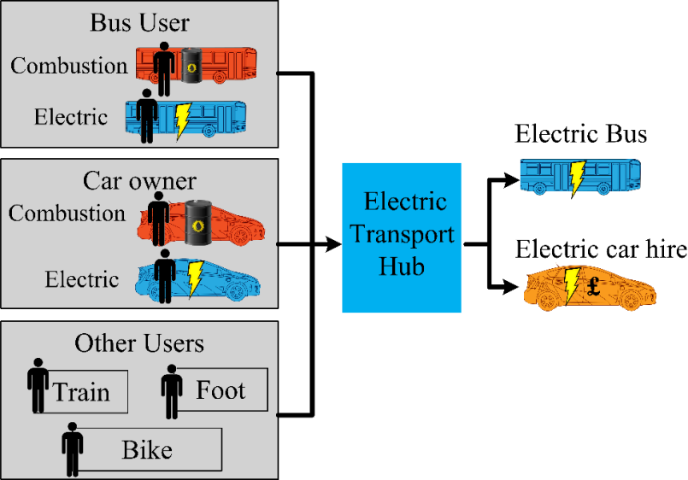

Figure 2: An overview of the proposed Smart Electric Transport Hub, structured by input transport modes (left) and output transport services.

Throughout the first two components of the method, use cases that were discovered, and the role of the ‘opts’ within them, were documented. The researchers scored participants’ views and reactions against two dimensions:

* *The value*: Participants were encouraged to articulate their perception of the scale of the benefit to all stakeholders within the city. Researchers then estimated this sentiment using an approximate scale of 0-100 where: 0 corresponded to no perceived value in any circumstance; 50 a moderate but noteworthy value; and 100 a value of substantial magnitude that could not conceivably be made meaningfully larger.
* *The certainty*: Participants were encouraged to articulate their perception of the certainty of their value estimations. Researchers then estimated this sentiment using an approximate scale of 0-100 where: 0 corresponded to stakeholders suggesting their estimation was essentially random and dependent on a vast range of unpredictable external factors; 50 indicated a relatively confident estimate but that was reliant on some external factors; and 100 a technical certainty that relied on no external factors.

The third and fourth components of the method were used primarily to shape and detail certain use cases, and did not directly feed into scoring.

Individuals were selected for the workshop and interview based on four criteria:

* Individuals involved in the delivery of services in the UK city of Bristol who have a deep understanding of the performance criteria of these systems and what value may look like from the operator perspective;
* Individuals who have experience of the urban challenges of the city and have a strong understand of what value looks like from a public good perspective;
* Individuals who had expertise in MaaS, EV and smart transport solutions in private transport systems in the UK;
* Individuals who those in the previous three groups recommended for insight on the problem space.

**2.3.1 Workshops**

Prospective candidates with the highest scores across the four criteria above were prioritised as workshop participants rather than interviewees. The workshops were iterative, designed to build a use case library while refining understanding of value and value certainty. The other methods proceeded in parallel. As such, workshop participants were – as much as practical – constant throughout. Each workshop was structured in the following manner: presentation of identified use cases so far; open discussion of possible new use cases or new segmentation of existing use cases; discussion of evidence on perceived value and value certainty in use cases, based on data provided and participant viewpoints. The workshops were designed so that all participants were able to contribute to all use cases.

**2.3.2 Interviews**

Interview participants were recruited using the same method as workshop participants. The interviews were all semi-structured and following best practice guidance from King and Horrocks (2010). All interviews followed the same broad structure: participant background (e.g. the individual’s experience and their current role), broad discussion of the problem space and alignment around issues (i.e. the ‘tri-opt’ as a concept and its component parts); an exploration of how these concepts might create use cases and their benefits, providing space both to propose new use cases and also to test on-going hypotheses; finishing with a free discussion.

**2.3.3 Assessment**

Interviews were manually coded using Computer-Assisted Qualitative Data Analysis Soft- ware (CAQDAS). Coding was used to find commonalities across suggested use cases; comments regarding value and value certainty; and comments regarding the wider context and about barriers and enablers. The process of quantifying qualitative information was based on the 8-step process (Chi, 1997). In particular, Chi’s recommendation to increase reliability by using multiple raters was implemented.

**3 Value Cases for EVs-as-a-Service in Bristol, UK**

**3.1 Car Component State (*Smart/MaaS/EV*)**

In the traditional car hire industry, it is common practice to run a maintenance program that involves inspection at a greater frequency than that recommended for a privately- owned automobile, designed to reduce the likelihood the car might suffer from a failure while hired by a customer.

Using mechanical health sensors – that could be considered a ‘smart’ element – attached to key components in the car an operator offering cars-as-a-service could gather insight on a car’s mechanical state close to the quality of that offered by a human inspection, in real time. This has the potential to reduce the rate of failures in such a service. If the sensor coverage were sufficient then this could lead to cost savings through reduced servicing and also decrease turn-around times, important in a service that will have more frequent car hiring than a traditional arrangement. This servicing issue is a wider concern in an EV context, because the workings of EV powertrains have less of a mechanical history than their ICE counterparts simply because they are a more recent technology.

**3.2 Live Air Quality Management (*Smart/MaaS*)**

Bristol City Council currently monitors air quality through a portfolio of permanent and semi-permanent sensor installations at points distributed around the city. In a typical UK urban environment, particularly one with no major heavy industry, air quality is primarily determined by road transport emissions, particularly those of diesel vehicles (BBC News, 2017; Greater London Authority, 2018). It can be hypothesised that if it was possible to understand the distribution of vehicles in the city at any one point in time, combined with other factors such as weather, it would be possible to estimate the air quality across the entire city, to an acceptable degree of accuracy.

At present, in certain areas of Bristol, car flow is monitored by automatic number plate recognition (ANPR) cameras. Coverage is, however, limited and scaling this infrastructure can be prohibitively expensive. Cars-as-a-service vehicles are likely to have near-identical behaviour to other cars on the road at that time. With sufficient coverage of hire cars distributed among the main car park, the total car distribution in Bristol could be extrapolated. Today other datasets exist for understanding car movements around a city (for example, Google Maps), but this is not always available to city managers, nor is it necessarily free. This information could be complemented by data from air quality sensors directly affixed to cars.

**3.3 Live Accident Reporting (*Smart/MaaS*)**

Cars could be fitted with impact sensors, alerting a cars-as-a-service monitoring system that a car has suffered a crash, enabling them to immediately alert the authorities. A number of trends have significantly improved road safety in the UK over the last 20 years (Department for Transport, 2018); combined with the relative rarity of users of this type of monitoring system, the impact on rural isolated crashes has not resulted in tangible improvement in injury or fatality rates. Instead, it is more likely that the main benefit of such a system would be an improved perception of safety by the user. It may also be possible that through connectivity to city transport systems, a system could alert traffic control teams of potential disruptions.

**3.4 User Journey Data (*Smart/MaaS*)**

Social media websites have shown that advertisement hit rates can be improved by accurate targeting of the advert to the correct recipient. Depending on the medium of transport being used, historically this technique would be attempted by advertising at a particular time or in a particular geographical area. Today, however, consumers are increasingly expressing preferences and specifics relating to their personal situation through various social media networks. It is thus possible to target individuals on a range of highly specific criteria, such as a relationship status, group affiliation or patrons of specific rival businesses. Facebook and Spotify are frequently highlighted examples of how these mechanisms can not only deliver high conversion rates – enabling the advertising to be sold at higher prices – but also enable the sale of smaller, but still effective, advertising packages to smaller businesses. This mechanism could produce value in a cars-as-a-service offering in two identified ways.

Information on the journeys of car hire users, contextualised with time of use and demographic details, could be sold – wider privacy and ethical considerations notwithstanding – as data valuable to companies in local retail and leisure sectors. Such clients can consider the expensive customer research they would otherwise have to undertake to obtain such data, and so a base price is conceivable. Alternatively, such data could be used in-house in the form of targeted advertising in-vehicle. Organisations could partner with the service, offering promotional deals to users it believes it may be able to induce to patronise their business during or after the trip. This could be done in real-time using spatial data e.g. when the vehicle occupied by the individual approaches a particular business. The value creation could be twofold: the advertising organisations could pay for the in-car advertising rights if they are simply showing promotional material; if appealing deals were exclusively available in-car then the take up of the cars-as-a-service offer could increase. This second mechanism is likely to enjoy higher data consent rates from users because the value to them is more direct.

**3.5 Demand-based Pricing (*Smart/MaaS/EV*)**

An alternate method to control congestion is to bring economic forces to bear on individual travel choices. In practice, the pricing of MaaS could incorporate an additional influence based on the expected congestion of the roads at point of travel, attempting to deter travel that would exacerbate congestion. Ultimately, of all the use cases addressed here this requires the highest critical resolution of a MaaS service. Furthermore, many ethical dilemmas exist. It might be extremely unpopular that the most sustainable cars are essentially ‘taxed’ into staying off the roads, while unsustainable private transport isn’t obliged to bear the cost of the externality it is generating.

An alternative, and more common, reason for using dynamic pricing is around the ability to better control demand for the service. This is a key consideration for electric vehicles due to the fact that, even with the increasing affordability of fast chargers, EVs require considerably longer than ICE cars to transition from zero to full range capacity.

Finally, dynamic pricing could also be used to manage car supply and demand between different nodes of car collection. There are a number of scenarios where the ability to maintain a serviceable fleet at a node could be jeopardised:

1. *Inclement driving conditions:* Compared to ICEs, EV’s energy consumption per mile is more susceptible to influence from weather conditions. Colder weather can have negative effects on the motor and battery performance. Furthermore, car cabin heaters in EVs do not have engine heat stream to redirect, so additional power from the battery is required to generate this, measured to be as much as 15% (Brook Lyndhurst, 2015; Department for Transport, 2008). Live battery data could enable the cars-as-as-service management system to know the exact power use of a journey and thus the expected battery use available at the end of a journey.
2. *Congestion*: High levels of traffic, resulting in ‘stop-start driving’, can significantly decrease the efficiency of an EV, although the effect is not as pronounced as with an ICE because an EV powertrain can turn off and on, thereby conserving energy. Congestion also increases journey time. Car speed data and GPS location data could inform the booking management system when a car is likely to have reduced efficiency, and when it is unlikely to be back at a node when expected.
3. *Satellite navigation*: Knowing the intended destination of a user can help pre-empt different levels of EV occupancy at nodes, and advise where a space needs to be made available. Furthermore, live satellite navigation data can advise what route is taken, and how this effects the arrival time and level of charge at arrival.

Pre-warning of any of these unforeseen circumstances can allow immediate shifting of the booking system to reflect increased hire duration or increased charging duration. This will prevent people booking in a time when the car will now be driving/charging. This system delivers value through the improved reliability of the car hire service. Insight from these and other scenarios will advise the cars-as-a-service operation system of when which specific EVs are likely to be at which nodes and with what charge, allowing interventions that adjust pricing at different nodes to ensure space at current destination nodes and availability of charged cars across all nodes.

An example of a simple dynamic pricing formula can be seen in Figure 3 whereby the size of the ‘smart power’ constant determines the influence of the dynamic component. Simulations based on such an algorithm were used to explore the potential impact of demand-based pricing on revenue and variance of booking density for a designed service of ‘smart EV MaaS’. The results are presented in Figure 4.

On certain theoretical assumptions about customer behaviour, it is possible to create a scenario through dynamic pricing where both total revenue is increased and bookings are more evenly distributed. This mechanism could be made stronger, or seen to be more of a ‘carrot’ than a ‘stick’ strategy, by using reduced parking costs in non- or limited-nodal MaaS systems.



Figure 3: Smart pricing formula.

**3.6 Driving Styles and Usage Habits (*Smart/EV/MaaS*)**

As a high growth market, the EV market is currently undergoing heavy R&D investment. As a distinctly different driving experience, automotive designers are particularly interested in how users interact with the vehicle (Ferreira et al., 2013). Such data is not commonplace and, therefore, to create an evidence base car manufacturers spend capital on customer surveys, on-road testing and other investments.

A similar situation can be observed in the car insurance industry: while the total cost of ownership of hybrid and electric vehicles compared to conventional vehicles has reduced from the year of introduction Palmer et al. (2018), at present relatively few car insurers offer cover for EVs due to a poor understanding of their risk. Those who do offer insurance price it at an average of 16-26% above the ICE equivalent. It is unclear if EV owners drive in an identical manner to combustion car owners, or if they are at a higher risk of collision due to lower noise and potential driving profiles than ICE cars. Furthermore, many fundamental components of the EV have yet to come close to their expected end of life, so it is risky for insurers who do not know if the vehicles will reach their rated life.

The UK’s National Grid could derive value from understanding how EV charging in a cars-as-a-service model has an impact on the grid, steering their strategic investment accordingly. Although information is available around how privately-owned EVs require charging (Darabi and Ferdowsi, 2013; Kennel et al., 2012), EVs making frequent trips throughout the day could have distinctly different charging requirements. The value of this insight also extends to regional distribution network operators: they hold the responsibility for ensuring local networks can service supply, upon which the nodal distribution of MaaS cars could have significant impacts. It is reasonable to assume these datasets also have a value to the operator of an EV MaaS system, through external sale, if an appropriate data strategy were in place.

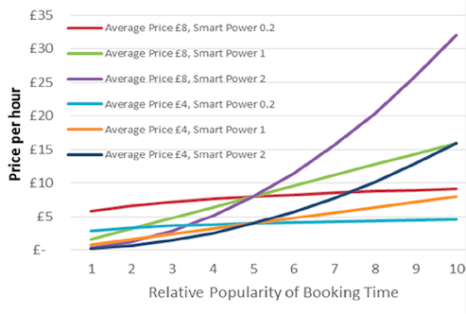

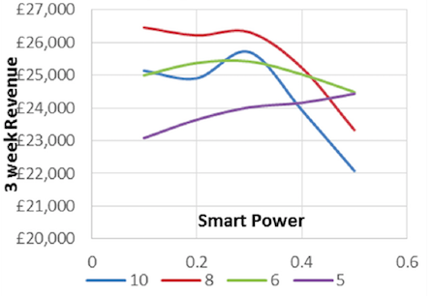

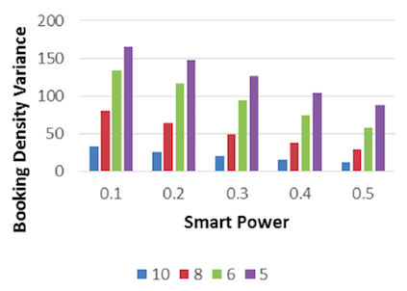

Figure 4: Data regarding varying dynamic pricing rates (top) derived from the smart pricing formula in Figure 3, and their effect on revenues (middle) and booking densities (bottom).

**3.7 Dynamic Traffic Routing (*Smart/MaaS*)**

Understanding the average speed of a road’s cars allows the city’s transport management to predict areas of congestion. The data resolution needed for this is much lower i.e. the speed of a given stretch of road is largely similar for all vehicles driving along it. A city transport management team with access to such information in real-time can employ data-based traffic management techniques. One of the most common such technique is dynamic traffic re-routing. Road users are directed to the fastest route to a given location by being mindful of congestion. The car hire scheme takes this concept one step further, as it will be possible to understand where individuals are planning on driving in advance. With this information, mitigation actions that would previously be considered to have too long a lead time even in the ’live’ mode can be implemented. For example, higher use of contraflow lanes that can be dynamically adjusted to allow for the particular nature of rush hour traffic, increased public transport frequencies to help move demand off the roads, or variable speed limits to maximise flow rates and relieve bottlenecks.

Much of the infrastructure necessary to facilitate this has already been tested at scale: dynamic lane direction has proven successful on the M6 (intercity) motorway around Birmingham and the M25 London orbital motorway in the UK, with extensive supporting evidence about its dynamic speed limit interventions. The effectiveness of this infrastructure could be improved by using data that arrive faster and more accurately than generated by existing, predominantly analogue, sensing techniques. A criticism of this concept might be that such datasets are currently collected by global technology firms such as Google. Such data however is not readily available to cities and, when it is, it typically comes with a substantial cost. A MaaS service would be an alternative route to accessing this data and could provide it to the city’s transport team.

**3.8 Grid Balancing (*EV/Smart/MaaS*)**

Grid balancing is a generalised term for the concept of taking action to mitigate against substantial divergence between supply and demand in regional or national electricity systems. In some definitions, balancing involves transferring power into the grid, but many techniques of simply avoiding drawing power (a.k.a. shaving) or moving the demand to another period (a.k.a. shifting) are considered balancing by the UK Government (Department of Energy & Climate Change, 2014). The challenge of balancing the network is becoming much larger as a consequence of more distributed generation and larger power demands. Many stakeholders in the UK’s energy industry are increasingly providing financial incentives for these services and view it as an important challenge of the future. Almost all of these solutions involve some aspect of a ‘smart grid’, i.e. that data is used in the management of these interventions.

This difficulty is highly relevant to EVs because they represent a growing load on the grid; some studies have suggested even moderate uptake of EVs might increase national power demand by up to 23% in some areas by 2021 (Paffumi et al., 2015). However, of greater concern is that EVs will increase the variation (essentially the peakiness) in demand, a quality that is harder for the grid to service than total demand. However, at the same time the potential of EVs to be used as charge storing devices enables a situation whereby, theoretically, rather than being seen as a burden on the grid which needs to be minimised, they could be seen as a positive asset to provide charge to meet demand at peak times. Typically batteries have a very quick response rate to grid requirements, something other balancing solutions can lack.

In a MaaS offering, the value of the charge to the grid at a particular time could be factored in to the cost of someone hiring the car, and so using the charge instead to drive the car. This would enable more opportunities for charge to be provided for grid balancing at times of need. Logistically, a MaaS arrangement would have EVs plugged in by default (requiring no manual intervention as likely with privately-owned EVs). Furthermore, such systems would also typically have large numbers of EVs connected to the grid on connections with substantial voltage capacity, facilitating sudden charge and discharge actions.

This potential for considering MaaS EVs as an asset to the grid comes with the caveat that required charging for the cars’ actual purpose can be sufficiently shifted to be of negligible impact. This is compounded by the context that many of the business models around balancing systems have yet to achieve commercial viability, and may not develop in the UK for at least 10 years. This, along with the general penetration of EVs – MaaS or otherwise – is an important factor to consider for this use case, but it is not relevant to our primary focus of examining the overlaps associated with the ‘tri-opt’.

**4 Value Case Comparison**

It is clear there is significant variation in the perception of value in the identified use cases, and the certainty with which we understand this value and the path to realising; these are presented in Figure 5. From observation of the results, three categories can be generalised:

* *Segment 3* comprises those use cases that have by far the greatest perceived value, but are also the most uncertain. Typically these have the highest critical masses and require considerable, cross-sector stakeholder buy-in. However, their potential value could be described as extreme. Discussion highlighted how these use cases typically have the most diverse forms of value, spanning environmental, social and economic value, beyond simply financial benefits. While these use cases are highly unlikely to be implemented immediately due to the substantial barriers they face, their significant potential cannot be ignored.
* *Segment 2* captures use cases with moderate benefit and a lower level of uncertainty than those in segment 1. These use cases enjoy a good overall value/certainty ratio. These are typically mechanisms that involve the collection, management and external vending of data. The value of these use cases will depend on how legal and contractual norms around data trading evolve. Cities, including Bristol, have launched open data initiatives, where certain public sector datasets are made freely available for reuse. There is an ongoing debate about how data monetisation strategies, such as those identified in our use cases, are compatible with city open data ambitions.
* *Segment 1* covers use cases with relatively low perceived value but relatively high certainty. This group are best characterised as ’operational’ changes, and as such require relatively little collaboration across stakeholder groups.

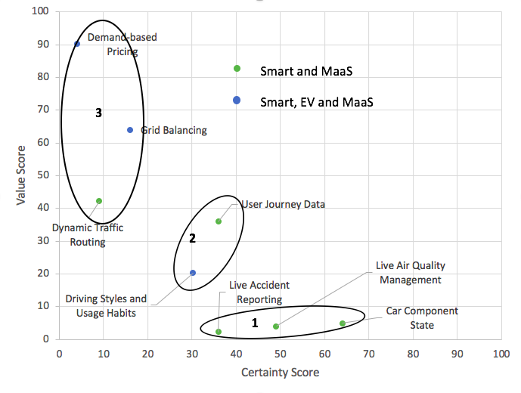

Figure 5: Results from workshop exercises on assigning qualitative value scores to use cases (note: log scale)

Graphical approximations of these characteristics across the three segments can be seen in Figure 6.

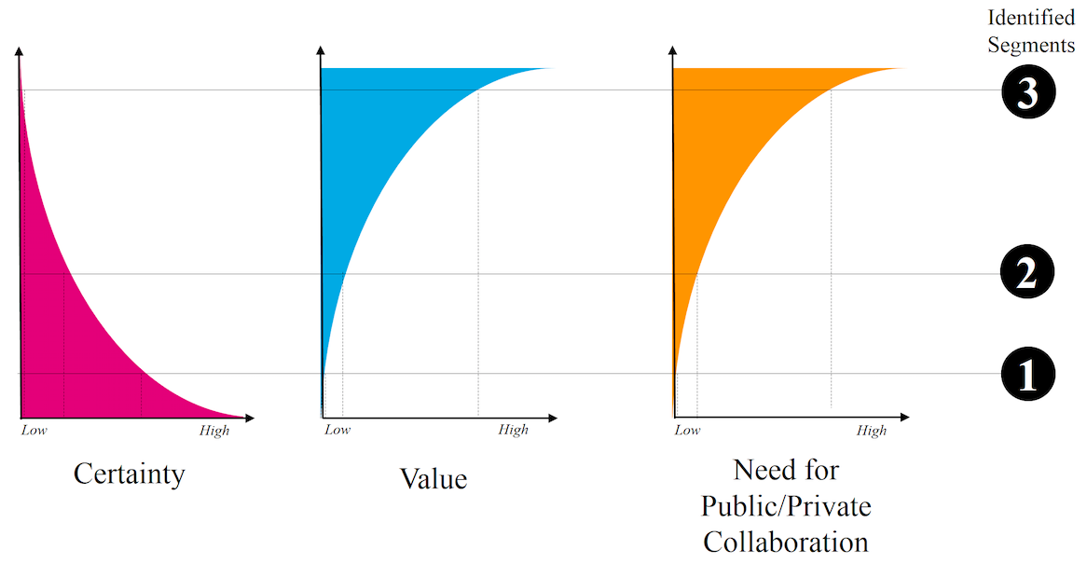

Figure 6: Generalised relationships across identified segments.

**5 Conclusions**

There is clearly synergistic value within the overlaps of the proposed ‘tri-opt’; however it appears the specifics of this are somewhat different to initial speculation. The findings suggest use cases that combine MaaS offerings and digital innovation are the main focus of value creation, rather than those which seek to exploit MaaS, EV and digital tri-overlaps. While we can still conclude that the triple overlaps exist as an area to be considered, it may be better to consider EVs as simply a ‘significant’ development that is set within the context of the two more transformative opportunities presented by MaaS and digital innovation. Reviewing the concepts that have emerged through our methodology, perceived value appears to take a wide range of forms, but overall is significant. Certainty is also variable but is generally scored at lower levels. This variability is to be expected when considering that all the identified use cases represent significant changes away from systems currently in operation, but are not necessarily transformative in nature.

With respect to recommendations that can be inferred from these findings:

* *Segment 1* should be considered good operational practice for smart, MaaS EV services. However, they are not transformative, and generally provide limited value, so might not justify being treated as high priority.
* *Segment 2* should be considered as positive additional revenue streams for smart, MaaS EV services. In particular, they may be beneficial for improving business cases to the degree that such services can attract investment and be launched, so releasing the individual benefits of each ‘opt’. While offering good value for relative certainty, they are not transformative in and of themselves. As end goals they might be considered to lack ambition.
* *Segment 3* can be considered as the potential focus of long term strategic planning that has transformative value, and have underlying mechanisms that span beyond transport. Currently highly uncertain, understanding these use cases, conceptually, should be a high priority, cross-sectoral aspiration.

It is important to note that this paper does not set out to define the value cases of the individual ‘opts’ themselves – such as reducing sunk-cost-induced car use in a MaaS model. It is designed to be a study of interaction between the three broad developments, rather than appraisal of each in isolation: there is extensive literature already in existence addressing these issues separately, as noted in Section 1. These recommendations should, however, be appreciated within the context of the benefits of MaaS, smart cities and digital innovation, and electric vehicles considered separately.

Our results suggest that there are significantly more barriers than enablers at play in these double and triple overlapping concepts. Of most significance in the eyes of the participants, and of most relevance to the highest-value segment of use cases, is the need for public and private sector collaboration. It seems reasonable to presume this is a barrier for ‘as-a-service’ and digital innovation concepts across a range of city services beyond transportation.

**6 Future Work**

For application beyond transport, it is recommended that the underlying generic value creation mechanisms at play are further explored. The particular emphasis on MaaS and digital innovation suggests ‘digitally-enabled innovative business models’ may be the best starting point for the analysis. Taking away the transport context, mechanisms observed included sharing of data to mutual benefit (e.g. driving habits); supporting new service delivery models that bring public benefit (e.g. dynamic car routing); and assistance in delivering public policy (e.g. demand-based pricing to reduce congestion). The mechanisms rest upon meaningful cross-sector, public-private collaboration.

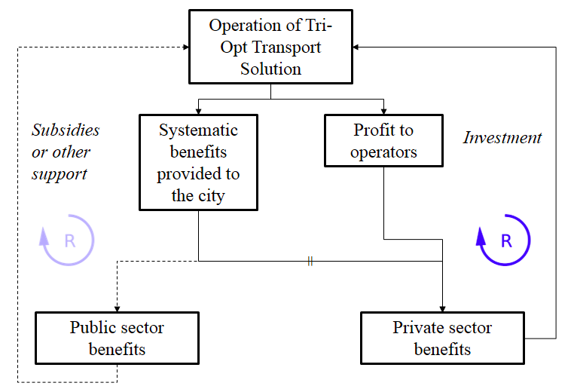

Figure 7: A causal loop diagram presenting the investment/value dilemma of certain 'tri-opt' transport solutions.

Little or no research could be found that sets out a consistent framework for representing and analysing these mechanisms. There is a significant evidence base that private sector participation in city digital initiatives is regularly criticised by the public sector (Martin, 2016). Yet, our work indicates that there is value in understanding this issue better. Furthermore, digitally-enabled public and private collaboration needs to be understood better: our research highlights its absence as the major current barrier to innovating to realise value. The distribution of value/risk/investment identified as part of this, and articulated in a simplified causal loop diagram in Figure 7, needs to be further investigated.

**Acknowledgments**

This work was supported by the UK EPSRC-funded Industrial Doctorate Centre in Systems (Grant EP/G037353/1) at the University of Bristol and Arup Group Ltd. We would also like to acknowledge the support of Bristol City Council and Source West for their involvement in the project.

**References**

E. Akhavan-Rezai, M. F. Shaaban, E. F. El-Saadany, and F. Karray. Demand response through interactive incorporation of plug-in electric vehicles. In *IEEE Power Energy Society General Meeting,* 2015.

Arup, The Climate Group, Accenture and Horizon, University of Nottingham. Information Marketplaces: The New Economics of Cities. Technical report, November 2011.

M. Batty, K. Axhausen, F. Giannotti, A. Pozdnoukhov, A. Bazzani, M. Wachowicz, G. Ouzounis, and Y. Portugali. Smart cities of the future. *The European Physical Journal Special Topics*, 214(1):481–518, 2012.

BBC News. New diesel and petrol vehicles to be banned from 2040 in UK. <http://www.bbc.co.uk/news/uk-40723581>, July 2017 (retrieved 1 September 2018).

B. Bimber. Karl Marx and the Three Faces of Technological Determinism. *Social Studies of Science,* 20(2):333–351, 1990.

C. Black, G. Parkhurst, and I. Shergold. The EVIDENCE project: Origins, review findings and prospects for enhanced urban transport appraisal and evaluation in the future. *World Transport Policy & Practice*, 22(1-2):6–11, 2016.

Brook Lyndhurst. Uptake of Ultra Low Emission Vehicles in the UK: A Rapid Evidence Assessment for the Department for Transport. August 2015.

N. C. C. Brown, S. Sentance, T. Crick, and S. Humphreys. Restart: The Resurgence of Computer Science in UK Schools. *ACM Transactions on Computer Science Education*, 14(2):1–22, 2014.

V. Buscher. Director – Arup, Interview, February 2014.

M. T. Chi. Quantifying Qualitative Analyses of Verbal Data: A Practical Guide. *Journal of the Learning Sciences*, 6(3):271–315, 1997.

P. Cooper, T. Crick, and T. Tryfonas. Smart Data-Harnessing for Financial Value in Short-Term Hire Electric Car Schemes. In *Proceedings of 10th IEEE System of Systems Engineering Conference*. IEEE, 2015a.

P. Cooper, T. Crick, T. Tryfonas, and G. Oikonomou. Whole-Life Environmental Impacts of ICT Use. In *Proceedings of IEEE International Workshop on Green Standardizations for ICT and Relevant Technologies*. IEEE, 2015b.

E. Cosgrave, K. Arbuthnot, and T. Tryfonas. Living Labs, Innovation Districts and Information Marketplaces: A Systems Approach for Smart Cities. *Procedia Computer Science*, 16:668–677, 2013.

E. Cosgrave, T. Tryfonas, and T. Crick. The Smart City from a Public Value Perspective. In *Proceedings of 2nd International Conference on ICT for Sustainability*, 2014.

Z. Darabi and M. Ferdowsi. An Event-Based Simulation Framework to Examine the Response of Power Grid to the Charging Demand of Plug-In Hybrid Electric Vehicles. *IEEE Transactions on Industrial Informatics*, 10(1):313–322, 2013.

Department for Transport. Investigation into the scope for the transport sector to switch to electric vehicles and plug-in hybrid vehicles. UK Government, October 2008.

Department for Transport. Road accidents and safety statistics. UK Government, August 2018.

Department of Energy & Climate Change. Smart Grid Forum’s Smart Grid vision and routemap. UK Government, February 2014.

M. P. Enoch. How a rapid modal convergence into a universal automated taxi service could be the future for local passenger transport. *Technology Analysis & Strategic Management*, 27(8):910–924, 2015.

J. C. Ferreira, V. Monteiro, and J. Afonso. Vehicle-to-Anything Application (V2Anything App) for Electric Vehicles. *IEEE Transactions on Industrial Informatics*, 10(3):1927– 1937, 2013.

T. Gnann, P. Plotz, S. Funke, and M. Wietschel. What is the market potential of plug-in electric vehicles as commercial passenger cars? A case study from Germany. *Transportation Research Part D: Transport and Environment*, 37:171–187, 2015.

B. J. Goold. Privacy rights and public spaces: CCTV and the problem of the “unobservable observer”. *Criminal Justice Ethics*, 21(1):21–27, 2002.

Greater London Authority. London Datastore: Air Quality Data. <https://data.london.gov.uk/air-quality/>, 2018.

S. Handy, B. van Wee, and M. Kroesen. Promoting Cycling for Transport: Research Needs and Challenges. *Transport Reviews*, 34(1):4–24, 2014.

C. Harrison and I. Abbott Donnelly. A Theory of Smart Cities. In *Proceedings of the 55th Annual Meeting of the International Society for the Systems Sciences*, pages 7–22, 2011.

IBM. Smarter Cities. <http://www.ibm.com/smarterplanet/nz/en/smarter_cities/ideas/>, 2014 (retrieved 1 September 2018).

M. Jenks and R. Burgess, editors. Compact Cities: *Sustainable Urban Forms for Developing Countries*. Routledge, 2001.

M. Kamargianni, W. Li, M. Matyas, and A. Schafer. A Critical Review of New Mobility Services for Urban Transport. *Transportation Research Procedia*, 14:3294–3303, 2016.

F. Kennel, D. Gorges, and S. Liu. Energy Management for Smart Grids With Electric Vehicles Based on Hierarchical MPC. *IEEE Transactions on Industrial Informatics*, 9 (3):1528–1537, 2012.

N. King and C. Horrocks. *Interviews in Qualitative Research*. Sage Publishing, 2010.  
  
N. Komninos. Intelligent Cities: Innovation, *Knowledge Systems and Digital Spaces*. Routledge, 2002.

W. Lerner. The Future of Urban Mobility: Towards networked, multimodal cities of 2050. Arthur D. Little Future Lab, 2011.

M. Lumsden. *Successfully Implementing a Plug-in Electric Vehicle Infrastructure*. IET Press, 2012.

C. J. Martin. The sharing economy: A pathway to sustainability or a nightmarish form of neoliberal capitalism? *Ecological Economics*, 121:149–159, 2016.

McKinsey Global Institute. Smart cities: Digital solutions for a more livable future. McKinsey & Company, June 2018.

J. Metcalf, E. F. Keller, and danah boyd. Perspectives on Big Data, Ethics, and Society. Technical report, The Council for Big Data, Ethics and Society, May 2016.

E. Musk. Master Plan, Part Deux. <https://www.tesla.com/en_GB/blog/master-plan-part-deux>, 2016 (retrieved 1 September 2018).

G. Oatley, T. Crick, and D. Bolt. CCTV as a Smart Sensor Network. In *Proceedings of 13th IEEE International Conference on Dependable, Autonomic and Secure Computing*. IEEE, 2015.

Office for Low Emission Vehicles. Making the connection: the plug-in vehicle infrastructure strategy. UK Government, June 2011.

A. Ojo, E. Curry, and F. Zeleti. A Tale of Open Data Innovations in Five Smart Cities. In *Proceeding of 48th Hawaii International Conference on System Sciences*, pages 2326– 2335, 2015.

E. Paffumi, M. De Gennaro, G. Martini, and H. Scholz. Assessment of the potential of electric vehicles and charging strategies to meet urban mobility requirements. *Transportmetrica A: Transport Science*, 11(1):22–60, 2015.

K. Palmer, J. E.Tate, Z. Wadud, and J. Nellthorp. Total cost of ownership and market share for hybrid and electric vehicles in the UK, US and Japan. *Applied Energy*, 209: 108–119, 2018.

Parliamentary Office of Science and Technology. Electric Vehicles. Report 365, UK Houses of Parliament, October 2010.

P. Rode, G. Floater, N. Thomopoulos, J. Docherty, P. Schwinger, A. Mahendra, and W. Fang. *Disrupting Mobility*, chapter Accessibility in Cities: Transport and Urban Form, pages 239–273. Lecture Notes in Mobility. Springer, 2017.

J. M. Shapiro. Smart Cities: Quality of Life, Productivity, and the Growth Effects of Human Capital. *The Review of Economics and Statistics*, 88(2):324–335, 2006.

H. Sta. Quality and the efficiency of data in “Smart-Cities”. *Future Generation Computer Systems*, 74:409–416, 2017.

W. Su, H. Eichi, W. Zeng, and M.-Y. Chow. A Survey on the Electrification of Transportation in a Smart Grid Environment. *IEEE Transactions on Industrial Informatics*, 8(1): 1–10, 2011.

A. M. Townsend. Smart Cities: *Big Data, Civic Hackers, and the Quest for a New Utopia*. W. W. Norton & Company, 2013.

Transport for London, The Climate Group, Cenex, Energy Saving Trust, and TNT. Plugged-in Fleets: A guide to deploying electric vehicles in fleets. February 2012.

Transport Systems Catapult. Mobility as a Service: Exploring the Opportunity for Mobility as a Service in the UK. UK Transport Systems Catapult, 2016.

T. Tryfonas and T. Crick. Public Policy and Skills for Smart Cities: The UK Outlook. In *Proceedings of 11th International Conference on PErvasive Technologies Related to Assistive Environments,* pages 116–117, 2018.

T. Tryfonas, M. Carter, T. Crick, and P. Andriotis. Mass Surveillance in Cyberspace and the Lost Art of Keeping a Secret: Policy Lessons for Government After the Snowden Leaks. In *Human Aspects of Information Security, Privacy and Trust*, volume 9750 of Lecture Notes in Computer Science, pages 174–185. Springer, 2016.

L. Tsoukalas. From smart grids to an energy internet: Assumptions, architectures and requirements. In *Proceedings of the 3rd International Conference on Electric Utility Deregulation and Restructuring and Power Technologies*. IEEE, 2008.

F.-J. Van Audenhove, O. Korniichuk, L. Dauby, and J. Pourbaix. The Future of Urban Mobility 2.0: Imperatives to shape extended mobility ecosystems of tomorrow. Arthur D. Little Future Lab, 2014.

World Energy Council. Energy Trilemma Index, 2015.

M. Yilmaz and P. T. Krein. Review of Battery Charger Topologies, Charging Power Levels, and Infrastructure for Plug-In Electric and Hybrid Vehicles. *IEEE Transactions on Power Electronics*, 23(5):2151–2169, 2012.

1. * Corresponding author: Theo Tryfonas, Faculty of Engineering, University of Bristol, Queen’s Building, University Walk, Bristol BS8 1TR, UK. E-mail: theo.tryfonas@bristol.ac.uk