|  |  |
| --- | --- |
|  |  |
| **Assignment 1**  **My Todo List** |  |
|  |  |
|  | Mobile Application Development - 7421ICT |
|  | Tom Sabu – s5372877 |

Table of Contents

1. Introduction 3

2. GitHub project URL 3

3. App Screenshots 3

a. Home Screen 3

b. Add New Todo Screen 4

c. Expanded Todo View 5

d. Todo Added Successfully Alert Message 5

4. GitHub Commit History 6

5. Screen Recording Video 6

6. Reflection 7

a. Learning Outcomes 7

b. Interest and Utility 7

c. Areas for Improvement 7

d. Technical Reflection 7

e. Personal Development 7

7. Overview 8

# Introduction

I developed a "My Todo List" app as part of my first assignment. The app helps users manage their tasks efficiently by providing a user-friendly interface to add, view, and manage todos.

# GitHub project URL

GitHub Repository Link: <https://github.com/tomcruzz/Assignment1-s5372877-7421ICT.git>

The GitHub repository serves as the central hub for my "My Todo List" app assignment, providing a structured and organized platform for version control, collaboration, and project documentation. The URL directs to a private repository where the app's codebase is securely stored, showcasing the evolution of the app from its initial stages to its current state.

# App Screenshots

# a. Home Screen

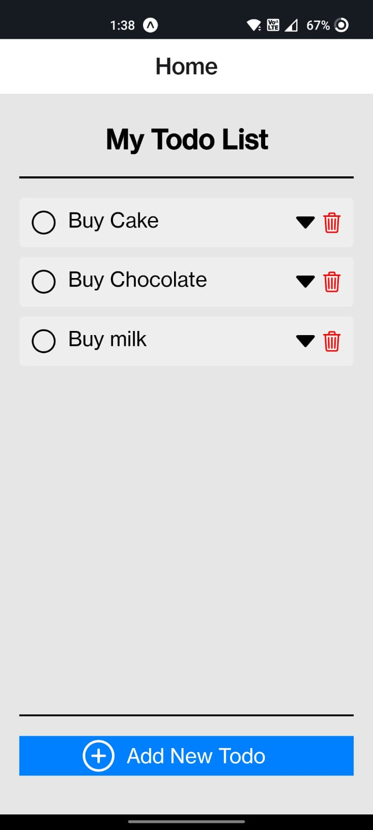

The home screen of the app serves as the main interface for users, displaying a dynamic list of todos fetched from the database. This screen is designed to provide users with a comprehensive overview of their tasks immediately, promoting productivity and task management efficiency.

# b. Add New Todo Screen

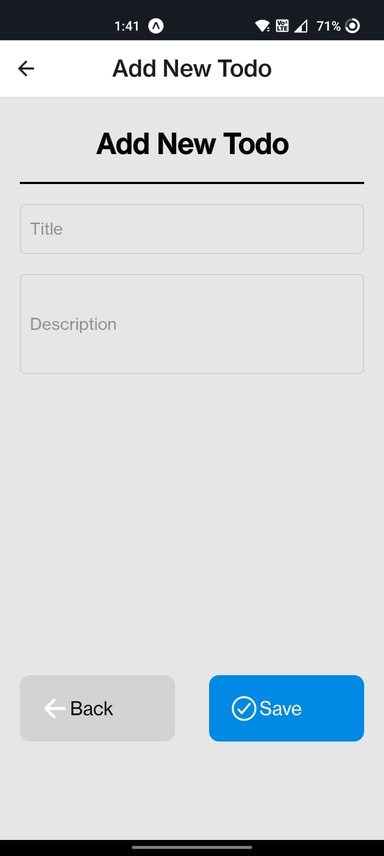

The "Add New Todo" screen incorporates input validation mechanisms to ensure the accuracy and completeness of user-entered data. By implementing validation rules, such as required fields and data format checks, this screen enhances the reliability and usability of the app, preventing potential errors and ensuring a seamless user experience.

# c. Expanded Todo View

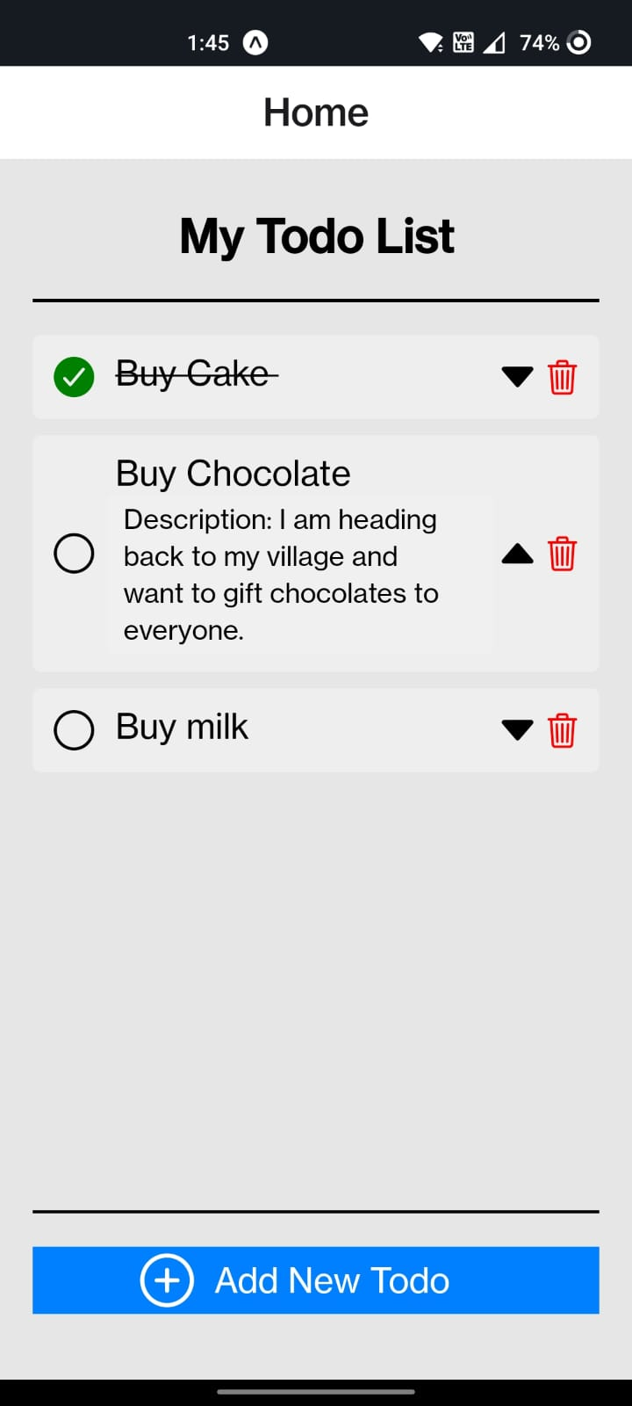

In the expanded todo view, users can access detailed information about each task, including its description, and status. The control panel within this view offers various actions, such as marking as complete and deleting a todo, empowering users with comprehensive task management capabilities within the app.

# d. Todo Added Successfully Alert Message

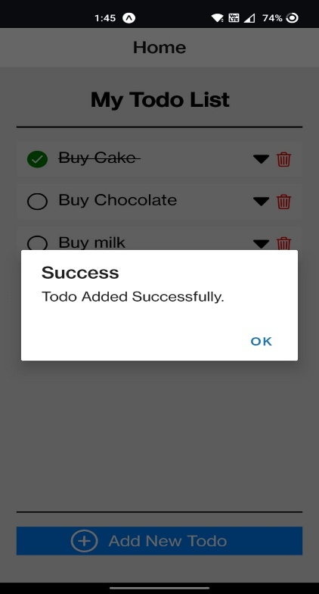

# GitHub Commit History

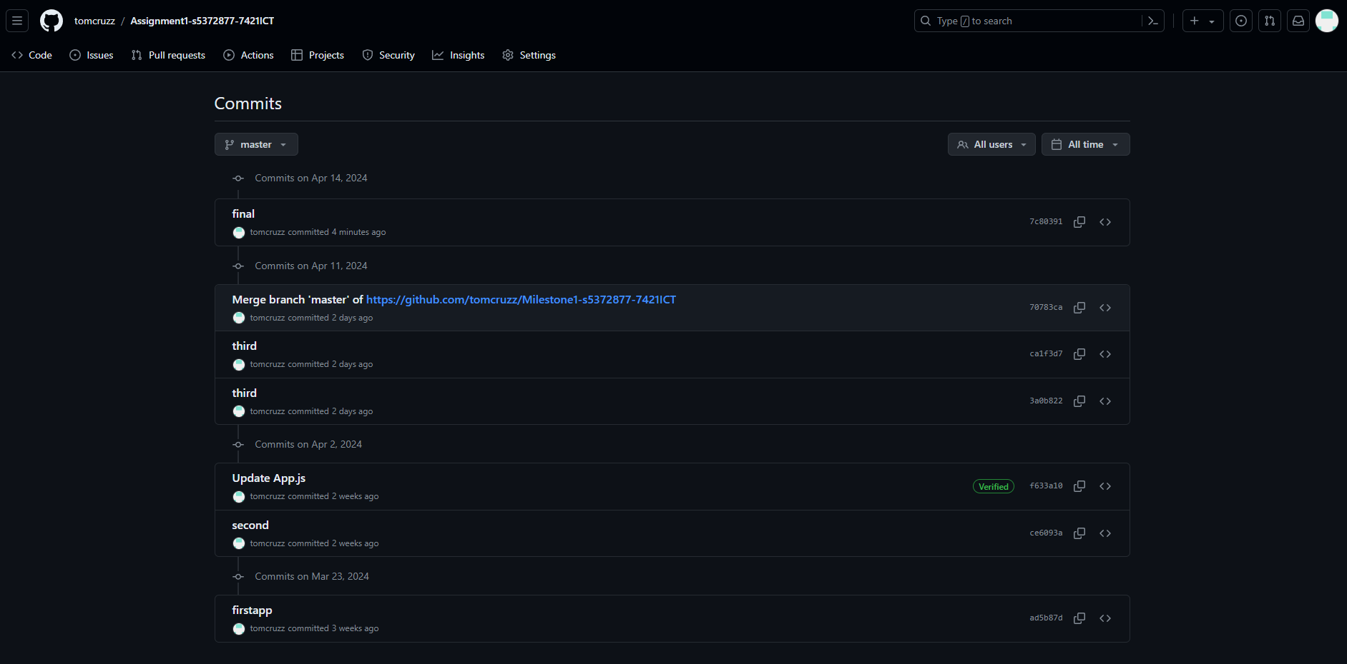

The GitHub commit history provides a chronological record of the app's development progress, showcasing the iterative nature of software development. Each commit represents a significant milestone or update in the app's functionality, highlighting the continuous efforts in refining and enhancing the app's features, performance, and user experience.

# Screen Recording Video

Screen Recording Video Link: <https://youtu.be/J-2JE6LcP0c>

The video demonstrates the app's functionalities within a 3-minute timeframe. It includes explanations of the code structure and key functionalities, ensuring a clear understanding of the app's workings. The screen recording video offers a comprehensive demonstration of the "My Todo List" app's functionalities, showcasing how users can interact with the app to manage their tasks effectively. The video includes explanations of the code structure, key function logic, and user interaction flow, providing viewers with a clear understanding of the app's workings and design principles.

# Reflection

# a. Learning Outcomes

Completing this assignment has been a transformative learning experience, enriching my understanding of mobile app development methodologies, best practices, and project management strategies. It has strengthened my technical proficiency while also fostering critical thinking and problem-solving skills essential for future professional endeavors.

# b. Interest and Utility

The implementation of input validation logic and the design of intuitive user interfaces were particularly engaging aspects of the assignment. These elements not only enhance the app's functionality and usability but also demonstrate the practical application of theoretical concepts in real-world software development scenarios.

# c. Areas for Improvement

Exploring alternative validation approaches, such as real-time data synchronization or advanced error-handling mechanisms, could further enhance the app's robustness and user experience. Additionally, integrating automated testing frameworks could streamline the testing process and ensure comprehensive code coverage, improving overall software quality.

# d. Technical Reflection

Analyzing different technical approaches, such as client-side versus server-side validation or adopting reactive frameworks for enhanced interactivity, provided valuable insights into optimizing performance, scalability, and maintainability. Evaluating these alternatives within the context of the assignment's requirements and constraints contributed to a more holistic understanding of software design considerations.

# e. Personal Development

This assignment has not only expanded my technical skill set but also fostered a mindset of continuous learning, adaptability, and innovation. The acquired knowledge and experience are invaluable assets that will guide my future career path, enabling me to tackle complex challenges and contribute meaningfully to the field of software development.

# Overview

This report aims to provide a comprehensive overview of the "My Todo List" app project, adhering to the submission guidelines and showcasing both technical proficiency and reflective insights gained from the assignment.