Appendix

Les Quizérables Requirements
- Create a new questionnaire
- Add, edit, delete questions
- View and aggregate results
- Answer questionnaire
- Change theme
- User registration and sessions
- Make questions (not) required

Additional requirements

- Multiple types of questions e.g. multiple choice, ratings, poll etc.
- Share form e.g. Email, social networks
- Export data to CSV
- Notification to quizmaster when answer is received
- Embed questionnaire
- Pages

SQL Tables

CREATE TABLE users (
user_id INT NOT NULL AUTO_INCREMENT PRIMARY KEY,
user_name VARCHAR(255) NOT NULL UNIQUE,
user_email VARCHAR(255) NOT NULL,
user_password VARCHAR(128) NOT NULL
);

CREATE TABLE quizs (
quiz_id INT NOT NULL AUTO_INCREMENT PRIMARY KEY,
quiz_user_id INT NOT NULL REFERENCES users(user_id),
quiz_title VARCHAR(255) NOT NULL,
quiz_description TEXT,
quiz_theme_id INT NOT NULL,
quiz_created TIMESTAMP DEFAULT CURRENT_TIMESTAMP,
quiz_updated TIMESTAMP DEFAULT 0
);

CREATE TABLE questions (
question_id INT NOT NULL AUTO_INCREMENT PRIMARY KEY,
question_quiz_id INT NOT NULL REFERENCES quizs(quiz_id),
question_text TEXT NOT NULL,
question_required BOOL NOT NULL
);

CREATE TABLE answers (
answer_id INT NOT NULL AUTO_INCREMENT PRIMARY KEY,
answer_question_id INT NOT NULL REFERENCES questions(question_id),
answer_text TEXT,
answer_time TIMESTAMP DEFAULT CURRENT_TIMESTAMP
);

SQL Diagram

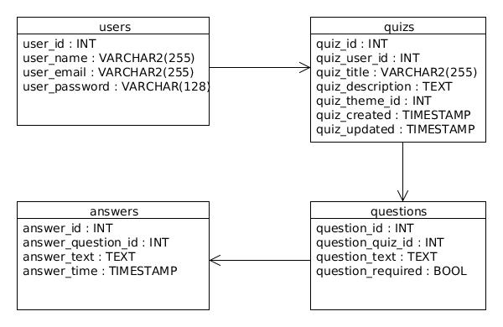
Class Diagram
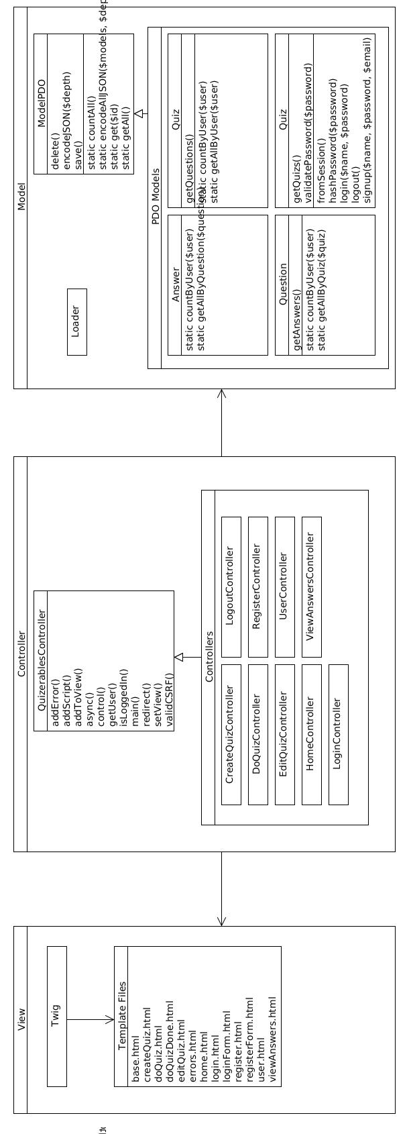

Design Mockups


