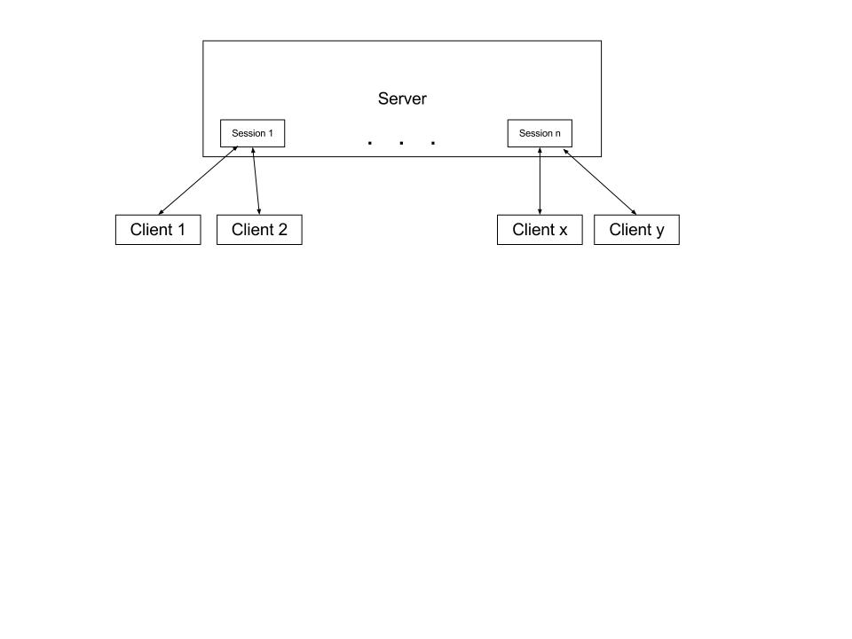

Diagram showing server creating many communication sessions

The server creates a session between two clients that wish to communicate. Each session is a new thread within the server. The server can establish any number of sessions to allow for multiple communication links between any two clients.

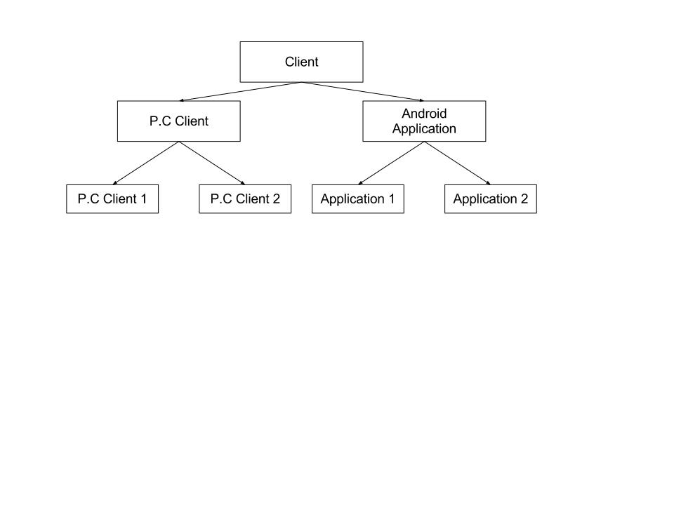

Diagram showing inheriting properties of the clients

The server facilitates communication between two clients. A client is either a P.C client or an Android Application (client) Two cryptographic schemes will be implemented. Application 1 and P.C Client 1 will utilise scheme 1 and Application 2 and P.C 2 will utilise scheme 2.

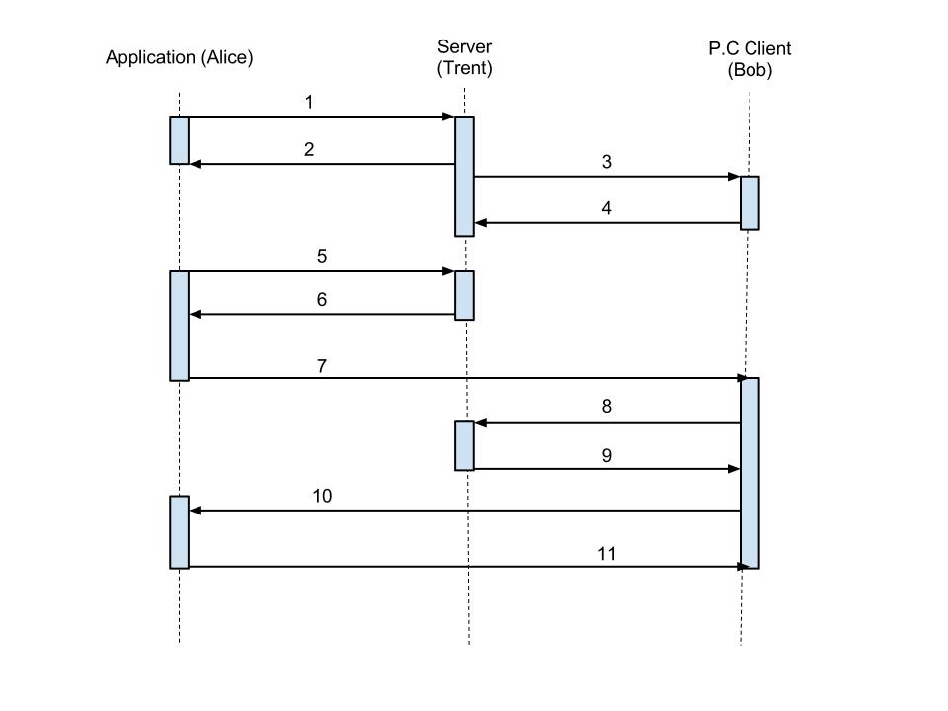

Sequence diagram showing distribution of public keys

(Steps 7, 10 and 11 passed through server and directed to client)