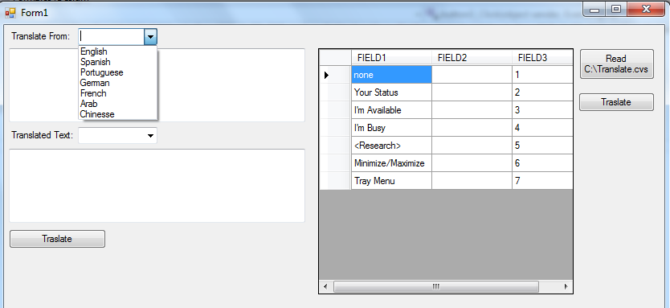

La aplicacion .NET debe estar a 32 bits, no a 64 para poder cargar archive csv

Build / Configure Management

1. Select Build del menu de arriba

2. Open the Configuration Manager dialog

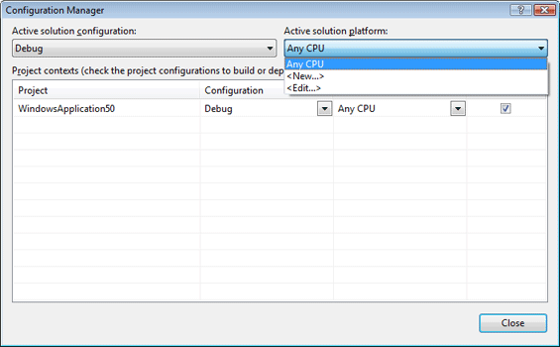

3. Select the <New...>

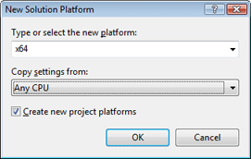

4. Confirm the settings in the dialog by clicking OK. A new configuration for x64 is created.

5. Repeat step 3 and 4 for an x86 configuration. The Active solution platform dropdown box of theConfiguration Manager dialog box should now look like this:

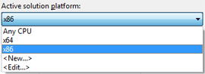

6. Select <Edit...> from the dropdown box to open the edit Solution Platforms dialog.

**Agregar referencia**

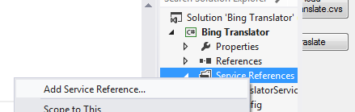

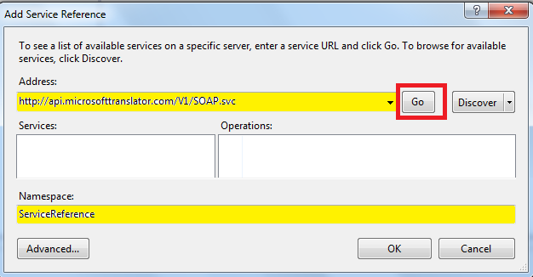

using System;

using System.Collections.Generic;

using System.ComponentModel;

using System.Data;

using System.Data.Odbc;

using System.Drawing;

using System.Linq;

using System.Text;

using System.Windows.Forms;

using System.IO;

namespace Bing_Translator

{

public partial class Form1 : Form

{

public Form1()

{

InitializeComponent();

}

private void btnTranslate_Click(object sender, EventArgs e)

{

txtTranslatedText.Text = Traducir(1, txtTraslateFrom.Text);

}

private string Traducir(int opcion, string fromText)

{

string from1 = "en";

string to1 = "en";

string strTranslatedText = null;

if (cb1.Text == "Spanish") from1 = "es";

if (cb1.Text == "Portuguese") from1 = "pt";

if (cb1.Text == "German") from1 = "de";

if (cb1.Text == "French") from1 = "fr";

if (cb1.Text == "Arab") from1 = "ar";

if (cb1.Text == "Chinesse") from1 = "zh-CHS";

if (cb2.Text == "Spanish") to1 = "es";

if (cb2.Text == "Portuguese") to1 = "pt";

if (cb2.Text == "German") to1 = "de";

if (cb2.Text == "French") to1 = "fr";

if (cb2.Text == "Arab") to1 = "ar";

if (cb2.Text == "Chinesse") to1 = "zh-CHS";

try {

TranslatorService.LanguageServiceClient client = new TranslatorService.LanguageServiceClient();

client = new TranslatorService.LanguageServiceClient();

strTranslatedText = client.Translate("6CE9C85A41571C050C379F60DA173D286384E0F2", fromText, from1, to1);

return strTranslatedText;

//en english

//de german

//es espanol

//ar arab

//fr french

//pt portuguese

//zh-CHS chinesse simplied traditions

//translationResult = client.Translate("", sourceText, "en", "de", "text/html", "general");

}

catch (Exception ex) {

MessageBox.Show(ex.Message);

}

return "";

}

#region Readfile

private DataTable ReadFile()

{

string sql2 = "Select * FROM [Translate.csv]";

string strPath = "c:\\";

string Cn1 = "Driver={Microsoft Text Driver (*.txt; *.csv)}; DefaultDir=" + strPath;

System.Data.Odbc.OdbcDataAdapter da = new OdbcDataAdapter(sql2, Cn1);

DataSet ds = new DataSet();

try

{

da.Fill(ds, "Files");

dataGridView1.Visible = true;

}

catch(Exception ex)

{

MessageBox.Show(ex.ToString());

return null;

}

return ds.Tables[0];

}

#endregion

private void Form1_Load(object sender, EventArgs e)

{

cb1.Items.Add("English");

cb1.Items.Add("Spanish");

cb1.Items.Add("Portuguese");

cb1.Items.Add("German");

cb1.Items.Add("French");

cb1.Items.Add("Arab");

cb1.Items.Add("Chinesse");

cb2.Items.Add("English");

cb2.Items.Add("Spanish");

cb2.Items.Add("Portuguese");

cb2.Items.Add("German");

cb2.Items.Add("French");

cb2.Items.Add("Arab");

cb2.Items.Add("Chinesse");

}

private void button1_Click(object sender, EventArgs e)

{

dataGridView1.DataSource = ReadFile();

dataGridView1.Visible = true;

button2.Visible = true;

}

private void button2_Click(object sender, EventArgs e)

{

int conteo = 0;

DataTable dt = ReadFile();

foreach (DataRow dr in dt.Rows)

{

string ss = Traducir(2, dr[0].ToString());

dataGridView1.Rows[conteo].Cells[1].Value = ss.ToString();

conteo++;

// string ss2;

// if ((conteo % 20) == 0)

// {

// MessageBox.Show("Message","Seguir"); //

// }

}

button3.Visible = true;

}

private void button3_Click(object sender, EventArgs e)

{

TextWriter sw = new StreamWriter(@"C:\\Translation.txt");

int rowcount = dataGridView1.Rows.Count;

for (int i = 0; i < rowcount - 1; i++)

{

sw.WriteLine(dataGridView1.Rows[i].Cells[0].Value.ToString() + "\t" + dataGridView1.Rows[i].Cells[1].Value.ToString() + "\t" + dataGridView1.Rows[i].Cells[2].Value.ToString());

}

sw.Close();

//Don't Forget Close the TextWriter Object(sw)

MessageBox.Show("Data Successfully Exported");

}

}

}

| **Language** | **Language code** |
| --- | --- |
| Afrikaans | af |
| Albanian | sq |
| Arabic | ar |
| Azerbaijani | az |
| Basque | eu |
| Bengali | bn |
| Belarusian | be |
| Bulgarian | bg |
| Catalan | ca |
| Chinese Simplified | zh-CN |
| Chinese Traditional | zh-TW |
| Croatian | hr |
| Czech | cs |
| Danish | da |
| Dutch | nl |
| English | en |
| Esperanto | eo |
| Estonian | et |
| Filipino | tl |
| Finnish | fi |
| French | fr |
| Galician | gl |
| Georgian | ka |
| German | de |
| Greek | el |
| Gujarati | gu |
| Haitian Creole | ht |
| Hebrew | iw |
| Hindi | hi |
| Hungarian | hu |
| Icelandic | is |
| Indonesian | id |
| Irish | ga |
| Italian | it |
| Japanese | ja |
| Kannada | kn |
| Korean | ko |
| Latin | la |
| Latvian | lv |
| Lithuanian | lt |
| Macedonian | mk |
| Malay | ms |
| Maltese | mt |
| Norwegian | no |
| Persian | fa |
| Polish | pl |
| Portuguese | pt |
| Romanian | ro |
| Russian | ru |
| Serbian | sr |
| Slovak | sk |
| Slovenian | sl |
| Spanish | es |
| Swahili | sw |
| Swedish | sv |
| Tamil | ta |
| Telugu | te |
| Thai | th |
| Turkish | tr |
| Ukrainian | uk |
| Urdu | ur |
| Vietnamese | vi |
| Welsh | cy |
| Yiddish | yi |

<https://cloud.google.com/translate/v2/using_rest>