Probar <https://regex101.com/>

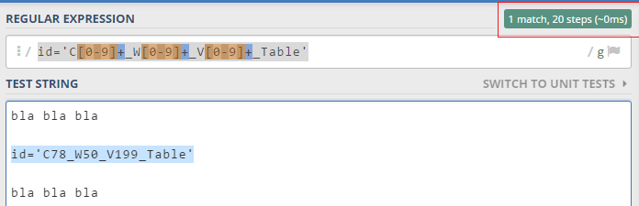

string id = Regex.Match(**StrSource, patron**, RegexOptions.IgnoreCase).Groups[0].Value;

Si da match devuelve en id el valor, sino null

patron = "id=C[0-9]+_Table";

**validos**

id=C7_Table

id=C71_Table

id=C723_Table

patron = "id=C[0-9]{2}+_Table";

**validos**

id=C12_Table

id=C34_Table

Regex.Match(currentline, @"\d{3}-\d{3}-\d{4}", RegexOptions.IgnoreCase).Groups[0].Value

\d digito

**validos**

123-456-7890