If your receive an error message then consider to **swap the conditions between** the equals, for example change

|  |  |
| --- | --- |
| From | Swap to |
| on notas.StudentID equals people.PersonID | on people.PersonID equals notas.StudentID |

If you receive the following message

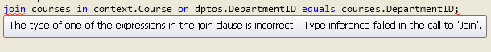

It is because

* The relationship doesn’t have the same type of data
* You are missing the select statement