<https://www.tutorialsteacher.com/linq/linq-filtering-operators-where>

IList<Student> studentList = new List<Student>() {

new Student() { StudentID = 1, StudentName = "John", Age = 13} ,

new Student() { StudentID = 2, StudentName = "Moin", Age = 21 } ,

new Student() { StudentID = 3, StudentName = "Bill", Age = 18 } ,

new Student() { StudentID = 4, StudentName = "Ram" , Age = 20} ,

new Student() { StudentID = 5, StudentName = "Ron" , Age = 15 }

};

var filteredResult = from s in studentList

where s.Age > 12 && s.Age < 20

select s.StudentName;

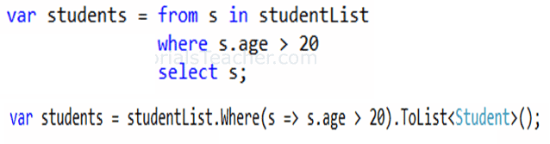

**With function**

var filteredResult = from s in studentList

where isTeenAger(s)

select s;

public static bool IsTeenAger(Student stud)

{

return stud.Age > 12 && stud.Age < 20;

}

Otra forma

var filteredResult = studentList.Where(s => s.Age > 12 && s.Age < 20);

GET EVEN ELEMENTS

var filteredResult = studentList.Where((s, i) => {

if(i % 2 == 0) // if it is even element

return true;

return false;

});

foreach (var std in filteredResult)

Console.WriteLine(std.StudentName);