In Pentaho there are 2 main objects to work with:

* JOBS: Need to start with a START Object
* TRANSFORMATION: Inside jobs

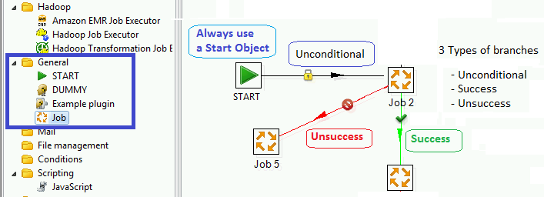

**When opening a Job**

* Set the name
* You may load a file where the job is store (file extension ‘ktr’)

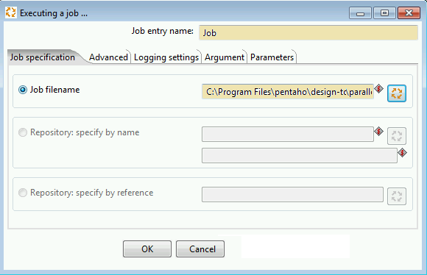

**TRANSFORMATIONS**

* There are inside each job
* The connectors are always unconditional
* You read, transform, output data

You can retrieve and output

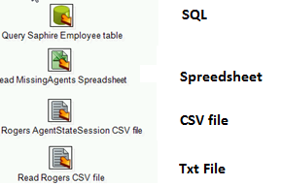

**FIRST GENERATE A CONNECTION**

To create a connection go to **View** and look for **Transformations**

Select a **Transformation, Data Connections** and **New**.

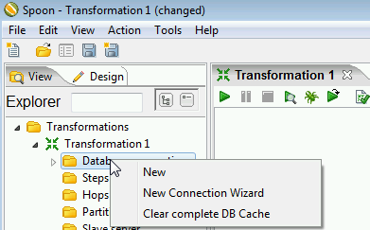

In the following screen shot we are configuring a connection to a SQL Server

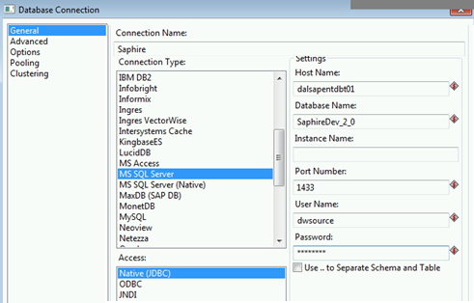

**A SQL TABLE INPUT**

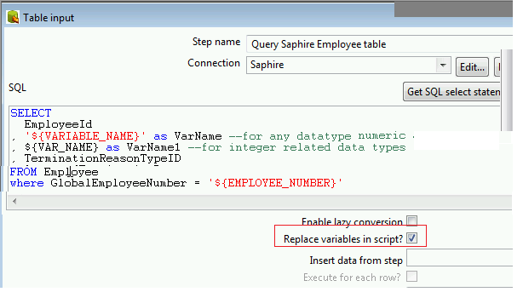

To set parameters :

* ‘${VAR_NAME}’ for not numeric
* ${VAR_NAME} for numeric

IMPORTANT: Check checkbox “ Replace variables in script?” to replace the variables.

**THE MOST COMMON UPDATE / INSERT**

**LOOK UP INSERT / UPDATE **

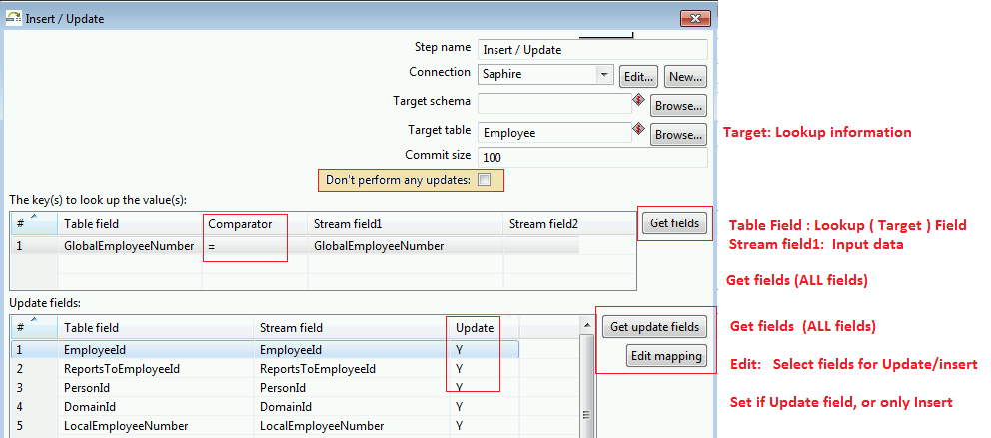

**LOOK UP UPDATE **

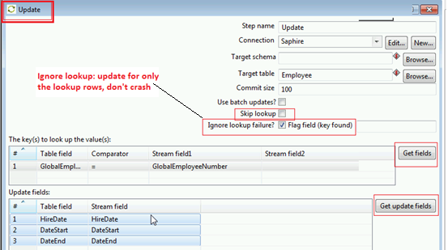

**THE MOST COMMON OPTION TO MANIPULATE DATA**

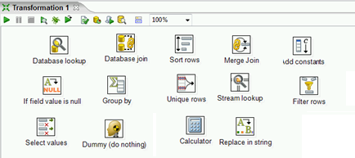

**LOOK UP**

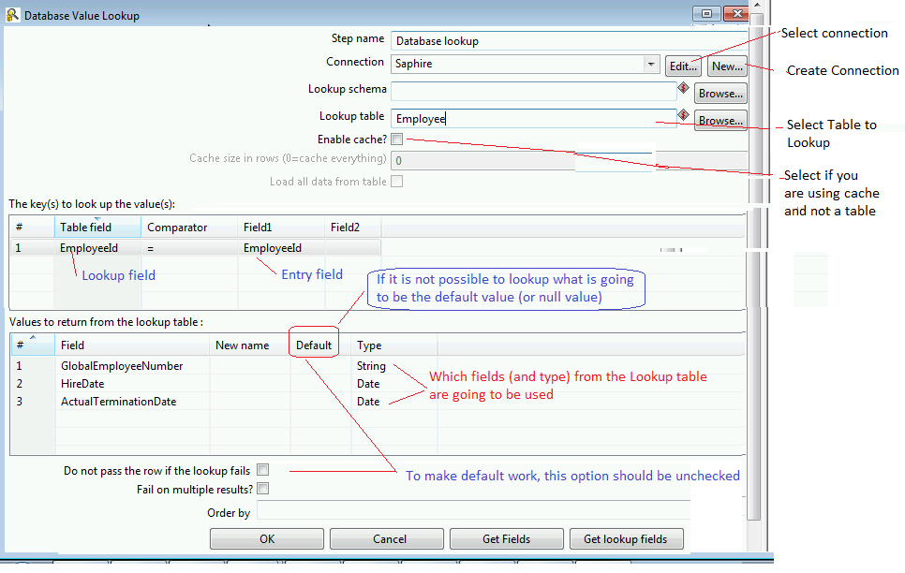

**JOIN**

When you need to look up with several tables use JOIN

