|  |  |
| --- | --- |
| **HTML Tag** | **What is it?** |
| **<thead>** | Table Header |
| **<tbody>** | Table Body |
| **<tr>** | Rows |
| **<th>** | Colum Header |
| **<td>** | Column data in body |

All of the code examples are based on this table (Credit to “w3schools”):

<table style="width:100%">

  <tr>

    <td>Jill</td>

    <td>Smith</td>

    <td>50</td>

  </tr>

  <tr>

    <td>Eve</td>

    <td>Jackson</td>

    <td>94</td>

  </tr>

  <tr>

</table>

**PREPERATIONS**

IWebElement WebElement_Table;

IWebDriver FFDriver = new FirefoxDriver();

FFDriver.Manage().Timeouts().ImplicitlyWait(TimeSpan.FromSeconds(60));

FFDriver.Navigate().GoToUrl("http://www.w3schools.com/html/html_tables.asp");

**STARTING FROM THE BASICS**

WebElement_Table =

FFDriver.FindElement(By.XPath("//h2[contains(.,'HTML Table Example')]"));

DebuggClass.PrintToFile(WebElement_Table.Displayed.ToString());

DebuggClass.PrintToFile(WebElement_Table.Enabled.ToString());

DebuggClass.PrintToFile(WebElement_Table.Text.ToString());

DebuggClass.PrintToFile(WebElement_Table.TagName.ToString());

**Results:**

Is the element displayed: True

Is the element enabled: True

Element Name: HTML Table Example

Element Tag: h2

**IDENTIFY DATA IN A SPECIFIC CELL**

When you need to work with “Static” tables, it’s very easy to access and manipulate each cell, way? Because you can access each cell in the same way that access any other web element.

**First, let’s review a few facts about the object:**

* The table has 4 columns.
* The table has 5 rows (including the title).
* The “Number” column is unique.

**Example 1: Working on a specific cell**

**Number Value:**

WebElement_Table = FFDriver.FindElement(By.XPath("//td[contains(.,'2')]"));

**First Name:**

WebElement_Table = FFDriver.FindElement(By.XPath("//td[contains(.,'Adam')]"));

**Last Name:**

WebElement_Table = FFDriver.FindElement(By.XPath("//td[contains(.,'Smith')]"));

**Points:**

WebElement_Table = FFDriver.FindElement(By.XPath("//td[contains(.,'94')]"));

**Example 2: Printing all values based on Rows (“Tr”)**

each row is defined with”tr” tag, this code will examine each table row and print the associated value.

WebElement_Table = FFDriver.FindElement(By.XPath("/html/body/div[4]/div/div[2]/div[2]/div[1]/div/table[1]"));

IList<IWebElement> rows_table = WebElement_Table.FindElements(By.TagName("tr"));

foreach (var item in rows_table)

{

DebuggClass.PrintToFile(item.Text.ToString());

}

**Result:**

Number First Name Last Name Points

1 Eve Jackson 94

2 John Doe 80

3 Adam Johnson 67

4 Jill Smith 50

**Example 3: Identify each cell with unique Row and column id’s**

In my previous example, I demonstrate the way to access data using the row Id, in this example I will demonstrate how to identify each cell by is tr/td identifiers.

To be able to accomplish this task, we need to achieve the ‘td’ value, let’s review the HTML code:

The XPath of this <td> is:

/html/body/div[4]/div/div[2]/div[2]/div[1]/div/table[1]/tbody/tr[2]/td[2]

Based on the given XPath, we can see that this cell has two unique identifiers (/tr [2]/td [2]), the rest of the line is equal to any other cell in the table.

**To illustrate this, I created an alternative table to the one that I used for this article:**

|  |  |  |  |
| --- | --- | --- | --- |
| **tr[1]/th[1]** | **tr[1]/th[2]** | **tr[1]/th[3]** | **tr[1]/th[4]** |
| tr[2]/td[1] | tr[2]/td[2] | tr[2]/td[3] | tr[2]/td[4] |
| tr[3]/td[1] | tr[3]/td[2] | tr[3]/td[3] | tr[3]/td[4] |
| tr[4]/td[1] | tr[4]/td[2] | tr[4]/td[3] | tr[4]/td[4] |
| tr[5]/td[1] | tr[5]/td[2] | tr[5]/td[3] | tr[5]/td[4] |

Now, let’s add an additional code that examine each cell by the two identifiers.

**Code:**

int row_tr = 5;

int Column_td = 4;

String CellValue;

for (int i = 2; i <= row_tr; i++)

{

for (int b = 1; b <= Column_td; b++)

{

CellValue = @"Row ID = " + i + " | Column ID = " + b + " | Cell Content = " +

FFDriver.FindElement(By.XPath("/html/body/div[4]/div/div[2]/div[2]/div[1]/div/table[1]/tbody/tr[" + i + "]/td[" + b +"]")).Text.ToString();

DebuggClass.PrintToFile(CellValue);}

**Result:**

Row ID = 2 | Column ID = 1 | Cell Content = 1

Row ID = 2 | Column ID = 2 | Cell Content = Eve

Row ID = 2 | Column ID = 3 | Cell Content = Jackson

Row ID = 2 | Column ID = 4 | Cell Content = 94

Row ID = 3 | Column ID = 1 | Cell Content = 2

Row ID = 3 | Column ID = 2 | Cell Content = John

Row ID = 3 | Column ID = 3 | Cell Content = Doe

Row ID = 3 | Column ID = 4 | Cell Content = 80

Row ID = 4 | Column ID = 1 | Cell Content = 3

Row ID = 4 | Column ID = 2 | Cell Content = Adam

Row ID = 4 | Column ID = 3 | Cell Content = Johnson

Row ID = 4 | Column ID = 4 | Cell Content = 67

Row ID = 5 | Column ID = 1 | Cell Content = 4

Row ID = 5 | Column ID = 2 | Cell Content = Jill

Row ID = 5 | Column ID = 3 | Cell Content = Smith

Row ID = 5 | Column ID = 4 | Cell Content = 50

**Example 4: How to Filter Cell Values**

IList<IWebElement> Rows1 = WebElement_Table.FindElements(By.TagName("tr"));

IList<IWebElement> Cols1 = WebElement_Table.FindElements(By.TagName("th"));

int row_tr = Rows1.Count ;

int Column_td = Cols1.Count; String CellValue;

for (int i = 2; i <= row_tr; i++)

{

for (int b = 1; b <= Column_td; b++)

{

String celda = "/html/body/div[4]/div/div[2]/div[2]/div[1]/div/table[1]/tbody/”;

celda = celda + "/tr[" + i + "]/td[" + b +"]";

CellValue = FFDriver.FindElement(By.XPath(celda)).Text.ToString();

}

}

**Example 5: Get the table Rows/Columns size**

IList<IWebElement> Rows1 = WebElement_Table.FindElements(By.TagName("tr"));

IList<IWebElement> Cols1 = WebElement_Table.FindElements(By.TagName("th"));

String Table1 = "Rows :" + Rows1.Count + " Columns : " + Cols1.Count;

DebuggClass.PrintToFile(Table1);

= = = = = = = =

decimal numOfOddRows = driver1.GetXpathCount("//tr[@class='v-table-row-odd']");

decimal numOfEvenRows = driver1.GetXpathCount("//tr[@class='v-table-row-odd']");

decimal numOfRows = numOfOddRows + numOfEvenRows;

= = = = =

int iRowsCount = driver1.FindElements(By.XPath("/html/body/..../table/tbody/tr")).Count;

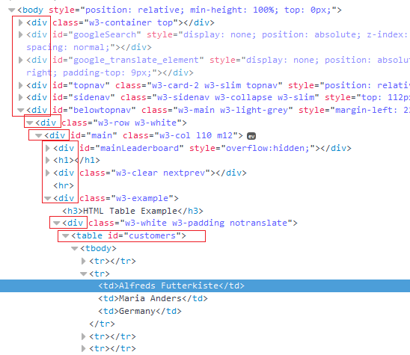

/html/body/div[5]/div/div/div[2]/div/table[1]/tbody/”;