listBox1.MultiColumn = true;
listBox1.ColumnWidth = 60;

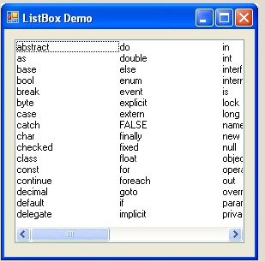

ListBox2.Items.Clear();

listBox1.SelectedItem = "Nickelback";

TextBox1.Text = ListBox1.SelectedItem

ListBox1.Items.RemoveAt(4);

PASAR DE UN LIST A OTRO

string Cual = ListBox1.SelectedItem.ToString();
ListBox2.Items.Add(Cual);
ListBox1.Items.Remove(ListBox1.SelectedItem);

PASAR DE UN LIST A OTRO CON MANEJO DE ERROR

protected void ImageButton1_Click(object sender, ImageClickEventArgs e)
{
string Cual;
try
{
Cual = ListBox1.SelectedItem.ToString();
}
catch
{
return;
}

ListBox2.Items.Add(Cual);
ListBox1.Items.Remove(ListBox1.SelectedItem);

// CARGUE EN VARIABLE LA LISTA DE ITEMS ESCOGIDOS

string agents = "";
if (ListBox2.Items.Count > 0)
{
agents = " in ('";
for (int i = 0; i < ListBox2.Items.Count; i++)
{
if (i > 0) agents = agents + ",'";
agents = agents + ListBox2.Items[i] + "'";

}
agents = agents + ")";
}

Session["AGENTS"] = agents;

}

CAUTION: IN WEB ENVIRONMENT REMEMBER TO USE

if (IsPostBack) return;

string agents = "";
if (ListBox2.Items.Count > 0)
{
agents = " and agents in ('";
for (int i = 0; i < ListBox2.Items.Count; i++)
{
if (i > 0) agents = agents + ",'";
agents = agents + ListBox2.Items[i] + "'";

}
agents = agents + ")";
}

