Poner WebChart.DLL en el BIN

SHOW 1 LINE (NOT COMPARE)

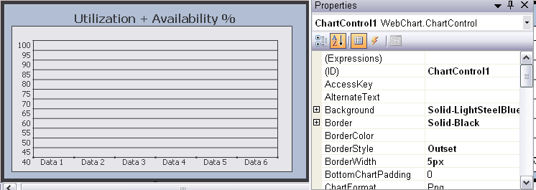

<Web:ChartControl id="ChartControl1" runat="server" Height="243px" Width="430px" BorderStyle="Outset" TopPadding="20" BorderWidth="5px" YValuesInterval="5" YCustomStart="40" YCustomEnd="100" Visible="False">
<YAxisFont stringformat="Far,Near,Character,LineLimit"></YAxisFont>
<XTitle stringformat="Center,Near,Character,LineLimit"></XTitle>
<ChartTitle stringformat="Center,Near,Character,LineLimit"
font="Tahoma, 12pt, style=Bold" text="Util + Avail">
</ChartTitle>
<XAxisFont stringformat="Center,Near,Character,LineLimit"></XAxisFont>
<Background color="LightSteelBlue"></Background>
<legend width="0" font="Tahoma, 6.75pt"></legend>
<YTitle stringformat="Center,Near,Character,LineLimit"></YTitle>
</Web:ChartControl>

using System;
using System.Data;
using System.Drawing;
using System.Web.UI.WebControls;
using WebChart;

public partial class Main_Page : System.Web.UI.Page
{
SmoothLineChart chart1 = new SmoothLineChart();
LineChart gchart1 = new LineChart();
}

INITIALIZE PARAMETERS
void StartCharts()
{
chart1.Legend = "EMail";
chart1.Legend = "Logging";
chart1.Legend = "Opening";

gchart1.Line.Color= Color.Green;
gchart1.LineMarker = new DiamondLineMarker(8, Color.Green, Color.Yellow);
}

LOAD
void Graph1(double numb)
{
float numb1 = (float)numb;
chart1.Data.Add(new ChartPoint(g_day.ToString(), (int)numb1));
gchart1.Data.Add(new ChartPoint(g_day.ToString(), 73));
}

SHOW
void ShowChart()
{
ChartControl1.Charts.Add(chart1);
ChartControl1.Charts.Add(gchart1);
ChartControl1.RedrawChart();
}

COMPARE 3 LINES

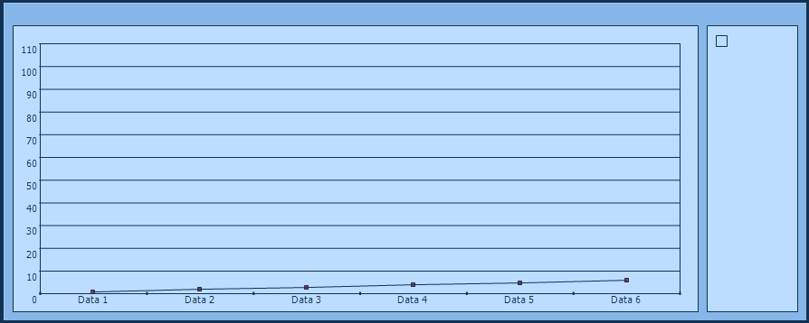

public partial class Main_Page : System.Web.UI.Page
{
SmoothLineChart chart19a = new SmoothLineChart();
SmoothLineChart chart19b = new SmoothLineChart();
SmoothLineChart chart19c = new SmoothLineChart();

LineChart gchart10 = new LineChart();
LineChart gchart11 = new LineChart();
LineChart gchart12 = new LineChart();`
}

INITIALIZE PARAMETERS
void StartCharts()
{

chart19a.Line.Color = Color.Green;
chart19b.Line.Color = Color.Red;
chart19c.Line.Color = Color.Blue;

chart19a.Legend = "EMail";
chart19b.Legend = "Logging";
chart19c.Legend = "Opening";
}

LOAD
void Graph1(double numb)
{

foreach (DataGridItem item in DataGrid9.Items)
{

string[] arreglo = new string[5];
arreglo = Generales.Time_date(item.Cells[0].Text, period1);

g_day = System.Convert.ToInt32(arreglo[3]);

if (g_Email > -1) item.Cells[qa_pos + 2].Text = String.Format("{0:##0}", g_Email) + " %";
if (g_Logging > -1) item.Cells[qa_pos + 3].Text = String.Format("{0:##0}", g_Logging);
if (g_Opening > -1) item.Cells[qa_pos + 4].Text = String.Format("{0:##0}", g_Opening);

if (Generales.IsDouble(g_Email.ToString()) & g_Email < 101 & g_Email > -1)
{
chart19a.Data.Add(new ChartPoint(g_day.ToString(), (int)g_Email));
}
if (Generales.IsDouble(g_Logging.ToString()) & g_Logging < 101 & g_Logging > -1)
{
chart19b.Data.Add(new ChartPoint(g_day.ToString(), (int)g_Logging));
}
if (Generales.IsDouble(g_Opening.ToString()) & g_Opening < 101 & g_Opening > -1)
{
chart19c.Data.Add(new ChartPoint(g_day.ToString(), (int)g_Opening));
}

}
}

SHOW
void ShowChart()
{
ChartControl19.Charts.Add(chart19a);
ChartControl19.Charts.Add(chart19b);
ChartControl19.Charts.Add(chart19c);
ChartControl19.RedrawChart();
}

<Web:ChartControl id="ChartControl19" runat="server" Height="352px" Width="887px" BorderStyle="Outset" BorderWidth="5px" YValuesInterval="10" YCustomStart="0" YCustomEnd="110" Visible="False">
<YAxisFont stringformat="Far,Near,Character,LineLimit"></YAxisFont>
<XTitle stringformat="Center,Near,Character,LineLimit"></XTitle>
<ChartTitle stringformat="Center,Near,Character,LineLimit"></ChartTitle>
<XAxisFont stringformat="Center,Near,Character,LineLimit"></XAxisFont>
<Background color="LightSteelBlue"></Background>
<YTitle stringformat="Center,Near,Character,LineLimit"></YTitle>
</Web:ChartControl>

