The Barracuda Web Filter is a network gateway appliance that is installed between your internal network and the Internet, to perform content filtering, stop spyware and virus downloads, block inbound and outbound access to known spyware Web sites, filter offensive content, and detect spyware accessing the Internet. The Barracuda Web Filter can also notify you of the presence of spyware on computers in your network. It will provide comprehensive protection of your web surfing.

1
Getting Started
This guide provides you with setup instructions for the Barracuda Web Filter. We recommend reading these instructions fully before starting the setup. To begin setting up your Barracuda Web Filter, you will need the following:

- Barracuda Web Filter
- AC Power Cord
- Ethernet Cables
- Mounting Rails (model 610/810 only)
- VGA Monitor (recommended)
- PS2 Keyboard (recommended)

2
Physical Installation
To install the Barracuda Web Filter:
- Fasten the Barracuda Web Filter to a 19-inch rack or place it in a stable location.
- Connect an Ethernet Cable from your network switch to the LAN ethernet port on the front panel of the Barracuda Web Filter. The WAN port will be used after the basic configuration is complete.
- Connect a Standard VGA Monitor, PS2 Keyboard, and AC power cord to the unit. Note: Immediately after connecting an AC Power Cord to the unit, it may power ON for a few seconds and then power OFF. This is because the unit is designed to automatically return to a powered ON state in the event of a power outage.
- Press the POWER button on the front panel to turn the unit on.

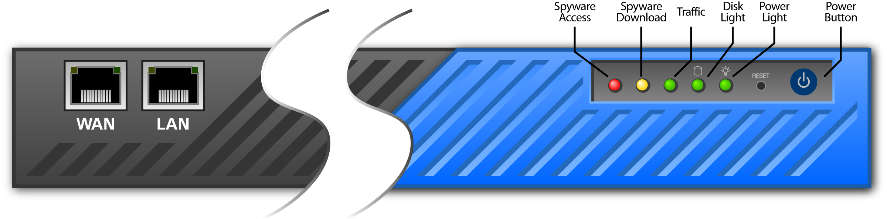

3
Configure IP Address and Network Settings
If you have a monitor connected, the Barracuda Web Filter will display the Boot Menu initially, and the Administrative Console login prompt once fully booted. To begin the configuration:

- Login to the Administrative Console using the admin login:
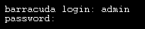
- Login: admin
- Password: admin
- Configure the IP Address, Subnet Mask, Default Gateway, Primary DNS Server and Secondary DNS Server as appropriate for your network.
- Save your changes.

If you do not have a monitor and keyboard and want to set the IP using the RESET button on the front panel, press and hold the RESET button per the following table:
IP address Press and hold RESET for…
192.168.200.200 5 seconds
192.168.1.200 8 seconds
10.1.1.200 12 seconds
4

Barracuda Web Filter Configuration
Use a computer with a Web browser that is connected to the same network as the Barracuda and follow these steps:
      - In the browser address bar, enter http:// followed by the IP address of the Barracuda, followed by the default Web Interface HTTP Port (:8000). For example, if you configured the Barracuda with an IP address of 192.168.200.200, you would enter the following:
http://192.168.200.200:8000
      - Login to the Web interface of the Barracuda Web Filter as the administrator:
Username: admin Password: admin
      - Go to the Basic→ IP Configuration page and configure the following:
- Domain Configuration: Enter the Default Hostname and Default Domain. These names will be associated with anti-spyware email notification messages from the unit.
- Operating Mode: Select Audit**. You will switch this to Active in a later step.
4. Click any one of the Save Changes buttons to save all of the information.

**WARNING: On Barracuda Models 310 and higher, when Hard Bypass is enabled, you will only be able to manage the device from the management ethernet port on the back of the Barracuda Web Filter.

Update the Firmware
5
1. Go to Advanced→Firmware Update.
2. Press Download Firmware. Click OK to acknowledge the download duration message. To avoid damaging the Barracuda, do not power OFF during an update or download. To view download progress, refresh your browser. You will be notified when the download is complete.
3. On the Advanced→Firmware Update page, click the Apply Now button to apply the firmware. This will take a few minutes to complete.
4. Click OK when prompted to reboot.
5. After applying the firmware, Barracuda Networks recommends logging in to the Web interface again and reading the Release Notes to learn about enhancements and new features. It’s also a good practice to verify settings, as new features may have been included with the firmware update.

6
Change the Administrator Password
To avoid unauthorized use, we recommend you change the default administrator password to a more secure password. You can only change the administrator password for the Web interface. You cannot change the password for the Administrative Console, but this is only accessible via the keyboard which you can disconnect at any time.
- Go to Basic→Administration and enter your old and new passwords.
- Press Save Password.

7
Product Activation
Verify that the Energize Updates feature is activated on your Barracuda by going to the Basic→Status page. Under Subscription Status, make sure the Energize Updates subscription is Current. If the Energize Updates is Not Activated, click the corresponding activation link to go to the Barracuda Networks Product Activation page and complete activation of your subscriptions.

8
Inline Connection of Ethernet
The Barracuda is now ready for testing. You should disconnect the ethernet cable that goes between your standard firewall and your internal network switch, and connect this to the WAN port on the front panel of the Barracuda Web Filter. You should then connect the cable from the LAN port of the Barracuda Web Filter to the internal router, hub, or switch that your firewall used to connect to (see diagram). Once this is complete return to the Operating Mode section and set the unit to Active.

9
Test Connectivity
You should verify network connectivity by utilizing a machine in your existing network to browse the Web. Once successful connectivity has been verified, you may adjust the settings within the Barracuda Web Filter to better suit your needs. Your Barracuda Web Filter is now ready to use.

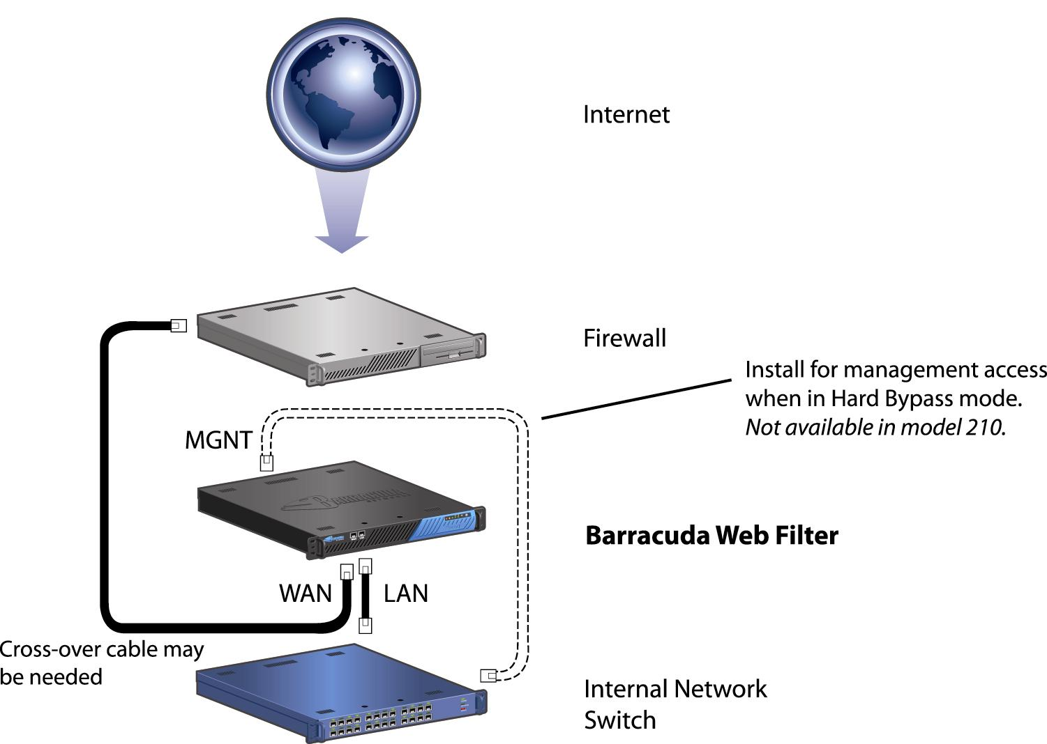
**WARNING: On Barracuda Models 310 and higher, when Hard Bypass is enabled, you will only be able to manage the device from the management ethernet port on the back of the Barracuda Web Filter.

Be sure to check out the Barracuda Networks Support Forum at: http://forum.barracuda.com for Frequently Asked Questions (FAQs) and other helpful tips for setting up and using your Barracuda Web Filter. For additional documentation, visit http://www.barracuda.com/documentation.

Contact and Copyright Information
Barracuda Networks, Inc. 3175 S. Winchester Blvd., Campbell, CA 95008 USA • phone: 408.342.5400 • fax: 408.342.1061 • www.barracuda.com
Copyright© 2007–2008 Barracuda Networks, Inc. All rights reserved. Use of this product and this manual is subject to license. Information in this document is subject to change without notice. Barracuda Web Filter is a trademark of Barracuda Networks, Inc. All other brand and product names mentioned in this document are registered trademarks or trademarks of their respective holders. 070208-320-07-0114

