Thomas Doyle - 20555006

Robot Writer Project

Software Description
The program reads text from a file, processes it, and outputs corresponding G-Code instructions to an Arduino that controls a drawing robot. The Arduino is pre-programmed to interpret these G-Code commands and move the robot’s pen accordingly.
The robot draws each character using a font defined in the SingleStrokeFont.txt file, and the height of the drawn text is determined by user input while ensuring the output fits within a 100 mm width without breaking words across lines.
Completed Features
Font Data Handling
- The program reads all font data from SingleStrokeFont.txt and stores it entirely in memory using an appropriate data structure.
Text Scaling
- The user specifies a desired letter height between 4 mm and 10 mm.
- The program applies a scaling factor to the stored font data, so the robot draws the characters at the requested height.
Text Processing
- The program accepts and processes a text file of any length.
- It reads each word sequentially, generates the corresponding G-Code, and sends it to the Arduino before processing the next word.
- Words are placed so that the resulting text fits within a 100 mm width, and the program ensures that words are never broken across lines.
G-Code Generation
- For each word, the program generates a sequence of G-Code commands that instruct the robot to:
  - Raise the pen,
  - Lower the pen,
  - Move to the correct X and Y coordinates according to the scaled font data.
- The origin of each character aligns with the final point defined within its font data.
- The robot leaves 5 mm of vertical spacing between consecutive lines of drawn text.
- The program interprets LF (ASCII 10, “\n”) and CR (ASCII 13, “\r”) characters by resetting the X-offset and adjusting the Y-offset to begin new lines.
- After sending each command, the program waits for the Arduino to return the confirmation message "ok\n" before proceeding.

Sample emulator output for a text file containing ‘A’:
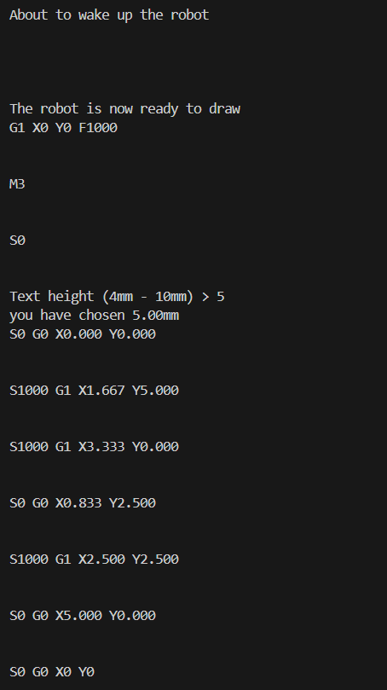

Project Files

- main.c – This is the main program file. It includes serial port set up, robot set up, user text height input, and the main text to G-Code conversion loop.
- functions.c – This file contains the definitions for the readFontData(), and letterToGCode() functions.
- functions.h – This file contains the function declarations for readFontData() and letterToGCode().
- InstructionBuffer.h – This file contains the definition for the struct used for storing G-Code and declarations for the functions used to add to and reset the buffer.
- instructionBuffer.c – This file contains code for the functions used to add to and reset the buffer
- rs232.c – This file contains the code for the RS232 library which is used to enable serial communication.
- Rs232.h – This is the header file for the RS232 library.
- Serial.c – This file contains serial-communication-based functions for the communication with the Robot. It also contains definitions for is serial communication isn’t being used where information is output to the console instead of through serial communication. The program can be switched between serial and emulator mode by uncommenting / commenting out “#define Serial_Mode” respectively.
- Serial.h – This is the header file for Serial.c.

Key Data Items

Name | Data type | Rationale
Font data | 3D integer array | It is convenient to be able to access the font data for each letter from a specific memory location. This can be achieved using a 1D array of letters. Each letter is itself a 1D array of instructions (the first element will contain the number of instructions). Each instruction is a 1D array of integers. Therefore, the whole structure will be a 3D array.  The data in SingleStrokeFont.txt is in integer form so it is convenient to keep it that way.
Text height | Float | Storing the text height as a float gives the user more precise control over the height of the text drawn by the robot than if the data was stored as an integer.
Words from text file | String | Strings read from the text file are lists of ASCII values by default. This is convenient as the ASCII values can be used directly as the indices for the font data array. This means no processing is required to convert the data read from the file into another data type.
G-Code instructions | Struct with string array and size value | The Arduino receives G-Code instructions as strings, so it is sensible to store the instructions for a given word as a string array where each element is an instruction.
Pen Position | Two floats | One float for the X position and one for the Y position

Functions
int*** readFontData(const char* fileName)
Parameters:
  - fileName: the name of the font data text file as a string e.g. “SingleStrokeFont.txt”
This function allocates a block of memory for the font data and returns a pointer array which can be treated as a 3D array e.g. array[letter][instruction][value].

void letterToGCode(char c, struct instructionBuffer* gCodeBuffer, int***fontData, float letterHeight, float* p_penX, float* p_penY)
Parameters:
  - c: the character to be converted
  - gCodeBuffer: a pointer to the G-Code Buffer structure.
  - fontData: a pointer to the fontData pointer array
  - letterHeight: the desired text height
  - p_penX: a pointer to the penX variable
  - p_penY: a pointer to the penY variable
This function takes a letter and converts it into a series of G-Code instructions. Each G-Code instruction is a string and is appended to the GCodeBuffer struct.

Testing Information

Function | Test Case | Test Data | Expected Output
readFontData | Valid text file | First letter of SingleStrokeFont.txt:  999 0 1  0 0 0 | An array which outputs returns the correct numbers when given any indices.
readFontData | Text file that doesn’t exist | “DoesNotExist.txt” | Exits with error message "Error: Could not open font data file.\n"  And exit code 1
letterToGCode | Letter with Known G-Code instruction set with letterHeight set to 4mm | c = ‘A’  letterHeight = 4.0f  penX = penY = 0 | {“S0 G0 X0.000 Y0.000”,  “S1000 G1 X1.333 Y4.000”,  “S1000 G1 X2.667 Y0.000”,  “S0 G0 X0.667 Y2.000”,  “S1000 G1 X2.000 Y2.000”,  “S0 G0 X4.000 Y0.000”} appended to GCodeBuffer  penX set to 4.0  penY set to 0.0
letterToGCode | Letter with Known G-Code instruction set with letterHeight set to 10mm | penX = penY = 0 | {"S0 G0 X0.000 Y0.000",  "S1000 G1 X3.333 Y10.000",  "S1000 G1 X6.667 Y0.000",  "S0 G0 X1.667 Y5.000",  "S1000 G1 X5.000 Y5.000",  "S0 G0 X10.000 Y0.000"} appended to GCodeBuffer  penX set to 10.0  penY set to 0.0
letterToGCode | Letter with ASCII value > 128 | c = ‘é’ (ASCII 233) | Error message: "Error: Could not convert character <character> to GCode"
letterToGCode | Space character | c = ‘ ‘ (space)  letterHeight = 5.0f  penX = penY = 0 | “S0 G0 X5.000 Y0.000” appended to GCodeBuffer  penX set to 5.0
letterToGCode | Newline character | c = ‘\n’ (newline)  letterHeight = 5.0f  penX = penY = 0 | “S0 G0 X0.000 Y-10.000” appended to GCodeBuffer  penX set to 0.0f  penY set to -10.0f

Extend table as required. Note that ‘Function’ includes main()

AI Statement
No AI was used in the making of this document

Flowchart(s)
Included as a separate PDF

