3
Programming Concepts in Scratch – Control
Activity: Work the following exercises as directed by your tutor:
Purpose of this Activity

This activity aims to give you an understanding of the programming concepts by using the Scratch development environment through engineering examples.
Learning Outcome

To be able to create complex programs incorporating and applying the taught programming concepts and interact with the physical world such as sensors.

Task 1 (Line-following vehicle LFV)
Resources: The sprite “yellow_car” and the background “line_background”.

Scientists are experimenting with vehicles that can drive themselves. One method of doing this is by programming the vehicle to follow a line painted on the road surface. These vehicles are known as LFVs.

Our task is to make a car to follow a line, just like the real engineers designing LFVs for use on the roads. Our main tool is going to be the “color [] is touching []?” block from the sensing menu. This block allows a program to detect when an area of one colour touches against another colour.

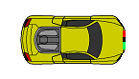

Now look closely at the “yellow_car” and you ‘ll see that there is a patch of green on its bumper. We ‘re going to use that green as our first “sensor”. Build the script that you can see in the next screenshot.

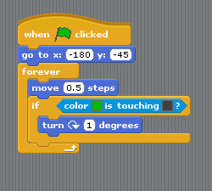

Now click on the green flag and see what happens. Everything is fine as long as the car curves to the left but as soon as it curves to the right the car wanders off. What’s going on?

Activity: Can you add the code required to fix the problem?

Task 2 (The level crossing)
Resources: The sprites “lights” and “barrier”, the background “level_crossing” and the sound “level_crossing_a”.

Context: At a level crossing we have to make sure that cars and trains never meet. This is done with a sensor at the track that detects the passing train. A computer then responds to this event by stopping the traffic approaching the level crossing and closing the barrier.

Import the necessary resources.

For the “lights” and the “barrier” sprites create the following scripts:

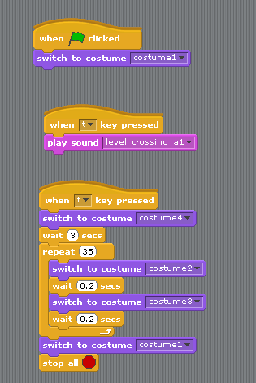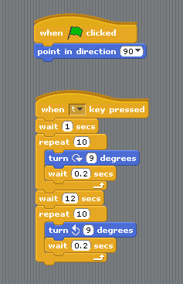

Activity: Execute the code and observe what is happening. Can you write a short explanation of this program and how it works?

Extension Activity: Create a train sprite that moves across the screen and makes the barrier drop (and a light flash) when it approaches.

Follow-up Task
Create a table that describes all the buttons in the Sensing block.

