4
Programming Concepts in Scratch – Maths and Decisions
Activity: Work the following exercises as directed by your tutor:
Purpose of this Activity

This activity aims to give you an understanding of the programming concepts by using the Scratch development environment through more advanced examples.

Learning Outcome

- To be able to understand in Scratch the fundamental programming concepts:
  - Sequence
  - Iteration
  - Conditional statements
  - Variables
- To be able to create more complex programs incorporating and applying the above programming concepts that include:
  - Mathematical operations (Task1)
  - Input data to a program and making decisions (Task2)

Task 1 (Calculator)

Create a basic calculator which will take two numbers as input and perform the basic arithmetic operations ( + , - , * , / ).
Note that for this task you need to practice using variables in Scratch in order to store the input variables and the result.

- Design a calculator layout with 10 + 5 sprites (numbers 0…9, +, -, *, /, =) and two number input fields.
- If a number sprite is clicked with the mouse, add this number to the corresponding field.
- When an operator is clicked, indicate the operation. For ‘=’, calculate the result.

Task 2 (Cat-Dog discussion)
Create the following “Cat-dog discussion” program:
- Create two sprites, a cat and a dog. The cat is going to ask the dog a number of questions, so we need some variables (age, country, holiday and name)
- You need to import four backgrounds: brick wall, and three backgrounds corresponding to three holiday destinations of your choice.

Here is part of the Scratch code for this example:

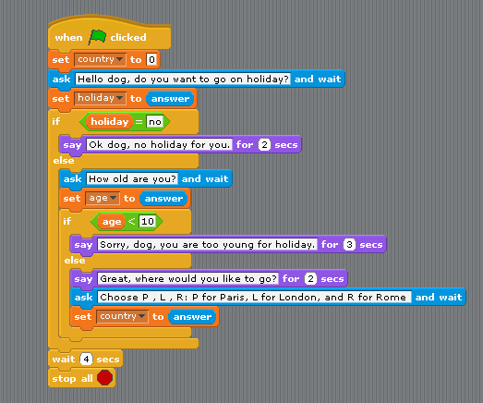

Can you perform the following Tasks:
- Type in the code in Scratch and execute it;
- Finish the code with something happening, e.g. ‘going on holiday’.
- Analyse every part of the code and write a short description of the scenario that is happening here into your logbook.
Such as: The cat asks the dog if he wants to go on holiday. The dog answers and that answer is stored in the holiday variable.

Follow-up Task

Analyse, aim to understand and describe the functionality of all the blocks from the Sensing pallet.

