Title Slide - Using Git and GitHub with RStudio Package Building
Building R packages and including version control is easy with RStudio. This video will walk through the proper setup. These steps are current as of 1/15/2016 and RStudio version 0.99.491.

Prerequisites slide
Existing GitHub account
Git running on local machine
RTools installed on local machine (Windows; for OS X you'll need XXXX)
devtools() R package installed
It is assumed that these several steps have already been completed. SPEAK THEM I'll briefly review them now.

GitHub Account - Web browser pointed at www.github.com
To setup a GitHub account go to www.github.com and select Sign up for GitHub. Provide the required information and create a free plan account. Be sure to make note of your chosen Username and the particular Email Address you used.

GitHub/Git running on local machine - Web browser pointed at https://help.github.com/articles/set-up-git/
Once you have a GitHub account, sign into it and select Set up Git. That will take you to https://help.github.com/articles/set-up-git/ where you can download, and subsequently install, a desktop program to connect Git on your desktop and your GitHub on the Web. Follow the steps here <Setting up Git block on page>. You should now login to GitHub using the desktop program. This login persists. [Can logout via Options and then force the login screen to show by trying to do a Sync] Don't think really using GitHub program on local when doing RStudio stuff!!! RIGHT! Not goign to be using GUI with RSudio projects

RTools - Web browser pointed at https://cran.r-project.org/
On a Windows computer you will also need RTools. Go to the CRAN site and the link where you download R for Windows. CLICK There you can download RTools for subsequent installation. On OS X ...

devtools() - Install the devtools() package in the usual way. [In R window type install.packages("devtools",dependencies=T)]

[https://github.com/ logged in]
Let's begin the real fun by creating a repository for your project on GitHub. Logged into your GitHub account click on the green New Repository button. Give it a name, whatever you are going to call your RStudio project/R package. Provide a description. Click Create repository. SHOULD CREATE WITH README?? - NO!!!

Let's now go to RStudio. [don't have a project up]
The first time you create a RStudio project with version control you need to tell it where the file git.exe (installed when you installed the GitHub desktop program) resides. On Windows it's in a strange location. [Tools|Global Options...|Git/SVN and do Browse and show full path PAUSE] The other options on this dialog can be left blank. BUT NEED TO HAVE Enable version control CHECKBOX CHECKED

You'll need to have the devtools package loaded. [show it in package list] [type library("devtools")]

Be sure your working directory is set to where you want your package project to reside. [setwd("xxx")]

To create a folder/directory for your package project create("xxx"); I find it most straightforward to use the repository name on GitHub. [show it in explorer]

To create your package project in RStudio File|New Project... Select Existing Directory and browse to the directory you just created. Click Create Project. Project menu far right New Project

Enable git for the package project by selecting Tools|Version Control|Project Setup... and selecting Git in the dropdown. Project menu Project Options...

Once RStudio restarts a Git tab will be added [point at] and a .git directory added to your package project directory. [show explorer] Push and Pull not active, Branch not set!

NOPE!! Try setting up using Set up in Desktop button

Next you need to enable push and pull with your GitHub repository. Follow the instructions provided by GitHub when you created the repository [show in Web]. Bring up a command window in RStudio by Tools|Shell... NO - Project area More|Shell Be sure >git config --global user.name and user.email are set like on github site
>echo "# Rtest3" >> README.md
>git init
>git commit -m "first commit"
>git remote add origin https://githib.com/tomeburk/Rtest3.git
>git push -u origin master

>git add *
>git commit -m "FIRST commit"
>git remote add origin git@githib.com:tomeburk/MyFirst3.git
>git push -u origin master

branch should show as master after third line
pull and push should be active after fourth, last, line
should show on github side after fourth line - SHOW IT!!

Got error on last line and don't know why
Messed with a few things and finally asked me for username and password -- don't know why then??

D:\teb\R_data\Rtest3>git push -u origin master
error: src refspec master does not match any.
error: failed to push some refs to 'https://github.com/tomeburk/Rtest3.git'

D:\teb\R_data\Rtest3>git push -u origin master
error: src refspec master does not match any.
error: failed to push some refs to 'https://github.com/tomeburk/Rtest3.git'

D:\teb\R_data\Rtest3>git push -u origin master
github --credentials get: github: command not found
Username for 'https://github.com': tomeburk
Password for 'https://tomeburk@github.com':
github --credentials store: github: command not found
Branch master set up to track remote branch master from origin.
Everything up-to-date

Maybe try in shell
git config --global credential.helper wincred
That's in the github Setting up Git part of authenticating
Likely have to do that when first setup!!!

Problem seems to be "branch" isn't set to Master on local side!!! - and I don't know how to fix in RStudio

When tried again got same run around until made some changes and tried to commit
Also did the setup via github button deal - I Don't Know!!!

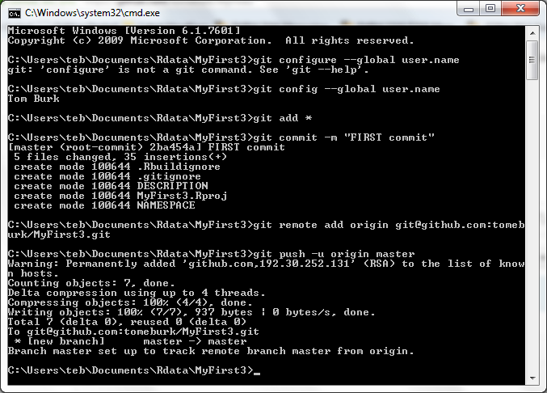

In RStudio
Modify Description file - Do - Absolutely nothin'
Add a .R - New Script
#' Title
dummy <- function(dum) {
print("A nothin function")
}
Commit and Push Description
Commit and Push .R
LOOKS LIKE NEED TO CLICK Staged CHECKBOX AND DO BOTH OR MAKE ADDITIONS SEPARATELY AND GO THOUGH WHOLE THING
Actually I think you just mis-saw that first push done!

On GitHub side Add a README
Then must do Pull request on RStudio side

Using GitHub desktop app (project that has a couple Word files)

Created repository on GitHub web
Added README and license files
Does and auto-commit

In desktop GitHub, did a clone
Was asked to login as wasn’t
Put in ~\GitHub directory

Added two doc files to directory
Did a commit (to register them with Git)
Did a sync to push (/pull) with GitHub

Had modified this file so saved and commit/Sync

