BIOSTATISTICS
Normal distribution occurs very frequently in statistics, economics, natural and social sciences and can be used to approximate many distributions occurring in nature and in the manmade world.
For example, the height of all people of a particular race, the length of all dogs of a particular breed, IQ, memory and reading skills of people in a general population and income distribution in an economy all approximately follow the normal probability distribution shaped like a bell curve.
The theory of normal distribution also finds use in advances sciences like astronomy, photonics and quantum mechanics.
The normal distribution can be characterized by the mean and standard deviation. The mean determines where the peak occurs, which is at 0 in our figure for all the curves. The standard deviation is a measure of the spread of the normal probability distribution, which can be seen as differing widths of the bell curves in our figure.
Read more: http://www.experiment-resources.com/normal-probability-distribution.html#ixzz1K8qxBI2k
Normal distribution occurs very frequently in statistics, economics, natural and social sciences and can be used to approximate many distributions occurring in nature and in the manmade world.
For example, the height of all people of a particular race, the length of all dogs of a particular breed, IQ, memory and reading skills of people in a general population and income distribution in an economy all approximately follow the normal probability distribution shaped like a bell curve.
The theory of normal distribution also finds use in advances sciences like astronomy, photonics and quantum mechanics.
The normal distribution can be characterized by the mean and standard deviation. The mean determines where the peak occurs, which is at 0 in our figure for all the curves. The standard deviation is a measure of the spread of the normal probability distribution, which can be seen as differing widths of the bell curves in our figure.
Read more: http://www.experiment-resources.com/normal-probability-distribution.html#ixzz1K8qxBI2k
Normal distribution occurs very frequently in statistics, economics, natural and social sciences and can be used to approximate many distributions occurring in nature and in the manmade world.
For example, the height of all people of a particular race, the length of all dogs of a particular breed, IQ, memory and reading skills of people in a general population and income distribution in an economy all approximately follow the normal probability distribution shaped like a bell curve.
The theory of normal distribution also finds use in advances sciences like astronomy, photonics and quantum mechanics.
The normal distribution can be characterized by the mean and standard deviation. The mean determines where the peak occurs, which is at 0 in our figure for all the curves. The standard deviation is a measure of the spread of the normal probability distribution, which can be seen as differing widths of the bell curves in our figure.
Read more: http://www.experiment-resources.com/normal-probability-distribution.html#ixzz1K8qxBI2k
Normal distribution occurs very frequently in statistics, economics, natural and social sciences and can be used to approximate many distributions occurring in nature and in the manmade world.
For example, the height of all people of a particular race, the length of all dogs of a particular breed, IQ, memory and reading skills of people in a general population and income distribution in an economy all approximately follow the normal probability distribution shaped like a bell curve.
The theory of normal distribution also finds use in advances sciences like astronomy, photonics and quantum mechanics.
The normal distribution can be characterized by the mean and standard deviation. The mean determines where the peak occurs, which is at 0 in our figure for all the curves. The standard deviation is a measure of the spread of the normal probability distribution, which can be seen as differing widths of the bell curves in our figure.
Read more: http://www.experiment-resources.com/normal-probability-distribution.html#ixzz1K8qxBI2k
The mean is generally represented by μ and the standard deviation by σ. For a perfect normal distribution, the mean, median and mode are all equal. The normal distribution function can be written in terms of the mean and standard deviation as follows:
p(x) = (1/σRoot(2π)) x exp (- (x-μ)2/2σ2)
o r
Read more: http://www.experiment-resources.com/normal-probability-distribution.html#ixzz1K8rwH19V

A.1)

a) t- distribution

In probability and statistics, Student’s t-distribution (or simply the t-distribution) is a continuous probability distribution that arises when estimating the mean of a normally distributed population in situations where the sample size is small. It plays a role in a number of widely-used statistical analyses, including the Student’s t-test for assessing the statistical significance of the difference between two sample means, the construction of confidence intervals for the difference between two population means, and in linear regression analysis. The Student’s t-distribution also arises in the Bayesian analysis of data from a normal family.
The t-distribution is symmetric and bell-shaped, like the normal distribution, but has heavier tails, meaning that it is more prone to producing values that fall far from its mean. This makes it useful for understanding the statistical behavior of certain types of ratios of random quantities, in which variation in the denominator is amplified and may produce outlying values when the denominator of the ratio falls close to zero.
Parameters for the t-distribution:-
support:-

pdf:

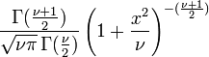
cdf:
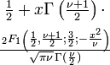
mean: 0 for ν > 1, otherwise undefined
median: 0
mode: 0
variance:
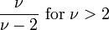
skewness: 0 for v>3
ex.kurtosis:
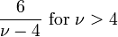
entropy:
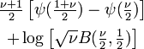
mgf: not defined

cf:
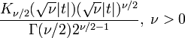

b) f- distribution

In probability theory and statistics, the F-distribution is a continuous probability distribution. It is also known as Snedecor's F distribution or the Fisher-Snedecor distribution (after R.A. Fisher and George W. Snedecor). The F-distribution arises frequently as the null distribution of a test statistic, especially in likelihood-ratio tests, perhaps most notably in the analysis of variance.

Parameters of F distribution:

support:
pdf:
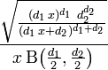
cdf:
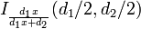
mean:
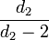
median: na
mode:
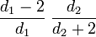
variance:
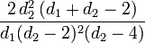
skewness:
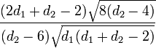
A.2)

In probability theory and statistics, the binomial distribution is the discrete probability distribution of the number of successes in a sequence of n independent yes/no experiments, each of which yields success with probability p. Such a success/failure experiment is also called a Bernoulli experiment or Bernoulli trial. In fact, when n = 1, the binomial distribution is a Bernoulli distribution. The binomial distribution is the basis for the popular binomial test of statistical significance.

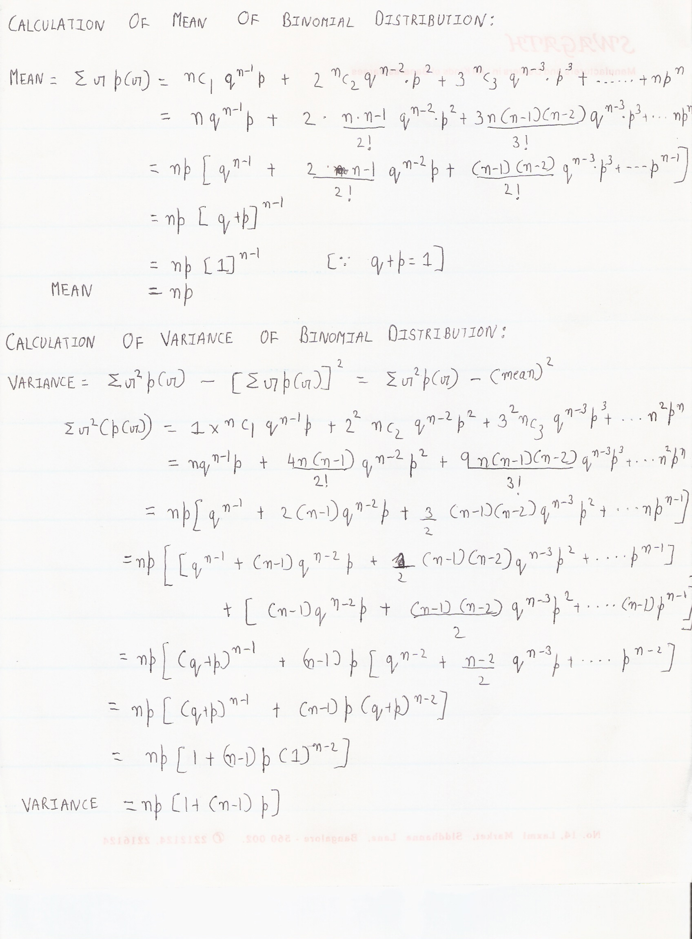
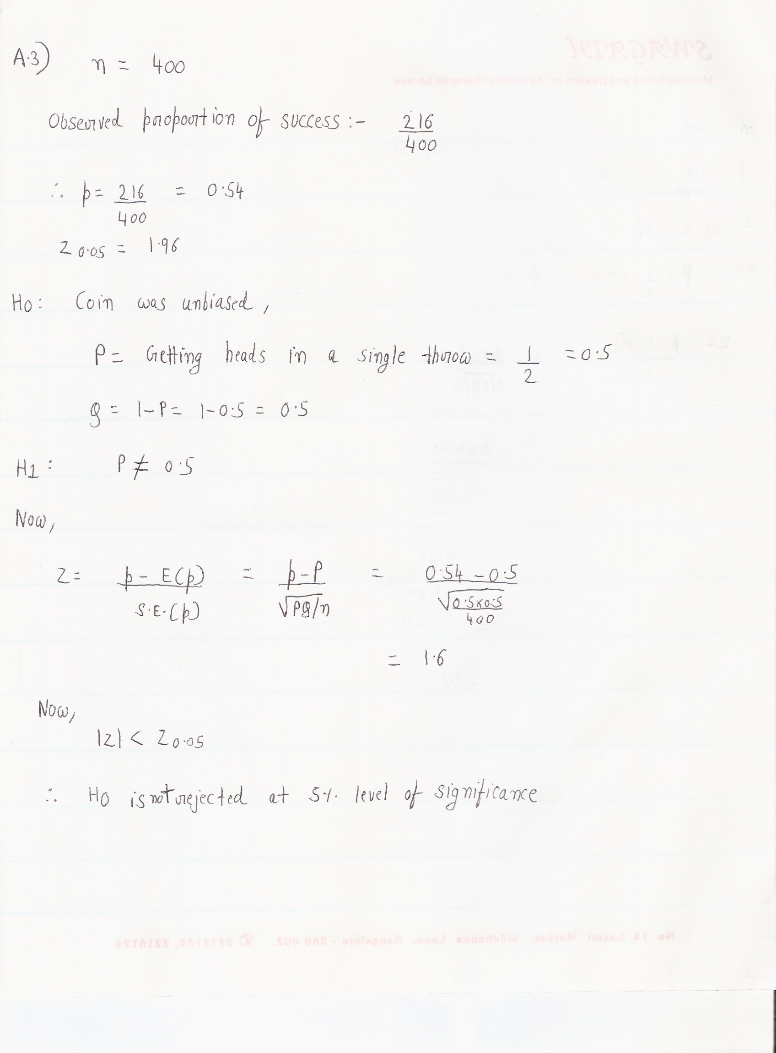

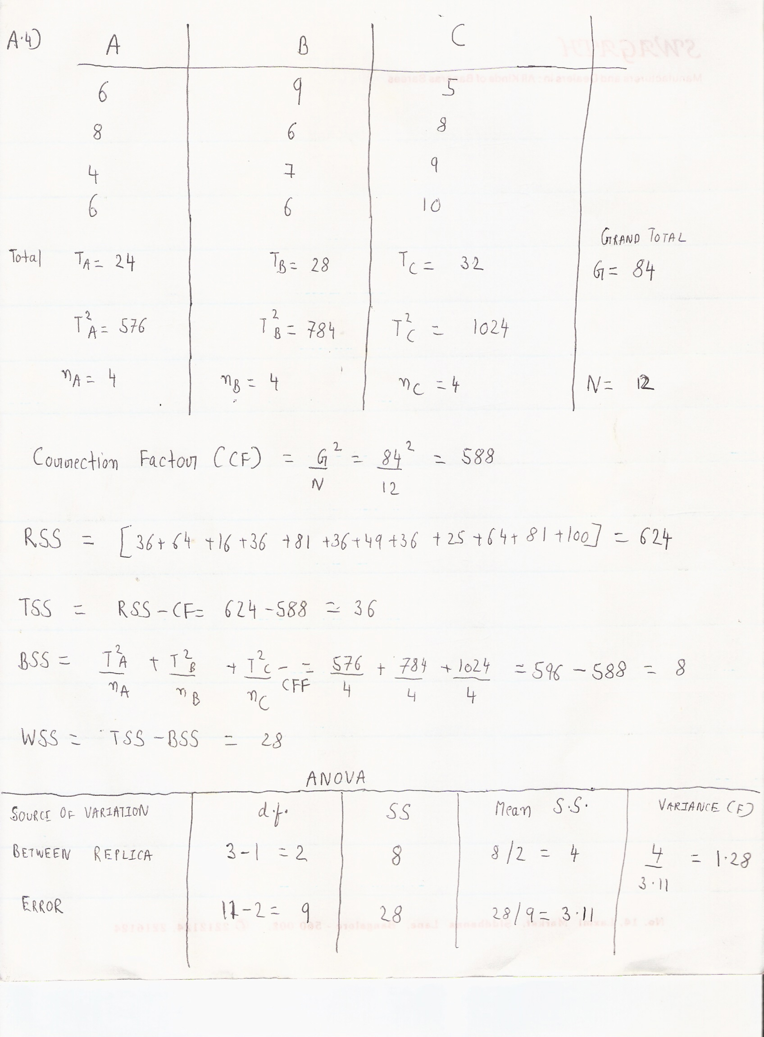

A.5)

A hidden Markov model (HMM) is a statistical Markov model in which the system being modeled is assumed to be a Markov process with unobserved (hidden) states. An HMM can be considered as the simplest dynamic Bayesian network.
In a regular Markov model, the state is directly visible to the observer, and therefore the state transition probabilities are the only parameters. In a hidden Markov model, the state is not directly visible, but output, dependent on the state, is visible. Each state has a probability distribution over the possible output tokens. Therefore the sequence of tokens generated by an HMM gives some information about the sequence of states. Note that the adjective 'hidden' refers to the state sequence through which the model passes, not to the parameters of the model; even if the model parameters are known exactly, the model is still 'hidden'.
Hidden Markov models are especially known for their application in temporal pattern recognition such as speech, handwriting, gesture recognition, part-of-speech tagging, musical score following, partial discharges and bioinformatics.
A hidden Markov model can be considered a generalization of a mixture model where the hidden variables (or latent variables), which control the mixture component to be selected for each observation, are related through a Markov process rather than independent of each other.
In Bioinformatics HMM is used to assist in the foloowing:-
a)Gene Prediction
b)Alignment of Bio-Sequences
c)Protein Folding
d)Data Mining
e)Protein Secondary Structure Prediction

The strong theoretical background of HMM allows the estimation of model parameters,and the prediction of the hidden features from the observed sequence. The secondary structure prediction task can be expressed in term of a hidden data problem as follows:

• the secondary structure of a particular residue along the
sequence is a hidden process,
• the amino acid sequence is the observed process.

In a very basic HMM, each secondary structure is modeled by a single state. The parameters of the model are the transition and emission probabilities. Here, we will consider more complex models with several hidden states per secondary
structure. The difficulty is to choose the optimal number of hidden states for each secondary structure. Model parameters are then estimated from available data.

HMM Predictions Using Single Sequences:-

Predictions are done using the forward/backward algorithm. This allows the computation of the posterior probability of each hidden state in each position of the query sequence, given the model and the whole sequence: P(St =u | X), where St is the hidden state at position t, u is a particular hidden state and X is the amino-acid sequence.

The posterior probability of hidden states of the same structural class c are summed together: c being the set of hidden states modeling the structural class. The structural class with the highest probability is predicted.

HMM Predictions Using Multiple Sequences

Models estimated with single sequences can be used in a framework of a multiple sequence prediction. The multiple sequence based prediction is carried out in three steps:

1. a PSI-BLAST search is performed using the sequence to be predicted, resulting in a family of n homologous sequences,

2. the secondary structures of these n sequences are independently predicted using the HMM,

3. the n predictions are combined into a unique prediction. In the first step, homologous sequences are extracted using PSI-BLAST with search parameters -j 3 -h 0.001 -e 0.001, against a non-redundant data bank. The redundancy level of the data bank is 70% (i.e., no pair of sequences has more than 70% identical residues after
alignment) and the data bank has been filtered to remove low-complexity regions, transmembrane regions, and coiled-coil segments. Other data banks (80 and 90%
redondancy level, filtered or not) were tested and the above choice provided the best results. In the second step, n predictions are performed, independently for each
sequence retrieved in the first step, with the forward-backward algorithm.

In the third step, the n independent predictions are combined. At each position of the sequence family, the predictions of the n sequences for the same position contribute
to the final prediction, with a sequence weight. Sequence weights are used to correct for the fact that the n sequences retrieved in the first step do not necessarily correctly sample the sequence space. For example, a sequence family can be composed of several very similar sequences and a few more distant sequences. Without sequence weights, the final prediction would be biased toward the set of similar sequences and the information carried by the more distant sequences would be lost. The probability of the secondary structure s at the position t of the sequence family
F is then given by: where Pi (St = s) is the posterior probability of the secondary
structure s obtained for the single sequence i at position t (see equation 1). The sum is taken over all the n sequences retrieved for the family that do not contain gap
at the considered position. The secondary structure with the highest probability is taken as the prediction.

A.6)

a) Contingency Table

In statistics, a contingency table (also referred to as cross tabulation or cross tab) is often used to record and analyze the relation between two or more categorical variables. It displays the (multivariate) frequency distribution of the variables in a matrix format.
A crucial problem of multivariate statistics is finding (direct-)dependence structure underlying the variables contained in high dimensional contingency tables. If some of the conditional independences are revealed, then even the storage of the data can be done in a smarter way. In order to do this one can use information theory concepts, which gain the information only from the distribution of probability, which can be expressed easily from the contingency table by the relative frequencies.

Suppose that we have two variables, sex (male or female) and handedness (right- or left-handed). Further suppose that 100 individuals are randomly sampled from a very large population as part of a study of sex differences in handedness. A contingency table can be created to display the numbers of individuals who are male and right-handed, male and left-handed, female and right-handed, and female and left-handed. Such a contingency table is shown below.
 | Right-handed | Left-handed | Totals
Males | 43 | 9 | 52
Females | 44 | 4 | 48
Totals | 87 | 13 | 100
The numbers of the males, females, and right- and left-handed individuals are called marginal totals. The grand total, i.e., the total number of individuals represented in the contingency table, is the number in the bottom right corner.
The table allows us to see at a glance that the proportion of men who are right-handed is about the same as the proportion of women who are right-handed although the proportions are not identical. The significance of the difference between the two proportions can be assessed with a variety of statistical tests including Pearson's chi-square test, the G-test, Fisher's exact test, and Barnard's test, provided the entries in the table represent individuals randomly sampled from the population about which we want to draw a conclusion. If the proportions of individuals in the different columns vary significantly between rows (or vice versa), we say that there is a contingency between the two variables. In other words, the two variables are not independent. If there is no contingency, we say that the two variables are independent.
The example above is the simplest kind of contingency table, a table in which each variable has only two levels; this is called a 2 x 2 contingency table. In principle, any number of rows and columns may be used. There may also be more than two variables, but higher order contingency tables are difficult to represent on paper. The relation between ordinal variables, or between ordinal and categorical variables, may also be represented in contingency tables, although such a practice is rare.

b)TYPE I and TYPE II Errors

Type I error, also known as false positive, occurs when a statistical test rejects a true null hypothesis. For example, a patient is healthy, null hypothesis states that he is healthy, but the test rejects the hypothesis, falsely suggesting that the patient is sick. The rate of type I error is denoted by the Greek letter alpha (α) and usually equals the significance level of a test, by convention 0.05.
Type II error, also known as false negative, occurs when the test fails to reject a false null hypothesis. For example, a patient is sick, null hypothesis states that he is healthy and the test fails to reject the hypothesis, falsely suggesting that the patient is healthy. The rate of type II error is denoted by the Greek letter beta (β) and related to the power of a test (which equals 1-β).
Both types of errors are problems for individuals, corporations, and data analysis. A false positive (with null hypothesis of health) in medicine causes unnecessary worry or treatment, while a false negative gives the patient the dangerous illusion of good health and the patient might not get an available treatment. A false positive in manufacturing quality control (with a null hypothesis of a product being well-made), discards a product, which is actually well-made, while a false negative stamps a broken product as operational. A false positive (with null hypothesis of no effect) in scientific research suggest an effect, which is not actually there, while a false negative fails to detect an effect that is there.
Statisticians note two sorts of statistical error. They begin with a "null hypothesis" which corresponds to a presumed default "state of nature", e.g., an individual is free of disease, an accused is innocent, a product is not broken. The "alternative hypothesis" corresponds to the opposite situation, that the individual has the disease, the accused is guilty, or the product is defective.. The goal is to accurately determine if the null hypothesis can be discarded in favor of the alternative.
A test is conducted and data are obtained. The test could be a medical diagnostic, or a criminal trial, or a lab procedure. The result of the test may be negative (no disease, not guilty, not broken). On the other hand, it may be positive (infected, guilty, defective). If the result of the test corresponds with reality, then a correct decision has been made. However, if the result of the test does not correspond with reality, then an error has occurred. These two basic kinds of error, are classified as "type I error" and "type II error," depending upon which hypothesis has incorrectly been identified as the true state of nature

Null Hypothesis (H0) is true | Alternative Hypothesis (H1) is true
Reject Null Hypothesis | Wrong decision  Type I Error  False Positive | Right decision
Fail to Reject Null Hypothesis | Right decision | Wrong decision  Type II Error  False Negative

c) Degrees Of Freedom:

In statistics, the number of degrees of freedom is the number of values in the final calculation of a statistic that are free to vary.
Estimates of statistical parameters can be based upon different amounts of information or data. The number of independent pieces of information that go into the estimate of a parameter is called the degrees of freedom (df). In general, the degrees of freedom of an estimate is equal to the number of independent scores that go into the estimate minus the number of parameters estimated as intermediate steps in the estimation of the parameter itself (which, in sample variance, is one, since the sample mean is the only intermediate step).
Mathematically, degrees of freedom is the dimension of the domain of a random vector, or essentially the number of 'free' components: how many components need to be known before the vector is fully determined.
The term is most often used in the context of linear models (linear regression, analysis of variance), where certain random vectors are constrained to lie in linear subspaces, and the number of degrees of freedom is the dimension of the subspace. The degrees-of-freedom are also commonly associated with the squared lengths (or “Sum of Squares”) of such vectors, and the parameters of chi-squared and other distributions that arise in associated statistical testing problems.

d) Critical Region:

A statistical hypothesis test is a method of making decisions using data, whether from a controlled experiment or an observational study (not controlled). In statistics, a result is called statistically significant if it is unlikely to have occurred by chance alone, according to a pre-determined threshold probability, the significance level. Critical tests of this kind may be called tests of significance, and when such tests are available we may discover whether a second sample is or is not significantly different from the first.
Hypothesis testing is sometimes called confirmatory data analysis, in contrast to exploratory data analysis. In frequency probability, these decisions are almost always made using null-hypothesis tests (i.e., tests that answer the question Assuming that the null hypothesis is true, what is the probability of observing a value for the test statistic that is at least as extreme as the value that was actually observed. One use of hypothesis testing is deciding whether experimental results contain enough information to cast doubt on conventional wisdom.
A result that was found to be statistically significant is also called a positive result; conversely, a result that is not unlikely under the null hypothesis is called a negative result or a null result.
Statistical hypothesis testing is a key technique of frequentist statistical inference. The Bayesian approach to hypothesis testing is to base rejection of the hypothesis on the posterior probability. Other approaches to reaching a decision based on data are available via decision theory and optimal decisions.
The critical region of a hypothesis test is the set of all outcomes which, if they occur, will lead us to decide that there is a difference. That is, cause the null hypothesis to be rejected in favor of the alternative hypothesis. The critical region is usually denoted by the letter C.
In the statistical literature, statistical hypothesis testing plays a fundamental role.[6] The usual line of reasoning is as follows:
- We start with a research hypothesis of which the truth is unknown.

- The first step is to state the relevant null and alternative hypotheses. This is important as mis-stating the hypotheses will muddy the rest of the process. Specifically, the null hypothesis allows to attach an attribute: it should be chosen in such a way that it allows us to conclude whether the alternative hypothesis can either be accepted or stays undecided as it was before the test.

- The second step is to consider the statistical assumptions being made about the sample in doing the test; for example, assumptions about the statistical independence or about the form of the distributions of the observations. This is equally important as invalid assumptions will mean that the results of the test are invalid.

- Decide which test is appropriate, and stating the relevant test statistic T.

- Derive the distribution of the test statistic under the null hypothesis from the assumptions. In standard cases this will be a well-known result. For example the test statistics may follow a Student's t distribution or a normal distribution.
- The distribution of the test statistic partitions the possible values of T into those for which the null-hypothesis is rejected, the so called critical region, and those for which it is not.

- Compute from the observations the observed value tobs of the test statistic T.

- Decide to either fail to reject the null hypothesis or reject it in favor of the alternative. The decision rule is to reject the null hypothesis H0 if the observed value tobs is in the critical region, and to accept or "fail to reject" the hypothesis otherwise.

e) Parameter and Statistic:-

In mathematics, statistics, and the mathematical sciences, a parameter (G: auxiliary measure) is a quantity that serves to relate functions and variables using a common variable when such a relationship would be difficult to explicate with an equation. In different contexts, the term may have special uses. Parameter is a computation from data values recorded but it is not actually a data value recorded from a subject. Example: for a population of test scores, a parameter would not be an actual score, but perhaps an average computed from all scores, or a percent computed from all scores.
Mathematical functions have one or more arguments that are designated in the definition by variables, while their definition can also contain parameters. The variables are mentioned in the list of arguments that the function takes, but the parameters are not. When parameters are present, the definition actually defines a whole family of functions, one for every valid set of values of the parameters. For instance one could define a general quadratic function by defining
f(x) = ax2 + bx + c;
here the variable x designates the function argument, but a, b, and c are parameters that determine which quadratic function one is considering. The parameter could be incorporated into the function name to indicate its dependence on the parameter; for instance one may define the base a logarithm by
where a is a parameter that indicates which logarithmic function is being used; it is not an argument of the function, and will for instance be a constant when considering the derivative .
In some informal situations, people regard it as a matter of convention (or historical accident) whether some or all the symbols in a function definition are called parameters. However, changing the status of symbols between parameter and variable changes the function as a mathematical object. For instance, the notation for the falling factorial power
,
defines a polynomial function of n (when k is considered a parameter), but is not a polynomial function of k (when n is considered a parameter); indeed, in the latter case, it is only defined at non-negative integer arguments.
In the special case of parametric equations, the independent variables are called the parameters.

A.7)

In probability theory, the normal (or Gaussian) distribution, is a continuous probability distribution that is often used as a first approximation to describe real-valued random variables that tend to cluster around a single mean value. The graph of the associated probability density function is “bell”-shaped, and is known as the Gaussian function or bell curve:
where parameter μ is the mean (location of the peak) and σ 2 is the variance (the measure of the width of the distribution). The distribution with μ = 0 and σ 2 = 1 is called the standard normal.
The normal distribution is considered the most prominent probability distribution in statistics. There are several reasons for this:
First, the normal distribution is very tractable analytically, that is, a large number of results involving this distribution can be derived in explicit form.
Second, the normal distribution arises as the outcome of the central limit theorem, which states that under mild conditions the sum of a large number of random variables is distributed approximately normally.
Finally, the “bell” shape of the normal distribution makes it a convenient choice for modelling a large variety of random variables encountered in practice.

For this reason, the normal distribution is commonly encountered in practice, and is used throughout statistics, natural sciences, and social sciences a simple model for complex phenomena. For example, the observational error in an experiment is usually assumed to follow a normal distribution, and the propagation of uncertainty is computed using this assumption. Note that a normally-distributed variable has a symmetric distribution about its mean. Quantities that grow exponentially, such as prices, incomes or populations, are often skewed to the right, and hence may be better described by other distributions, such as the log-normal distribution or Pareto distribution. In addition, the probability of seeing a normally-distributed value that is far (i.e. more than a few standard deviations) from the mean drops off extremely rapidly. As a result, statistical inference using a normal distribution is not robust to the presence of outliers (data that is unexpectedly far from the mean, due to exceptional circumstances, observational error, etc.). When outliers are expected, data may be better described using a heavy-tailed distribution such as the Student’s t-distribution.
From a technical perspective, alternative characterizations are possible, for example:
- The normal distribution is the only absolutely continuous distribution all of whose cumulants beyond the first two (i.e. other than the mean and variance) are zero.
- For a given mean and variance, the corresponding normal distribution is the continuous distribution with the maximum entropy.
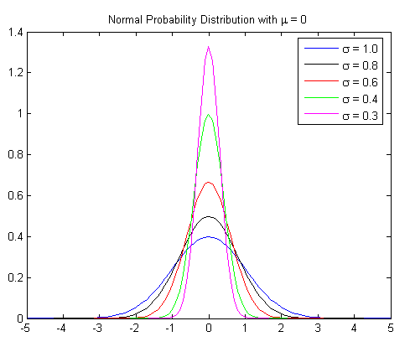

Normal distribution occurs very frequently in statistics, economics, natural and social sciences and can be used to approximate many distributions occurring in nature and in the manmade world.
For example, the height of all people of a particular race, the length of all dogs of a particular breed, IQ, memory and reading skills of people in a general population and income distribution in an economy all approximately follow the normal probability distribution shaped like a bell curve.
The theory of normal distribution also finds use in advances sciences like astronomy, photonics and quantum mechanics. The normal distribution can be characterized by the mean and standard deviation. The mean determines where the peak occurs, which is at 0 in our figure for all the curves. The standard deviation is a measure of the spread of the normal probability distribution, which can be seen as differing widths of the bell curves in our figure.
The mean is generally represented by μ and the standard deviation by σ. For a perfect normal distribution, the mean, median and mode are all equal. The normal distribution function can be written in terms of the mean and standard deviation as follows:
p(x) = (1/σRoot(2π)) x exp (- (x-μ)2/2σ2)

A.8)

a) Bar Diagram

A bar diagram or bar graph is a chart with rectangular bars with lengths proportional to the values that they represent. The bars can be plotted vertically or horizontally.
Bar charts are used for plotting discrete (or 'discontinuous') data i.e. data which has discrete values and is not continuous. Some examples of discontinuous data include 'shoe size' or 'eye colour', for which you would use a bar chart. In contrast, some examples of continuous data would be 'height' or 'weight'. A bar chart is very useful if you are trying to record certain information whether it is continuous or not continuous data. Bar charts also look a lot like a histogram.They are often mistaken for each other
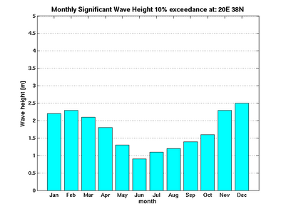
b) Histogram

In statistics, a histogram is a graphical representation, showing a visual impression of the distribution of data. It is an estimate of the probability distribution of a continuous variable and was first introduced by Karl Pearson. A histogram consists of tabular frequencies, shown as adjacent rectangles, erected over discrete intervals (bins), with an area equal to the frequency of the observations in the interval. The height of a rectangle is also equal to the frequency density of the interval, i.e., the frequency divided by the width of the interval. The total area of the histogram is equal to the number of data. A histogram may also be normalized displaying relative frequencies. It then shows the proportion of cases that fall into each of several categories, with the total area equaling 1. The categories are usually specified as consecutive, non-overlapping intervals of a variable. The categories (intervals) must be adjacent, and often are chosen to be of the same size.
Histograms are used to plot density of data, and often for density estimation: estimating the probability density function of the underlying variable. The total area of a histogram used for probability density is always normalized to 1. If the length of the intervals on the x-axis are all 1, then a histogram is identical to a relative frequency plot.
An alternative to the histogram is kernel density estimation, which uses a kernel to smooth samples. This will construct a smooth probability density function, which will in general more accurately reflect the underlying variable.

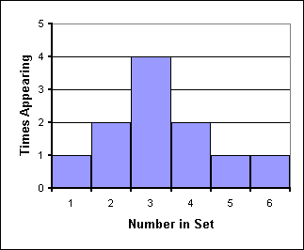

c) Frequency Polygon

A frequency polygon is another way to showthe information in a frequency table. It looks a little bit like a linegraph. To make a frequency polygon, you just need to plot a few points andthen join the points by straight lines. So what points do you need to plot? Well, first you have to find the midpoints of each class. The midpointof a class is the point in the middle of the class. So for instance, ifI have a class “10 – 19”, then the midpoint is 14.5. A class of“0 – 5” has a midpoint of 2.5.

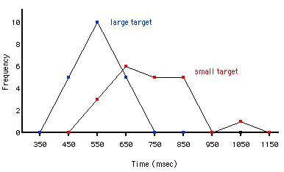

A.9)

A statistical hypothesis test is a method of making decisions using data, whether from a controlled experiment or an observational study (not controlled). In statistics, a result is called statistically significant if it is unlikely to have occurred by chance alone, according to a pre-determined threshold probability, the significance level. Critical tests of this kind may be called tests of significance, and when such tests are available we may discover whether a second sample is or is not significantly different from the first.
Hypothesis testing is sometimes called confirmatory data analysis, in contrast to exploratory data analysis. In frequency probability, these decisions are almost always made using null-hypothesis tests (i.e., tests that answer the question Assuming that the null hypothesis is true, what is the probability of observing a value for the test statistic that is at least as extreme as the value that was actually observed. One use of hypothesis testing is deciding whether experimental results contain enough information to cast doubt on conventional wisdom.
A result that was found to be statistically significant is also called a positive result; conversely, a result that is not unlikely under the null hypothesis is called a negative result or a null result.
Statistical hypothesis testing is a key technique of frequentist statistical inference. The Bayesian approach to hypothesis testing is to base rejection of the hypothesis on the posterior probability. Other approaches to reaching a decision based on data are available via decision theory and optimal decisions.
The critical region of a hypothesis test is the set of all outcomes which, if they occur, will lead us to decide that there is a difference. That is, cause the null hypothesis to be rejected in favor of the alternative hypothesis. The critical region is usually denoted by the letter C.
In the statistical literature, statistical hypothesis testing plays a fundamental role.[6] The usual line of reasoning is as follows:
- We start with a research hypothesis of which the truth is unknown.

- The first step is to state the relevant null and alternative hypotheses. This is important as mis-stating the hypotheses will muddy the rest of the process. Specifically, the null hypothesis allows to attach an attribute: it should be chosen in such a way that it allows us to conclude whether the alternative hypothesis can either be accepted or stays undecided as it was before the test.

- The second step is to consider the statistical assumptions being made about the sample in doing the test; for example, assumptions about the statistical independence or about the form of the distributions of the observations. This is equally important as invalid assumptions will mean that the results of the test are invalid.

- Decide which test is appropriate, and stating the relevant test statistic T.

- Derive the distribution of the test statistic under the null hypothesis from the assumptions. In standard cases this will be a well-known result. For example the test statistics may follow a Student's t distribution or a normal distribution.
- The distribution of the test statistic partitions the possible values of T into those for which the null-hypothesis is rejected, the so called critical region, and those for which it is not.

- Compute from the observations the observed value tobs of the test statistic T.

- Decide to either fail to reject the null hypothesis or reject it in favor of the alternative. The decision rule is to reject the null hypothesis H0 if the observed value tobs is in the critical region, and to accept or "fail to reject" the hypothesis otherwise.

There are two types of statistical inferences: estimation of population parameters and hypothesis testing. Hypothesis testing is one of the most important tools of application of statistics to real life problems. Most often, decisions are required to be made concerning populations on the basis of sample information. Statistical tests are used in arriving at these decisions.
There are five ingredients to any statistical test :
(a) Null Hypothesis
(b) Alternate Hypothesis
(c) Test Statistic
(d) Rejection/Critical Region
(e) Conclusion
In attempting to reach a decision, it is useful to make an educated guess or assumption about the population involved, such as the type of distribution.
Statistical Hypotheses : They are defined as assertion or conjecture about the parameter or parameters of a population, for example the mean or the variance of a normal population. They may also concern the type, nature or probability distribution of the population.
Statistical hypotheses are based on the concept of proof by contradiction. For example, say, we test the mean (μ) of a population to see if an experiment has caused an increase or decrease in μ. We do this by proof of contradiction by formulating a null hypothesis.
Null Hypothesis : It is a hypothesis which states that there is no difference between the procedures and is denoted by H0. For the above example the corresponding H0 would be that there has been no increase or decrease in the mean. Always the null hypothesis is tested, i.e., we want to either accept or reject the null hypothesis because we have information only for the null hypothesis.
Alternative Hypothesis : It is a hypothesis which states that there is a difference between the procedures and is denoted by HA.

Test Statistic : It is the random variable X whose value is tested to arrive at a decision. The Central Limit Theorem states that for large sample sizes (n > 30) drawn randomly from a population, the distribution of the means of those samples will approximate normality, even when the data in the parent population are not distributed normally. A z statistic is usually used for large sample sizes (n > 30), but often large samples are not easy to obtain, in which case the t-distribution can be used. The population standard deviation σ is estimated by the sample standard deviation, s. The t curves are bell shaped and distributed around t=0. The exact shape on a given t-curve depends on the degrees of freedom. In case of performing multiple comparisons by one way Anova, the F-statistic is normally used.It is defined as the ratio of the mean square due to the variability between groups to the mean square due to the variability within groups. The critical value of F is read off from tables on the F-distribution knowing the Type-I error αand the degrees of freedom between & within the groups.
Rejection Region : It is the part of the sample space (critical region) where the null hypothesis H0 is rejected. The size of this region, is determined by the probability (α) of the sample point falling in the critical region when H0 is true. α is also known as the level of significance, the probability of the value of the random variable falling in the critical region. Also it should be noted that the term "Statistical significance" refers only to the rejection of a null hypothesis at some level α.It implies only that the observed difference between the sample statistic and the mean of the sampling distribution did not occur by chance alone.

Tests of hypothesis can be carried out on one or two samples. One sample tests are used to test if the population parameter (μ) is different from a specified value. Two sample tests are used to detect the difference between the parameters of two populations (μ1 and μ2).
Two sample tests can further be classified as unpaired or paired two sample tests. While in unpaired two sample tests the sample data are not related, in paired two sample tests the sample data are paired according to some identifiable characteristic. For example, when testing hypothesis about the effect of a treatment on (say) a landfill, we would like to pair the data taken at different points before and after implementation of the treatment.
Both one sample and two sample tests can be classified as :
One tailed test : Here the alternate hypothesis HA is one-sided and we test whether the test statistic falls in the critical region on only one side of the distribution.
- One sample test: For example, we are measuring the concentration of a lake and we need to know if the mean concentration of the lake is greater than a specified value of 10mg/L.
Hence, H0: μ � 10 mg/L, vs, HA: μ > 10 mg/L.
- Two sample test: In Table1, cases 2 and 3 are illustrations of two sample, one tailed tests. In case 2 we want to test whether the population mean of the first sample is lesser than that of the second sample.
Hence, H0: μ1 � μ2 , vs, HA: μ1 < μ2.
Two tailed test : Here the alternate hypothesis HA is formulated to test for difference in either direction, i.e., for either an increase or a decrease in the random variable. Hence the test statistic is tested for occurrence within either of the two critical regions on the two extremes of the distribution.
- One sample test: For the lake example we need to know if the mean concentration of the lake is the same as or different from a specified value of 10 mg/L.
Hence, H0: μ � 10 mg/L, vs, HA: μ = 10 mg/L.
- Two sample test: In Table 1, case 1 is an illustration of a two sample two tailed test. In case 1 we want to test whether the population mean of the first sample (μ1) is the same as or different from the mean of the second sample (μ2).
Hence H0: μ1 = μ2 , vs, HA: μ1 � μ2.

