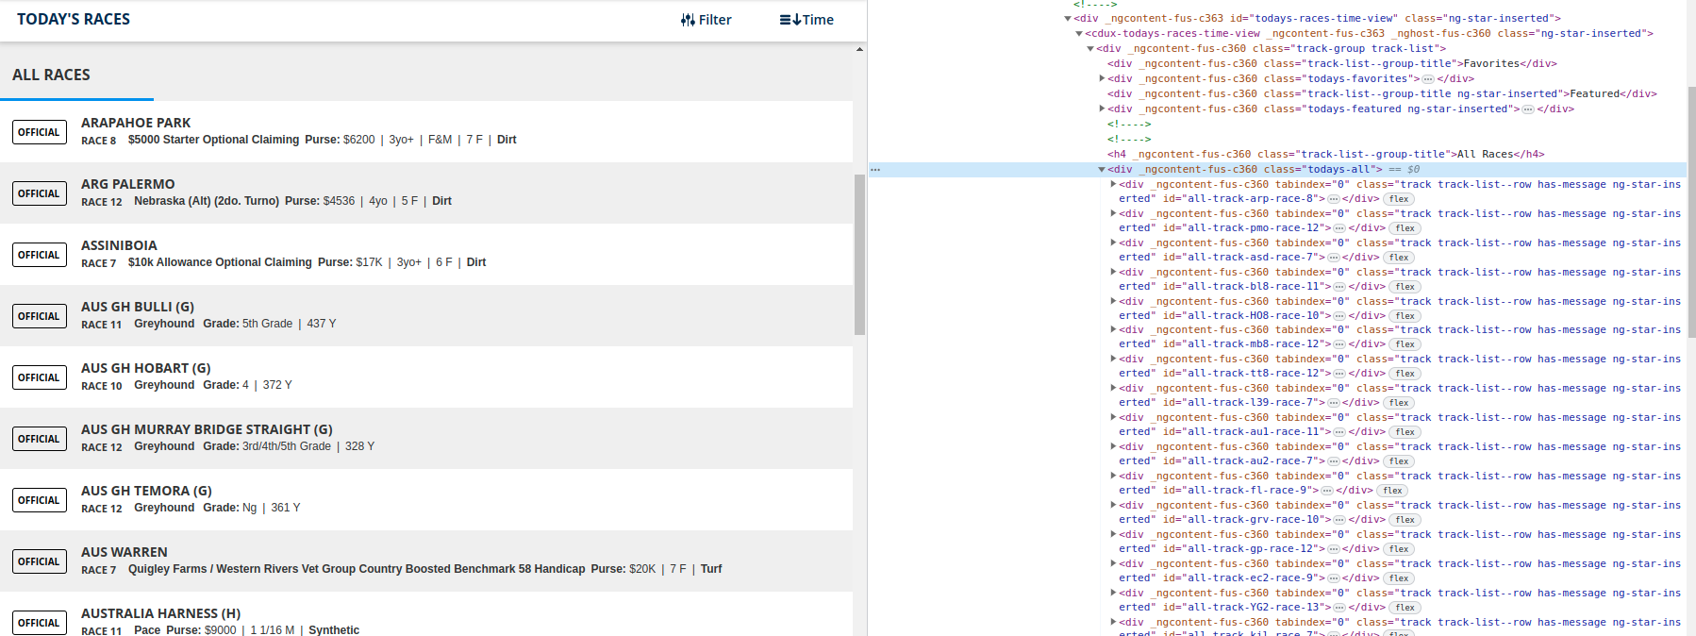
You can see in the above screenshot that there is an HTML element for all of today's races and they are all encapsulated within the highlighted div tag

If you click on any of these races, dynamic javascript code will execute, taking the user to the race page where they can find the odds.

For your project, we want to collect the urls of these race pages which change everyday as new races are listed. This means once a day we need to scrape these urls first, then we can iterate through the urls to get the odds.

We can use selenium to gather these urls, see the code below:

# Set up a Selenium browser instance
browser = webdriver.Firefox() # You can also use Chrome()

# Load the webpage
browser.get('https://www.twinspires.com/bet/todays-races/time')

# Wait for the page to fully load
browser.implicitly_wait(10)

# Initialize URLs list
urls = []

# Initialize the index
index = 1

# Start an infinite loop
while True:
try:
# Try to find the div element at the current index
div = browser.find_element(By.CSS_SELECTOR, f'#todays-races-time-view > cdux-todays-races-time-view > div > div.todays-all > .track.track-list--row.has-message.ng-star-inserted:nth-child({index})')

# Scroll to the div
browser.execute_script("arguments[0].scrollIntoView();", div)

# Allow some time for scrolling
sleep(1)

# Click the div
div.click()

sleep(2)
# Collect the URL
urls.append(browser.current_url)

# Go back to the previous page
browser.back()

# Give the page some time to load
sleep(2)

# Increase the index
index += 1

except NoSuchElementException:
# No more elements to process, break the loop
break

except Exception as e:
print(f"Skipping element due to error: {e}")
# Increase the index
index += 1

# Print all the collected URLs
for url in urls:
print(url)

# Close the browser
browser.quit()

Once we have run this code which takes about 4 mins but could be further optimised, we will have a list of the URLs for all of today’s races like so:

https://www.twinspires.com/bet/program/classic/arapahoe-park/arp/Thoroughbred/8/advanced
https://www.twinspires.com/bet/program/classic/arg-palermo/pmo/Thoroughbred/12/advanced
https://www.twinspires.com/bet/program/classic/assiniboia/asd/Thoroughbred/7/advanced
https://www.twinspires.com/bet/program/classic/aus-gh-bulli/bl8/Greyhound/11/advanced
https://www.twinspires.com/bet/program/classic/aus-gh-hobart/HO8/Greyhound/10/advanced
https://www.twinspires.com/bet/program/classic/aus-gh-murray-bridge-straight/mb8/Greyhound/12/advanced
https://www.twinspires.com/bet/program/classic/aus-gh-temora/tt8/Greyhound/12/advanced
https://www.twinspires.com/bet/program/classic/aus-warren/l39/Thoroughbred/7/advanced
https://www.twinspires.com/bet/program/classic/australia-harness/au1/Harness/11/advanced
https://www.twinspires.com/bet/program/classic/australia-harness-2/au2/Harness/7/advanced
https://www.twinspires.com/bet/program/classic/finger-lakes/fl/Thoroughbred/9/advanced
https://www.twinspires.com/bet/program/classic/grand-river/grv/Harness/10/advanced
https://www.twinspires.com/bet/program/classic/gulfstream-simulcast/gp/Thoroughbred/12/advanced
https://www.twinspires.com/bet/program/classic/ire-gh-enniscorthy/ec2/Greyhound/9/advanced
https://www.twinspires.com/bet/program/classic/ire-gh-youghal/YG2/Greyhound/13/advanced
https://www.twinspires.com/bet/program/classic/ire-killarney/kil/Thoroughbred/7/advanced
https://www.twinspires.com/bet/program/classic/jpn-urawa/ura/Thoroughbred/11/advanced
https://www.twinspires.com/bet/program/classic/laurel-simulcast/lrl/Thoroughbred/9/advanced
https://www.twinspires.com/bet/program/classic/louisiana-downs/lad/Thoroughbred/7/advanced
https://www.twinspires.com/bet/program/classic/monticello-raceway/mr/Harness/7/advanced
https://www.twinspires.com/bet/program/classic/mountaineer/mnr/Thoroughbred/8/advanced
https://www.twinspires.com/bet/program/classic/northfield-park/nfl/Harness/15/advanced
https://www.twinspires.com/bet/program/classic/ocean-downs/od/Harness/12/advanced
https://www.twinspires.com/bet/program/classic/parx-racing/prx/Thoroughbred/10/advanced
https://www.twinspires.com/bet/program/classic/plainridge/prc/Harness/11/advanced
https://www.twinspires.com/bet/program/classic/pocono-downs/pcd/Harness/14/advanced
https://www.twinspires.com/bet/program/classic/prairie-meadows/prm/Thoroughbred/11/advanced
https://www.twinspires.com/bet/program/classic/presque-isle/pid/Thoroughbred/8/advanced
https://www.twinspires.com/bet/program/classic/saf-greyville/gvl/Thoroughbred/8/advanced
https://www.twinspires.com/bet/program/classic/swe-halmstad/xhd/Harness/10/advanced
https://www.twinspires.com/bet/program/classic/swe-rattvik/xra/Harness/9/advanced
https://www.twinspires.com/bet/program/classic/swe-skelleftea/xsk/Harness/8/advanced
https://www.twinspires.com/bet/program/classic/thistledown/tdn/Thoroughbred/8/advanced
https://www.twinspires.com/bet/program/classic/uk-ayr/ayr/Thoroughbred/6/advanced
https://www.twinspires.com/bet/program/classic/uk-gh-kinsley/ki1/Greyhound/12/advanced
https://www.twinspires.com/bet/program/classic/uk-gh-perry-barr/pr1/Greyhound/12/advanced
https://www.twinspires.com/bet/program/classic/uk-gh-sheffield/SF1/Greyhound/12/advanced
https://www.twinspires.com/bet/program/classic/uk-gh-swindon/sw1/Greyhound/12/advanced
https://www.twinspires.com/bet/program/classic/uk-newton-abbot/ntn/Thoroughbred/6/advanced
https://www.twinspires.com/bet/program/classic/uk-windsor/wsr/Thoroughbred/7/advanced
https://www.twinspires.com/bet/program/classic/uk-wolverhampton/wol/Thoroughbred/6/advanced
https://www.twinspires.com/bet/program/classic/woodbine-mohawk/wbs/Harness/11/advanced
https://www.twinspires.com/bet/program/classic/yonkers/yr/Harness/12/advanced

Then, we can iterate through these addresses using another script to gather some data from the race pages.

Again we can use selenium to navigate to these pages and then scrape the data we want from them, here is some example code for that:

from selenium import webdriver
from selenium.webdriver.firefox.service import Service
from webdriver_manager.firefox import GeckoDriverManager
from selenium.webdriver.common.by import By
from selenium.webdriver.support.ui import WebDriverWait
from selenium.webdriver.support import expected_conditions as EC
import time
from selenium.common.exceptions import TimeoutException
import pandas as pd
from bs4 import BeautifulSoup

driver = webdriver.Firefox()

retry_count = 3

for i in range(retry_count):
try:
driver.get('https://www.twinspires.com/bet/program/classic/uk-gh-perry-barr/pr1/Greyhound/5/advanced')

time.sleep(3)

# use explicit wait
wait = WebDriverWait(driver, 10)

entry_container = driver.find_element(By.CLASS_NAME, 'entry-container')

runners = entry_container.find_elements(By.TAG_NAME, 'cdux-program-entry')

runner_data = []

for runner in runners:
horse_name_element = runner.find_element(By.CLASS_NAME, 'entry-runner-name')
horse_name = horse_name_element.get_attribute('innerHTML').split('<!---->')[0].strip()
# Locate the odds element
odds_element = runner.find_element(By.CLASS_NAME, 'odds-main-detail')
odds_html = odds_element.get_attribute('innerHTML').strip()
soup = BeautifulSoup(odds_html, 'html.parser')

# Extract the odds text
odds = soup.get_text().strip()

# Locate the trainer element
trainer_element = runner.find_element(By.CLASS_NAME, 'entry-trainer-name')

# Extract the trainer text
trainer = trainer_element.get_attribute('innerHTML').strip()

# Print the runner details
print("Runner: ", horse_name)
print("Odds: ", odds)
print("Trainer: ", trainer)
print()

driver.quit()

# if no exception is thrown, break the loop
break

except TimeoutException:
print(f"TimeoutException caught, retrying ({i+1}/{retry_count})")
continue

This produces an output like this:
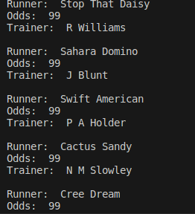

We could get more data points if you needed them, depending on what is available on the page.

This takes less than 10 seconds to scrape for one page, so it fits within the time scales of your use case.

Once we have the data we can format this into a dataframe using pandas and then export it to an excel sheet, that’s the easy part.

There's obviously more work I need to do to build this out for you but this should suffice as a proof of concept.

