14 mins read
Published on arXiv on: 10 Apr 2023
Published by: VinBigdata & Hanoi, Vietnam
- ChatGPT: How does ChatGPT work?
ChatGPT is OpenAI’s latest Large Language Model (LLM) and represents a significant improvement over its predecessor, GPT-3. Like many LLMs, ChatGPT is capable of generating text in a variety of styles and for a variety of purposes, but ChatGPT demonstrates significantly greater accuracy, detail, and coherence. ChatGPT is on trend, representing the next generation of LLMs, with a strong focus on interactive conversations.
OpenAI used a combination of Supervised Learning and Reinforment Learning to fine-tune ChatGPT, but it is Reinforcement Learning that makes ChatGPT unique . The specific technique is called Reinforcement Learning from Human Feedback (RLHF) , which uses a human feedback loop during training to minimize the generation of harmful, dishonest, or knowledge-biased feedback.
- Capability vs Alignment trong LLMs
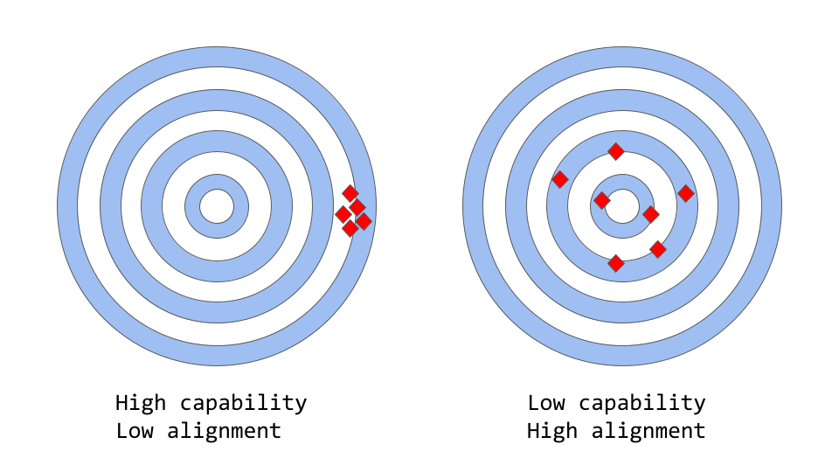
First, we need to understand the two concepts of Capability and Alignment in machine learning. Capability refers to the ability of a model to perform one or more specific tasks. The capability of a particular model is evaluated by how well it optimizes its objective function. For example, a model designed to predict stock market prices must have an objective function that measures the accuracy of the model's predictions. If the model is able to accurately predict stock price movements over time, it is considered to have a high capability for this task.
Alignment , on the other hand, is concerned with what we actually want the model to do versus what it is being trained to do . We ask ourselves, “Do the objective functions that the model is trained on match our intentions?” and how well do those objective functions and the behavior the model produces compare to human expectations? A simple concrete example is building a bird classification model to classify a bird as a sparrow or a nightingale. Typically, we use log loss as the objective function (to measure how well the model’s predicted probability distribution differentiates from the distribution of the true label) even though the ultimate goal is high classification accuracy. Therefore, the model will tend to have low log loss, meaning the model’s capability is high, but the accuracy on the test set is poor. In practice, log loss does not correlate well with accuracy in classification tasks. This is an example of misalignment where the objective function is optimized during training but poorly aligned with the final goal.
LLMs like GPT-3 are misaligned.
LLMs such as GPT3, LLaMA, BLOOM, PaLM, … are trained on a huge amount of text data from the internet and are capable of generating text similar to humans, but LLMs do not always produce output as expected by humans or with accuracy. In fact, their objective function is a probability distribution over word sequences or token sequences that allows to accurately predict the next word in the sequence.
However, in real-world applications, these models are intended to perform some form of valuable recognition, and there is a clear distinction between how they are trained and how we want to use the model. While mathematically, using a statistical distribution of word sequences can be a very effective choice for a language model, we humans generate language by selecting the most appropriate text sequences for a given situation using a knowledge base and rules or conventions to guide this process. This can be a problem when language models are used in applications that require a high level of trust and confidence, such as dialog systems or intelligent personal assistants.
While these complex models trained on massive amounts of data have become incredibly powerful in recent years, when used in real-world product systems that make people’s lives easier, they often fall short. Some of the alignment issues in LLMs are evident in the form of:
- Lack of usefulness: that is, the model does not follow the user's specific instructions.
- Unrealistic: the model creates facts that do not exist or are false.
- Lack of interpretability: it is difficult for humans to understand how the model makes a particular decision or prediction.
- Bias or toxic in output: a model trained with biased/toxic data can reproduce that in the output.
But where does this alignment problem come from? Is it because the way language models are trained is inherently prone to misalignment ?
- Why language model training methods encounter misalignment problems
Next token predictionand masked language modelingis one of the core techniques used to train language models, such as transformers.
In the first approach, the model takes as input a sequence of words (or tokens) and predicts the next word in the sequence. For example, the model’s input sequence is: Con mèo đang nằm trên _. The model has to predict the next word as “bed”, “chair”, “table”, “yard” for example. Because the probability of the next word appearing for those words in the previous context is high. In fact, the language model can estimate the likelihood of each word (in its vocabulary) appearing next based on the previous sequence of words.
The following approach masked language modelingis a variation of next token prediction, where some words in the input string are replaced by a special token, for example [MASK]. The model has to predict the exact word that will be added at the masked position. For example, if the input string to the model is: Con [MASK] đang nằm trên ghế .then the model has to predict the masked word as “cat”, “dog”, or “rabbit”, for example.
One of the advantages of these objective functions is that they allow the model to learn the statistical structure of the language, such as frequent word sequences or patterns in word usage. This often results in more fluent and natural-sounding text, and is a pre-training step for any language model.
However, these objective functions can also lead to problems, essentially because the model is unable to distinguish between important and unimportant errors. As a simple example, suppose the model is given the following sentence: Đề chế La Mã [MASK] với triều đại Augustus.. The model can predict either “start” or “end” because both are highly likely (in fact, both sentences are historically correct), even though the second choice has a very different meaning.
More generally, these training strategies can lead to misalignment problems in language models for many complex tasks, because a model trained solely on predicting the next word (or mask token) in a text sequence may not need to learn higher-level representations of its meaning to perform well enough for that objective function. As a result, the model has great difficulty generalizing to tasks or contexts that require a deeper understanding of language.
Researchers and developers are working on different approaches to address the alignment issue in LLMs. ChatGPT is based on GPT-3 which is an LLM but has been trained using human feedback to make the learning process of the model with the specific goal of minimizing misalignment issues . The specific technique is called Reinforcement learning from Human Feedback . ChatGPT is the first instance of using this technique for a production model.
But how the people who created ChatGPT used human feedback to solve the alignment problem is also a question that needs to be answered.
- Reinforcement Learning from Human Feedback (RLHF)
This method consists of 3 steps as follows:
- Supervised fine-tuning: Pre-trained LLMs are fine-tuned on a small amount of data called demonstration data created by labelers to learn the supervised policy ( SFT model ) and generate output from the prepared prompts. To understand more about demonstration data, you can see my explanation in the detailed steps of forming chatGPT below. In short, this process creates a baseline model.
- Mimic human preference: This step will have a new dataset created by labelers by voting on the texts generated by the SFT model, this dataset is called comparison data . The Reward model (RM) will be trained on this dataset.
- Proximal Policy Optimization (PPO): The reward model is used to fine-tune and improve the SFT model. The output of this step is called the Policy model , which is essentially the fine-tuned SFT model.
Step 1 is only done once, while steps 2 and 3 can be repeated continuously because as more comparison data is collected based on the best policy up to that point, it will be trained to create a new, better reward model and policy model.
- Bước 1: Supervised Fine-Tuning (SFT) model
The first step involves collecting/building a dataset called demonstration data to train the supervised policy model. Demonstration data is a dataset that is used to illustrate or introduce how the model works, helping the model learn language patterns and structures, understand language more accurately, and learn the types of tasks that the model will gradually form in this step. For example, it helps the model recognize how to handle classification, extraction, QnA, generation, etc. In this process, people will prepare this dataset to be as diverse as possible. Of course, diversifying and building this dataset well will also help the model learn better, understand and give more accurate responses.
- Data Collection: A list of prompts is collected, selected, and a group of labelers are asked to write down the expected output response for that prompt. For chatGPT, two different sources of prompts are used: some are prepared directly by their labelers and developers, and some are taken from OpenAI's public requests and collected from users. Since this process is slow and expensive, they end up with a relatively small amount of good quality data (~12-15k data points) that is used to fine-tune the LLM.
- Model selection: The chatGPT developer uses pre-trained LLM to fine-tune is GPT-3or its variants such as GPT-3.5, text-davinci-003.
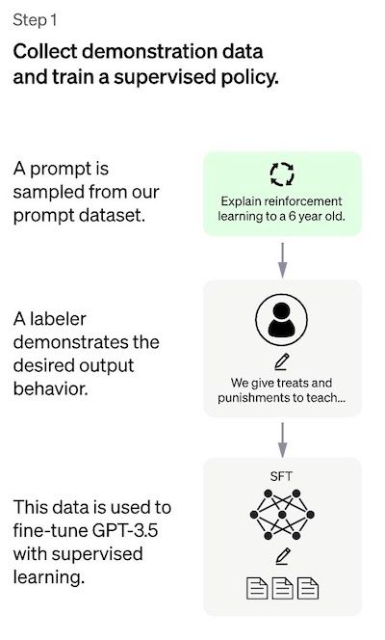
Because of the limited amount of data for this step, the SFT model after this process is capable of generating text but still has the problem of misalignment . The problem in the supervised learning step is that the cost of expanding the dataset is high. To solve this problem, instead of requiring labelers to create a large supervised dataset, which is time-consuming and expensive, the strategy now is to let labelers rank different outputs (candidates) of the SFT model to create a Reward model.
- Step 2: Reward Model (RM)
The goal is to learn an objective function (reward model) directly from the data. The purpose of this function is to output a score that represents how well the SFT model outputs compare to what humans would want. In practice, this will reflect the specific preferences of a group of labelers and the general ranking guidelines/rules they have followed. Ultimately, this process will extract from the data an automated system that mimics human-like behavior.
Here's how it works:
- A list of prompts is selected and the SFT model generates multiple outputs (candidates), usually 4 -> 9 for each prompt.
- The labelers rank the outputs from high to low score. The higher the score, the closer they are to human expectations. The result is a new dataset, where the ranking order is the label. The size of this dataset can be about 10 times larger than the data in step 1 used to train the SFT model.
- This new dataset is used to train the reward model (RM). This model takes as input the outputs of the SFT model and ranks them in the order of human expectation.
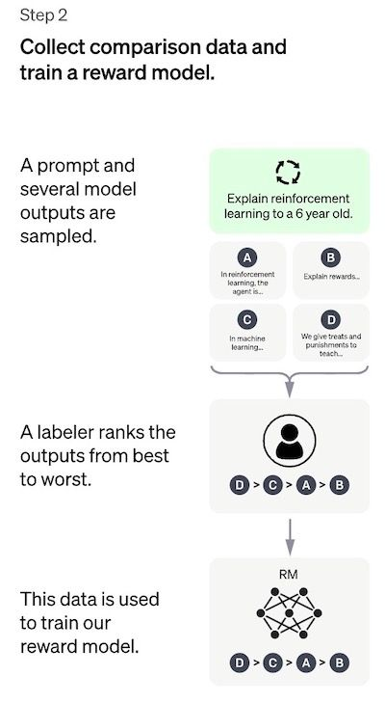
For labelers, ranking these outputs is much easier than creating supervised data from scratch as in step 1. This process is easier and more efficient to scale up. In fact, this dataset is created from a selection of around 30-40k prompts, and a different number of SFT model outputs between prompts.
- Step 3: Fine-tuning the SFT model via Proximal Policy Optimization (PPO)
Reinforcement Learning in this step is used to fine-tune the SFT policy by optimizing it by the reward model. The algorithm used for this process is Proximal Policy Optimization (PPO) and the fine-tuned model is called a PPO model.
One question arises what is PPO?
I will note the main points of this method.
- PPO is an algorithm used to train agents in reinforcement learning. It is called an “on-policy” algorithm because it learns and updates the current policy directly, instead of learning from past experiences like in “off-policy” algorithms such as DQN (Deep Q-Network). This means that PPO continuously adjusts the current policy based on the actions the agent is taking and the rewards it receives.
- PPO uses trust region optimization to train the policy, which means it limits the change in the new policy to a certain range compared to the previous policy to ensure stability. This is in contrast to other policy gradient methods that can update the policy with large changes that can cause instability during learning.
- PPO uses a value function to estimate the return value of a given state or action. The value function is used to calculate an advantage function that represents the difference between the expected return and the current return. The advantage function is then used to update the policy by comparing the action taken by the current policy and the action that would have been taken by the previous policy. This allows PPO to make more informed updates to the policy based on the estimated value of the actions taken.
Phương pháp trust region optimization -phương pháp tối ưu hóa khu vực tin cậy là một phương pháp tối ưu hóa trong đó
ta giải quyết vấn đề tối ưu hóa bằng cách tìm kiếm một điểm tối ưu trong một vùng "trust region - vùng tin cậy" của
không gian tìm kiếm. Điều này được thực hiện bằng cách giới hạn các bước cập nhật giá trị biến của bài toán tối ưu
trong một vùng khu vực nhỏ xung quanh điểm hiện tại, gọi là "trust region". Vùng tin cậy này được xác định bằng cách
sử dụng một hàm mô hình bậc hai (quadratic model) để dự đoán sự thay đổi của hàm mục tiêu trong vùng đó.
In this step, the PPO model is initialized from the SFT model itself, i.e., it is initially an SFT model. The value function is initialized from the reward model. The environment is a bandit environment that represents a random prompt and the corresponding response for that prompt. From the prompt and response, a reward (determined by the reward model) can be derived.
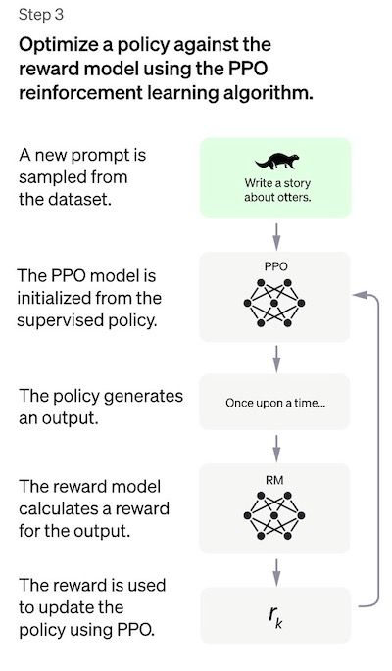
- Performance Evaluation
Because the model is trained on human labelers’ inputs, the core component of the evaluation is also based on human input, that is, humans judge the quality of the model’s outputs. To avoid overfitting with the labelers’ mindset during training, the testing process uses prompts from the OpenAI community that were not used during training.
Models are evaluated based on three high-level criteria:
- Usefulness: evaluates the model's ability to follow human instructions, as well as make inferences.
- Truthfulness: measures how well the model generates falsehoods on closed-domain tasks. The model can be evaluated on the TruthfulQA dataset.
- Harmlessness: evaluates whether the model output is appropriate, produces output that harms protected object classes, or contains offensive content. The model can be benchmarked on datasets such as RealToxicityPrompts, CrowS-Pairs.
The model is also evaluated for zero-shot capability on traditional NLP tasks such as QA, MRC, Summarization.
- References
[1] Training language models to follow instructions with human feedback, https://arxiv.org/pdf/1706.03741.pdf.
[2] Training a Helpful and Harmless Assistant with Reinforcement Learning from Human Feedback, https://arxiv.org/pdf/2204.05862.pdf.
[3] Learning to summarize from human feedback, https://arxiv.org/pdf/2009.01325.pdf.
[4] Proximal Policy Optimization Algorithms, https://arxiv.org/pdf/1707.06347.pdf.
[5] Deep reinforcement learning from human preferences, https://arxiv.org/pdf/1706.03741.pdf.
[6] A General Language Assistant as a Laboratory for Alignment, https://arxiv.org/pdf/2112.00861.pdf.

