Homework #1

- Create a Markdown cell with the headline QESTION1. The Cell will present another two lines the first one will be your highlighted first name and the second will be your last name in red color.
Example:


- Create a Markdown cell with a smaller headline QUESTION2. The cell will present another two lines the first one will be your phone number in bold the second one will present your home address in bold and italic mode.
Example:

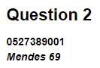

- Create a Markdown cell with a smaller headline QUESTION3. The cell will print the following pyramid by using the indenting tab.
Example:

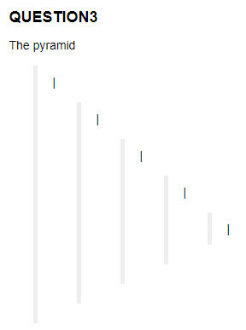

- Create a Markdown cell with the headline QUESTION4. The cell will present the Pythagorean Theorem.
Example:
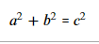

- Create a Code cell. Create a comment in the beginning of the cell QUESTION5. Create a variable named x that will hold the value 3, create a variable named y that will hold the value 3.141. Create a variable named AREA that will hold the result of y * x ^ 2. Print the values of x,y, and AREA. Print the types of x, y, and AREA.

- Create a Code cell. Create a comment at the beginning of the cell QUESTION6. Print the value of AREA // 4 <= 7. Print the value of AREA / 4 < 7. Print the value of: not AREA / 4 < 7 and AREA // 4 <= 7. Use the variable AREA from the previous cell.

- Create a Code cell. Create a comment at the beginning of the cell QUESTION7. Create a variable named str_name that will hold your full name, first name, and last name separated by space between them. Print all values in the even indexes. Print all values in the odd indexes.

Challenges:
- Create a Code cell. Create a comment at the beginning of the cell QUESTION8. Create a variable named “a” that will hold the value “#####”. Create a variable named “b” that will hold the variable “*****”. Create a variable named “c” that will hold your name. Concatenate between the variables in the following order a, c, b accordingly. Use the right arithmetical operator between the variables. Find the index of the space character, you can use .find() method to find it. Use the index of space that you found and print in f string the length of the first name and the length of the last name.

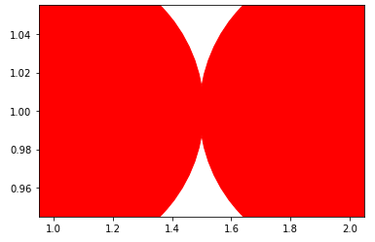
- Create a Code cell. Create a comment in the beginning of the cell QUESTION9. Use the matplotlib example that we saw in the lecture to solve the next question. Print two red circles that will touch each other as in the following example. Example:

