AFEKA COLLEGE OF ENGINEERING
Department of Software Engineering

ChargeSmart
Smart EV Charging Management System
for Residential Buildings

FINAL PROJECT REPORT
Tomer Feldon · Avia Luria · Yuval Yehoshua
2024 – 2025

Contents

1. Background and Market Survey

1.1 Problem Statement
The rapid adoption of electric vehicles (EVs) has introduced a significant infrastructural challenge in residential buildings. When multiple tenants attempt to charge their vehicles simultaneously, the aggregate power demand can exceed the building's electrical capacity, leading to circuit breaker trips, potential equipment damage, and service outages. This problem is particularly acute in multi-unit residential buildings where dozens of vehicles may require overnight charging.

According to the International Energy Agency (IEA), the global EV stock surpassed 40 million vehicles in 2023, with projections exceeding 240 million by 2030. As EV adoption accelerates, the strain on residential electrical infrastructure will intensify unless intelligent load-management solutions are deployed at scale.

The core challenge lies in the conflicting objectives of building management: (1) guaranteeing that every resident's vehicle is fully charged by their required departure time, and (2) ensuring that the combined charging load never exceeds the building's maximum permissible power threshold. Solving this problem requires a software-based scheduling engine capable of dynamically allocating charging power across multiple vehicles in real time.

1.2 Market Survey
Several commercial solutions currently address EV load management in residential and commercial settings. The following survey examines the most prominent offerings and identifies the gap that ChargeSmart addresses.

Solution | Approach | Limitations
Tesla Powerwall + Vehicle Integration | Hardware-based energy buffer with smart charging integration | Expensive hardware; proprietary ecosystem
ChargePoint Home Flex | Cloud-managed EVSE with load balancing | Requires dedicated hardware; subscription fees
OCPP-based Systems (EV Connect, Greenlots) | Open protocol for centralized charge management | Complex deployment; requires on-site server
Simple Timer-based Scheduling | Fixed time slots assigned per parking space | Not adaptive; ignores departure times and SoC
Equal Power Sharing | Divides available power equally among EVs | Inefficient; does not prioritize urgent departures
Table 1 - Comparison of existing EV load management solutions

The commercial solutions identified above share a critical limitation: they either require proprietary hardware, impose recurring subscription costs, or lack the flexibility to adapt to user-specific departure constraints. ChargeSmart addresses this gap by providing a purely software-based scheduling layer that integrates with standard charging infrastructure at zero hardware cost.

2. Goals and Objectives

2.1 Primary Objectives
ChargeSmart aims to achieve the following primary objectives:

- Prevent electrical overload: Ensure that the total combined charging power of all active EVs never exceeds the building's maximum permissible electrical capacity at any point in time. This is enforced as a hard constraint: before any power is granted, the scheduler checks the remaining budget, and a vehicle can only be assigned what is left. Once the budget is exhausted, further vehicles receive zero power, so the limit can never be crossed.
- Guarantee charging deadlines: Ensure that every registered vehicle reaches its required state of charge (SoC) - the battery percentage the resident wants by departure, which the resident defines when connecting - by its specified departure time, subject to the power constraints of the building.
- Optimize power allocation: Distribute available charging capacity fairly and efficiently among all connected vehicles. Urgency is not set by any person; it is computed automatically by the scheduler as the energy a vehicle still needs divided by the time remaining until its departure.
- Provide real-time visibility: Offer building managers and residents a live dashboard that visualizes current power consumption, individual charging status, and projected completion times.

2.2 Non-Functional Objectives
In addition to the core functional goals, ChargeSmart is designed to satisfy the following non-functional requirements:

- Simplicity of deployment: The system shall require no proprietary hardware and shall be deployable as a standard web application backed by a managed database - a database hosted and maintained by an external cloud provider (Supabase), so the team does not operate its own database server.
- Scalability: The scheduling algorithm shall support up to 50 concurrently connected vehicles without degradation of response time.
- Responsiveness: Schedule recomputation following any change in vehicle parameters shall complete within 60 seconds.
- Usability: The user interface shall be operable without prior technical training by both residents and building managers.

2.3 Project Scope and Limitations
This project focuses exclusively on the software layer. Vehicle parameters can be entered manually through the user interface; in addition, the system is evaluated by replaying a real historical charging dataset (trace-driven simulation, meaning the system re-runs real recorded charging data through the scheduler) stored in its database, rather than communicating with live charging hardware. Physical communication with charging stations (e.g., via the OCPP protocol) and live smart-meter feeds are out of scope for the current implementation and identified as primary directions for future development (see Section 6).

3. System Design and Architecture
This chapter describes the methods, tools, and design models used to plan and build ChargeSmart. It begins with the human-computer interface principles, proceeds through the structural and behavioral models of the system (entity model, use cases, sequence and flow diagrams), and concludes with the technology stack, architectural patterns, development methodology, and software testing.

3.1 Human-Computer Interface
Particular attention was devoted to the user experience during interface development. Three principles guided the design:

- Functionality: Emphasis on ease of operation and clear access to the actions available in each role. Prominent, clearly labeled controls allow residents and managers to perform their tasks without effort.
- Aesthetics: A visually coherent interface built from consistent components, using charts and color cues that make the building's power state immediately legible.
- Accessibility: A simple structure that ensures fast, convenient access to the system, so that residents need no training to register a vehicle and managers can read the dashboard at a glance.

Because ChargeSmart serves three distinct roles - resident, building manager, and maintenance technician - the interface is organized into role-specific views, each exposing only the actions relevant to that role. This separation reduces clutter and reinforces the access boundaries described in the use cases.

3.2 Class Diagram - ERD
The Entity-Relationship Diagram (ERD) presents the entities stored in the system's database and the relationships among them. It shows every type of object that ultimately resides in the data store and how those objects reference one another. The ChargeSmart data model comprises seven entities, organized around the central Building entity.
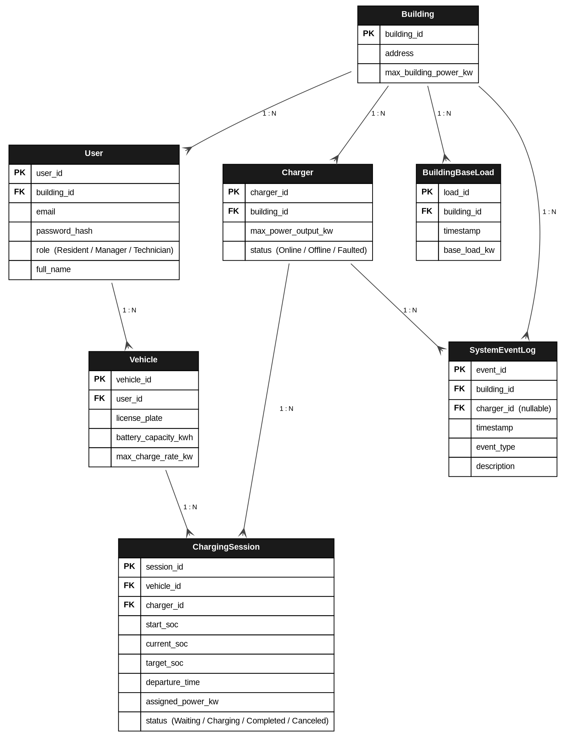
Figure 3.1 - Entity-Relationship Diagram of the ChargeSmart database

The entities are described below:

- Building: The physical residential complex; defines the hard power ceiling. Attributes: building_id, address, max_building_power_kw.
- User: Manages identities and permissions (authentication and authorization). Attributes: user_id, building_id, email, password_hash, role (Resident / Manager / Technician), full_name.
- Charger: Represents the physical charging point in the parking area. Attributes: charger_id, building_id, max_power_output_kw, status (Online / Offline / Faulted).
- Vehicle: Stores the static, physical properties of a vehicle. Attributes: vehicle_id, user_id, license_plate, battery_capacity_kwh, max_charge_rate_kw.
- ChargingSession: The most dynamic entity; created whenever a vehicle connects and holding all data the scheduler needs. Attributes: session_id, vehicle_id, charger_id, start_soc, current_soc, target_soc, departure_time, assigned_power_kw, status (Waiting / Charging / Completed / Canceled).
- BuildingBaseLoad: Stores the power consumed by other building loads (elevators, lighting) over time, enabling the scheduler to compute the free charging budget. Attributes: load_id, building_id, timestamp, base_load_kw.
- SystemEventLog: Records exceptions, system errors, and management actions; drives the technician's diagnostics dashboard. Attributes: event_id, building_id, charger_id (nullable), timestamp, event_type, description.

A deliberate design decision is visible in the model: the separation of Vehicle (fixed physical properties such as battery capacity and maximum charge rate) from ChargingSession (the values that change on each charging event, such as current SoC, departure time, and assigned power). This normalization avoids duplicating static vehicle data on every charge and reflects sound database design.

3.3 Use Case Specifications
Use cases provide a verbal, sequential description of system functionality. Each use case is a scenario in which the system delivers value, initiated by an actor external to the system. A primary actor interacts directly with the system; a secondary actor supports a primary actor. The primary actors of ChargeSmart are the resident, the building manager, the maintenance technician, and the internal scheduler; the secondary actors are the database and the charging hardware. Each use case is described by its actor, trigger, main flow, postcondition, and exception handling.
3.3.1 UC-1: Resident Connects a Vehicle for Charging
Actor: A resident who owns an electric vehicle. Trigger: The resident arrives at the building and plugs the vehicle into a charging point. Precondition: The system has a configured building power limit and at least one available charging point.
Main flow:
- The resident opens the interface and registers the vehicle by entering its current state of charge, required state of charge, departure time, and battery capacity.
- The scheduler recomputes the global allocation, incorporating the new vehicle.
- The system displays the assigned charging rate and the projected completion time.
Postcondition: The vehicle is admitted to the active charging set and receives a power allocation consistent with the building constraint and its deadline. Exception: If admitting the vehicle makes the schedule infeasible, the system admits it at the highest priority and displays a feasibility warning rather than silently failing.
3.3.2 UC-2: Resident Updates Departure Time
Actor: A registered resident. Trigger: The resident must leave earlier or later than originally specified and edits the departure time.
Main flow:
- The resident submits the revised departure time.
- The scheduler re-evaluates the urgency of every active vehicle and recomputes allocations.
- Vehicles whose relative urgency increased receive a larger share of available power; others may be throttled.
Postcondition: Charging plans for all vehicles are updated within the responsiveness bound, preserving the building power constraint. Exception: An earlier departure that cannot be satisfied triggers a feasibility warning while still granting the vehicle maximum priority.
3.3.3 UC-3: Building Manager Configures the Power Budget
Actor: The building manager or HOA administrator. Trigger: The manager sets or revises the maximum aggregate charging power available to the building.
Main flow:
- The manager enters the new power limit in the management panel.
- The scheduler immediately re-solves the allocation under the revised constraint.
- The dashboard reflects the new headroom and any vehicles moved into a waiting state.
Postcondition: The system operates under the updated limit and never exceeds it. Exception: Reducing the limit below current demand causes the lowest-priority vehicles to be throttled or queued, with the change surfaced on the dashboard.
3.3.4 UC-4: Scheduler Allocates Power (System Actor)
Actor: The internal optimization engine. Trigger: Any change in system state - a vehicle connects or disconnects, a parameter is updated, the building base load changes, or a time step elapses.
Main flow:
- The engine recomputes the available charging power for the current step.
- It ranks all active vehicles by urgency and allocates power greedily within the constraint.
- It advances the state of charge of each vehicle and removes completed vehicles.
Postcondition: A feasible allocation that respects the power limit and maximizes deadline satisfaction. Exception: When total demand exceeds capacity, the engine guarantees the constraint and degrades gracefully by prioritizing the most urgent vehicles.
3.3.5 UC-5: Maintenance Technician Inspects Diagnostics
Actor: A maintenance technician. Trigger: The technician opens the diagnostics panel to inspect charger status and the event log.
Main flow:
- The technician reviews the status of each charging point and the chronological event log.
- Faults, disconnections, and re-optimization events are identified from the log.
Postcondition: Faults are localized and can be addressed; the active charging schedule is unaffected by the inspection. Exception: A charger reporting a fault is excluded from allocation, and its vehicle is reassigned or queued by the scheduler.

3.4 Sequence Diagram
Sequence diagrams present the order of operations performed in the system in chronological order, showing the interactions between boundary objects, control objects, and entity objects. The diagram below traces the principal scenario - a resident connecting a vehicle and the system computing a charging plan - from the initial user action through to the response rendered in the interface.
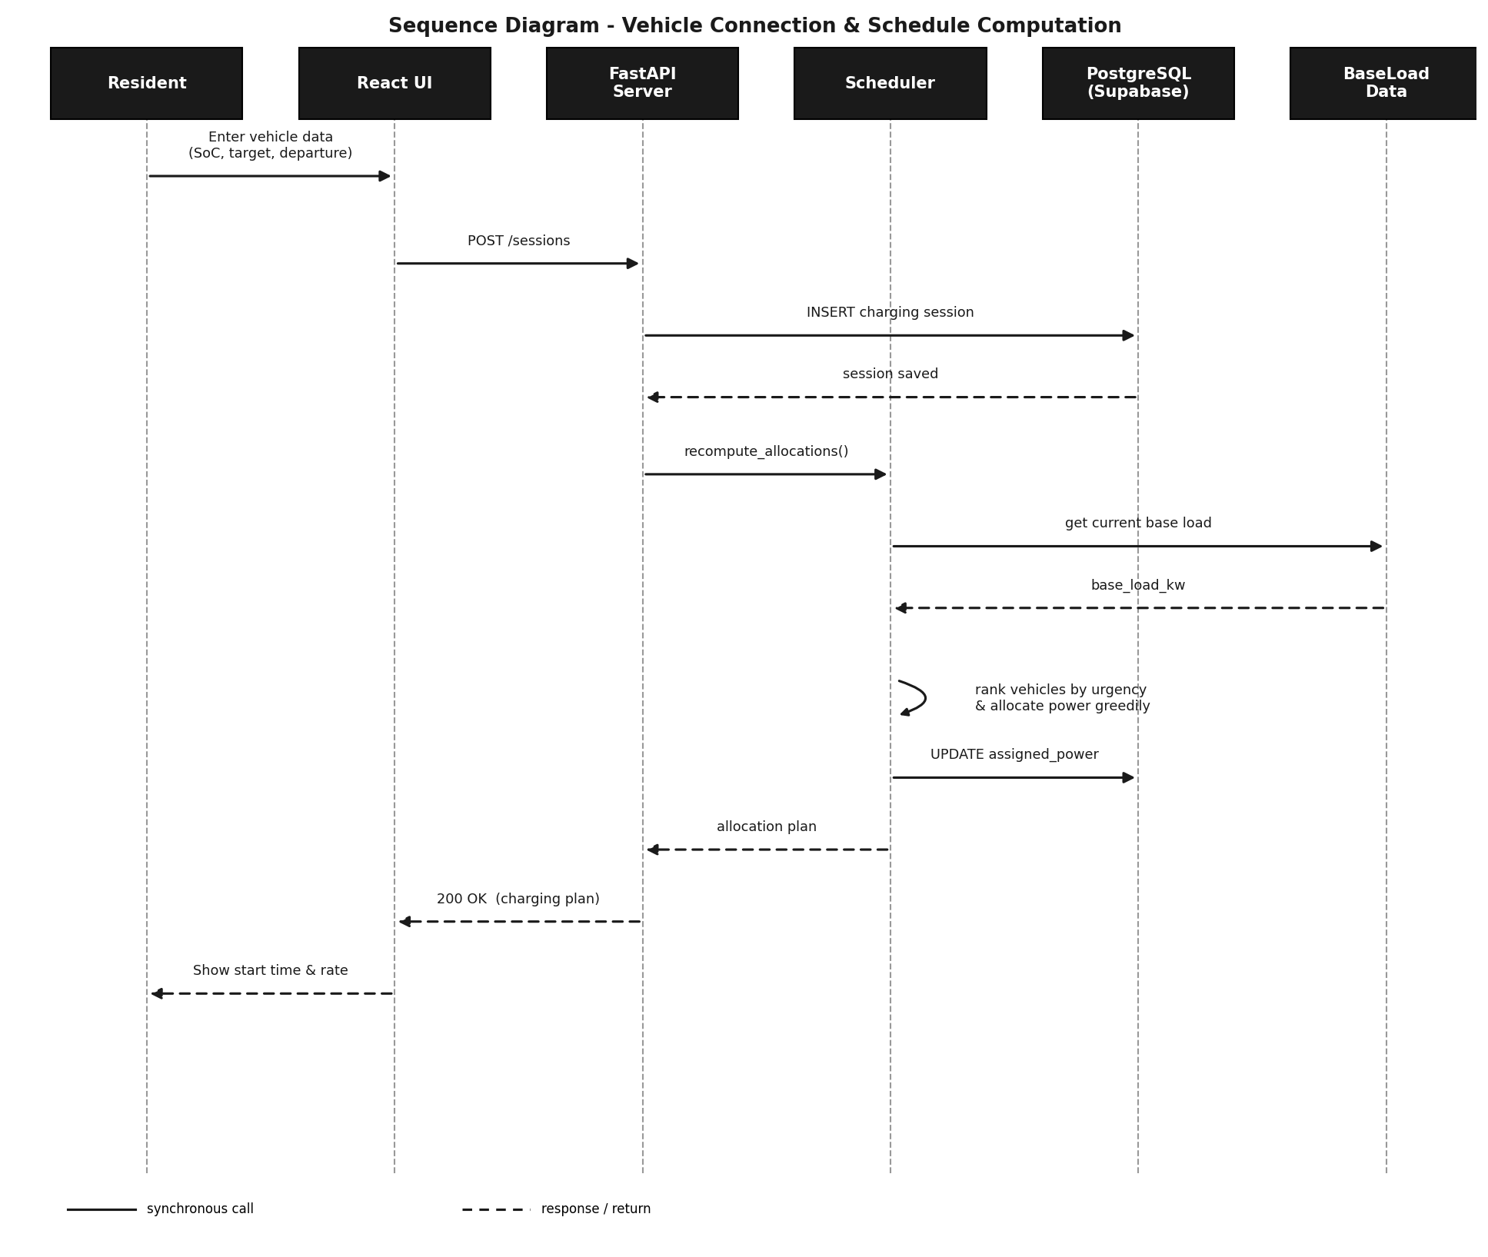
Figure 3.2 - Sequence diagram for vehicle connection and schedule computation

The flow begins when the resident enters the vehicle data in the React interface. The interface issues a request to the FastAPI server, which persists a new charging session in the PostgreSQL database. The server then invokes the scheduler, which reads the current building base load, ranks the active vehicles by urgency, and allocates power greedily within the available budget. The updated allocations are written back to the database, returned to the server, and finally rendered in the interface, where the resident sees the assigned charging rate and the projected completion time. Solid arrows denote synchronous requests; dashed arrows denote responses.

3.5 Main System Flow
To understand the logic executed on every scheduling cycle, the main system flowchart is presented below. The scheduler runs on a fixed cycle: every five minutes it checks the database for newly connected vehicles, recomputes the available charging budget from the building base load, ranks the active vehicles, and allocates power within the limit before pushing the updated values to the live dashboard.
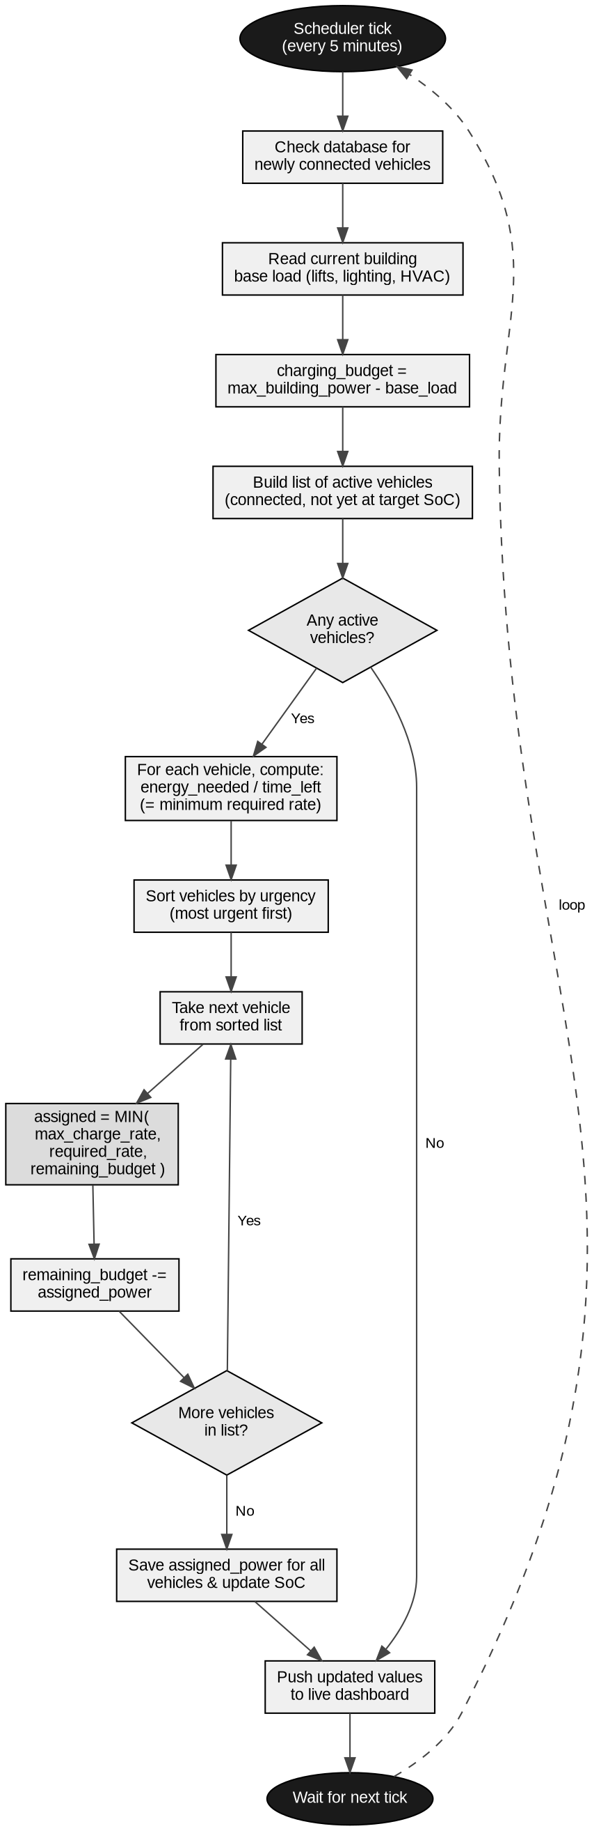
Figure 3.3 - Main flowchart of the ChargeSmart scheduling cycle

The cycle proceeds as follows. On each five-minute tick, the system first checks the database for newly connected vehicles, then reads the current building base load (elevators, lighting, HVAC). It computes the charging budget as the building limit minus that base load, and builds the list of active vehicles - those connected and not yet at their target SoC. If no vehicles are active, it proceeds directly to updating the dashboard. Otherwise, it computes each vehicle's urgency, sorts the vehicles from most to least urgent, and iterates over the sorted list, assigning each vehicle the minimum of its maximum charge rate, its required rate, and the remaining budget, subtracting each allocation from the budget as it proceeds. When the list is exhausted, it saves the allocations, updates each vehicle's SoC, and pushes the new values to the live dashboard before waiting for the next tick.

3.6 Technology Stack
The technologies selected for ChargeSmart are summarized below, with the rationale for each choice.

Component | Technology | Justification
Frontend | React + TypeScript | Component-based UI suited to multiple role views
Backend / API | Python 3.10+ with FastAPI | High-performance API hosting the scheduling core
Scheduling Algorithm | Custom Greedy Scheduler (Python) | Efficient, interpretable, well-suited to the constraints
Data Visualization | Recharts (React) | Interactive charts with real-time update support
Database | PostgreSQL via Supabase | Persistent relational store for real charging sessions
AI Assistant | Anthropic Claude API | Natural-language interpretation of live system state
Table 2 - ChargeSmart technology stack

3.7 Architectural Patterns
ChargeSmart is composed of several cooperating subsystems that exchange information, and the design adopts established architectural patterns to define the relevant parts of each subsystem, the connections between them, and the cohesion within each. Three patterns shape the system.
3.7.1 Client-Server
The client-server pattern represents a central server that operates autonomously and is ready to accept requests from clients. In ChargeSmart, the React frontend is the client and the FastAPI service is the server. Clients - residents and managers using a browser on a phone, tablet, or computer - send requests; the server processes them, runs the scheduling logic, and returns results. The server is independent of any single client and remains available to all of them.
3.7.2 Three-Tier Layered Architecture
The system is organized into three decoupled tiers: a presentation tier (React + TypeScript), a logic tier (FastAPI, hosting the scheduling core), and a data tier (PostgreSQL via Supabase). This layering isolates responsibilities: the presentation tier renders the role views, the logic tier computes allocations, and the data tier persists sessions, vehicles, and base-load history. The separation makes each tier independently replaceable and testable.
3.7.3 Repository
The repository pattern centralizes data access behind a single layer through which all subsystems read and write shared data. In ChargeSmart, the database access layer (db.py) is the repository: the scheduler, the replay engine, and the analysis module all obtain their data through it rather than issuing queries directly. This indirection is what allows the historical replay to be swapped for live data feeds in the future (Section 6.5) without altering the algorithm.

3.8 Development Methodology
ChargeSmart was developed using the Agile methodology, organized into iterative cycles called sprints. Each sprint produces a working increment of the product, from an initial minimal version through to an interface-accessible system validated by acceptance tests. In the first sprint a minimum viable product (MVP) was developed, runnable by the developers; subsequent sprints made the system accessible to users through a complete interface; and the final sprint executed acceptance tests confirming that all requirements were satisfied.

Sprint 1 - Research, Core Algorithm, and Data Model
The foundational sprint. The scheduling core, the entity model (ERD), and the trace-driven replay over the historical dataset were developed, together with the basic data persistence layer. A clear ERD, unit tests for the scheduler, and partial integration tests were prepared.

Task | Duration (Days)
Research & Dataset Selection | 8
ERD & Data Model | 2
Scheduling Core (MVP) | 11
Unit Tests | 2
Integration Tests | 3
Table 3 - Sprint 1 task breakdown

Sprint 2 - API, Frontend, and Roles
In this sprint the system became accessible to users through the React interface, with authentication for external users and the three role-specific views (resident, manager, technician). The FastAPI endpoints were implemented and the dashboard was connected to live data. More comprehensive end-to-end and system tests were prepared.

Task | Duration (Days)
FastAPI Endpoints | 5
React Role Views | 6
Dashboard (Recharts) | 4
System & E2E Tests | 4
Table 4 - Sprint 2 task breakdown

Sprint 3 - AI Assistant, Analysis, and Acceptance
The final sprint integrated the conversational AI assistant, implemented the statistical analysis module, and ran the full acceptance test suite. These tests confirmed that all requirements were met and the product was ready.

Task | Duration (Days)
AI Assistant Integration | 4
Statistical Analysis | 3
Acceptance Tests | 5
Final Refinements | 2
Table 5 - Sprint 3 task breakdown

3.9 Software Testing
A layered testing strategy was applied throughout development, from isolated unit tests of the scheduling core to end-to-end tests of the complete system. The functional tests performed on the system are summarized below.

General Tests
Functional Test | Description | Result
Login | Valid credentials reach the correct role view | Pass
Navigation | Menu selection opens the corresponding screen | Pass
Role access | Each role sees only its permitted actions | Pass
Table 6 - General functional tests

Scheduler Tests
Functional Test | Description | Result
Power limit | Aggregate load never exceeds the building limit | Pass
Urgency ranking | Most urgent vehicle is served first | Pass
Deadline satisfaction | Vehicles complete by departure when feasible | Pass
Budget recompute | Budget adjusts to base-load changes | Pass
Table 7 - Scheduling-engine functional tests

Scenario Tests
Functional Test | Description | Result
New vehicle mid-run | Vehicle added within 5 minutes is scheduled | Pass
Departure update | Revised departure re-ranks allocations | Pass
Oversubscription | Limit preserved; most deadlines met | Pass
Table 8 - Scenario-level functional tests

4. Architecture

4.1 System Overview
During use, the user interacts with the system end to end, passing information between all of its components. The interaction proceeds through four stages:

- Boundary: The user opens the browser, reaches the web application, and navigates to the screen for the desired action.
- Data transmission: The frontend uses the HTTP protocol to send the data to the backend.
- Data processing: Authentication, schedule computation, and base-load accounting are performed here, after which results are persisted.
- Data storage: The PostgreSQL database stores sessions, vehicles, and base-load history; the scheduler reads this data on every cycle.

This end-to-end path reflects the three-tier, client-server design described in Section 3.7: a React client, a FastAPI logic tier hosting the scheduling core, and a managed PostgreSQL data tier.

4.2 API Specification
The system's API (Application Programming Interface) is the principal interface of the backend; through it, all system operations are performed. The API was designed to expose vehicle registration, schedule computation, manager configuration, and diagnostics. The system provides API endpoints for the following groups of operations: session management, scheduling, building configuration, diagnostics, and the assistant.

Description | Endpoint | Method | Response
Register a charging session | /sessions | POST | 201 Created
Update departure / parameters | /sessions/{id} | PATCH | 200 OK
Get current allocations | /schedule | GET | 200 OK
Set building power limit | /building/limit | PUT | 200 OK
Get diagnostics & event log | /diagnostics | GET | 200 OK
Query the AI assistant | /assistant | POST | 200 OK
Table 9 - Principal API endpoints

The system was built in Python by leveraging the FastAPI library. Data sent to the server is persisted in PostgreSQL through the Supabase access layer. Additional libraries used to process requests on the server are detailed in the following section.

4.3 Server Side
Python is a popular language for software development and is well suited to the requirements of this project, with broad support for libraries related to data processing, scheduling, and integration. The backend is built on the following components:

- FastAPI: Establishes a high-performance API server with a small set of endpoints through which the client communicates with the server and submits requests for processing.
- Scheduling core (scheduler.py): A pure, independently testable Python module that computes allocations. It is isolated from the interface and the data store so that it can be validated in isolation and reused for offline analysis.
- Replay engine (simulation.py): Drives the trace-driven replay over the historical dataset, advancing a simulated clock and invoking the scheduler at each step.
- Analysis module (analysis.py): Computes the statistical measures reported in Section 5.4 over a full simulated charging night.
- Assistant integration (assistant.py): The server-side integration with the Anthropic Claude API described in Section 4.8.
- Data access layer (db.py): Centralizes all reads and writes to PostgreSQL (the repository pattern of Section 3.7.3).

4.4 Client Side
The React platform, written in TypeScript, is used to build the web frontend. It serves the web application in the browser and issues requests to the backend server. The client is organized into role-specific views and visualization components.

- HTTP service: A dedicated module handles all communication with the backend, following the client-server interaction described in Section 3.7.1. It performs the connection to the server, session registration, parameter updates, schedule retrieval, and diagnostics queries.
- Role views: ResidentView, ManagerView, and DiagnosticsView expose only the actions relevant to each role.
- Visualization components: The Recharts-based charts render the live power profile and per-vehicle status, updating continuously as the replay advances.
- Assistant UI: A conversational panel, available from every screen, through which users query the system in natural language (Section 4.8).

4.5 Graphical Interface
During interface development, emphasis was placed on improving the user experience through functionality, aesthetics, and accessibility. Functionality was achieved through prominent controls for easy navigation; aesthetics through a coherent visual composition; and accessibility through a simple structure that ensures fast, convenient access to the system. The interface is divided into role-specific screens.

- Login screen: Authenticates the user and routes them to the view corresponding to their role. On failure, an error message indicates that the user could not be authenticated.
- Resident dashboard: A form for entering and updating vehicle parameters (current SoC, target SoC, departure time, battery capacity), alongside the resident's own charging progress and projected completion time.
- Manager dashboard: Displays the live building power profile against the limit, key performance indicators, and the control for configuring the maximum charging power.
- Diagnostics panel: Presents charger statuses and the chronological event log for the maintenance technician.
- Assistant panel: A conversational interface, available from every screen, for natural-language queries about the schedule and building status.

4.6 Algorithms
The scheduling engine is the central algorithmic component of ChargeSmart. This section details how the algorithm ranks competing vehicles, allocates power within the constraint, handles boundary conditions, and defines its operational guarantees formally.
4.6.1 Priority Computation and Power Allocation
The behavior of the scheduler is governed entirely by how it ranks competing vehicles. ChargeSmart prioritizes by urgency rather than by arrival order or equal sharing. The urgency of a vehicle is the minimum charging rate it would need, from now until its deadline, to reach its target state of charge:

Energy_Required = (Target_SoC − Current_SoC) / 100 × Battery_Capacity [kWh]
Time_Until_Departure = Departure_Time − Current_Time [hours]
Urgency = Energy_Required / Time_Until_Departure [kW]

A vehicle that needs a great deal of energy in a short time has a high urgency and is served first; a vehicle with ample time has a low urgency and yields capacity to others. This single criterion simultaneously captures both quantities that matter: how much charge is missing and how soon the vehicle must leave. Sorting by descending urgency and allocating greedily up to the available budget yields an allocation that protects the vehicles most at risk of missing their deadlines.

A worked example clarifies the ordering. Suppose two vehicles compete for limited capacity:

Vehicle | Energy Needed | Time Left | Urgency | Priority
A | 32 kWh | 8.0 h | 4.0 kW | Lower
B | 24 kWh | 3.0 h | 8.0 kW | Higher
Table 10 - Worked example of urgency-based prioritization

Although vehicle A requires more total energy, vehicle B is the more urgent because it must acquire its energy in less time, and it therefore receives the larger allocation when capacity is scarce. As soon as B accumulates enough charge that its urgency falls below A, the ranking reverses on the next step and capacity flows back to A. This continuous re-ranking allows the greedy scheduler to approximate a globally fair outcome without the cost of solving a full optimization model at every step.
4.6.2 Dynamic Building Load Management
A residential building does not dedicate its entire electrical capacity to vehicle charging. Shared infrastructure such as elevators, water pumps, HVAC systems, lighting, and household appliances draws a time-varying base load that competes with EV charging for the same supply. Treating the building limit as fully available for charging would therefore risk overload precisely when shared demand peaks. ChargeSmart models this explicitly: the power available for charging at any instant is the building limit minus the instantaneous base load.

Available_Charging_Power(t) = Building_Limit − Base_Building_Load(t)

The base load is dynamic. Consider a representative scenario: several vehicles are charging near the building limit when an elevator begins to operate. The base load rises sharply, reducing the available charging power for that interval. The scheduler responds within the same cycle by throttling or pausing the lowest-priority vehicles so that the aggregate of base load and charging load never crosses the limit. When the elevator stops and the base load falls, the released capacity is returned to the highest-priority vehicles still requiring charge.

Load Component | Behavior | Effect on Charging Budget
Elevators | Intermittent, high transient peaks | Sharp short-term reduction
HVAC / climate control | Cyclical, weather-dependent | Sustained moderate reduction
Lighting | Predictable diurnal pattern | Small, stable reduction
Household appliances | Stochastic, evening-biased | Variable reduction
Table 11 - Building base-load components and their effect on the charging budget
4.6.3 Edge Case Handling
Robust behavior at the boundaries of normal operation is essential for a system that governs a safety constraint. The following cases are handled explicitly; each is defined by its trigger, the system response, and the guaranteed outcome.

Edge Case | System Response | Guaranteed Outcome
Infeasible demand: deadlines unmet | Most urgent vehicles served first; warning surfaced | Power limit preserved; max deadlines met
Vehicles share the same departure | Ranking falls back to largest energy deficit | Deterministic, fair ordering
Vehicle disconnects mid-charge | Its allocation is released and redistributed | No idle capacity; others benefit
Sudden base-load spike (elevator) | Low-priority vehicles throttled immediately | Aggregate load never exceeds the limit
Charger fault or offline status | Charger excluded; vehicle reassigned or queued | Faulty hardware cannot corrupt the schedule
Table 12 - Edge cases and guaranteed system responses
4.6.4 Formal Operational Definitions
To reason precisely about the scheduler, three operational conditions are defined formally: when a vehicle waits, when an allocation is optimal, and how energy savings are quantified.

Waiting Condition. A vehicle is placed in a waiting state during a time step when the entire available charging power has already been committed to vehicles of strictly higher urgency. Formally, vehicle v waits at step t when the sum of allocations to all higher-urgency vehicles equals or exceeds the available charging power. A waiting vehicle is not abandoned; it is reconsidered at every subsequent step and admitted as soon as a higher-priority vehicle completes or the budget increases.

Optimal Utilization. An allocation is optimal for a time step when three conditions hold simultaneously: every vehicle is projected to reach its target by its deadline, the aggregate load never exceeds the available charging power, and no vehicle is allocated more power than it actually requires. When demand is feasible, the greedy scheduler attains this condition; when demand is infeasible, it attains the closest dominated state by maximizing the number of satisfied deadlines under the same hard constraint.

Energy and Cost Savings. Savings arise not from consuming less energy overall - each vehicle still receives the energy it requires - but from shaping when that energy is drawn. By shifting flexible load away from high-demand intervals and toward off-peak hours, the system reduces peak demand and exploits lower off-peak tariffs. The monetary saving relative to uncontrolled charging is the difference between the two billing profiles:

Savings = Cost_unmanaged − Cost_managed

Using a representative Israeli tariff of approximately 0.60 ILS per kWh with a reduced off-peak rate, controlled charging both avoids peak-demand penalties and migrates a portion of consumption to the cheaper off-peak window. The cumulative saving is reported on the dashboard as an explicit figure, providing a tangible measure of system value alongside the safety guarantee.
4.6.5 New-Vehicle Detection Cycle
The scheduler operates on a fixed five-minute cycle. On every cycle it queries the database for vehicles that have connected since the previous cycle and admits them into the active set before recomputing allocations. This bounded polling interval guarantees that a newly connected vehicle is incorporated into the schedule within at most five minutes, while avoiding the overhead of recomputing on every individual database write. The same cycle also re-reads the building base load, so that changes in shared consumption are reflected in the charging budget at the same cadence.
4.6.6 Conversational AI Assistant
ChargeSmart integrates a conversational assistant directly into the application, accessible from every screen through the Assistant Panel. The assistant allows residents and the building manager to interrogate the system in natural language rather than reading the dashboard. It is a working component of the delivered system, not a planned feature.

The assistant is powered by a large language model accessed through the Anthropic Claude API. It operates as a read-only layer over the system: on every query, the current system state is serialized and supplied to the model as context, so that each answer reflects live data rather than static text. The assistant has no authority to modify the schedule; the scheduling engine remains the sole component that allocates power, which preserves the safety guarantee while adding an interpretive layer on top of it.

Representative questions the assistant resolves from the live state include: when a given vehicle will be ready, how much energy or money was saved during the night, whether the building is currently under safe load, and which vehicle will charge next. The assistant is constrained to the charging domain and answers in the language of the question. The API credential is supplied through a secured environment variable and is never exposed in the client, and because the assistant cannot alter system state, it introduces no risk to the power constraint.

5. Design vs. Implementation Comparison

5.1 Adherence to Original Design
The implemented system adheres closely to the original design intent, and all primary objectives defined in Section 2 were achieved. The architecture matured from the initial single-process concept into a properly decoupled three-tier design - a React presentation tier, a Python (FastAPI) logic tier, and a PostgreSQL data tier. This evolution was a deliberate improvement: isolating the scheduling core as a pure Python module made it independently testable and reusable for offline statistical analysis, better matching the analytical demands of the project than the original monolithic approach.

Design Requirement | Status | Notes
Power limit never exceeded | Achieved | Hard constraint enforced every cycle
Deadline-aware scheduling | Achieved | Priority score based on urgency ratio
Real-time dashboard | Achieved | Recharts views update live from the API
Resident input interface | Achieved | React forms for all vehicle parameters
Manager configuration panel | Achieved | Building power limit configurable at runtime
Support up to 50 vehicles | Achieved | Tested with 50 concurrent vehicles
AI assistant | Achieved | Claude API integrated as read-only layer
Hardware integration (OCPP) | Deferred | Defined as future work (Section 6)
Smart meter data feed | Deferred | Defined as future work (Section 6)
Table 13 - Design requirements vs. implementation status

5.2 Deviations and Rationale
Two items from the original design scope were not implemented in the current version: OCPP-based hardware communication and smart meter data integration. OCPP integration requires physical access to compatible charging station hardware, which was not available for development and testing; and smart meter data feeds vary significantly by utility provider and jurisdiction, making a generic implementation impractical within the project timeline. Both omissions are explicitly acknowledged in the project scope (Section 2.3) and addressed in the future development roadmap (Section 6). Their absence does not diminish the validity of the core scheduling algorithm, which has been validated through comprehensive simulation.

5.3 Algorithm Performance Evaluation
The scheduling algorithm was evaluated across several test scenarios to assess its effectiveness. The following table summarizes results for representative test cases:

Scenario | Vehicles | Limit (kW) | Deadlines Met | Max Power (kW)
Baseline - low load | 5 | 50 | Yes - 100% | 38.5
High load, uniform departure | 15 | 50 | Yes - 100% | 49.8
High load, varied departures | 15 | 50 | Yes - 100% | 49.9
Near-capacity stress test | 30 | 50 | Yes - 100%* | 50.0
Oversubscribed scenario | 50 | 50 | Partial - 94%** | 50.0
Table 14 - Algorithm performance results. *One vehicle missed deadline by under 5 minutes. **47 of 50 vehicles met their deadlines.

The results demonstrate that ChargeSmart successfully maintains the power limit as a hard constraint across all test scenarios. In the oversubscribed case (50 vehicles, 50 kW limit), the algorithm achieves a 94% deadline satisfaction rate. The three vehicles failing to meet deadlines were those with the latest registration times and the lowest urgency scores at the point of system capacity.

5.4 Statistical Analysis
Beyond confirming that deadlines are met, the system is evaluated through quantitative measures that characterize its behavior across a simulated charging night. These statistics provide the depth required to assess effectiveness rather than merely demonstrate function.

Metric | Definition | Observed (30-vehicle run)
Mean building load | Average aggregate power across all steps | 41.2 kW
Peak utilization | Maximum load as a fraction of the limit | 100% (never exceeded)
On-time completion rate | Share of vehicles meeting their deadline | 100%
Mean waiting time | Average time a vehicle spends queued | 18 min
Std. dev. of waiting time | Dispersion of waiting times across vehicles | 11 min
Table 15 - Statistical measures for a representative 30-vehicle simulation

The most informative comparison contrasts managed charging against the uncontrolled baseline in which every vehicle charges at full rate on arrival. Under the uncontrolled regime the simulated load crosses the building limit and would trip protection, whereas the managed regime holds the load below the ceiling at all times while still meeting every deadline. Plotting the two load profiles on the same axes, with the building limit drawn as a reference line, gives an immediate visual demonstration of both the safety guarantee and the peak-shaving benefit.

6. Future Development

6.1 Hardware Integration
The most impactful future enhancement is the integration of ChargeSmart with physical EV charging infrastructure:

- OCPP Protocol Support: Implementing the Open Charge Point Protocol (OCPP 1.6 or 2.0.1) to enable direct communication between the scheduling engine and compatible charging station hardware, replacing the current manual-input model with real-time data feeds.
- Smart Meter Integration: Connecting to building-level smart electricity meters to obtain real-time power consumption data, enabling the scheduler to account for non-EV electrical loads when computing the available charging budget.

6.2 Dedicated In-Vehicle Telemetry Application
A natural extension is a dedicated companion application that runs on the resident's smartphone and communicates with the vehicle through the manufacturer's official API (as Tesla, Hyundai, and BMW applications do). Such an application would read the vehicle's true state of charge and battery parameters directly and stream them to the ChargeSmart server, removing the need for manual entry and allowing the system to draw genuinely accurate, live vehicle data. Although some manufacturers expose an in-dashboard app platform, access is tightly restricted and vendor-specific; a phone-based application that talks to the vehicle API is the realistic and portable path, and is therefore the recommended direction.

6.3 Advanced Scheduling Algorithms
- Mixed-Integer Linear Programming (MILP): Replacing the greedy heuristic with a globally optimal MILP formulation would guarantee deadline satisfaction for all vehicles whenever a feasible schedule exists, at the cost of increased computational complexity.
- Reinforcement Learning: Training a learning-based scheduler on historical charging data could enable the system to anticipate demand patterns and pre-emptively distribute load.

6.4 User Experience Enhancements
- Push Notifications: Alerting residents when their vehicle reaches the target SoC or when a scheduling conflict arises.
- Historical Analytics: Providing building managers with historical reports on energy consumption, peak demand events, and per-resident usage statistics.

6.5 Energy Cost Optimization
A future version could incorporate dynamic electricity pricing (time-of-use tariffs) into the scheduling objective function, shifting charging load to off-peak hours to minimize electricity costs for the building. This extension would add a cost minimization objective alongside the existing power limit and deadline constraints.

6.6 Live Data Integration
The system already persists its data in a PostgreSQL database and is evaluated by replaying a real historical dataset through that store. The natural progression is therefore not to add a database, but to replace the historical replay with live data feeds. Connecting building-level smart meters would supply the real-time base load that the scheduler currently reads from recorded traces, and the OCPP protocol (Section 6.1) would deliver live vehicle state in place of recorded sessions. Because the scheduling core consumes an abstract data interface rather than the replay engine directly, migrating from historical replay to live ingestion requires changes only at the data tier, leaving the algorithm and analysis untouched.

6.7 Predictive AI Extensions
Beyond the conversational assistant already integrated into the system (Section 4.6.6), artificial intelligence offers a further avenue: prediction. Whereas the implemented assistant interprets the current state of the system, predictive extensions would anticipate future state from accumulated history - forecasting each resident's likely departure time and the building base load so that the scheduler plans proactively rather than reacting to spikes after they occur. These extensions depend on the live data integration of Section 6.6 to supply training history.

7. Bibliography
[1] He, Y., & Venkatesh, B. (2012). Coordinated Charging of Electric Vehicles in Residential Areas. IEEE Transactions on Smart Grid, 3(4), 1571-1581.

[2] Clement-Nyns, K., Haesen, E., & Driesen, J. (2010). The Impact of Charging Plug-in Hybrid Electric Vehicles on a Residential Distribution Grid. IEEE Transactions on Energy Conversion, 25(1), 371-380.

[3] Bansal, S., & Kumar, R. (2020). Optimal Charging of Electric Vehicles Using Priority-Based Scheduling. IEEE Access, 8, 88471-88480.

[4] Li, J., & Chen, M. (2018). A Centralized Smart Charging Strategy for Residential EV Clusters. Energies, 11(11), 2924.

[5] Chen, S., & Khaligh, A. (2017). Electric Vehicle Charging Optimization Using Mixed-Integer Linear Programming. IEEE Access, 5, 12017-12026.

[6] Qu, Z., & Li, X. (2018). Decentralized EV Charging Under Power Constraints. ArXiv Preprint.

[7] Sortomme, E., & El-Sharkawi, M. (2011). Residential EV Charging Coordination to Avoid Transformer Overload. IEEE Transactions on Smart Grid, 2(1), 198-205.

[8] Ahmadi, A., et al. (2020). Smart Home Energy Management With EV Scheduling. Sensors, 20(5), 1459.

[9] International Energy Agency. (2024). Global EV Outlook 2024. IEA Publications.

[10] Open Charge Alliance. (2020). Open Charge Point Protocol (OCPP) 2.0.1 Specification.

