Machine Learning – Exercise 4’s Report
Tomer Gill
************
gilltom
24/05/2018

Fully Connected Model (A)
Learning Rate = 0.01, Batch Size = 500, Optimizer = Adam
Criterion \ Set | Training Set | Validation Set | Test Set
Accuracy | 89.4542% | 89.125% | 87.43%
Average Loss | 0.282047 | 0.308665 | 0.350237

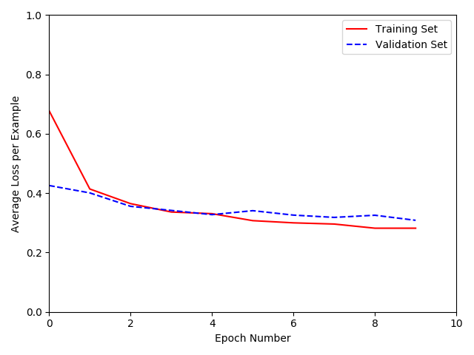

Fully Connected Model with Dropout (B)
Learning Rate = 0.01, Batch Size = 500, Optimizer = Adam, Dropout Probability = 0.1
Criterion \ Set | Training Set | Validation Set | Test Set
Accuracy | 88.0563% | 87.725% | 87.03%
Average Loss | 0.321081 | 0.341904 | 0.37650

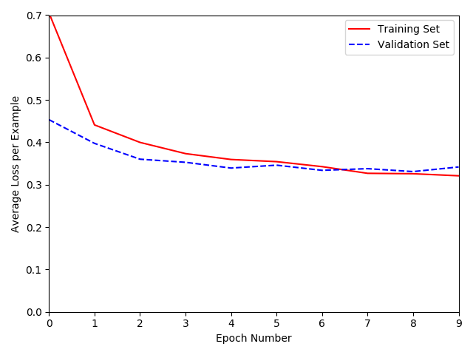

Fully Connected Model with Batch Normalization (c)
Learning Rate = 0.005, Batch Size = 500, Optimizer = Adam
Criterion \ Set | Training Set | Validation Set | Test Set
Accuracy | 92.6063% | 88.325% | 87.52%
Average Loss | 0.198931 | 0.349009 | 0.38695

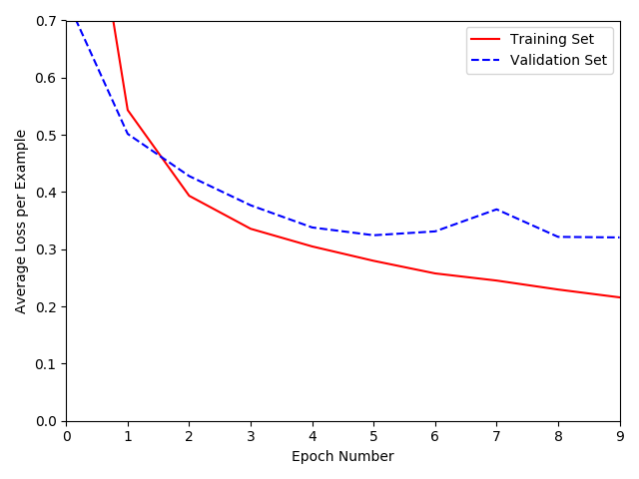

Fully Connected Model with Dropout and Batch Normalization (B & C)
Criterion \ Set | Training Set | Validation Set | Test Set
Accuracy | 90.6229% | 88.017% | 87.6%
Average Loss | 0.263369 | 0.325380 | 0.35217

