Machine Learning Exercise 5 Report
Name: | Tomer Gill
I.D.: | *********
U2 User Name: | gilltom
Date: | 9.6.2018

Part 1 - Training with CNN
Used with batch normalization and dropout, trained with batches sized 64 examples using Adam with learning rate of 0.001.
Result \ Set | Training Set | Validation Set | Test Set
Accuracy | 74.7750% | 67.010% | 66.92%
Average Loss per Example | 0.726887 | 0.999954 | 1.01201

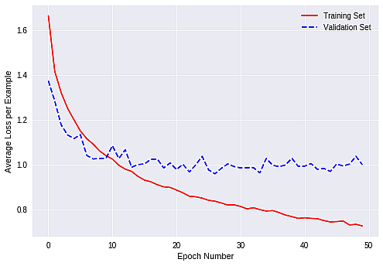
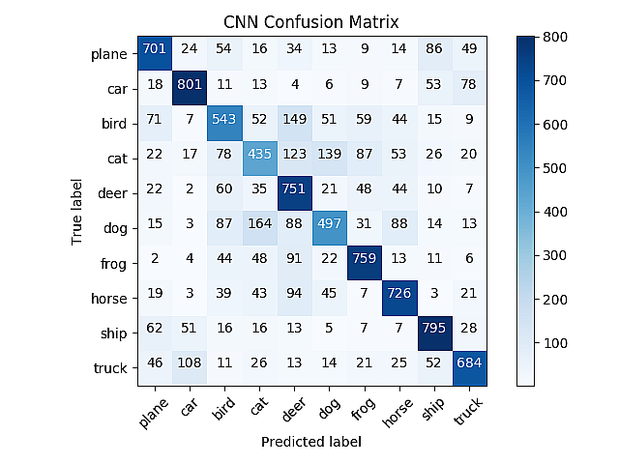

Part 2 – Transfer Learning using ResNet18

Result \ Set | Training Set | Validation Set | Test Set
Accuracy | 79.2575% | 79.140% | 78.11%
Average Loss per Example | 0.598719 | 0.597621 | 0.62303

