4.a

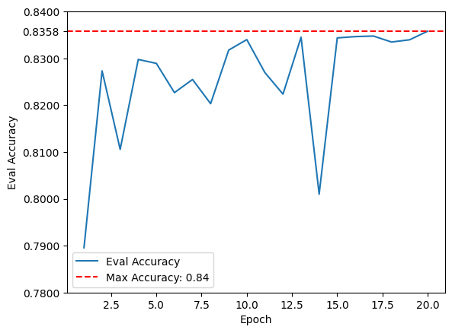  
4.b

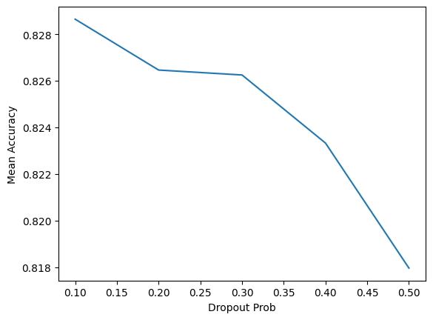

4.c

As illustrated in the graph, the accuracy increases with the number of hidden layers up to 2 layers, after which the benefit diminishes. This phenomenon is known as diminishing returns, where the slope of the accuracy gain starts to decrease. This could be due to several factors, primarily model overfitting. As the model becomes more complex, it is more prone to overfitting the training data, thus not generalizing well to new data.

Another potential reason is the vanishing or exploding gradient problem. With an increasing number of layers, the gradients used for updating the model parameters during training may either become very small (vanishing) or very large (exploding), making the training process unstable and less effective.

4.d

We experimented with three different activation functions: ReLU, Sigmoid, and Mish. The graph shows that all three variants of the DynamicDAN model achieved similar accuracy scores throughout the training process. Among them, the model using ReLU demonstrated the most stable performance across epochs.

This experiment highlights that while ReLU is widely recognized and commonly used due to its simplicity and effectiveness, alternative activation functions like Sigmoid and Mish can also perform comparably well in specific models, such as the DynamicDAN model we used. This suggests that exploring different activation functions can be beneficial.

Furthermore, finetuning hyperparameters such as the learning rate and batch size specifically for each activation function might result in even better performance. This can lead to optimizing the model further, potentially surpassing the results obtained with ReLU.

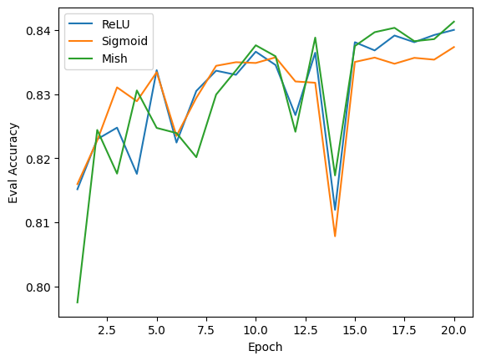

4.e

1.

**Review:** The harsh realities of the mafia world are truly dogeatdog, where any sign of weakness can lead to a gangster's death, as they become a liability. While I appreciate the human aspect of gangsters being shown, Bugsy goes too far in portraying them as soft and comical. Although the film is enjoyable and serves as light entertainment, it fails to be a serious biopic of a dangerous and fearsome man. The acting is solid, and the direction is commendable. The setting and era are wellcaptured, and the themes are intriguing. Did Bugsy really intend to kill Mussolini?

Prediction: Positive

Label: Negative

Explanation: The model might have predicted this review as positive due to phrases like "the film is enjoyable" and "the acting is solid," which are positive statements that may have misled the model.

2.

**Review**: Glenn Ford, a New York native who has been saving up, hitchhikes and rides the rails to the Arizona ranch he bought, expecting to find HEAVEN WITH A BARBED WIRE FENCE. Directed by villain extraordinaire Ricardo Cortez, with a Dalton Trumbo script and story, and starring the twitchy Glenn Ford and restless Richard Conte, the film surprisingly turns out to be overly nice. Despite the harsh system depicted, the proletarians are portrayed as overly sweet, causing a sense of nausea. The heroine, a sweet blonde refugee from Franco’s Spain, is irritating due to both scripting and acting flaws. The only redeeming features are Richard Conte's performance and some astonishing 30s leftist camp moments. However, the film ultimately offers an unconvincing vision, is tied to a risible political viewpoint, and lacks Trumbo's screenwriting strengths.

Prediction: Positive

Label: Negative

Explanation: The model may have been confused by the numerous positive keywords and initial positive comments, causing it to misclassify this review.

3.

**Review**: Our story follows two U.S. Navy deepsea divers searching for silver coins off the Filipino coast. Unfortunately, the entertainment is extremely dull with no plot. Jim Brown's contribution to this 70s war movie is wasted. Richard Jaeckel performs as expected, and special thanks are given to Don Cornelius and Richard Pryor. BOMBS AWAY!!!

Prediction: Positive

Label: Negative

Explanation: Phrases like "entertainment at its best" and "special thanks" might have misled the model to think this review is positive, despite the overall negative sentiment.

4.

**Review**: George Barry's "Death Bed: The Bed That Eats" is essentially a dark fairy tale in a horrormovie format. It's one of the best films of the 1970s, but it's a shame it was stolen and distributed without Barry's consent. Those responsible should be punished. If you're seeking gore or action, this isn't the film for you. "Death Bed" is a strange, dreamlike film that I'd recommend reading about in Stephen Thrower's book "Nightmare USA." Barry is an original, and in a just world, he would have made many more bizarre films.

Prediction: Negative

Label: Positive

Explanation: Despite negative phrases like "stolen," "punished," and "isn't the film for you," the review overall praises the film, leading to the model's misclassification.

5.