Course project: An AI-powered customer support assistant for an online store.
- Project goal
Build a customer support agent that can answer questions about online store policies and customer-specific order/account data by combining:
- RAG (Retrieval-Augmented Generation) - semantic search over policy documents.
- LLM with tool use - LLM decides when to retrieve policies and when to query the database.
- MCP tools - a Model Context Protocol server exposing read/write access to the SQLite store database.
- Two interfaces - a command-line chat and a browser-based chat with live “thinking” steps.
- Agentic loop - the agent receives a goal and decides on its own what is the next step - use one of the available tools or respond to the customer.
- Long conversations - the agent should have a memory of the current conversation.
The agent should handle customer support questions like “Can I return my last order?”, “Where is my shipment?”, and “Why was my payment rejected?” by retrieving the right policy text and querying the right database tables.
The agent should also be able to perform operations on behalf of the user. In this case it will be able to open a ticket for the user by adding it to the support_tickets table.
What you receive (starter materials):
- Policy knowledge base (dataset_design/01_knowledge_base_documents.md) - 21 store policy documents
- Database schema design (dataset_design/02_sql_schema_definition.md)
- Sample data specification (dataset_design/03_generated_dataset_samples.md)
- Example support scenarios for testing (dataset_design/05_example_support_scenarios.md)
- Database initialization script (database/init_db.py) - creates database/store.db with sample data
- What you must build: All application code: RAG indexing and retrieval, MCP server, agent logic, CLI, and web UI.

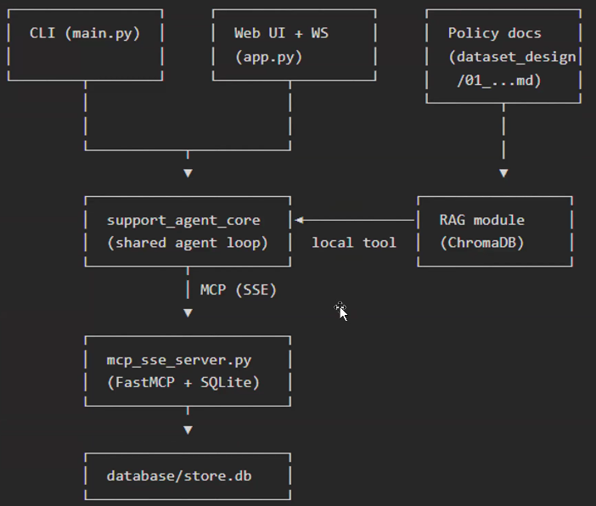

- General Requirement:
  - The core of the agent is an agentic loop that uses LLM, tools, and memory.
  - The agent should be able to handle multiple users simultaneously. All LLM and API calls should be asynchronous. Use async and await where required.
  - LLM - use Anthropic Haiku 4.5 or a model with similar capabilities.
  - Memory - the agent will keep the history of the conversation, up to 20 messages.
  - MCP - the connection to the database will be through an MCP server.
  - RAG - the knowledge base (policies) will be kept in a RAG system using Chroma DB and exposed as a tool for the agent.
  - The agent will have a command-line interface and a web interface.
  - The web UI should update using WebSocket to maintain a smooth web experience.
  - The agent should help the user create a support ticket when needed by inserting a row into the tickets table.
  - Guardrails - the agent should authenticate the user and must not allow access to unsafe information, such as other users' information or database table information.

- Knowledge base requirements:
  - The knowledge base will contain all the relevant policies.
  - Use Chroma DB on a local server and the BERT all-MiniLM-L6-v2 model.
  - No chunking is required, as we want to give the agent the full policy.
  - Return 5 policies per query. This should be easily configurable.
- Database requirements:
  - Use SQLite on a local server.
  - Use init_db.py to create the tables and content.
  - The database should expose read and write operations. Write operations should be used to create a ticket in the support_tickets table.
  - You can use the SQLite Viewer extension in Cursor to view the database structure and content.
- Web UI requirements:
  - The Web UI should be a simple chat - the client enters a prompt, and the agent answers.
  - There should also be an option to view the thinking process for debugging purposes. The thinking process consists of the agent’s intermediate steps before producing the final result, including reasoning and tool use.
  - See the example UI below.

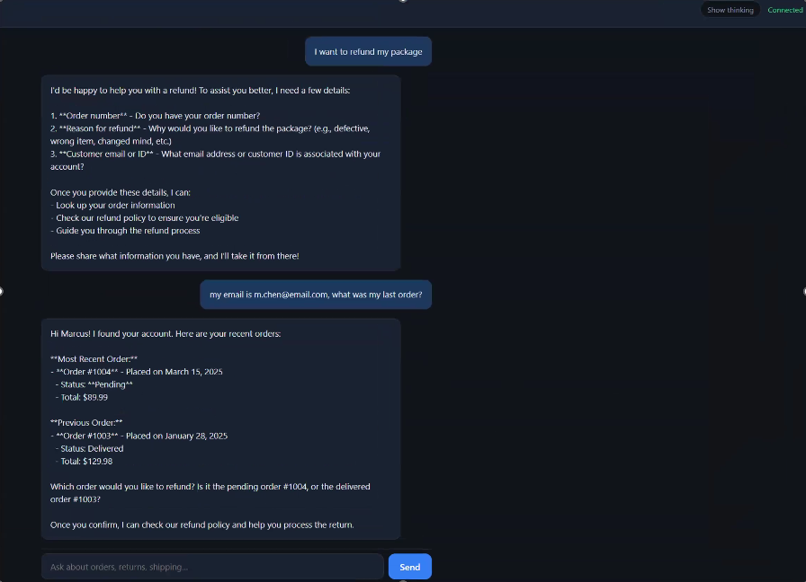

- Deployment:
  - Should be able to deploy on an AWS EC2 server.
  - Deploy on an EC2 server and make sure you can access it from your own PC.
  - Remember: Shut down the server when it is not being used to avoid excessive payments.
- Stretch goals:
  - Wrap the agent in a Docker container.
  - Separate the web into a new process so the web will be the client and the agent will be the server. You still need to use WebSocket communication between the agent and the client.
  - Have an option for a fallback model using LiteLLM. For example, use Haiku 4.5 as the main model, but if the request to Anthropic is unsuccessful, fall back to Gemini 3.5 Flash.

Implementation plan:

Phase 1:

Build a RAG solution for the knowledge base. The agent should know how to respond to questions about the company policies.

