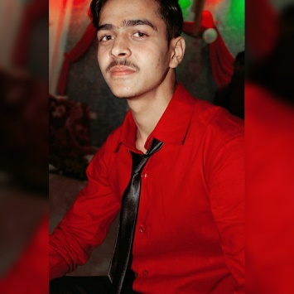CURICULUM VITAE

CURICULUM VITAE

CURICULUM

**Vivek Singh**

* 4910vivek@gmail.com
* +91 8707794910
* Technologypupils.com
* C.Add- 16/704 Munsipuliyha Indira Nagar.
* P. Add- village-Chhatiha post-kaudiya dis-hardoi (U.P) 241202

Highschool School name –Shri Narayan singh higher secondary school atrauli, hardoi.

Bord name – UP Board.

Passing year – 2014.

Percentage – 85%

**EDUCATION**

**CONTACT**

I improve by best way to update myself. I know I am not a magician but practice is a way to become a magician any field that’s way I am quick leaner and positive person.

**PROFILE**

* **Python**
* Javascript,HTML5,CSS.
* ReactJs
* Nodejs, Expressjs
* MongoDB, MySQL .

**SKILLS**

* PROGRAMING
* SPORTS

**HOBBIES**

**Language**

Hindi, English.

* Professional diploma in ITI (computer operator and programming assistant) from government ITI Atrauli hardoi.
* Course on computer concepts.

**Others**

Graduation

Collage Name – IISE kalayanpur Lucknow .

Affiliated by – MCRP Bhopal university.

Passing year – Pursuing (6th semester)

Intermediate

School name –Janta Inter Collage bharawan hardoi.

Bord name – UP Board.

Passing year – 2016.

Percentage – 75%