**Final Project – Hierarchical Linear Models**

**Background**

The current study asks how perceived social status affects identity individuation. Differences in the ability to distinguish between the faces of people from different groups are theorized to arise from (1) perceptual expertise differences and/or (2) motivational effects. Following the latter theory, we study whether different perceived social status levels induce motivation that alters subsequent face individuation. We hypothesize that participants will better distinguish between faces of higher compared with lower social status. Subject's socio-economic status could also interact with target's social status by creating status-based social groups. These groups could create an ingroup bias in face individuation, as subjects will be more accurate in individuating ingroup- compared with outgroup members.

**Method**

In each trial participants will be asked to decide of the second face is different or identical to the first face. Trials will differ by target's social status (indicated by occupational title) and second face's identity (same or different). Answers will be given while the second face is presented. Statistical analysis will be conducted on data from trials with different faces, in order to isolate participant's ability to distinguish between two different individuals.

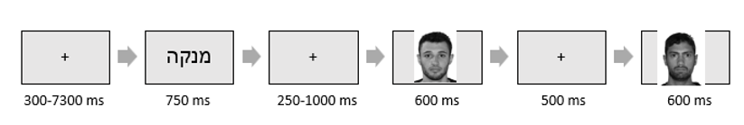

**Variables**

Participant's socio-economic status (SES) – Self reported socio-economic status on a scale of 1-10. This variable is centered around the mean.

Target's social status (TSS) – High or Low social status indicated by occupational title. A total of 10 titles in each status level were presented randomly in the experiment. Each title is nested in one of the social status levels.

**Dependent Measure**

Correct Recognition – participants' answers on the identification question in the end of each trial.

**Analytical Plan**

For participant $i$ and trial $t$, the probability to correctly identify the second face as different will be modeled as $θ_{it}$:

Level 1:

$${logit(θ}_{it})=β_{0i}+β_{1it}*TSS+e_{it}$$

Level 2:

$$β_{0i}=γ_{00}+γ_{01}*{title}_{t}+U_{0t}$$

$$β_{1it}=γ_{10}+γ_{11}*{title}_{t}+U_{1t}$$

Level 3:

$$γ_{00}=ζ_{000}+ζ_{001}*{SES}_{i}$$

$$γ_{01}=ζ_{010}+ζ_{011}*{SES}_{i}$$

$$γ_{10}=ζ_{100}+ζ_{101}*{SES}_{i}$$

$$γ_{11}=ζ_{110}+ζ_{111}*{SES}_{i}$$

Composite:

$${logit(θ}_{it})=ζ_{000}+ζ_{001}*{SES}_{i}+(ζ_{010}+ζ_{011}*{SES}_{i})*{title}_{t}+U_{0t}+(ζ_{100}+ζ_{101}*{SES}_{i}+(ζ_{110}+ζ_{111}*{SES}_{i})*{title}_{t}+U_{1t})*TSS+e_{it}$$

*Results*

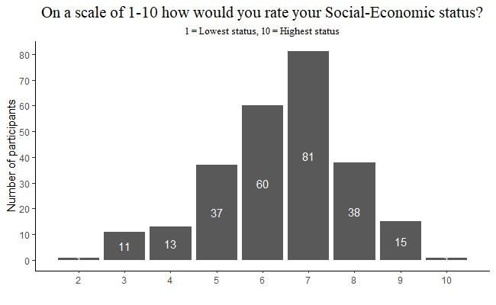Participants answers correctly on 89.78% of trials (89.91% in trials with high social status target, and 89.65% in trials with low status target). Mean socio-economic status was 6.42 with a median of 7. SES distribution can be seen in figure 1.

*Figure 1. Number of participants from each self-reported Socio-economic level.*

An empty model with random intercept for participant enabled the evaluation of within-subject variance in the dependent measure. Interclass Correlation Coefficient (ICC) was 0.293, indicating that within-subject variance accounted for 29.3% of the variance in the dependent measure.

The second model contained the hypothesized fixed effects without their interaction term. Both coefficients were not significant (${OR}_{SES}=1.12, p=0.092; {OR}_{Status}=0.97, p=0.791$). The third model added the interaction term, which was not significant (${OR}_{SESxStatus}=0.96, p=0.269$). the addition of an interaction term did not add a significant amount of explained variance further than the two main fixed effects ($Δ_{marginal R^{2}}=0$). Similarly, adding both main fixed effects did not add a significant amount of explained variance further than the empty model (). תמונה שמכילה טקסט, צילום מסך, גופן, מספר
Summary of the last model (containing the interaction term) is in table 1.

**Discussion:**

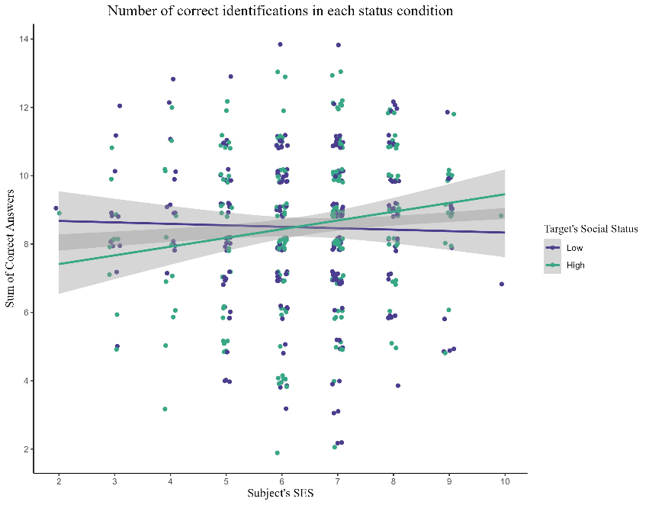None of the fixed effects was statistically significant, meaning that the level 1 predictor of target's social status, and the Level 2 predictor of subject's SES did not explain the variance in the DV – probability of correct individuation of target's face. Cross-level interaction also was not significant. This could be inferred from the p-values of each regression coefficient, as well as from the fact that the added explained variance by each was not significant in itself. As indicated by the empty model's ICC, the best predictor in the current design (29.3% explained variance) was inter-subject differences.

*Figure 2. Each point represents the number of correct answers one participant had in one of the two social status conditions.*