EDA Lesson 4

Tom Gocken

Sunday, January 24, 2016

### Scatterplots

# https://s3.amazonaws.com/udacity-hosted-downloads/ud651/EDA_Course_Materials.zip  
# Set directory, load data and ggplot2 library  
  
setwd("C:/Projects/UD651")  
list.files()

## [1] "EDA_lesson3.docx" "EDA_lesson3.html" "EDA_lesson3.Rmd"   
## [4] "EDA_lesson4.html" "EDA_lesson4.Rmd" "pseudo_facebook.tsv"  
## [7] "UD651.Rproj"

pf <- read.csv('pseudo_facebook.tsv', sep = '\t')  
library(ggplot2)  
  
qplot(x = age, y = friend_count, data = pf)

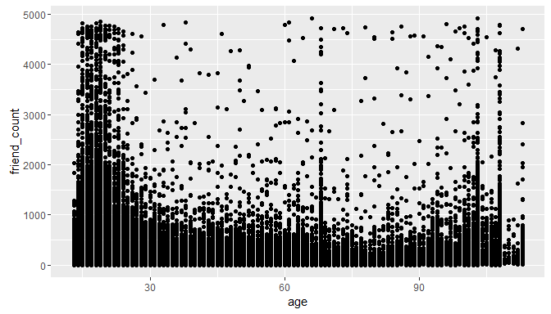

# Alternative syntax  
qplot(age, friend_count, data = pf)



# ggplot syntax  
ggplot(aes(x = age, y = friend_count), data = pf) + geom_point()



summary(pf$age)

## Min. 1st Qu. Median Mean 3rd Qu. Max.   
## 13.00 20.00 28.00 37.28 50.00 113.00

# Limit x axis range  
ggplot(aes(x = age, y = friend_count), data = pf) + geom_point() + xlim(13,90)

## Warning: Removed 4906 rows containing missing values (geom_point).

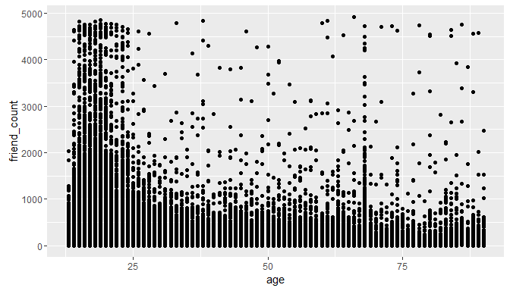

### Overplotting

# Reduce overplotting with alpha where 1 graph point equal to 20 data points  
ggplot(aes(x = age, y = friend_count), data = pf) +   
 geom_point(alpha = 1/20) +   
 xlim(13,90)

## Warning: Removed 4906 rows containing missing values (geom_point).

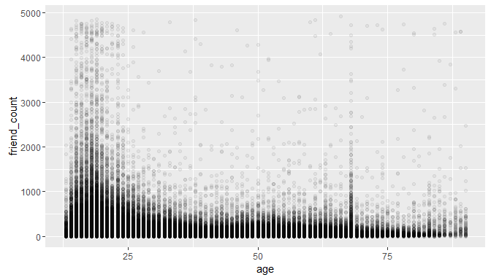

# Add jitter  
ggplot(aes(x = age, y = friend_count), data = pf) +   
 geom_jitter(alpha = 1/20) +   
 xlim(13,90)

## Warning: Removed 5193 rows containing missing values (geom_point).

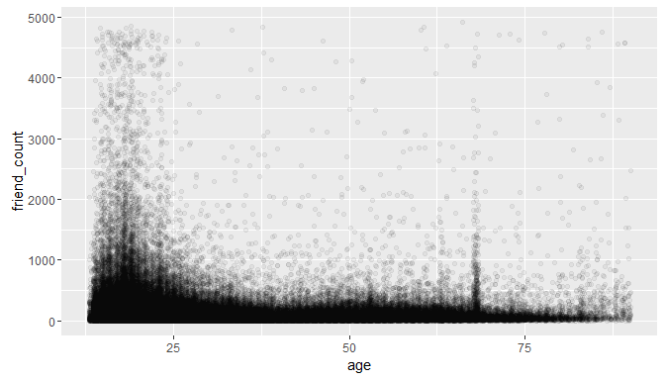

### coord_trans

# Square root transformation  
ggplot(aes(x = age, y = friend_count), data = pf) +   
 geom_point(alpha = 1/20) +   
 xlim(13,90) +  
 coord_trans(y = 'sqrt')

## Warning: Removed 4906 rows containing missing values (geom_point).

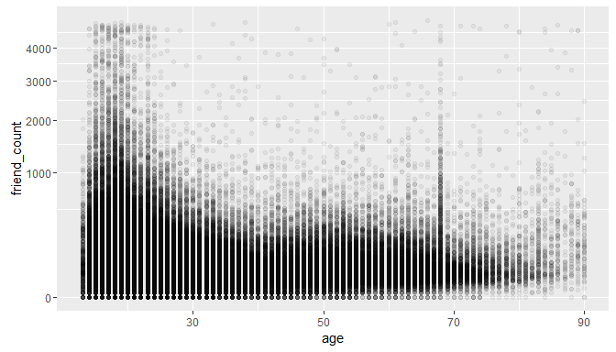

# Jitter age, > 0 only  
ggplot(aes(x = age, y = friend_count), data = pf) +   
 geom_point(alpha = 1/20, position = position_jitter(h = 0)) +   
 xlim(13,90) +  
 coord_trans(y = 'sqrt')

## Warning: Removed 5190 rows containing missing values (geom_point).

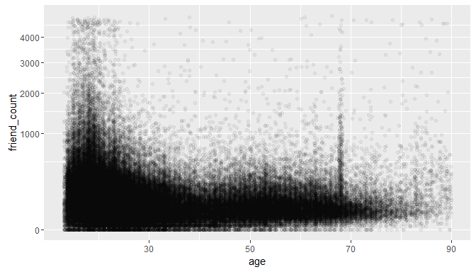

### Alpha and Jitter

names(pf)

## [1] "userid" "age"   
## [3] "dob_day" "dob_year"   
## [5] "dob_month" "gender"   
## [7] "tenure" "friend_count"   
## [9] "friendships_initiated" "likes"   
## [11] "likes_received" "mobile_likes"   
## [13] "mobile_likes_received" "www_likes"   
## [15] "www_likes_received"

ggplot(aes(x = age, y = friendships_initiated), data = pf) +  
 geom_point()

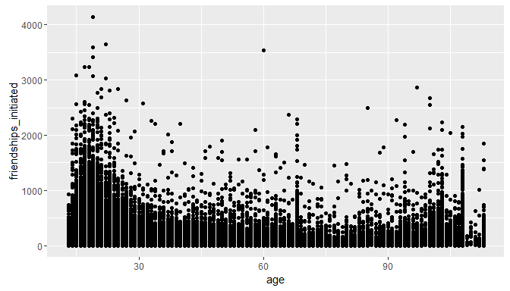

# Add jitter  
ggplot(aes(x = age, y = friendships_initiated), data = pf) +  
 geom_jitter() +  
 xlim(13,90)

## Warning: Removed 5179 rows containing missing values (geom_point).

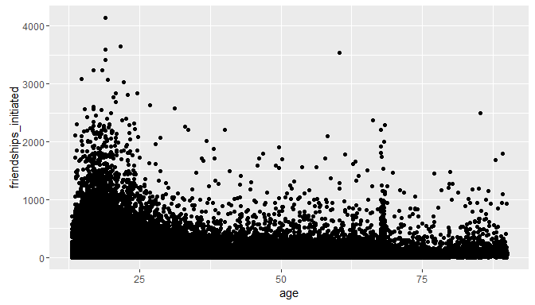

# Add alpha  
ggplot(aes(x = age, y = friendships_initiated), data = pf) +  
 geom_jitter(alpha = 1/10) +  
 xlim(13,90)

## Warning: Removed 5207 rows containing missing values (geom_point).

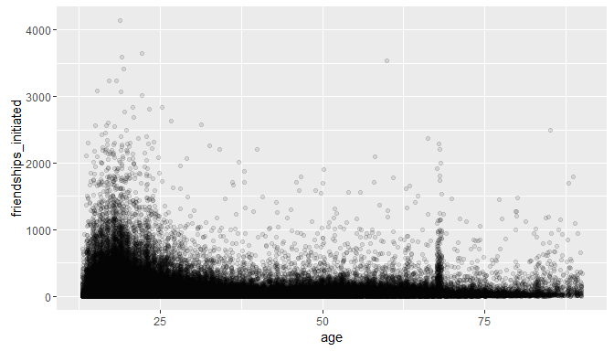

# Alt jitter syntax, sqrt transformation  
ggplot(aes(x = age, y = friendships_initiated), data = pf) +  
 geom_point(alpha = 1/10, position = position_jitter(h = 0)) +  
 xlim(13,90) +  
 coord_trans(y = 'sqrt')

## Warning: Removed 5185 rows containing missing values (geom_point).

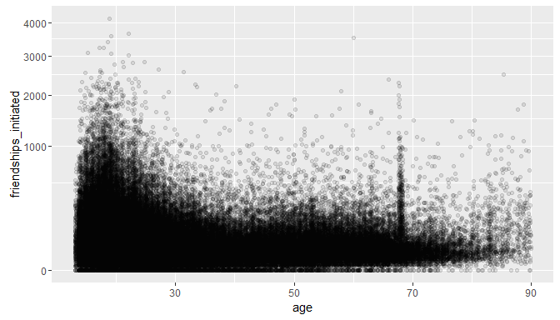

### Conditional Means

# install.packages('dplyr')  
library(dplyr)

##   
## Attaching package: 'dplyr'  
##   
## The following objects are masked from 'package:stats':  
##   
## filter, lag  
##   
## The following objects are masked from 'package:base':  
##   
## intersect, setdiff, setequal, union

age_groups <- group_by(pf, age)  
  
pf.fc_by_age <- summarise(age_groups,  
 friend_count_mean = mean(friend_count),  
 friend_count_median = median(friend_count),  
 n = n())  
  
pf.fc_by_age <- arrange(pf.fc_by_age, age)  
  
head(pf.fc_by_age)

## Source: local data frame [6 x 4]  
##   
## age friend_count_mean friend_count_median n  
## (int) (dbl) (dbl) (int)  
## 1 13 164.7500 74.0 484  
## 2 14 251.3901 132.0 1925  
## 3 15 347.6921 161.0 2618  
## 4 16 351.9371 171.5 3086  
## 5 17 350.3006 156.0 3283  
## 6 18 331.1663 162.0 5196

# Alternative syntax, note: %.% equivalent to %>%  
pf.fc_by_age <- pf %.%   
 group_by(age) %.%  
 summarise(friend_count_mean = mean(friend_count),  
 friend_count_median = median(friend_count),  
 n = n()) %.%  
 arrange(age)

## Warning: '%.%' is deprecated.  
## Use '%>%' instead.  
## See help("Deprecated")

## Warning: '%.%' is deprecated.  
## Use '%>%' instead.  
## See help("Deprecated")

## Warning: '%.%' is deprecated.  
## Use '%>%' instead.  
## See help("Deprecated")

head(pf.fc_by_age)

## Source: local data frame [6 x 4]  
##   
## age friend_count_mean friend_count_median n  
## (int) (dbl) (dbl) (int)  
## 1 13 164.7500 74.0 484  
## 2 14 251.3901 132.0 1925  
## 3 15 347.6921 161.0 2618  
## 4 16 351.9371 171.5 3086  
## 5 17 350.3006 156.0 3283  
## 6 18 331.1663 162.0 5196

# geom_line on summarized values  
ggplot(aes(x= age, y = friend_count_mean), data = pf.fc_by_age) +  
 geom_line()

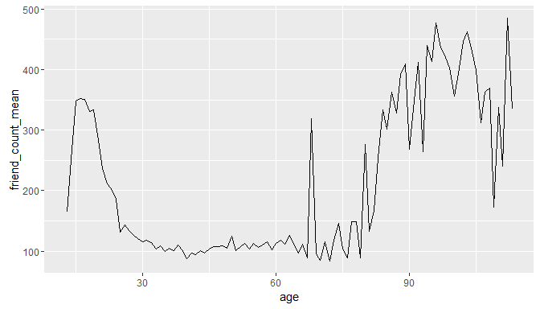

### Overlaying Summaries with Raw Data

# Display raw data and mean  
ggplot(aes(x = age, y = friendships_initiated), data = pf) +  
 geom_point(alpha = 0.05,   
 position = position_jitter(h = 0),  
 color = 'orange') +  
 xlim(13,90) +  
 coord_trans(y = 'sqrt') +  
 geom_line(stat = 'summary', fun.y = mean)

## Warning: Removed 4906 rows containing non-finite values (stat_summary).

## Warning: Removed 5176 rows containing missing values (geom_point).

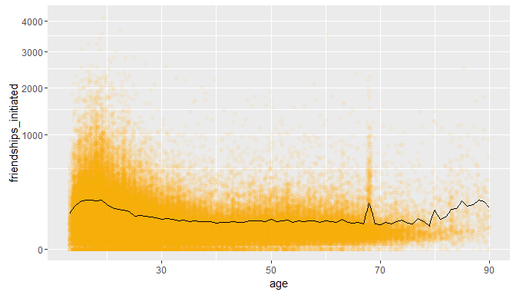

# Add quantiles  
ggplot(aes(x = age, y = friendships_initiated), data = pf) +  
 geom_point(alpha = 0.05,   
 position = position_jitter(h = 0),  
 color = 'orange') +  
 xlim(13,90) +  
 coord_trans(y = 'sqrt') +  
 geom_line(stat = 'summary', fun.y = mean) +  
 geom_line(stat = 'summary', fun.y = quantile, fun.args=list(probs=0.1),  
 linetype = 2, color = 'blue') +  
 geom_line(stat = 'summary', fun.y = quantile, fun.args=list(probs=0.5), # = median  
 color = 'blue') +  
 geom_line(stat = 'summary', fun.y = quantile, fun.args=list(probs=0.9),  
 linetype = 2, color = 'blue')

## Warning: Removed 4906 rows containing non-finite values (stat_summary).

## Warning: Removed 4906 rows containing non-finite values (stat_summary).

## Warning: Removed 4906 rows containing non-finite values (stat_summary).

## Warning: Removed 4906 rows containing non-finite values (stat_summary).

## Warning: Removed 5188 rows containing missing values (geom_point).

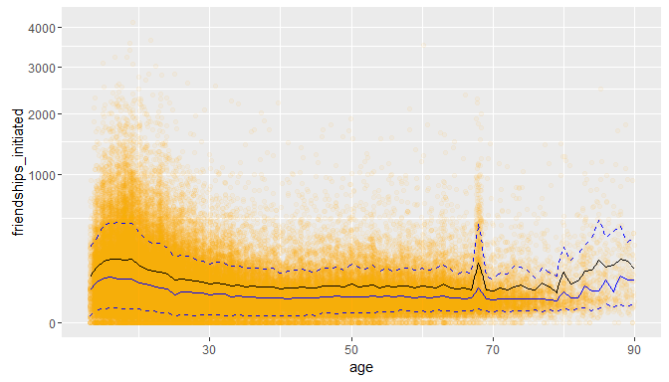

# Use coord_cartesian to zoom in  
ggplot(aes(x = age, y = friendships_initiated), data = pf) +  
 coord_cartesian(xlim = c(13, 70), ylim = c(0, 1000)) +  
 geom_point(alpha = 0.05,   
 position = position_jitter(h = 0),  
 color = 'orange') +  
 geom_line(stat = 'summary', fun.y = mean) +  
 geom_line(stat = 'summary', fun.y = quantile, fun.args=list(probs=0.1),  
 linetype = 2, color = 'blue') +  
 geom_line(stat = 'summary', fun.y = quantile, fun.args=list(probs=0.5), # = median  
 color = 'blue') +  
 geom_line(stat = 'summary', fun.y = quantile, fun.args=list(probs=0.9),  
 linetype = 2, color = 'blue')

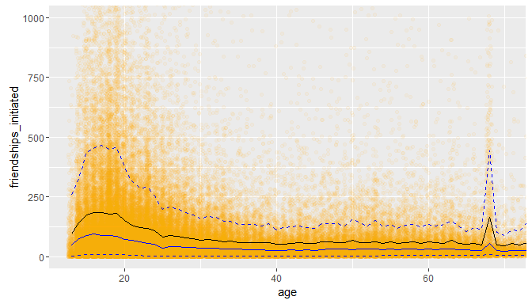

### Correlation

cor.test(pf$age, pf$friend_count, method = 'pearson')

##   
## Pearson's product-moment correlation  
##   
## data: pf$age and pf$friend_count  
## t = -8.6268, df = 99001, p-value < 2.2e-16  
## alternative hypothesis: true correlation is not equal to 0  
## 95 percent confidence interval:  
## -0.03363072 -0.02118189  
## sample estimates:  
## cor   
## -0.02740737

# Alt syntax  
with(pf, cor.test(age, friend_count, method = 'pearson'))

##   
## Pearson's product-moment correlation  
##   
## data: age and friend_count  
## t = -8.6268, df = 99001, p-value < 2.2e-16  
## alternative hypothesis: true correlation is not equal to 0  
## 95 percent confidence interval:  
## -0.03363072 -0.02118189  
## sample estimates:  
## cor   
## -0.02740737

### Correlation on Subsets

with(subset(pf, age <= 70), cor.test(age, friend_count)) # method = 'peason' is default

##   
## Pearson's product-moment correlation  
##   
## data: age and friend_count  
## t = -52.5923, df = 91029, p-value < 2.2e-16  
## alternative hypothesis: true correlation is not equal to 0  
## 95 percent confidence interval:  
## -0.1780220 -0.1654129  
## sample estimates:  
## cor   
## -0.1717245

### Create Scatterplots

ggplot(aes(x = www_likes_received, likes_received), data = pf) +  
 geom_point()

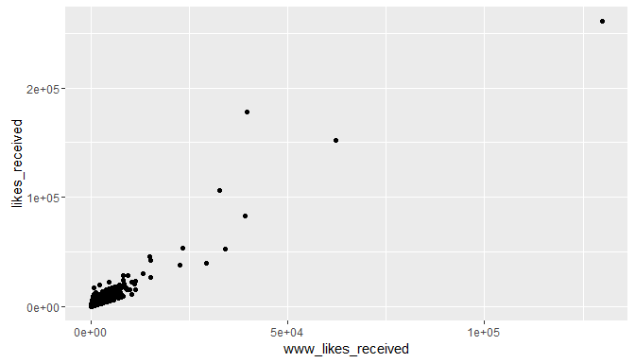

### Strong Correlations

# Limit range using 95% quantiles, add line for correlation coefficient  
ggplot(aes(x = www_likes_received, likes_received), data = pf) +  
 geom_point() +  
 xlim(0, quantile(pf$www_likes_received, 0.95)) +  
 ylim(0, quantile(pf$likes_received, 0.95)) +  
 geom_smooth(method = 'lm', color = 'red')

## Warning: Removed 6075 rows containing non-finite values (stat_smooth).

## Warning: Removed 6075 rows containing missing values (geom_point).

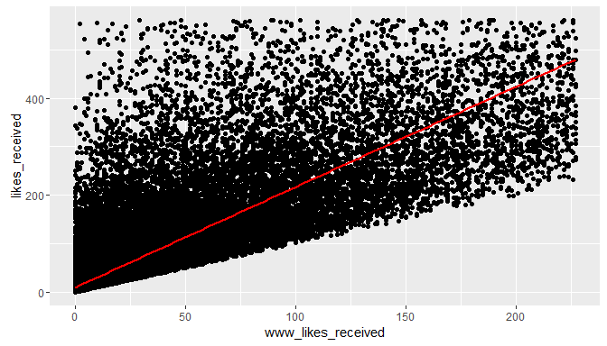

cor.test(pf$www_likes_received, pf$likes_received)

##   
## Pearson's product-moment correlation  
##   
## data: pf$www_likes_received and pf$likes_received  
## t = 937.1035, df = 99001, p-value < 2.2e-16  
## alternative hypothesis: true correlation is not equal to 0  
## 95 percent confidence interval:  
## 0.9473553 0.9486176  
## sample estimates:  
## cor   
## 0.9479902

# High correlation not meaningful since www_likes_received is a subset of likes_received

### More Caution with Correlation

# install.packages('alr3')  
library(alr3)

## Loading required package: car

data(Mitchell)  
# ?Mitchell  
# Mitchell soil temperature  
# Description: Data collected by Kenneth G. Hubbard on soil temperature at 20 cm depth   
# in Mitchell, Nebraska for 17 years (1976-1992) The variable month is the month number.  
  
ggplot(data = Mitchell, aes(x = Month, y = Temp)) +  
 geom_point()

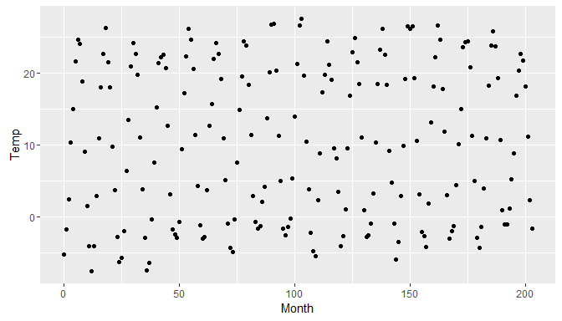

# Alt syntax  
qplot(data = Mitchell, Month, Temp)



### Noisy Scatterplots

### Making Sense of Data

ggplot(data = Mitchell, aes(x = Month, y = Temp)) +  
 geom_point() +  
 scale_x_discrete(breaks = seq(0, 203, 12))

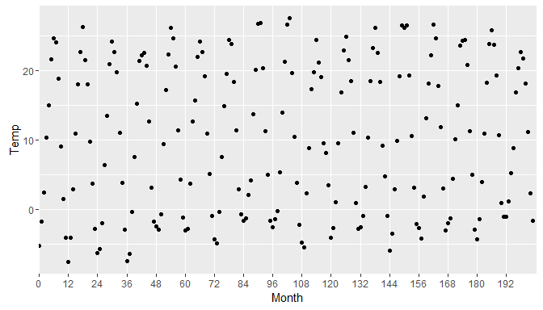

### A New Perspective

# Stretch horizontal axis to reveal cyclic pattern

### Understanding Noise Age to Age Months

ggplot(aes(x = age, y = friend_count_mean), data = pf.fc_by_age) +  
 geom_line()



head(pf.fc_by_age, 10)

## Source: local data frame [10 x 4]  
##   
## age friend_count_mean friend_count_median n  
## (int) (dbl) (dbl) (int)  
## 1 13 164.7500 74.0 484  
## 2 14 251.3901 132.0 1925  
## 3 15 347.6921 161.0 2618  
## 4 16 351.9371 171.5 3086  
## 5 17 350.3006 156.0 3283  
## 6 18 331.1663 162.0 5196  
## 7 19 333.6921 157.0 4391  
## 8 20 283.4991 135.0 3769  
## 9 21 235.9412 121.0 3671  
## 10 22 211.3948 106.0 3032

pf.fc_by_age[17:19, ]

## Source: local data frame [3 x 4]  
##   
## age friend_count_mean friend_count_median n  
## (int) (dbl) (dbl) (int)  
## 1 29 120.8182 66.0 1936  
## 2 30 115.2080 67.5 1716  
## 3 31 118.4599 63.0 1694

pf$age_with_months <- pf$age + (12 - pf$dob_month) / 12

### Age with Months Means

library(dplyr)  
pf.fc_by_age_months <- pf %>%  
 group_by(age_with_months) %>%  
 summarise(friend_count_mean = mean(friend_count),  
 friend_count_median = median(friend_count),  
 n = n()) %>%  
 arrange(age_with_months)  
  
head(pf.fc_by_age_months)

## Source: local data frame [6 x 4]  
##   
## age_with_months friend_count_mean friend_count_median n  
## (dbl) (dbl) (dbl) (int)  
## 1 13.16667 46.33333 30.5 6  
## 2 13.25000 115.07143 23.5 14  
## 3 13.33333 136.20000 44.0 25  
## 4 13.41667 164.24242 72.0 33  
## 5 13.50000 131.17778 66.0 45  
## 6 13.58333 156.81481 64.0 54

### Noise in Conditional Means

ggplot(aes(x = age, y = friend_count_mean), data = pf.fc_by_age) +  
 geom_line()



# Revise using age_with_months, subset by age_with_months < 71  
ggplot(aes(x = age_with_months, y = friend_count_mean),   
 data = subset(pf.fc_by_age_months, age_with_months < 71)) +  
 geom_line()

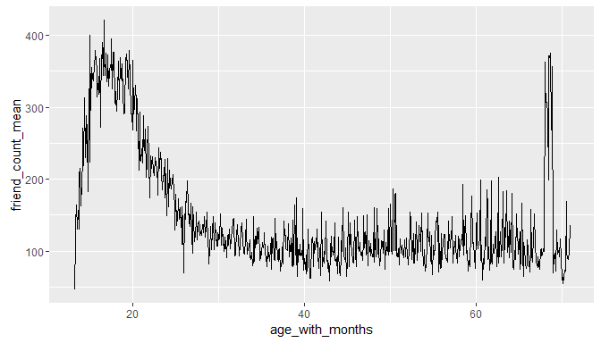

### Smoothing Conditional Means

# Save each plot to a variable, add smoothing lines, plot in one column  
# Reducing number of bins reduces noise but may also leave out important details  
# bias / variance trade-off  
  
p1 <- ggplot(aes(x = age, y = friend_count_mean),   
 data = subset(pf.fc_by_age, age < 71)) +  
 geom_line() +  
 geom_smooth()  
  
p2 <- ggplot(aes(x = age_with_months, y = friend_count_mean),   
 data = subset(pf.fc_by_age_months, age_with_months < 71)) +  
 geom_line() +  
 geom_smooth()  
  
p3 <- ggplot(aes(x = round(age / 5) * 5, y = friend_count),   
 data = subset(pf, age < 71)) +  
 geom_line(stat = 'summary', fun.y = mean)  
  
library(gridExtra)  
grid.arrange(p2, p1, p3, ncol = 1)

