Capstone Project - Pollination Date Prediction

Tom Gocken

Monday, February 15, 2016

## Introduction

Research sites that develop new plant varieties must predict when certain seasonal events, such as pollination, will occur. These events drive work timelines and allocation of resources. The timing of these events depends on 1) planting date, 2) variety maturity expressed in growing degree units (GDUs) required to reach a specified growth stage, such as pollination or physiological maturity, and 3) how rapidly GDUs accumulate during the growing season. While planting date and variety maturity are known values determined by the researcher, the rate of GDU accumulation depends on conditions that vary by growing season and location.

A regression model was developed to predict GDU accumulation during the growing season at five research sites in the U.S. Midwest. Examples are provided demonstrating how predicted accumulated GDUs can be combined with inputs for planting date and variety maturity to predict pollination date and to model planting scenarios.

## Data Sources

* Environmental data for counties of interest: <http://wonder.cdc.gov/EnvironmentalData.html>
  + List variables and provide definitions...
* County centroid coordinates: <https://www.census.gov/geo/maps-data/data/gazetteer.html>
* Frost-free growing season length: <http://davesgarden.com/guides/freeze-frost-dates/> summarized from <http://www.ncdc.noaa.gov/>
* Monthly ERSST data measuring El Nino / La Nina effects: <http://www.cpc.noaa.gov/products/analysis_monitoring/ensostuff/ensoyears.shtml>

## GDU Calculation Method

Growing degree units (GDUs), also known as growing degree days, were calculated by taking the average of the daily maximum and minimum temperatures compared to a base temperature, Tbase, as follows:

#### GDU = ((Tmax + Tmin) / 2) -- Tbase

where Tmax is equal to the maximum daily temperature but not greater than a defined upper limit and Tmin is equal to the minimum daily temperature but not less than the base temperature. The upper limit and base in this project were set to 50°F and 86°F (10°C and 50°C), respectively, typical values for corn.

#### References

* <http://en.wikipedia.org/wiki/Growing_degree-day>
* <http://agron-www.agron.iastate.edu/Courses/agron212/Calculations/GDD.htm>

## Data Wrangling Steps

Add from previous project...

setwd("C:/Projects/springboard-capstone")  
envdat <- read.delim("../data/envdat.txt") # Previously created tidy dataset  
envdat_inseason <- subset(envdat, day_of_yr >= 90 & day_of_yr < 300)  
envdat_train <- subset(envdat_inseason, year < 2010)  
envdat_test <- subset(envdat_inseason, year >= 2010)

## Correlations

Below is a heat map showing correlations among all numeric variables and a table showing correlation coefficients greater than 0.3. As expected, high correlations exist between variables that measure similar things, such as ersst, ersst_lag3mo, and ersst_lag6mo measuring recent El Nino effects; gdu, max_air_temp, and min_air_temp measuring daily temperatures; and day_of_year and month measuring time of year.

Even though latitude and longitude both measure geographical position, their correlation (-0.48) is an artifact of the data. Since latitude measures North/South direction and longitude measures East/West direction, the two variables are expected to be uncorrelated in a random selection of locations. The high correlation between grow_season (frost-free growing season length) and latitude (-0.91) is expected since growing season length is directly affected by distance from the equator.

library(ggplot2)  
library(reshape2)  
library(dplyr)  
library(tidyr)

# Heat map of correlation matrix  
corplot1 <- qplot(x=Var1, y=Var2, data=melt(cor(  
 select(envdat_inseason, -county, -date), use="p")), fill=value, geom="tile") +  
 scale_fill_gradient2(limits=c(-1, 1)) # create heatmap  
corplot2 <- corplot1 +  
 theme(axis.text.x=element_text(angle = 90, vjust = 0)) # change label orientation  
print(corplot2)

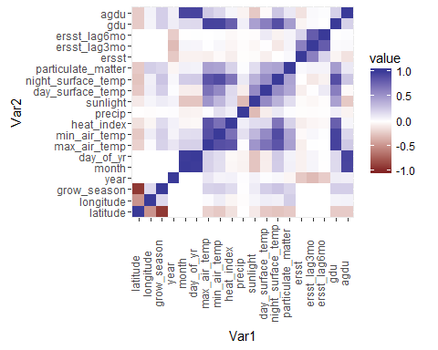

# Highest correlations  
melt(cor(select(envdat_inseason, -county, -date))) %>% # all numeric variables  
 rename(Corr_Coeff = value) %>%  
 filter(abs(Corr_Coeff) > 0.3 & Corr_Coeff != 1) %>%  
 arrange(as.character(Var1), as.character(Var2))

## Var1 Var2 Corr_Coeff  
## 1 agdu day_of_yr 0.9465124  
## 2 agdu month 0.9384011  
## 3 day_of_yr agdu 0.9465124  
## 4 day_of_yr month 0.9895758  
## 5 ersst ersst_lag3mo 0.6147758  
## 6 ersst_lag3mo ersst 0.6147758  
## 7 ersst_lag3mo ersst_lag6mo 0.8060249  
## 8 ersst_lag3mo year -0.3023568  
## 9 ersst_lag6mo ersst_lag3mo 0.8060249  
## 10 gdu max_air_temp 0.9517451  
## 11 gdu min_air_temp 0.9494270  
## 12 gdu sunlight 0.4534379  
## 13 grow_season latitude -0.9119482  
## 14 latitude grow_season -0.9119482  
## 15 latitude longitude -0.4849110  
## 16 longitude latitude -0.4849110  
## 17 max_air_temp gdu 0.9517451  
## 18 max_air_temp min_air_temp 0.8814343  
## 19 max_air_temp sunlight 0.5095273  
## 20 min_air_temp gdu 0.9494270  
## 21 min_air_temp max_air_temp 0.8814343  
## 22 min_air_temp sunlight 0.3383542  
## 23 month agdu 0.9384011  
## 24 month day_of_yr 0.9895758  
## 25 precip sunlight -0.3021674  
## 26 sunlight gdu 0.4534379  
## 27 sunlight max_air_temp 0.5095273  
## 28 sunlight min_air_temp 0.3383542  
## 29 sunlight precip -0.3021674  
## 30 year ersst_lag3mo -0.3023568

## Model Building

#### Day of Year

The strongest correlation between response variable agdu and potential predictor variables was with day_of_year (0.95). However, this relationship is known to be non-linear since GDUs accumulate more slowly during cool days in the early spring and late fall than they do during hot days in the summer. To examine the relationship further, a simple regression model was considered for only day_of_yr. The 20 year dataset was split into a training set consisting of data from 1992 through 2009 and a test set with data from 2010 through 2011. Plotting predicted values versus residuals from the training dataset shows a non-linear distribution with high heteroscedasticity.

lm1 <- lm(agdu ~ day_of_yr, data = envdat_train)  
plot(predict(lm1), residuals(lm1))

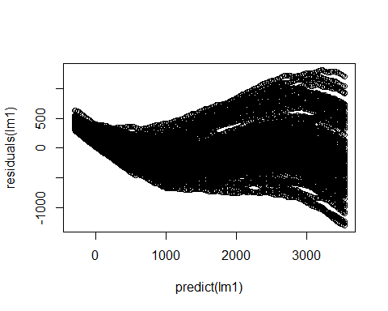

A cubic polynomial model addresses the issue of non-linearity but heteroscedasticity remains.

lm1 <- lm(agdu ~ poly(day_of_yr, 3), data = envdat_train)  
plot(predict(lm1), residuals(lm1))

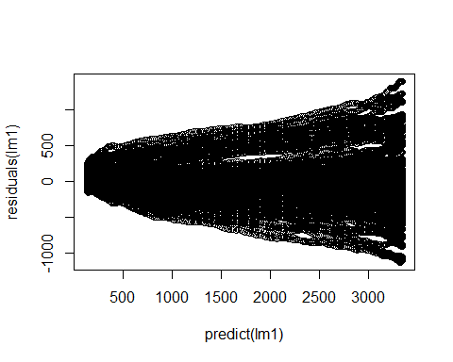

Heteroscedasticity was addressed with a square root tranformation of response varible agdu, as recommended by James, et al., An Introduction to Statistical Learning (<http://www-bcf.usc.edu/~gareth/ISL/>).

lm1 <- lm(sqrt(agdu) ~ poly(day_of_yr, 3), data = envdat_train)  
plot(predict(lm1), residuals(lm1))

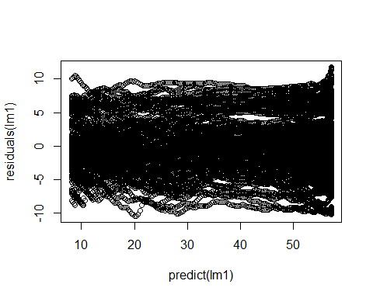

#### Other Terms

In addition to Day of Year, other variables were considered using the leaps package. All possible combinations were of numeric variables were considered to predict the square root of agdu for the training dataset. The best model for each subset size is plotted below, starting with the best 1 predictor model at the bottom to the best 8 variable model at the top.

library (leaps)  
envdat_train2 <- select(envdat_train, -county, -date)  
envdat_train2$day_of_yr2 <- envdat_train2$day_of_yr^2  
envdat_train2$day_of_yr3 <- envdat_train2$day_of_yr^3  
  
models <- regsubsets(sqrt(agdu) ~ . , nbest = 1, data = envdat_train2)  
plot(models, scale = "bic") # Bayesian Information Criterion

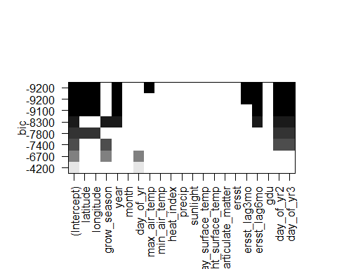

Note that this type of model fitting isn't ideal for the previously described polynomial variables for Day of Year (variables day_of_yr, doy2, and doy3) since they are considered independently but we are interested in their combined effect. Even so, it provides a good indication of the overall combination of variables that will best predict agdu.

The terms selected for the model are the cubic polynomial predictors for day of year, grow_season, year, and ersst_lag6mo (El Nino effects from 6 months prior. These terms correspond to the best 5 predictor model plus main effects for day of year. Additional terms provide little additional improvement and risk overfitting.

# Training data results:  
sel_model <- lm(sqrt(agdu) ~ poly(day_of_yr, 3) + grow_season   
 + year + ersst_lag6mo, data = envdat_train)  
summary(sel_model)

##   
## Call:  
## lm(formula = sqrt(agdu) ~ poly(day_of_yr, 3) + grow_season +   
## year + ersst_lag6mo, data = envdat_train)  
##   
## Residuals:  
## Min 1Q Median 3Q Max   
## -5.9847 -1.3554 0.1647 1.3175 6.3457   
##   
## Coefficients:  
## Estimate Std. Error t value Pr(>|t|)   
## (Intercept) -4.027e+02 5.961e+00 -67.55 <2e-16 ***  
## poly(day_of_yr, 3)1 2.175e+03 2.050e+00 1060.76 <2e-16 ***  
## poly(day_of_yr, 3)2 -2.577e+02 2.051e+00 -125.65 <2e-16 ***  
## poly(day_of_yr, 3)3 -1.506e+02 2.050e+00 -73.45 <2e-16 ***  
## grow_season 2.010e-01 8.607e-04 233.47 <2e-16 ***  
## year 2.031e-01 2.979e-03 68.17 <2e-16 ***  
## ersst_lag6mo 6.700e-01 1.720e-02 38.95 <2e-16 ***  
## ---  
## Signif. codes: 0 '***' 0.001 '**' 0.01 '*' 0.05 '.' 0.1 ' ' 1  
##   
## Residual standard error: 2.05 on 18893 degrees of freedom  
## Multiple R-squared: 0.9846, Adjusted R-squared: 0.9846   
## F-statistic: 2.008e+05 on 6 and 18893 DF, p-value: < 2.2e-16

agdu_predsqrt <- predict(sel_model, envdat_test)  
agdu_compare <- data.frame(obs = envdat_test$agdu, pred = agdu_predsqrt^2)  
  
# R sq for test data:  
caret::defaultSummary(agdu_compare)

## RMSE Rsquared   
## 173.0558143 0.9906839

plot(predict(sel_model), residuals(sel_model))

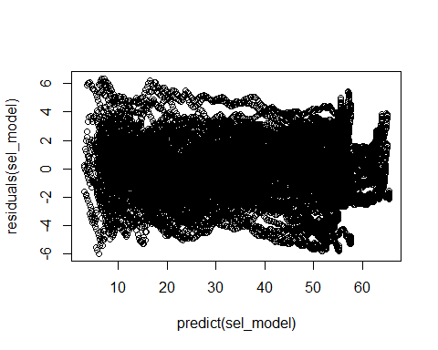

plot(agdu_compare)

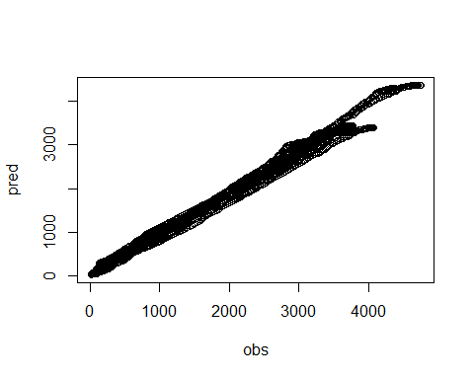

## Prediction Scenarios

As a researcher, the practical value of pollination date prediction is to model different planting scenarios and make informed resourcing decisions. Below are examples.

Considerations:

* Planting date and variety maturity are user provided inputs.
* Plant development is only affected by GDUs after planting. GDUs prior to planting are subtracted in variable agdu_ap_pred.
* Predicted pollination date is the date when gdu_mat# is reached as defined in scenario#.3.

#### Example 1: A researcher plants two varieties on the same date, one that pollinates at 1200 GDUs and one that pollinates at 1400 GDUs. Predict the date each variety will pollinate.

xy <- data.frame(envdat_test, agdu_pred = agdu_predsqrt^2)  
  
# Scenario 1 inputs:  
loc1 <- "Iowa County, IA"  
plant_yr1 <- 2011  
plant_day1 <- 112  
gdu_mat1 <- 1200  
  
# Scenario 2 inputs:  
loc2 <- "Iowa County, IA"  
plant_yr2 <- 2011  
plant_day2 <- 112  
gdu_mat2 <- 1400  
  
scenario1.1 <- subset(xy, county == loc1   
 & year == plant_yr1   
 & day_of_yr == plant_day1 - 1)  
scenario1.2 <- mutate(subset(xy, county == loc1   
 & year == plant_yr1   
 & day_of_yr >= plant_day1),  
 agdu_ap_pred = agdu_pred - scenario1.1$agdu_pred)  
scenario1.3 <- filter(scenario1.2, abs(agdu_ap_pred - gdu_mat1)   
 == min(abs(agdu_ap_pred - gdu_mat1)))  
  
scenario2.1 <- subset(xy, county == loc2   
 & year == plant_yr2   
 & day_of_yr == plant_day2 - 1)  
scenario2.2 <- mutate(subset(xy, county == loc2   
 & year == plant_yr2   
 & day_of_yr >= plant_day2),  
 agdu_ap_pred = agdu_pred - scenario2.1$agdu_pred)  
scenario2.3 <- filter(scenario2.2, abs(agdu_ap_pred - gdu_mat2)  
 == min(abs(agdu_ap_pred - gdu_mat2)))  
  
ggplot(mapping = aes(x = day_of_yr, y = agdu_ap_pred)) +  
 geom_line(data = scenario1.2, color = "blue", size = 1) +  
 geom_segment(aes(x = min(scenario1.2$day_of_yr), y = gdu_mat1,  
 xend = scenario1.3$day_of_yr, yend = gdu_mat1),  
 size = 1, linetype = 3) +  
 geom_segment(aes(x = scenario1.3$day_of_yr, y = 0,  
 xend = scenario1.3$day_of_yr, yend = gdu_mat1),  
 size = 1, linetype = 3) +  
 geom_line(data = scenario2.2, color = "red", size = 1) +  
 geom_segment(aes(x = min(scenario2.2$day_of_yr), y = gdu_mat2,  
 xend = scenario2.3$day_of_yr, yend = gdu_mat2),  
 size = 1, linetype = 3) +  
 geom_segment(aes(x = scenario2.3$day_of_yr, y = 0,  
 xend = scenario2.3$day_of_yr, yend = gdu_mat2),  
 size = 1, linetype = 3)

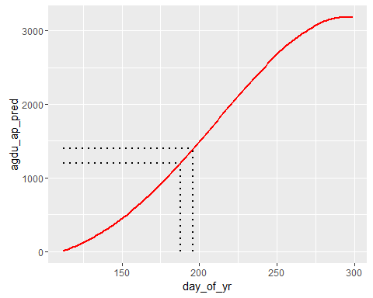

scenario1.3$date

## [1] 2011-07-07  
## 7305 Levels: 1992-01-01 1992-01-02 1992-01-03 1992-01-04 ... 2011-12-31

scenario2.3$date

## [1] 2011-07-15  
## 7305 Levels: 1992-01-01 1992-01-02 1992-01-03 1992-01-04 ... 2011-12-31

#### Example 2: A researcher intended to plant on April 9 (day 100) but was delayed for 14 days due to rain. Predict the number of days that pollination will be delayed.

# Scenario 1 inputs:  
loc1 <- "Darke County, OH"  
plant_yr1 <- 2011  
plant_day1 <- 100  
gdu_mat1 <- 1300  
  
# Scenario 2 inputs:  
loc2 <- "Darke County, OH"  
plant_yr2 <- 2011  
plant_day2 <- 114  
gdu_mat2 <- 1300  
  
scenario1.1 <- subset(xy, county == loc1   
 & year == plant_yr1   
 & day_of_yr == plant_day1 - 1)  
scenario1.2 <- mutate(subset(xy, county == loc1   
 & year == plant_yr1   
 & day_of_yr >= plant_day1),  
 agdu_ap_pred = agdu_pred - scenario1.1$agdu_pred)  
scenario1.3 <- filter(scenario1.2, abs(agdu_ap_pred - gdu_mat1)   
 == min(abs(agdu_ap_pred - gdu_mat1)))  
  
scenario2.1 <- subset(xy, county == loc2   
 & year == plant_yr2   
 & day_of_yr == plant_day2 - 1)  
scenario2.2 <- mutate(subset(xy, county == loc2   
 & year == plant_yr2   
 & day_of_yr >= plant_day2),  
 agdu_ap_pred = agdu_pred - scenario2.1$agdu_pred)  
scenario2.3 <- filter(scenario2.2, abs(agdu_ap_pred - gdu_mat2)  
 == min(abs(agdu_ap_pred - gdu_mat2)))  
  
ggplot(mapping = aes(x = day_of_yr, y = agdu_ap_pred)) +  
 geom_line(data = scenario1.2, color = "blue", size = 1) +  
 geom_segment(aes(x = min(scenario1.2$day_of_yr), y = gdu_mat1,  
 xend = scenario1.3$day_of_yr, yend = gdu_mat1),  
 size = 1, linetype = 3) +  
 geom_segment(aes(x = scenario1.3$day_of_yr, y = 0,  
 xend = scenario1.3$day_of_yr, yend = gdu_mat1),  
 size = 1, linetype = 3) +  
 geom_line(data = scenario2.2, color = "red", size = 1) +  
 geom_segment(aes(x = min(scenario2.2$day_of_yr), y = gdu_mat2,  
 xend = scenario2.3$day_of_yr, yend = gdu_mat2),  
 size = 1, linetype = 3) +  
 geom_segment(aes(x = scenario2.3$day_of_yr, y = 0,  
 xend = scenario2.3$day_of_yr, yend = gdu_mat2),  
 size = 1, linetype = 3)

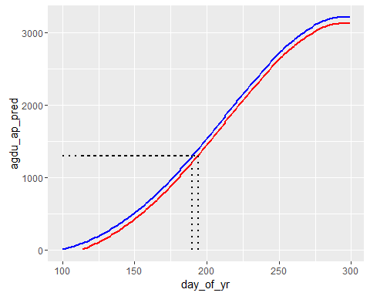

scenario1.3$date

## [1] 2011-07-09  
## 7305 Levels: 1992-01-01 1992-01-02 1992-01-03 1992-01-04 ... 2011-12-31

scenario2.3$date

## [1] 2011-07-13  
## 7305 Levels: 1992-01-01 1992-01-02 1992-01-03 1992-01-04 ... 2011-12-31

Because GDUs accumulate more slowly in the early spring, a 14 day planting delay is predicted to result in only a 4 day delay in pollination.

## Conclusions

...

## Follow-up before submitting...

* Replace above model with robust linear model with no sqrt transformation?
* Get feedback from Henry

# Training data results:  
sel_model_rlm <- MASS::rlm(agdu ~ poly(day_of_yr, 3) + grow_season   
 + year + ersst_lag6mo, data = envdat_train)  
summary(sel_model_rlm)

##   
## Call: rlm(formula = agdu ~ poly(day_of_yr, 3) + grow_season + year +   
## ersst_lag6mo, data = envdat_train)  
## Residuals:  
## Min 1Q Median 3Q Max   
## -807.48 -123.60 13.97 115.77 793.72   
##   
## Coefficients:  
## Value Std. Error t value   
## (Intercept) -28539.3203 564.6188 -50.5462  
## poly(day_of_yr, 3)1 153135.6928 194.1987 788.5514  
## poly(day_of_yr, 3)2 9316.0361 194.2824 47.9510  
## poly(day_of_yr, 3)3 -18109.7407 194.1972 -93.2544  
## grow_season 15.1692 0.0815 186.0627  
## year 13.8316 0.2822 49.0206  
## ersst_lag6mo 40.8404 1.6293 25.0660  
##   
## Residual standard error: 176.8 on 18893 degrees of freedom

agdu_pred_rlm <- predict(sel_model_rlm, envdat_test)  
agdu_compare_rlm <- data.frame(obs = envdat_test$agdu, pred = agdu_pred_rlm)  
  
# R sq for test data:  
caret::defaultSummary(agdu_compare_rlm)

## RMSE Rsquared   
## 236.6786619 0.9829922

plot(predict(sel_model), residuals(sel_model))



plot(agdu_compare)

