Temperature Plots

Tom Gocken

Tuesday, January 26, 2016

### Load previously created tidy dataset, envdat

envdat <- read.delim("C:/Projects/data/envdat.txt")

### Create by month and by year datasets

library(dplyr)

##   
## Attaching package: 'dplyr'  
##   
## The following objects are masked from 'package:stats':  
##   
## filter, lag  
##   
## The following objects are masked from 'package:base':  
##   
## intersect, setdiff, setequal, union

envdat$yr_mo <- envdat$year + envdat$month / 12  
  
envdat_by_month <- envdat %>%  
 group_by(yr_mo) %>%  
 summarize(max_air_temp_mean = mean(max_air_temp),  
 max_air_temp_median = median(max_air_temp),  
 n = n()) %>%  
 arrange(yr_mo)  
  
envdat_by_year <- envdat %>%  
 group_by(year) %>%  
 summarize(max_air_temp_mean = mean(max_air_temp),  
 max_air_temp_median = median(max_air_temp),  
 n = n()) %>%  
 arrange(year)

### Plot raw max temp air data, by month data, and by year data

library(ggplot2)  
library(gridExtra)  
  
p1 <- ggplot(aes(x = date, y = max_air_temp), data = envdat) + geom_point(alpha = 1/20)  
p2 <- ggplot(aes(x = yr_mo, y = max_air_temp_mean), data = envdat_by_month) +  
 geom_line() + geom_smooth()  
p3 <- ggplot(aes(x = year, y = max_air_temp_mean), data = envdat_by_year) +  
 geom_line() + geom_smooth()  
  
grid.arrange(p1, p2, p3, ncol = 1)

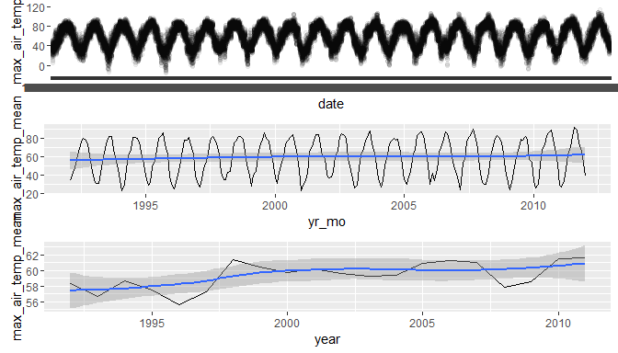

### Correlations of max air temp with month and year

cor.test(envdat_by_month$yr_mo, envdat_by_month$max_air_temp_mean, method = 'pearson')

##   
## Pearson's product-moment correlation  
##   
## data: envdat_by_month$yr_mo and envdat_by_month$max_air_temp_mean  
## t = 1.0033, df = 238, p-value = 0.3167  
## alternative hypothesis: true correlation is not equal to 0  
## 95 percent confidence interval:  
## -0.06224436 0.18996586  
## sample estimates:  
## cor   
## 0.06489707

cor.test(envdat_by_year$year, envdat_by_year$max_air_temp_mean, method = 'pearson')

##   
## Pearson's product-moment correlation  
##   
## data: envdat_by_year$year and envdat_by_year$max_air_temp_mean  
## t = 3.1131, df = 18, p-value = 0.006005  
## alternative hypothesis: true correlation is not equal to 0  
## 95 percent confidence interval:  
## 0.2019319 0.8195574  
## sample estimates:  
## cor   
## 0.5915888