

Predicting Success Rates of Kickstarter Projects

Milestone report #1

Tom Halloin

2019

Problem Statement:

Kickstarter is a crowdfunding website where users can raise funds to support creative projects. With enough funding, creators have the ability to launch new products, market new ideas, and possibly create new businesses. A successful project is one that passes its funding goal amount. If a project does not pass its goal amount, the project creators receive no funding. The goal is to determine the characteristics of a successful project and look for ways that creators can improve their chances of getting funding.

The Dataset:

There are many different Kickstarter data sets available, such as on Kaggle. I used the monthly files on <https://webrobots.io/kickstarter-datasets/> to get projects scraped from January 2016 to April 2019. For each project, I kept the following columns: backers_count, blurb, category name, category slug, country, currency, goal, launched_at, deadline, location_displayable_name, location_country, location_state, location_type, name, usd_pledged, slug, spotlight, staff_pick, static_usd_rate, and state.

Data Wrangling:

I created some new features: days before deadline, a goal converted from foreign currency to US dollars, the length of the blurb, and a binary final state. The original state had five different outcomes: success, failed, live, cancelled, and suspended. The binary final state converts these five outcomes to only success and failure by treating cancelled, suspended, and live projects that did not reach their funding goal as failures, while converting live projects that exceeded their funding goals as successful projects. This will be the target variable.

Five columns had missing values: blurb, location.displayable_name, location.country, location.state, and location.type. I replaced the missing blurbs with a ‘-‘, missing location.state values with ‘-‘, and missing location.type values with ‘Miscellaneous’. There are instances where the country differed from the ‘location.country’. The location.country matched the location.displayable_name (i.e. Jamaica to Kingston, Jamaica), so I kept that column and dropped the ‘country’ column.

Most scrapes had duplicate projects, which I dropped. The final data frame has 430,714 projects and 29 variables.

Exploratory Data Analysis

This is the original distribution of projects for each target category. When considering canceled, suspended, and live projects that have not met their goal as “failed”, there are more failed projects than successful ones.

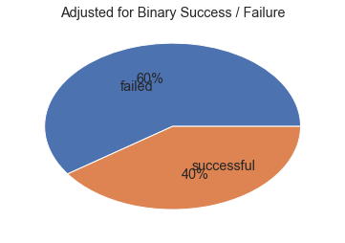

The most successful projects have the most people backing them. There is almost a direct correlation between the number of people backing a project and the project’s success rate. I will not include this in the final model, though. The goal is to build a model that will predict the success of a Kickstarter project before its launch. Models before launch have zero backers.

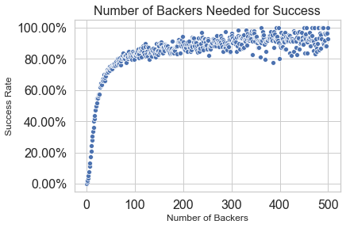

Kickstarter classifies their projects into 15 different categories: art, comics, crafts, design, film and video, food, games, music, journalism, publishing, photography, technology, theater, and dance. Each one of these categories has a number of different sub-categories for a better description of the project. For the sake of EDA, I will stick with the broader categories. I included two additional charts by category: number of backers for each project and number of projects without any backers.

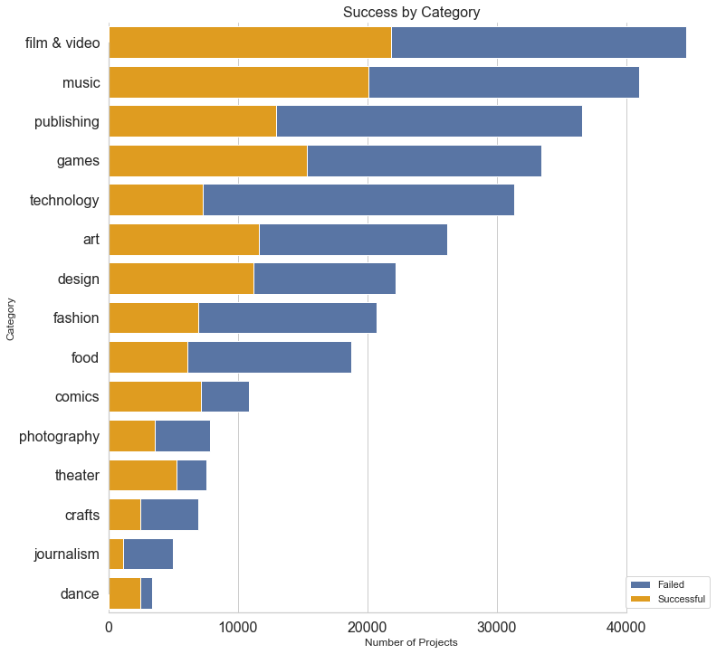

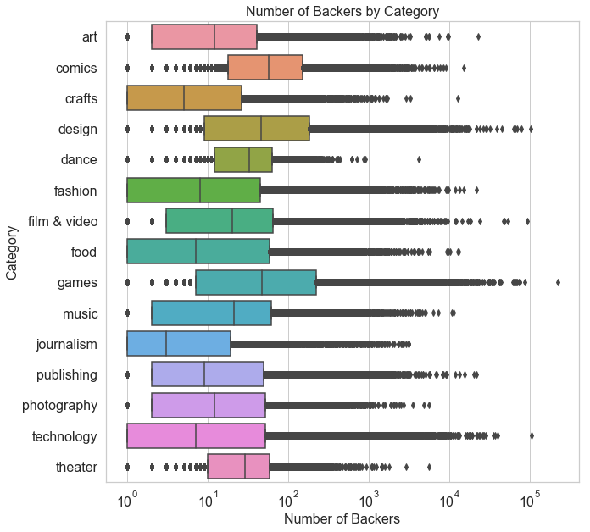

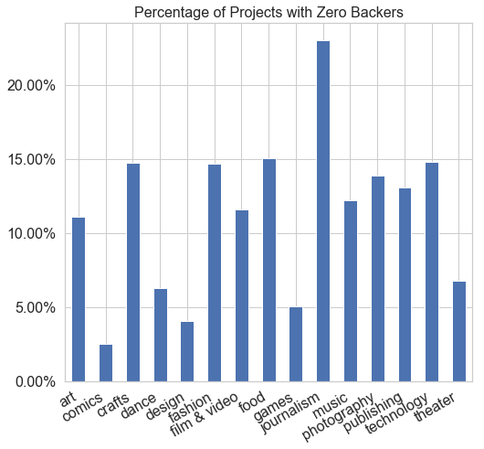

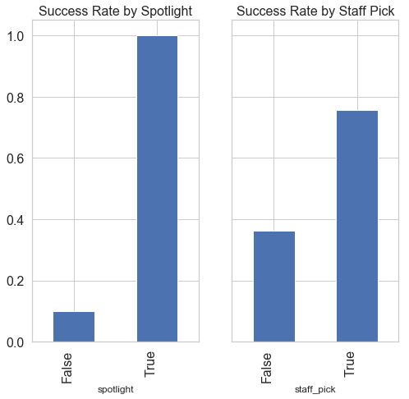Kickstarter projects can have two additional designations: spotlight and staff_pick. The spotlight is for successful projects to share their story and progression. Staff picks are listed under “projects we love” and the first item that appears when searching for a project. It appears that putting a project in the spotlight or giving it a staff pick does increase the odds of the project receiving funding.

Over time, fewer Kickstarter projects have received funding. A part of this trend might come from the data collection and scraping process. The data come from JSONs scraped from January 2016 to April 2019. Each month contains scrapes from projects started before the scrape date. The monthly scrape in January 2016 contained 13 projects started in 2009. As Kickstarter became more popular, more people started to advertise their projects on the site. This led to more competition, driving the success rate down. It is also worth noting that some live projects are marked as “failures” even though their projects have not reached the funding deadline. That explains much of the drop in 2019 success rates.

The United States has the most number of Kickstarter projects, followed by Great Britain, Canada, and Australia. Over 50 percent of the Hong Kong, Switzerland, and Japan projects surpassed their funding goal.

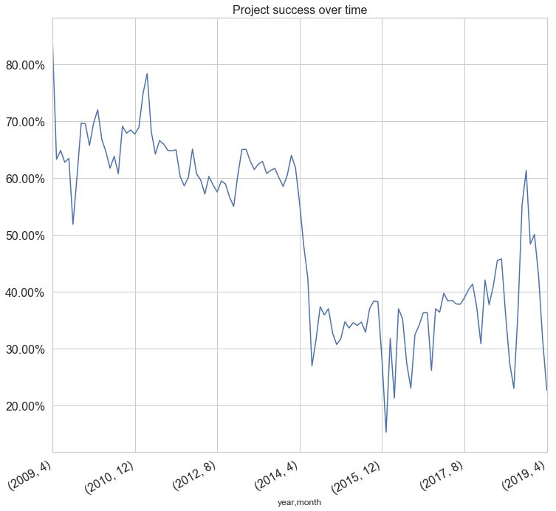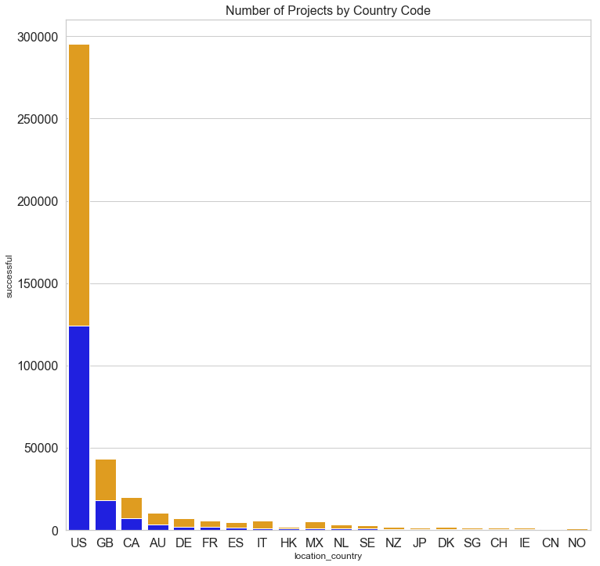

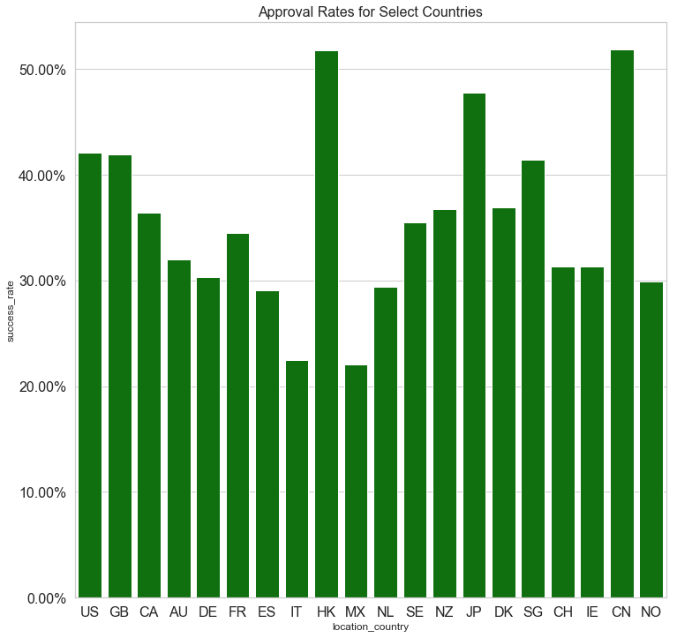

Statistical Inference

At this point, I have four quantitative variables: goal amount, amount pledged, number of backers, and blurb length. On the next page is a scatterplot for all four variables compared against each other. Ideally, all of the variables would be normally distributed, but that is not the case here. Some projects have goal amounts over $10,000,000, while most have much less than that. It also appears that the number of backers correlates to the amount raised. Before log transformation, I want to show a correlation matrix of these four variables. While there isn’t an association between the goal amount and the actual amount raised, there is a positive association between the number of backers a project has and the amount raised. An R^2 value of .77 means that 77% of the variance in the amount raised can be explained by the number of backers. After performing a log transformation on the goal amount, pledged amount, and number of backers, the R^2 rises to .93.

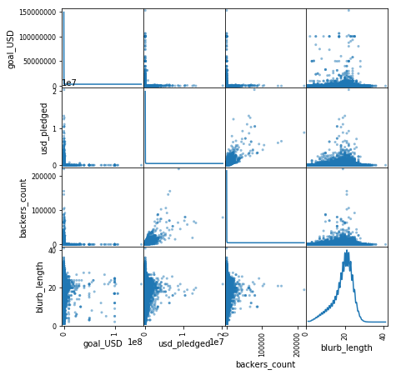

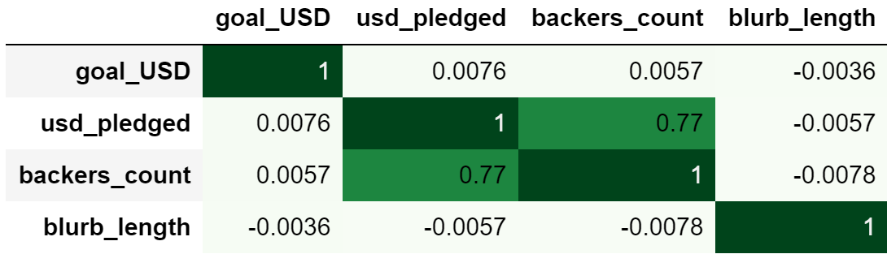

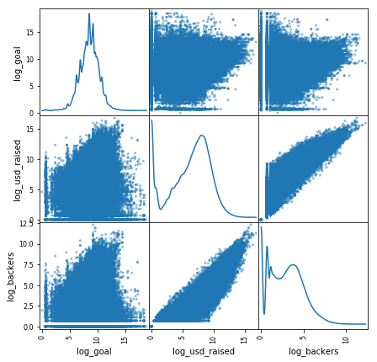

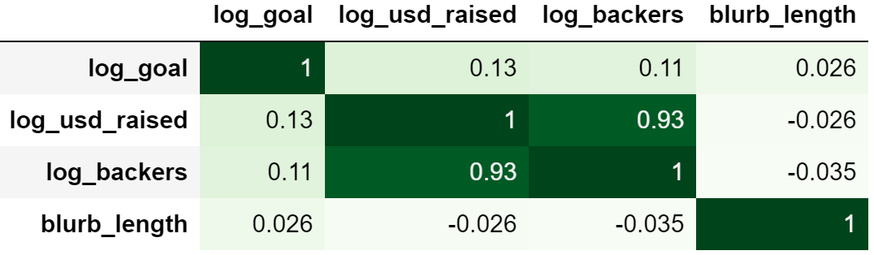

For the categorical variables, I performed a series of Chi-Square tests to determine

whether there was any statistically significant difference between the expected frequency and actual frequency of project approval rates. Below is a table showing the null and alternative hypothesis, the test value result, and conclusion. All of the p-values turned out to be small enough so that they were considered to be zero after significant rounding error, so we can assume all of these variables matter in terms of predicting Kickstarter project success.



What is to come:

Machine learning and model selection (Logistic Regression, Decision tree (baseline, max depth of 9), Random forest, Support Vector Machines, XGBoost, Light GBM

Performing Natural Language Processing on the blurb (project description) to find popular topics

The Basics of Kickstarter Projects:

Before performing any machine learning, I want to take a step back to reexamine the original question and purpose of this project. Suppose I want to start a Kickstarter project and want to use this study to figure out what will bring a successful outcome. Here are the steps to create a basic project:

1. Pick a category and subcategory
2. Give project a title.
3. Describe what you’re creating (blurb).
4. Pick your country from the following: Australia, Austria, Belgium, Canada, France, Denmark, Germany, Hong Kong, Ireland, Italy, Japan, Luxembourg, Mexico, New Zealand, Netherlands, Norway, Singapore, Spain, Sweden, Switzerland, United States, United Kingdom.
5. Give the project an image
6. Set a funding goal
7. Set a campaign duration

Since this is what creators can fill in for basic information, these are what we should put in the model. Factors like number of backers and amount raised can predict approval, but a project creator cannot control them. I want to model what I can control and optimize that.