Lectures 4: Constitutional Safeguards
  - GOVT2305: Federal Government
Tom Hanna
2026-07-14
Table of contents
1. Agenda and Announcements 3
1.1 Today’s Agenda 3
1.2 Due Dates 4
1.3 Next Week’s Agenda 4
1.4 Important Dates 4
1.5 Important Dates 2 4
2. Today’s Topic: Separation of Powers, Federalism, Checks and Balances 4
2.1 Review 4
2.2 Discussion 5
2.3 Why do we care about the Constitution 5
2.4 How did the Constitutional design limit abuse of power 5
2.5 Separation of Powers 6
2.6 Separation of Powers 6
2.7 Separation of Powers 6
2.8 Splitting up power to prevent abuse 6
2.9 Splitting up power to prevent abuse 6
2.10 Splitting up power to prevent abuse 7
2.11 Checks and Balances 7
2.12 Splitting up power to prevent abuse 7
2.13 Splitting up power to prevent abuse 7
2.14 Three Branches of Government: Basic Powers 8
2.15 Three Branches of Government: Basic Powers 8
2.16 Legislative Branch: Article I 8
2.17 Legislative Branch: Article I 8
2.18 Legislative Branch: Article I 9
2.19 Executive Branch: Article II 9
2.20 Executive Branch: Article II 9
2.21 Executive Branch: Article II 9
2.22 Question 1 9
2.23 Question 1 9
2.24 Judicial Branch: Article III 10
2.25 Judicial Branch: Article III 10
2.26 Judicial Branch: Article III 10
2.27 Judicial Branch: Article III 10
2.28 Judicial Branch: Article III 10
2.29 Judicial Branch: Article III 10
2.30 Judicial Branch: Article III 11
2.31 Question 2 11
2.32 Question 2 11
2.33 Three Branches of Government: Checks on other branches 11
2.34 Congress: More Separation of Powers 11
2.35 Congress: More Separation of Powers 12
2.36 Congress: More Separation of Powers 12
2.37 Congress: More Separation of Powers 12
2.38 Question 3 12
2.39 Question 3 12
2.40 The interests of the states 12
2.41 The interests of the states 12
2.42 The interests of the states 12
2.43 The interests of the states 13
2.44 The interests of the states 13
2.45 Federalism: National and State Power 14
2.46 Federalism: National and State Power 14
2.47 Federalism: National and State Power 14
2.48 Federalism: National and State Power 14
2.49 State Powers 14
2.50 State Powers 15
2.51 State Powers 15
2.52 State Powers 15
2.53 State Powers 15
2.54 State Powers 15
2.55 Question 4 15
2.56 Question 4 15
2.57 National Powers 15
2.58 Bill of Rights 16
2.59 Bill of Rights 16
2.60 Question 5 16
2.61 Question 5 16
2.62 Government: Delegated Violence 16
2.63 Government: Delegated Violence 17
2.64 Government: Delegated Violence 17
2.65 Government: Delegated Violence 17
2.66 Government: Delegated Violence 17
2.67 Authorship and License 18

1. Agenda and Announcements

1.1 Today’s Agenda
- Suggested to complete today:
- - Chapter 3 and 4
- Journal on Chapter 3 and 4
- Think about/begin Study Guide 2 Questions
- Activity and Discussion (First half):
- - If government is violence what is appropriate for government to do?
- If government is violence how much should we limit its use?
- If government is violence how can we best enforce those limits?
- Lecture (Second half):
- - Constitutional Safeguards
- Checks and Balances
- Separation of Powers
- Federalism

1.2 Due Dates
- Friday, July 17, 11:59 PM - Turn in Module 1 Study Guide
- Monday, July 20, beginning of class - Module 1 Quiz
- Monday, July 20, beginning of Class - Module 1 Journals (8 pages handwritten or 2400 words typed total)
- Monday, July 20, 11:59 PM - Module 1 Connect Assignments

1.3 Next Week’s Agenda
- Monday Lecture: Misinformation
- Discussion: Misinformation and Civil Discourse
- Tuesday Lecture: Civil Liberties
- Tuesday Discussion: Civil Liberties and Majority Power

1.4 Important Dates
- Total for next week is 7 chapters, but still 8 pages or 2400 words for journals.
- July 20 Suggested
- - These entries are half size, one page handwritten or 300 words typed each. You can write slightly less for each and total 6 pages or 1800 words.
- Chapter 6: Chapter 6: Public Opinion and Political Socialization: Shaping the People’s Voice
- Chapter 7: Political Participation: Activating the Popular Will
- Chapter 8: Political Parties, Candidates, and Campaigns: Defining the Voter’s Choice
- Chapter 9: Interest Groups: Organizing for Influence
- Chapter 10: The News Media and the Internet: Communicating Politics

1.5 Important Dates 2
- Suggested for July 21
- - Chapter 11: Congress: Balancing National Goals and Local Interests
- The Federalist: 58, 62, and 63

2. Today’s Topic: Separation of Powers, Federalism, Checks and Balances

2.1 Review
- Basic problem: Government is organized coercive violence seen as legitimate
- - Great power to do good consensually where we are largely unified
- Great power to do bad if resort to corecive violence is necessary because there is not wide agreement

2.2 Discussion
- If government is violence what is appropriate for government to do?
- If government is violence how much should we limit its use?
- If government is violence how can we best enforce those limits?

2.3 Why do we care about the Constitution
- The Constitution set out a system to limit the power of government to allow for the good and limit the bad
- If we just pretend to follow it, it has no real power to limit oppression - political violence
- The Constitution has been changed, in some ways drastically to deal with some of its original flaws
- There is a process to change it further if there is unity in the desire for change, but fundamental rights are not up to simple majorities

2.4 How did the Constitutional design limit abuse of power
- Separation of Powers within the federal government
- Checks and balances between individuals groups in the federal government
- Federalism: separation of powers between levels of government - state/federal
- The addition of the Bill of Rights (First 10 Amendments)

2.5 Separation of Powers
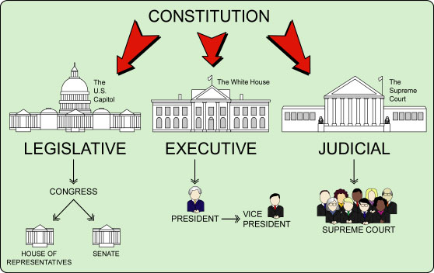
Source: Bill of Rights Institute

2.6 Separation of Powers
The Constitution was devised with an ingenious and intricate built-in system of checks and balances to guard the people’s liberty against combinations of government power.
National Center for Constitutional Studies: https://nccs.net/

2.7 Separation of Powers
The Constitution was devised with an ingenious and intricate built-in system of checks and balances to guard the people’s liberty against combinations of government power.
National Center for Constitutional Studies: https://nccs.net/
It has gotten much better through Amendment!

2.8 Splitting up power to prevent abuse
- Separate power among competing groups with different agendas

2.9 Splitting up power to prevent abuse
- Separate power among competing groups with different agendas
- The power of one group balances the power of competing groups

2.10 Splitting up power to prevent abuse
- Separate power among competing groups with different agendas
- The power of one group balances the power of competing groups
- The competing interests force the groups to check each other’s power

2.11 Checks and Balances
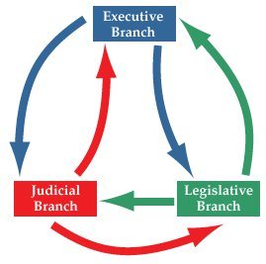
Source: https://lsintspl3.wgbh.org/en-us/lesson/midlit10-soc-splgovt/1

2.12 Splitting up power to prevent abuse
- Separate power among competing groups with different interests
- The power of one group balances the power of competing groups
- The competing interests force the groups to check each other’s power
- No one group or individual has sufficient power to dominate the others and act alone

2.13 Splitting up power to prevent abuse
- Separate power among competing groups with different interests
- The power of one group balances the power of competing groups
- The competing interests force the groups to check each other’s power
- No one group or individual has sufficient power to dominate the others and act alone
This is Separation of Powers and Checks and Balances

2.14 Three Branches of Government: Basic Powers
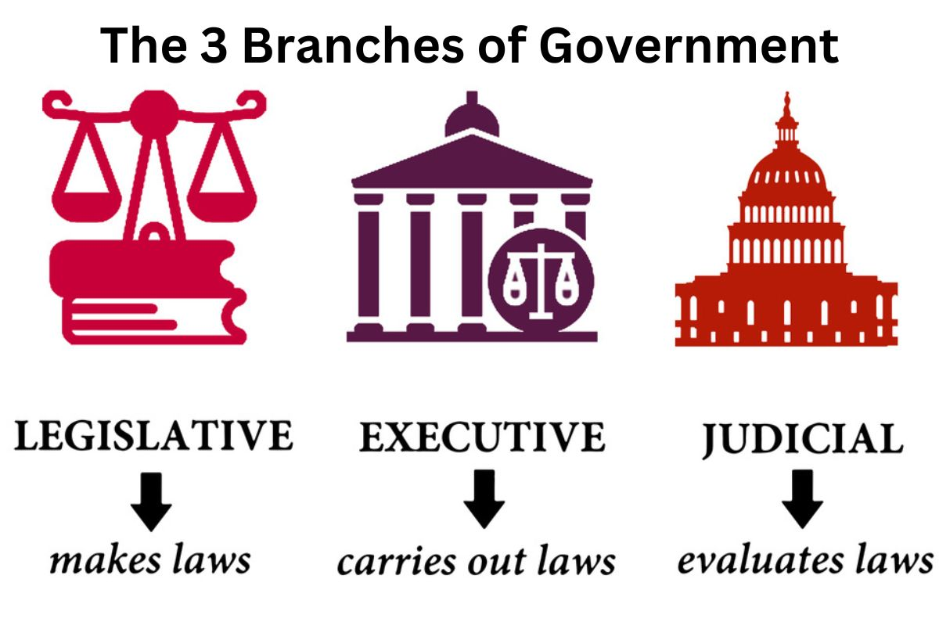
Source: Have Fun with History

2.15 Three Branches of Government: Basic Powers
- Legislative: Congress - Makes laws
- Executive: President - Executes the laws and governs
- Judicial: Courts - Interprets and applies the laws

2.16 Legislative Branch: Article I
Congress: Makes laws
- Impeach Presidents and Justices of Supreme Court

2.17 Legislative Branch: Article I
Congress: Makes laws
- Impeach Presidents and Justices of Supreme Court
- Override Presidential vetoes by 2/3 majority of both houses

2.18 Legislative Branch: Article I
Congress: Makes laws
- Impeach Presidents and Justices of Supreme Court
- Override Presidential vetoes by 2/3 majority of both houses
- Restrict extent of the Supreme Courts jurisdiction

2.19 Executive Branch: Article II
President: Executes the laws and governs
- Veto bills passed by Congress

2.20 Executive Branch: Article II
President: Executes the laws and governs
- Veto bills passed by Congress
- Pardon criminals convicted by Courts

2.21 Executive Branch: Article II
President: Executes the laws and governs
- Veto bills passed by Congress
- Pardon criminals convicted by Courts
- Some discretion in how laws are carried out and enforced

2.22 Question 1
- Which branch of government has the power to impeach the President and Justices of the Supreme Court?
  - A. Legislative
  - B. Executive
  - C. Judicial
  - D. None of the above

2.23 Question 1
Answer: A. Legislative - Congress has the power to impeach the President and Justices of the Supreme Court

2.24 Judicial Branch: Article III
Courts: Interpret and apply the laws
- No explicit powers to check the other branches listed in the COnstitution

2.25 Judicial Branch: Article III
Courts: Interpret and apply the laws
- No explicit powers to check the other branches listed in the COnstitution
- Major implied power: Judicial Review

2.26 Judicial Branch: Article III
Courts: Interpret and apply the laws
- The Constitution is the ”supreme law of the land”

2.27 Judicial Branch: Article III
This Constitution, and the Laws of the United States which shall be made in Pursuance thereof; and all Treaties made, or which shall be made, under the Authority of the United States, shall be the supreme Law of the Land; and the Judges in every State shall be bound thereby, any Thing in the Constitution or Laws of any State to the Contrary notwithstanding
United States Constituion, Article VI, Clause 2

2.28 Judicial Branch: Article III
Courts: Interpret and apply the laws
- The Constitution is the ”supreme law of the land”
- Interpret and apply the laws including the Constitution

2.29 Judicial Branch: Article III
Courts: Interpret and apply the laws
- The Constitution is the ”supreme law of the land”
- Interpret and apply the laws including the Constitution
- Implied: The power to review laws passed by Congress to enforce the Constitution

2.30 Judicial Branch: Article III
Courts: Interpret and apply the laws
- The Constitution is the ”supreme law of the land”
- Interpret and apply the laws including the Constitution
- Implied: The power to review laws passed by Congress to enforce the Constitution
- Implied: The power to review the acts of Presidents

2.31 Question 2
- Which branch of government has the power to review laws passed by Congress to enforce the Constitution?
  - A. Legislative
  - B. Executive
  - C. Judicial
  - D. None of the above

2.32 Question 2
Answer: C. Judicial - Courts have the power to review laws passed by Congress to enforce the Constitution

2.33 Three Branches of Government: Checks on other branches
- Congress - veto override, impeachment, set jurisdiction
- President - veto, pardon, discretion in enforcement
- Courts - Judicial review - decide the Constitutionality

2.34 Congress: More Separation of Powers
Congress is split into two houses
- House of Representatives
- Senate
We, therefore, the Representatives of the united States of America, in General Congress, Assembled, appealing to the Supreme Judge of the world for the rectitude of our intentions, do, in the Name, and by Authority of the good People of these Colonies, solemnly publish and declare, That these United Colonies are, and of Right ought to be Free and Independent States…
States - plural, not “A Free and Independent State” singular

2.35 Congress: More Separation of Powers
- Bills must pass both houses to become law
- Each house has different powers and responsibilities
- Each house has different constituencies and terms of office
- Each house has different rules and procedures

2.36 Congress: More Separation of Powers
- House of Representatives
- - elected every two years
- elected by districts
- closer to the people, more responsive to public opinion

2.37 Congress: More Separation of Powers
- Senate
- - elected every six years
- elected by states (originally appointed by states)
- more insulated from public opinion, more deliberative
- intended to represent the interests of the states

2.38 Question 3
- The states claimed the status of 13 free and independent sovereign states in the Declaration of Independence states. True or False?
  - A. True
  - B. False

2.39 Question 3
Answer: True

2.40 The interests of the states
- The Senate was intended to represent the interests of the states

2.41 The interests of the states
- The Senate was intended to represent the interests of the states
- This was a compromise between large and small states

2.42 The interests of the states
- The Senate was intended to represent the interests of the states
- This was a compromise between large and small states
- This was necessary to pass the Constitution because:
- - the states were sovereign entities, essentially independent nations

2.43 The interests of the states
- The Senate was intended to represent the interests of the states
- This was a compromise between large and small states
- This was necessary to pass the Constitution because:
- - the states were sovereign entities, essentially independent nations
- the states had to ratify the Constitution

2.44 The interests of the states
- The Senate was intended to represent the interests of the states
- This was a compromise between large and small states
- This was necessary to pass the Constitution because:
- - the states were sovereign entities, essentially independent nations
- the states had to ratify the Constitution
- the states were the original source of the federal government's power

2.45 Federalism: National and State Power
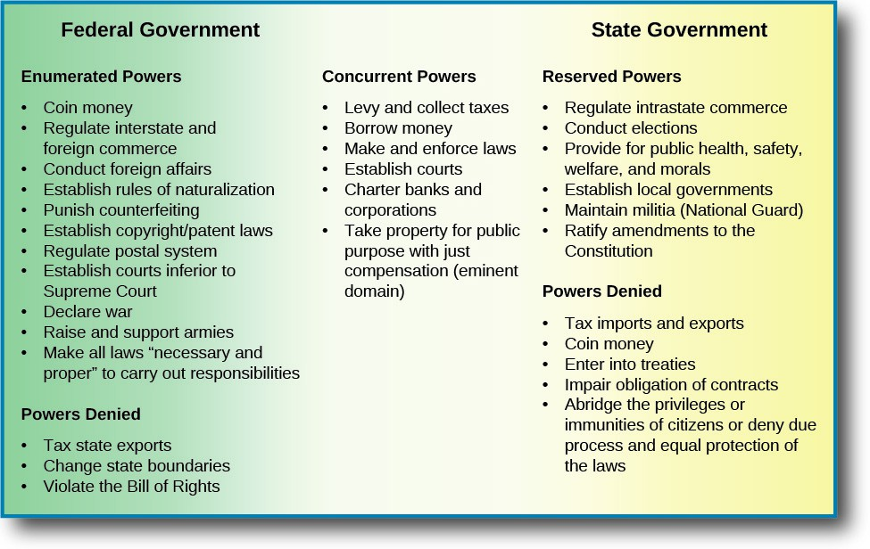
Source: https://mlpp.pressbooks.pub/pol111mhs/chapter/3-1-federalism-as-a-structure-for-power/

2.46 Federalism: National and State Power
- Original states were sovereign countries

2.47 Federalism: National and State Power
- Original states were sovereign countries
- States kept all powers not expressly given to the federal government

2.48 Federalism: National and State Power
- Original states were sovereign countries
- States kept all powers not expressly given to the federal government
- Police powers: laws regulating most major issues like:

2.49 State Powers
MURDER!
- Assault, battery, kidnapping, almost all crimes of violence

2.50 State Powers
THEFT!
- fraud, robbery, trespassing, almost all crimes against property

2.51 State Powers
PROPERTY REGISTRATION!

2.52 State Powers
BUSINESS FORMATION and CONTRACTS
Most laws relating to contracts, types of businesses, liability, and more

2.53 State Powers
INSURANCE

2.54 State Powers
ALMOST EVERYTHING INTRASTATE
Intrastate is within a single state’s borders

2.55 Question 4
Which of the following is a power of the states?
- A. Regulating commerce with other states (interstate)
- B. Regulating foreign commerce
- C. Regulating commerce within the state (intrastate)
- D. Regulating the military

2.56 Question 4
Answer: - C. Regulating commerce within the state (intrastate)

2.57 National Powers
- Constitution gave explicit powers to the federal government
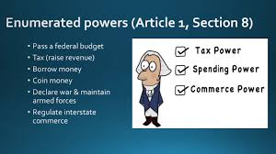
Source: https://www.youtube.com/@CareyLaManna

2.58 Bill of Rights
The powers not delegated to the United States by the Constitution, nor prohibited by it to the States, are reserved to the States respectively, or to the people.
- 10th Amendment to the United States Constitution

2.59 Bill of Rights
Unless the Constitution gives the federal government a power, it remains a state power or a right of the people

2.60 Question 5
Which part of the Congress was intended to represent the interests of the states?
- A. The House of Representatives
- B. The Senate
- C. The President
- D. The Supreme Court

2.61 Question 5
Answer: B. The Senate

2.62 Government: Delegated Violence
- Who is responsible for hired violence, the client or the hired muscle?

John Wick

2.63 Government: Delegated Violence
- Government acts on our behalf, especially in a democracy

2.64 Government: Delegated Violence
- Government acts on our behalf, especially in a democracy
- If something is unethical for individuals to do, does a majority or plurality vote make it ethical?

2.65 Government: Delegated Violence
- Government acts on our behalf, especially in a democracy
- If something is unethical for individuals to do, does a majority or plurality vote make it ethical?
- Can we delegate violence to the government that we cannot ethically do ourselves?

2.66 Government: Delegated Violence
- Government acts on our behalf, especially in a democracy
- If something is unethical for individuals to do, does a majority or plurality vote make it ethical?
- Can we delegate violence to the government that we cannot ethically do ourselves?
- What consequences does this have for the need to restrain government?

2.67 Authorship and License
Do not submit to Quizlet, Chegg, Coursehero, or other similar commercial websites.
- Author: Tom Hanna
- Website: tomhanna.me
Graphics Credit: Unless otherwise noted graphics are from Norton Publishers
- License: This work is licensed under a Creative Commons Attribution-NonCommercial-ShareAlike 4.0 International License.

