Trade-offs and Unintended Consequences
  - GOVT2305: Federal Government
Tom Hanna
2026-07-27
Table of contents
1. Agenda and Announcements 2
1.1 Agenda Today 2
1.2 Upcoming Dates 2
2. Trade-offs and Unintended Consequences 3
2.1 Review 3
2.2 Where today fits 3
2.3 Federalist 10 3
2.4 What if men were angels? 3
3. Trade-offs 4
3.1 What is a trade-off? 4
3.2 Government rade-offs: Collective Benefits vs Individual Rights 4
3.3 The trade-off 4
3.4 John Hancock: Smuggler 1737-1793 5
3.5 Eric Garner: Smuggler 1970-2014 6
3.6 Unintended Consequences Add Complexity 6
3.7 Unintended consequences Examples 6
3.8 Unintended consequences Examples 7
3.9 Unintended consequences Examples 7
3.10 Unintended consequences Examples 7
3.11 Unintended consequences Examples 7
3.12 Unintended Consequences 7
3.13 Road to Serfdom 8
3.14 Road to Serfdom 8
3.15 Road to Serfdom 8
3.16 Incarceration Rates 8
3.17 Judging Public Policy Trade-offs: Economic and Social Trade-offs 9
3.18 Judging Public Policy Trade-offs: Economic and Social Trade-offs 9
3.19 Judging Public Policy Trade-offs: Economic and Social Trade-offs 9
3.20 Judging Public Policy Trade-offs: Economic and Social Trade-offs 10
3.21 Judging Public Policy Trade-offs: Economic and Social Trade-offs 11
3.22 Judging Public Policy Trade-offs: Economic and Social Trade-offs 12
3.23 Judging Public Policy Trade-offs: Short-term vs Long-term Benefits 12
3.24 Recap 13
3.25 Authorship and License 13

1. Agenda and Announcements

1.1 Agenda Today
- Lecture: Trade-offs and Unintended Consequences
- - Short review - how today's topic fits
- What are the trade-offs?
- What are the costs?
- Economic vs Social trade-offs
- Short term vs long term trade-offs
- Discussion: Trade-offs and Unintended Consequences

1.2 Upcoming Dates
- Semester Drawing to a close
- Module 3 Quiz August 3
- - Study Guide due Friday
- Journals Due Monday
- Connect Due Monday
- Module 4 Quiz August 4
- - Everything for Module 4 due Tuesday
- All late work due August 6
- Finals - August 5 and 6 per HCC schedule

2. Trade-offs and Unintended Consequences

2.1 Review
- We limit government because:
- - Government is the legitimate use of violent coercive force
- The only unique domestic tool of government is some form of police and prisons
- Force is "a dangerous servant and a fearful master"
- We enumerate individual rights because:
- - Specific lists eliminate confusion
- This is an additional protection against the abuse of violent force
- Why do we have government?
- - To secure the rights to life, liberty and property (core - original - hard to dispute)
- To do the additional things that allow us to live together peacefully in a society of dignified equals (fuzzier - decided democratically)

2.2 Where today fits
- The problems that make us want government to “do something” are only one part of deciding if certain laws or policies are good - often the least important part
- The violent force inherent in government is only one reason for this

2.3 Federalist 10
Madison wrote in Federalist 10:
If men were angels, no government would be necessary

2.4 What if men were angels?
- Madison meant angels in the sense of **goodness*
- So, if government officials were always purely good in their intentions and absolutely incorruptible, would that be enough?
- Even if we were governed by perfectly good beings, what are some reasons we might still need to limit government?
- What are some reasons we might need to limit voters (ourselves)?

3. Trade-offs

3.1 What is a trade-off?
Think of your personal life
- Cheap used car no payments - repair bills; new car payments - warranty and comfort
- Fun and enjoyment - spending money; hard and boring work - making money
- You have $3, you can buy a soda or a candy bar (or save the $3)
- Spending now vs. investing for the long term

3.2 Government rade-offs: Collective Benefits vs Individual Rights
- Free riders and taxation
- Economic trade-offs
- - inflation vs unemployment
- taxes vs economic growth
- too high tax rates can reduce government revenue
- Public health vs. vice laws and excise taxes
- - alcohol tax
- marijuana prohibition
- cigarette taxes
- prohibition of flavored cigarettes
- soda taxes

3.3 The trade-off
- The trade off: not just about public benefit vs private wants and needs
- benefit vs cost of enforcement
- financial costs of enforcement - just the beginning
- Human costs of enforcement
- Remember the definition of government!

3.4 John Hancock: Smuggler 1737-1793
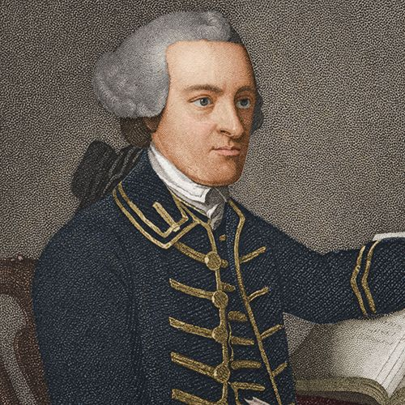
John Hancock, first signer of the Declaration of Independence was a smuggler evading British taxes on imported goods.

3.5 Eric Garner: Smuggler 1970-2014

Eric Garner: Killed by New York police while selling loose cigarettes to evade NY cigarette taxes
Source: Seven Last Words of the Unarmed

3.6 Unintended Consequences Add Complexity
- Unintended consequences of public policy make it even more difficult to judge the trade-offs
- Unintended consequences: the results of actions that were not foreseen or intended by a purposeful action.

3.7 Unintended consequences Examples
- Policy: Raising “sin” taxes
- - People use less and revenue drops
- Black markets are created - crime increases
- Black market are created - revenue drops
- Policy: very high progressive income taxes
- - more later

3.8 Unintended consequences Examples
- Raising “sin” taxes
- Very high progressive income taxes
- Ban of pesticide DDT in 1972
- - millions of mosquito born illness deaths
- sickness related financial costs to individuals, families, and governments

3.9 Unintended consequences Examples
- Raising “sin” taxes
- Very high progressive income taxes
- Ban of pesticide DDT in 1972
- Three strikes laws and capital punishment for rape or kidnapping

3.10 Unintended consequences Examples
- Raising “sin” taxes
- Very high progressive income taxes
- Ban of pesticide DDT in 1972
- Three strikes laws and capital punishment for rape or kidnapping
- - Criminals want no witnesses
- increase in murders

3.11 Unintended consequences Examples
Ten Examples of Unintended Consequences

3.12 Unintended Consequences
- Unintended consequences are an important trade-off
- They are not always predictable
- They should be expected and considered

3.13 Road to Serfdom
- F.A. Hayek - Nobel Memorial Prize in Economic Sciences (1974)
- Instead of repealing bad economic regulations because of unintended consequences, we pass more more economic regulations with more unintended consequences
- WWII, response to totalitarianism in Nazi Germany and Soviet Russia
The Road to Serfdom in Five Minutes

3.14 Road to Serfdom
- F.A. Hayek - Nobel Memorial Prize in Economic Sciences (1974)
- Instead of repealing bad laws because of unintended consequences, we pass more laws with more unintended consequences
- Hayek focus: economic central planning

3.15 Road to Serfdom
- F.A. Hayek - Nobel Memorial Prize in Economic Sciences (1974)
- Instead of repealing bad laws because of unintended consequences, we pass more laws with more unintended consequences
- Hayek focus: economic central planning
- What else could this apply to?

3.16 Incarceration Rates
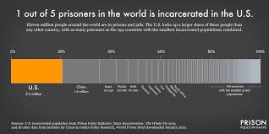
Incarceration Rates

3.17 Judging Public Policy Trade-offs: Economic and Social Trade-offs
- Poverty reduction versus climate change reduction
- Minimum wage increase versus job growth
- Subsidized healthcare versus inflation in healthcare prices
- Higher public spending vs higher deficits and inflation
- Education vs infrastructure
- Inequality vs. income growth

3.18 Judging Public Policy Trade-offs: Economic and Social Trade-offs
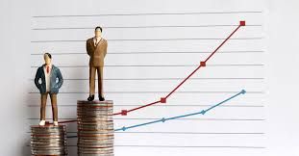
Inequality vs. income growth
Source: What’s So Bad about Increasing Inequality in Canada?

3.19 Judging Public Policy Trade-offs: Economic and Social Trade-offs
- Defense vs social services
- Free trade: more jobs overall vs job losses in some industries
- Costs of immigration vs economic growth contributions of immigrants
- inequality vs economic growth
- Tax rates vs tax revenue
- Tax rates vs economic growth

3.20 Judging Public Policy Trade-offs: Economic and Social Trade-offs
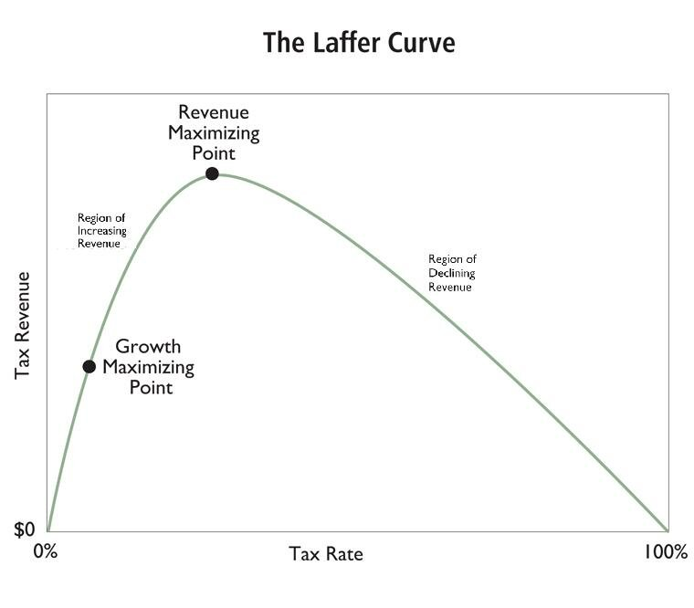
Laffer Curve: Tax Revenue vs Tax Rate
Source: Cato Institute

3.21 Judging Public Policy Trade-offs: Economic and Social Trade-offs

Laffer Curve: Tax Revenue vs Tax Rate
- Does the Laffer Curve mean lowering taxes always increases revenue?
- Does the Laffer Curve tell us anything about economic growth?
Source: Cato Institute

3.22 Judging Public Policy Trade-offs: Economic and Social Trade-offs
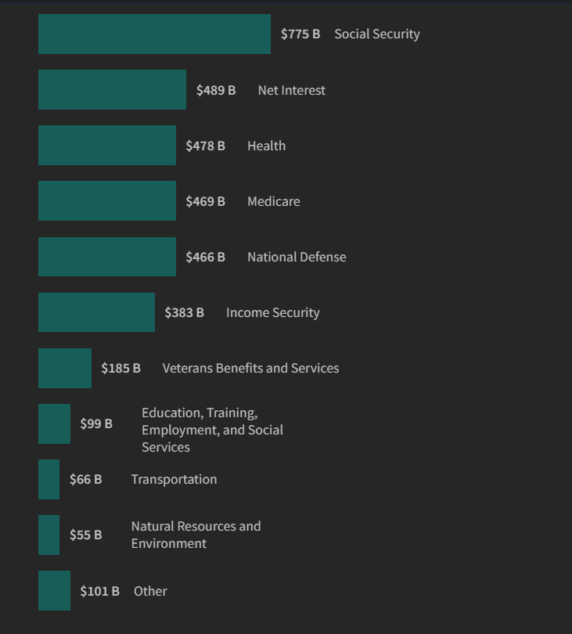
Federal Spending Categories: 2024-2025

3.23 Judging Public Policy Trade-offs: Short-term vs Long-term Benefits
- Higher taxes now vs. slower poverty reduction
- More consumption now vs. environmental issues later
- Higher spending now vs. Higher taxes later
- More educations spending now vs. economic growth later
- More infrastructure spending now vs. economic growth later
- More regulation now vs. fewer and lower paid jobs later
- Lower immigration now vs. population decline soon

3.24 Recap
- Government is a dangerous solutiona and not the only solution
- Where government is the solution, trade-offs should be considered carefully including:
- - policy benefits versus individual freedoms and human costs
- economic and social trade-offs
- short-term versus long-term benefits
- The problem that makes us want government to “do something” is only one part of deciding if a policy is good - often the least important part

3.25 Authorship and License
Cover image created with Imagen 3.0, part of Google’s Gemini.
Do not submit to Quizlet, Chegg, Coursehero, or other similar commercial websites.
- Author: Tom Hanna
- Website: tomhanna.me
- License: This work is licensed under a Creative Commons Attribution-NonCommercial-ShareAlike 4.0 International License.

