Topic 12: Experiments and Experimental Design
  - Argument, Data, and Politics - POLS 3312
Tom Hanna
2026-04-05
Table of contents

0.1 Agenda and Recap
- Recap Midterm next Monday and release answers on Canvas later this week
- Today: Scientific method, cause and effect, and experiments

0.2 Question
Which of the following is not a required element of an experiment?
- Control Group
- Manipulation (treatment)
- Random Assignment
- A laboratory setting

0.3 Recap of scientific method, cause and effect
- Cause and effect
- What is science?
- Scientific method

0.4 Recap of scientific method, cause and effect
- Cause and effect
- - What is a cause?
- What is science?
- Scientific method

0.5 Recap of scientific method, cause and effect
- Cause and effect
- - What is a cause?
- what is the general problem with finding true causes?
- What is science?
- Scientific method

0.6 Recap of scientific method, cause and effect
- Cause and effect
- - What is a cause?
- what is the general problem with finding true causes?
- What is the fundamental problem of causal inference? (Put differently: What is the hardest obstacle to determining true causes?)

0.7 Recap of scientific method, cause and effect
- Cause and effect
- - What is a cause?
- what is the general problem with finding true causes?
- What is the fundamental problem of causal inference? (Put differently: What is the main problem in determining true causes?)
- What is the problem in determining causes that statistical methods address?
- What is science?
- Scientific method

0.8 Recap of scientific method, cause and effect
- Cause and effect: Three sets of problems
- - General problem - causes are complicated
- Fundamental problem - we can't observe the "what if" scenario directly (the counterfactual)
- There is a random element to the world (statistical problem)
- What is science?
- Scientific method

0.9 Recap of scientific method, cause and effect
- Cause and effect
- What is science?
- - Based on proof or evidence - concerns the world as it actually exists
- Scientific method

0.10 Recap of scientific method, cause and effect
- Cause and effect
- What is science?
- - Based on proof or evidence
- About cause and effect - again the concern is with how the world actually works
- Scientific method

0.11 Recap of scientific method, cause and effect
- Cause and effect
- What is science?
- - Based on proof or evidence
- About cause and effect
- Scientific method involving falsifiable hypotheses
- Scientific method

0.12 Recap of scientific method, cause and effect
- Cause and effect
- What is science?
- Scientific method
The steps in the scientific method parallel the order of the sections in a research paper.

0.13 Recap of scientific method, cause and effect
- Cause and effect
- What is science?
- Scientific method
The steps in the scientific method parallel the order of the sections in a research paper.
What is step 1?

0.14 Recap of scientific method, cause and effect
- Cause and effect
- What is science?
- Scientific method
- 1. Define a *research question*

0.15 Recap of scientific method, cause and effect
- Cause and effect
- What is science?
- Scientific method
- 1. Define a *research question*
In a paper we look two places. First, we review the current literature for answers to the question. Then we move to the next step a new theory and...
The theory section includes what? (Step Two)

0.16 Recap of scientific method, cause and effect
- Cause and effect
- What is science?
- Scientific method
- 1. Define a *research question*
2. Make predictions - *hypothesis*
Once we have predictions, we need to do two things to test them. What is step 3?

0.17 Recap of scientific method, cause and effect
- Cause and effect
- What is science?
- Scientific method
- 1. Define a *research question*
2. Make predictions - *hypothesis*
3. Gather *data*

0.18 Recap of scientific method, cause and effect
- Cause and effect
- What is science?
- Scientific method
- 1. Define a *research question*
2. Make predictions - *hypothesis*
3. Gather *data*
After we have data, what do we do with it?

0.19 Recap of scientific method, cause and effect
- Cause and effect
- What is science?
- Scientific method
- 1. Define a *research question*
2. Make predictions - *hypothesis*
3. Gather *data*
4. Analyze the data to *test* the hypothesis
After testing the hypotheses, what do we do?

0.20 Recap of scientific method, cause and effect
- Cause and effect
- What is science?
- Scientific method
- 1. Define a *research question*
2. Make predictions - *hypothesis*
3. Gather *data*
4. Analyze the data to *test* the hypothesis
5. Draw conclusions
Is drawing conclusions the end of the scientific process?

0.21 Recap of scientific method, cause and effect
- Cause and effect
- - What is a cause?
- what is the general problem with finding true causes?
- What is the fundamental problem of causal inference? (Put differently: What is the main problem in determining true causes?)
- What is the problem in determining causes that statistical methods address?
- What is science?
- - Based on proof or evidence
- About cause and effect
- Scientific method involving falsifiable hypotheses
- Scientific method
- 1. Define a *research question*
2. Make predictions - *hypothesis*
3. Gather *data*
4. Analyze the data to *test* the hypothesis
5. Draw conclusions - Start again at step 1

1. Experiments

1.1 Excellent resource - highly recommended to read on your own
Experiments Chapter 7 from Empirical Methods in Political Science
Reading this will be of great use to you in understanding the topic for testing, future discussion in this class, and your own knowledge

1.2 Overview
- Why do we do experiments?
- What is an experiment?
- What are the types of experiment?
- What makes a good experiment?

1.3 Why do we do experiments?
- In the real world, we can't observe the counterfactual or "what if" scenario. We can't observe what would have happened if we had done something different.

1.4 Why do we do experiments?
In an experiment, we do it differently. We create the counterfactual. We create the "what if" scenario and the factual scenario and compare them.

1.5 Why do we do experiments?
How can we devise a way to create and compare the factual and counterfactual scenarios reliably?

1.6 What is an experiment?
Experiments are also known as randomized controlled trials (RCTs) or controlled studies.

1.7 What is an experiment?
The name "randomized controlled trial" tells us a lot about what an experiment is.

1.8 What is an experiment?
- Controlled
- - The researcher controls the manipulation (treatment or intervention)
- The subjects (people in the trial) are divided into control group and a treatment group

1.9 What is manipulation?
- The manipulation is the treatment or intervention that the researcher applies to the treatment group
- In a clinical trial this might be a new drug or a new therapy
- In one of the first political field experiments, the manipulation was a mail get-out-the-vote campaign
- The treatment group gets the manipulation, the control group does not

1.10 Why do we split into two groups?
- The control group is the counterfactual scenario, the "what if" scenario
- The treatment group is the factual scenario that receives the manipulation (treatment or intervention)
- We compare the two groups to see if the manipulation had an effect
- The control group allows us to see what would have happened if we had not done the manipulation, for example if we had not sent out the get-out-the-vote campaign in the mail

1.11 What is an experiment?
Randomized
- The subjects are randomly assigned to the control group or the treatment group
- Random selection, which we will discuss in non-experimental studies, is different from random assignment and not as important in experiments

1.12 Why do we randomize?
- Randomization allows us to compare the groups more reliably
- Randomization in a large enough sample allows us to assume that the groups are similar in all ways except for the manipulation
- Randomization should assure that any confounding variables are distributed equally between the groups

1.13 What is an experiment?
An experiment has three vital components:
- Manipulation (treatment or intervention)
- Random assignment
- Control group

1.14 What are the types of experiment?
- Lab experiments
- Survey experiments
- Field experiments

1.15 What are the types of experiment?
Lab experiments
- In a lab (controlled environment)
- High internal validity
- Low external validity

1.16 What are the types of experiment?
Survey experiments
- In a survey
- The treatment group is shown a vignette before answering the survey
- Vignette may be a photo, video, or text
- Many vignettes have subjects read a mock news story about an issue
- Control vignette that omits the treatment

1.17 Vignette example
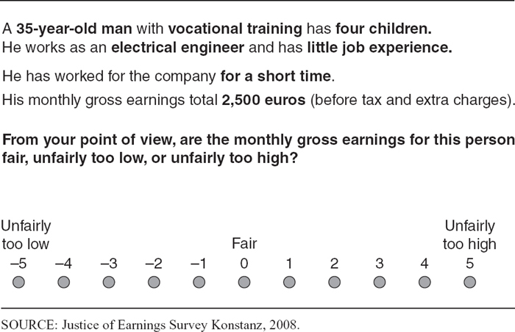 ## Vignette example
From the previous example, what are some things we could "leave out" of the control vignette to study a particular treatement effect?

1.18 What are the types of experiment?
Field experiments
- In the real world
- Less concern about psychological effects of setting
- May be more generalizable

1.19 Field experiment examples
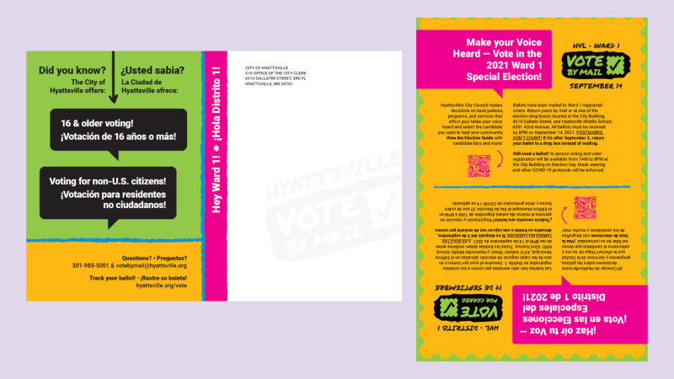
Field experiment

1.20 Field experiment examples
In a Get Out the Vote (GOTV) experiment, a typical design would:
- pick multiple voting precincts in the same election
- randomly assign some to receive a mailer and some not in each precinct
- select precincts to match the population of interest

1.21 What makes a good experiment?
- Internal validity
- External validity

1.22 What makes a good experiment?
Internal validity: Unbiased (not influenced by the researcher other than the manipulation)
- Design
- Content
- Analysis
Effective randomization is a major portion of internal validity

1.23 What makes a good experiment?
External validity: Generalizability
- To what populations can we generalize the results?
- To what settings can we generalize the results?
- To what times can we generalize the results?
Sample selection is a major portion of external validity

1.24 What can improve external validity?
- Field experiments (natural setting)
- Large, diverse samples
- Inclusion and exclusion criteria
- Replication (repeating with different samples)
- Psychological realism ("cover story")
- Statistical methods

1.25 Authorship, License, Credits
- Author: Tom Hanna
- Website: tomhanna.me
- Do not submit to Chegg or similar websites
- License: This work is licensed under a Creative Commons Attribution-NonCommercial-ShareAlike 4.0 International License.</>

https://civic.umd.edu/news/hyattsville-and-umd-conduct-first-nation-experiment-mobilizing-voters-under-18

