Topic 13: What Regression Lines Do (OLS in Practice)
  - Argument, Data, and Politics - POLS 3312
Tom Hanna
2026-04-12
Table of contents
1. Agenda and recap 2
1.1 Today 2
1.2 Where we are in the course 2
2. What OLS is doing (no heavy math) 2
2.1 A cloud of points and a line 2
2.2 “Best” in the OLS sense 2
2.3 Video example 3
2.4 Visual example (graphic) 3
3. Turning the line into a formula 3
3.1 The basic regression equation 3
3.2 Interpreting the slope 3
3.3 Example with a story 4
4. Reading a simple regression table 4
4.1 What a one-variable regression table looks like 4
4.2 Turning the table into the formula 4
4.3 Using the formula for prediction 4
5. From change in X to change in Y 5
5.1 The key idea 5
5.2 Step-by-step method students should use 5
5.3 Worked example 5
5.4 Another example with a different outcome 5
6. Very brief: other models in articles 5
6.1 Why you might see models that are not OLS 5
6.2 What stays the same conceptually 6
6.3 What changes compared to OLS 6
6.4 How students can read these models at this level 6
7. Wrap-up and practice 6
7.1 Key takeaways 6
7.2 Practice Table 7
7.3 Practice questions 7

1. Agenda and recap

1.1 Today
- What a regression line (OLS) does, in pictures
- How the line becomes a prediction formula
- How to read a simple journal-article regression table
- How to turn coefficients into a prediction for a change in (X)
- Brief: what if the model is not OLS? (logit, probit, etc.)

1.2 Where we are in the course
- We have talked about variables, distributions, and relationships.
- We have seen scatterplots and talked about “positive” and “negative” relationships.
- Today we move from describing a relationship to writing a specific line that summarizes it.

2. What OLS is doing (no heavy math)

2.1 A cloud of points and a line
- Imagine a scatterplot of (X) (e.g., income) and (Y) (e.g., turnout).
- Many lines could be drawn, but some will “fit” the points better than others.
- Ordinary Least Squares picks one line as “best.”

2.2 “Best” in the OLS sense
- For each point, the residual is “actual (Y) minus predicted (Y).”
- OLS chooses the line that makes the squared residuals as small as possible overall.
- Visually: the chosen line keeps the vertical distances from the points to the line as small as possible on average.

2.3 Video example
Show the video example here

2.4 Visual example (graphic)
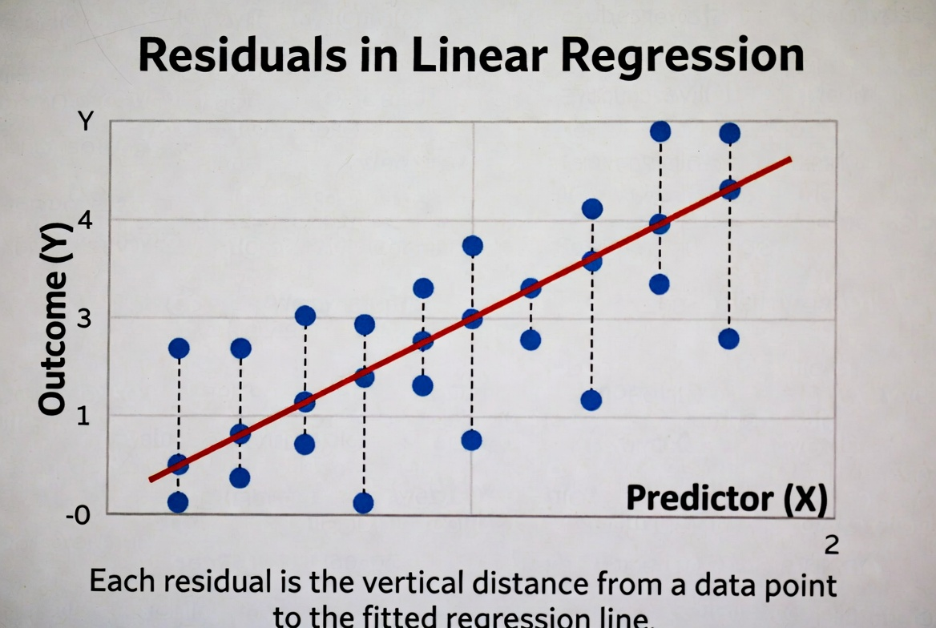
Regression line drawn through a cloud of points, showing vertical distances (residuals) from each point to the line

3. Turning the line into a formula

3.1 The basic regression equation
- The line can be written as a formula:
[ = a + bX ]
- (a) is the intercept (predicted (Y) when (X = 0)).
- (b) is the slope (how much we expect (Y) to change when (X) increases by 1 unit).

3.2 Interpreting the slope
- If (b = 2), then when (X) increases by 1 unit, predicted (Y) increases by 2 units.
- If (b = -0.5), a 1-unit increase in (X) is associated with a 0.5-unit decrease in predicted (Y).
- The slope is the “effect” of (X) on (Y) in this simple model.

3.3 Example with a story
- Suppose (Y =) political knowledge score (0–10) and (X =) years of education.
- If the estimated line is ( = 2 + 0.3X), then:
  - A person with 10 years of education has predicted knowledge (= 2 + 0.3(10) = 5).
  - A person with 14 years of education has predicted knowledge (= 2 + 0.3(14) = 6.2).
- Going from 10 to 14 years (a 4‑year increase) raises predicted knowledge by (0.3 = 1.2) points.

4. Reading a simple regression table

4.1 What a one-variable regression table looks like
In a journal article, a very simple OLS table for one (X) might look like this:
Variable | Coefficient | Std. Error
Education (years) | 0.30 | 0.05
Constant | 2.00 | 0.40
- “Coefficient” is the estimate of (b) (for Education) or (a) (for the Constant).
- “Std. Error” is a measure of uncertainty, but today we focus on using the coefficients for predictions.

4.2 Turning the table into the formula
- From the table, the intercept is 2.00.
- The slope for Education is 0.30.
- So the regression line is: [ = 2.00 + 0.30 ]

4.3 Using the formula for prediction
- If a person has 12 years of education:
  - ( = 2.00 + 0.30(12) = 5.6).
- If a person has 16 years of education:
  - ( = 2.00 + 0.30(16) = 6.8).
- The model gives a predicted knowledge score for any value of education.

5. From change in X to change in Y

5.1 The key idea
- In a simple line ( = a + bX), the slope (b) tells us the change in predicted (Y) for a 1‑unit change in (X).
- For a bigger change in (X), multiply (b) by the size of that change.
- This is often what authors mean by “substantive effect.”

5.2 Step-by-step method students should use
- Read the coefficient for the variable (X) of interest (this is (b)).
- Decide on a realistic change in (X) (for example, 4 extra years of education).
- Multiply the coefficient by that change in (X).
- Interpret the result as the predicted change in (Y).

5.3 Worked example
Using the table above:
- Coefficient on Education: (b = 0.30).
- Consider a change in Education from 10 to 14 years ((X = 4)).
- Predicted change in (Y) is: [ = b X = 0.30 = 1.2 ]
- Interpretation: increasing education from 10 to 14 years is associated with a 1.2‑point increase in predicted knowledge.

5.4 Another example with a different outcome
- Suppose an article has (Y =) turnout percentage in a district and (X =) campaign spending (in thousands of dollars).
- If the coefficient is (b = 0.8), then:
  - A $10,000 increase in spending ((X = 10)) leads to a predicted turnout change of (0.8 = 8) percentage points.
- Students can always ask: “For a realistic change in (X), how big is the predicted change in (Y)?”

6. Very brief: other models in articles

6.1 Why you might see models that are not OLS
- Some outcomes are not continuous numbers (e.g., yes/no, counts, ordered categories).
- Authors use other models that fit the outcome type better.
- Common ones in political science:
  - Logistic regression (logit)
  - Probit
  - Count models (Poisson, negative binomial)
  - Ordered logit/probit

6.2 What stays the same conceptually
- There is still an equation linking (X) to a prediction for (Y).
- The model still has coefficients that describe how changes in (X) affect the prediction.
- We can still think in terms of:
  - Coefficient () effect of one-unit change in (X).
  - Bigger change in (X) () coefficient times that change.

6.3 What changes compared to OLS
- In OLS, the line is directly in the units of (Y).
- In logit/probit, the equation predicts something like a transformed version of the probability (not raw (Y) itself).
- Authors often help by converting results into:
  - Predicted probabilities for particular values of (X).
  - “Marginal effects” that say “a one-unit change in (X) changes the probability of (Y=1) by so many percentage points.”

6.4 How students can read these models at this level
- Focus on the direction: is the coefficient positive or negative?
- Focus on whether authors say the effect is “large,” “small,” or “not statistically significant.”
- When authors provide predicted probabilities or marginal effects, read those the same way you did for OLS:
  - For a change in (X), how much does the predicted probability change?

7. Wrap-up and practice

7.1 Key takeaways
- OLS chooses a single regression line to summarize the relationship between (X) and (Y).
- The line becomes a simple formula: ( = a + bX).
- Given the coefficient (b), a change in (X) of size (X) leads to a predicted change in (Y) of (b X).
- Other models in articles still link (X) to a prediction; you can read direction and size of effects even without the math.

7.2 Practice Table
Variable | Coefficient | Std. Error
Political interest | 1.50 | 0.30
Constant | 20.00 | 2.00
Y political knowledge index on a 0–10 scale, X political interest on a 1–5 scale.

7.3 Practice questions
- Write the regression line formula based on the table.
- Write the effect in a sentence: “A one-unit increase in political interest is associated with a ___-point increase in the predicted political knowledge index.”
- What is the predicted $Y$, political knowledge index, for someone with a political interest score of 3?
- If political interest increases from 2 to 4, what is the predicted change in the political knowledge index?

