Lecture 7: Hypothesis Testing and Confidence Intervals
Tom Hanna
2026-03-01
Table of contents

1. Agenda and Announcements
- Today
- - Hypothesis Testing and Confidence Intervals
- Top Hat Quiz
- Next class
- - Lab 3 completion

1.1
- Announcements
- - CASA Registration
- No class next Monday or Tuesday (March 10)
- I will record a midterm review and post an online pre-midterm quiz **for points**

2. Hypothesis testing

2.1 What is a hypothesis
A falsifiable statement about what we believe will happen based on the theory we are trying to test.

2.2 Falsifiability
- We start from the assumption that our theory is wrong
- Our hypothesis is called the
alternative hypothesis or H1
- because it is the alternative to our assumption of no relationship
null hypothesis or H0

2.3 Testing the null hypothesis
- Statistical tests show the degree of certainty that we can reject the null hypothesis
- They show the probability that the alternative hypothesis is due to random chance
- When the probability, p, is below our pre-determined threshold, we reject the null hypothesis
- If we reject the null hypothesis, the alternative hypothesis is true, right?

2.4 NO!
- If we reject the null hypothesis, the alternative hypothesis is true, right?
NO!!!!
- If we reject the null, we infer that the alternative hypothesis (our hypothesis) is approximately true within the probability we have chosen.
- If we reject the null, we can say there is strong evidence that the alternative hypothesis (our hypothesis) is true
- We often test multiple hypotheses

2.5 How do we get there?
How do we get from a sample with a correlation to talking about testing a hypothesis for a population?
- Tying sample statistics to population parameters (LLN)
- Probability distributions
- Tying our data to the probability distributions (CLT)

2.6 Statistics to parameters
- We rely on the Law of Large Numbers and use sample statistics
- With sufficient sample size and proper math, our sample mean is an unbiased estimator of the population mean
- With CLT, $s^{2}$ is an unbiased and consistent estimator of $σ^{2}$
- For the normal distribution $s^{2}$ is also the Minimum Variance Unbiased Estimator for $σ^{2}$

2.7 Probability distributions
The 68-95-99.7 Rule
+ Allows us to estimate probability based on distance from the mean
+ Applies to normal distribution
+ Basis for the actual decision rules

2.8 The 68-95-99.7 Rule
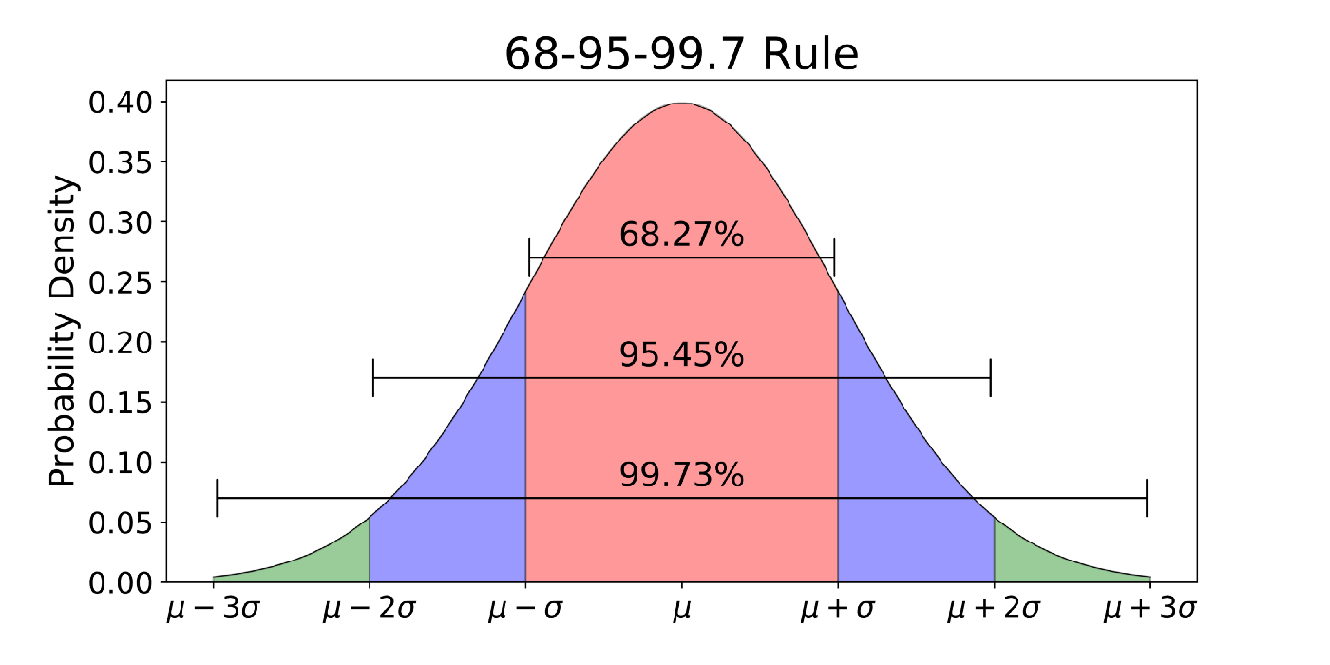
68-95-99.7 rule

2.9 From Distribution to Confidence
- We can now bridge the gap between probability distributions and our sample data.
- CLT ties our sample means to the normal distribution
- Sample stats are unbiased estimators of population parameters
- They are only point estimates, so we construct a confidence interval
- confidence interval a range of values around the point estimate that we are X% confident contains the true population parameter

2.10 Math and philosophy of the confidence interval
- Math and philosophy detail: The true population parameter is a fixed but unknown number, while our calculated interval is random but known with certainty. Our X percent confidence reflects the long-run reliability of our method. If we repeated this exact sampling process 100 times, X of the resulting intervals would successfully capture the true population parameter.

2.11 Calculating the Interval
- we need three pieces of information:
- - point estimate = sample statistics
- standard error = the standard deviation of the sampling distribution
- critical value derived from our desired confidence level - for normal distribution this is a z-score
- For 95% confidence, the critical z is 1.96
- The general formula for a confidence interval is:
$$CI=\overset{‾}{x}±z\left(\frac{s}{\sqrt{n}}\right)$$
## CI of the variance
$$\frac{\left(n−1\right)s^{2}}{χ_{α/2}^{2}}≤σ^{2}≤\frac{\left(n−1\right)s^{2}}{χ_{1−α/2}^{2}}$$
- This use the Chi Square distribution which we will discuss after midterm

2.12 CI of the standard deviation
$$\sqrt{\frac{\left(n−1\right)s^{2}}{χ_{α/2}^{2}}}≤σ≤\sqrt{\frac{\left(n−1\right)s^{2}}{χ_{1−α/2}^{2}}}$$
- Also uses the Chi-square distribution

2.13 Why the Chi-Square not the normal?
- When we square distances from the mean to get the variance, the distribution changes
- By eliminating all negative numbers, the distribution becomes skewed and looks like this:

2.14 Distribution Comparison
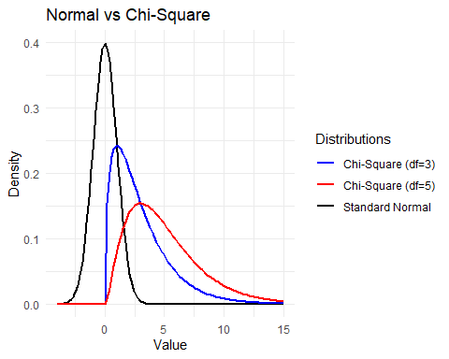

2.15 Authorship, License, Credits
- Stephen Moore code used to simulate the Law of Large Numbers
- 68-95-99 rule graphic Source:https://towardsdatascience.com/understanding-the-68-95-99-7-rule-for-a-normal-distribution-b7b7cbf760c2
- Author: Tom Hanna
- Website: tomhanna.me
- License: This work is licensed under a Creative Commons Attribution-NonCommercial-ShareAlike 4.0 International License.</>

