Lecture 8: Hypothesis Testing: Z-score and Chi-Square
Tom Hanna
2026-03-22
Table of contents
1. Agenda and Announcements 2
2. Hypothesis testing Z-Scores 2
2.1 What is a Z-Score? 2
2.2 The 68-95-99.7 Rule 3
2.3 What is a Z-Score? (cont) 3
2.4 The tails 4
2.5 Two-tail test 4
2.6 Z-Test: Formula 4
2.7 Z-Test: Steps 5
2.8 Z-test: Decision rule 5
2.9 Z-tail: Right tail decision rule 5
2.10 Z-tail: Left-tail decision rule 5
2.11 What is a Crosstab? 5
2.12 Example Crosstab 5
2.13 Example: Observed Counts Only 6
2.14 Example: Add Row and Column Totals 6
2.15 Example: Completed Observed Table 6
2.16 Example: Calculate Expected Counts 6
2.17 Example: Expected Counts Table 7
2.18 Example: Calculate (O - E) for Each Cell 7
2.19 Example: Differences (O - E) 7
2.20 Where did we run into this before? 7
2.21 Distribution Comparison 8
2.22 χ² instead of z-score 8
2.23 What is degrees of freedom? 8
2.24 χ² Critical Values (α = 0.05) 8
2.25 Example: next step 9
2.26 Example: Chi-Square Components 9
2.27 Example: Chi-Square Test Statistic 9
2.28 Example: Find Degrees of Freedom 9
2.29 Example: Degrees of Freedom 10
2.30 Example: Critical Value 10
2.31 Example: Make Decision 10
2.32 Example: Conclusion 10
2.33 Berkeley Graduate Admissions 1973 10
2.34 1973 Berkeley Example Data (Overall) 11
2.35 1973 Berkeley Example Data (By Department) 12
2.36 For this week's quiz points (25 points) 12
2.37 Part 2 12
2.38 Authorship, License, Credits 13

1. Agenda and Announcements
- Today
- - Hypothesis Testing: Z-Score and Chi-Square
- Top Hat Quiz
- Next class
- - Lab 4 completion
- Lab 5

2. Hypothesis testing Z-Scores

2.1 What is a Z-Score?
- A z-score tells us how many standard deviations a value is from the mean.
- Positive z-scores are above the mean
- Negative z-scores are below the mean
- A z-score is the precise representation of the 68-95-99 Rule

2.2 The 68-95-99.7 Rule
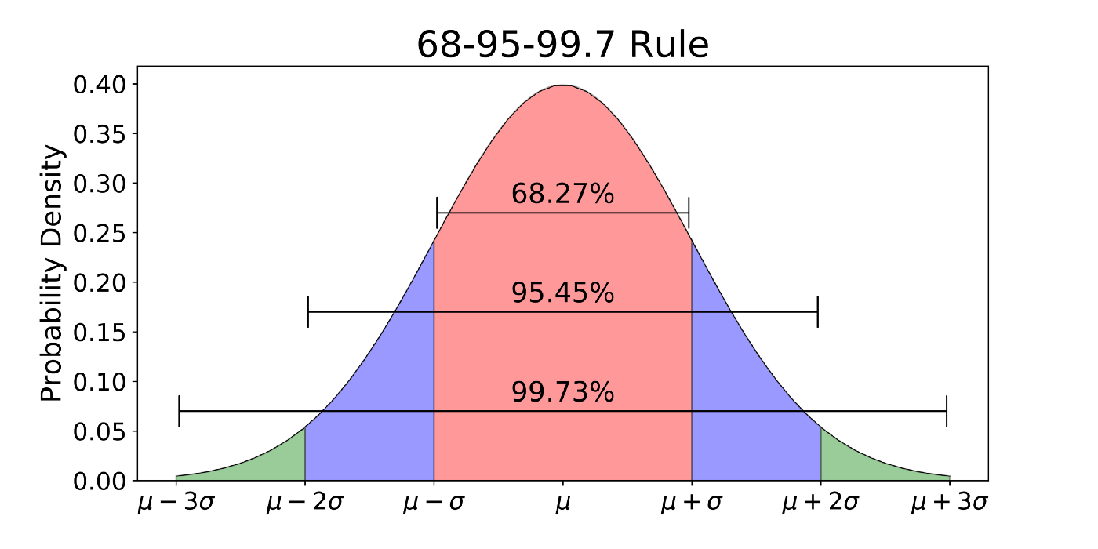
68-95-99.7 rule

2.3 What is a Z-Score? (cont)
- The actual 95% area under the normal curve is between -1.96 and +1.96 standard deviations from the mean
- The actual 95% area is from z = -1.96 to z = 1.956
- If the area under the curve is 95%, then 5% is outside it in the two tails

2.4 The tails
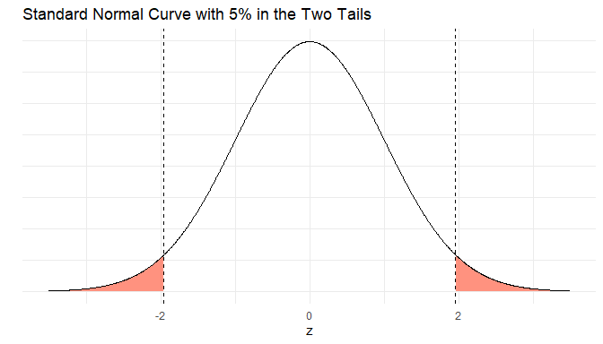

2.5 Two-tail test
- In a hypothesis test, we are testing the probability that the event is not due to random chance
- We set a threshold (usually α = 0.05) for how unlikely a result must be before we reject the null hypothesis
- In a two-tail test, we split α into both tails: α/2 = 0.025 in each tail
- If our test statistic falls in either tail (beyond ±1.96), we reject the null hypothesis
- This corresponds to a probability less than 5% or p < .05

2.6 Z-Test: Formula
Formula:
$$z=\frac{\overset{‾}{x}-μ_{0}}{σ/\sqrt{n}}$$
Where:
- $\overset{‾}{x}$ = sample mean
- $μ_{0}$ = hypothesized population mean (from null hypothesis)
- $σ$ = population standard deviation
- $n$ = sample size

2.7 Z-Test: Steps
Steps:
- State your null hypothesis ($H_{0}:μ=μ_{0}$) and alternative hypothesis ($H_{a}$)
- Calculate the test statistic using the formula above
- For a two-tail test at $α=0.05$, the critical values are $z=±1.96$

2.8 Z-test: Decision rule
Two tail:
- Reject $H_{0}$ if $z>1.96$ or $z<-1.96$
- Fail to reject $H_{0}$ if $-1.96≤z≤1.96$
- Shorthand: reject if $\left|z\right|>1.96$

2.9 Z-tail: Right tail decision rule
Right-tail test ($H_{a}:μ>μ_{0}$)
- Critical value: $z_{critical}=1.645$
- Decision rule:
  - Reject $H_{0}$ if $z>1.645$
  - Fail to reject $H_{0}$ if $z≤1.645$
  - Shorthand: reject if $z$ is in the right tail beyond 1.645

2.10 Z-tail: Left-tail decision rule
Left-tail test ($H_{a}:μ<μ_{0}$)
- Critical value: $z_{critical}=-1.645$
- Decision rule:
  - Reject $H_{0}$ if $z<-1.645$
  - Fail to reject $H_{0}$ if $z≥-1.645$
  - Shorthand: reject if $z$ is in the left tail beyond -1.645

2.11 What is a Crosstab?
- A crosstab (contingency table) shows counts for two categorical variables in rows and columns
- Each cell contains the frequency of cases with that combination of categories

2.12 Example Crosstab
Example structure (2×3 table):
 | Category 1 | Category 2 | Category 3
Group A | ? | ? | ?
Group B | ? | ? | ?

2.13 Example: Observed Counts Only
Research Question: Is there an association between gender and support for a new campus policy?
Observed data from 200 students:
 | Support | Oppose
Female | 60 | 40
Male | 45 | 55

2.14 Example: Add Row and Column Totals
Fill in the marginals (row totals, column totals, and grand total):
 | Support | Oppose | Row Total
Female | 60 | 40 | ___
Male | 45 | 55 | ___
Column Total | ___ | ___ | **___**

2.15 Example: Completed Observed Table
 | Support | Oppose | Row Total
Female | 60 | 40 | 100
Male | 45 | 55 | 100
Column Total | 105 | 95 | 200

2.16 Example: Calculate Expected Counts
Formula: $E_{ij}=\frac{\left(\text{row total}\right)×\left(\text{column total}\right)}{\text{grand total}}$
Calculate expected count for each cell:
- Female & Support: $E_{11}=\frac{100×105}{200}=___$
- Female & Oppose: $E_{12}=\frac{100×95}{200}=___$
- Male & Support: $E_{21}=\frac{100×105}{200}=___$
- Male & Oppose: $E_{22}=\frac{100×95}{200}=___$

2.17 Example: Expected Counts Table
 | Support | Oppose | Row Total
Female | 52.5 | 47.5 | 100
Male | 52.5 | 47.5 | 100
Column Total | 105 | 95 | 200
These are the counts we would expect if there were NO association

2.18 Example: Calculate (O - E) for Each Cell
For each cell, compute: Observed - Expected
 | Support | Oppose
Female | 60 - 52.5 = ___ | 40 - 47.5 = ___
Male | 45 - 52.5 = ___ | 55 - 47.5 = ___

2.19 Example: Differences (O - E)
 | Support | Oppose
Female | +7.5 | -7.5
Male | -7.5 | +7.5
Note the symmetry: Differences sum to zero in each row and column

2.20 Where did we run into this before?
- Variance
- When we talked about computing confidence intervals, squaring deviations meant we couldn't use the normal distribution
- That meant we couldn't use a z-score there
- What distribution did we have to use?

2.21 Distribution Comparison
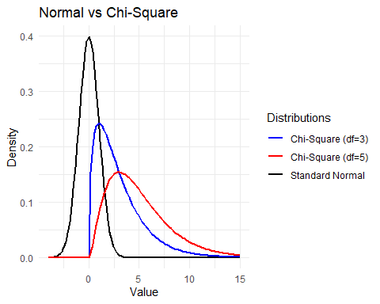

2.22 χ² instead of z-score
- Here we will use the χ² statistic instead of the z-score
- The z-score is always based on the same normal distribution
- The chi-square is not just one curve: we pick a specific χ² distribution based on the degrees of freedom

2.23 What is degrees of freedom?
- Chi-square shows up whenever we add up squared differences between what we observe and what we expect
- These are also called squared residuals
- The degrees of freedom tell us how many independent pieces of information went into that total
- In a crosstab, fixing the row and column totals means not every cell can vary freely, so the df is $\left(r-1\right)\left(c-1\right)$
- So instead of one universal z table, we have a family of χ² tables—one curve for each degrees-of-freedom value.

2.24 χ² Critical Values (α = 0.05)
df | χ² critical (α = 0.05)
1 | 3.84
2 | 5.99
3 | 7.82
4 | 9.49
5 | 11.07
6 | 12.59

2.25 Example: next step
Calculate $\frac{{\left(O-E\right)}^{2}}{E}$ for Each Cell
$$χ^{2}=∑\frac{{\left(O-E\right)}^{2}}{E}$$
Female & Support: $\frac{{\left(7.5\right)}^{2}}{52.5}=\frac{56.25}{52.5}=___$
Female & Oppose: $\frac{{\left(-7.5\right)}^{2}}{47.5}=\frac{56.25}{47.5}=___$
Male & Support: $\frac{{\left(-7.5\right)}^{2}}{52.5}=\frac{56.25}{52.5}=___$
Male & Oppose: $\frac{{\left(7.5\right)}^{2}}{47.5}=\frac{56.25}{47.5}=___$

2.26 Example: Chi-Square Components
Female & Support: $\frac{56.25}{52.5}=1.071$
Female & Oppose: $\frac{56.25}{47.5}=1.184$
Male & Support: $\frac{56.25}{52.5}=1.071$
Male & Oppose: $\frac{56.25}{47.5}=1.184$
Sum all four: $χ^{2}=1.071+1.184+1.071+1.184=___$

2.27 Example: Chi-Square Test Statistic
$$χ_{calc}^{2}=4.51$$
Now we need to compare this to the critical value

2.28 Example: Find Degrees of Freedom
$$df=\left(r-1\right)\left(c-1\right)$$
- Number of rows: $r=___$
- Number of columns: $c=___$
$$df=\left(___-1\right)\left(___-1\right)=___$$

2.29 Example: Degrees of Freedom
$$df=\left(r-1\right)\left(c-1\right)$$
- Number of rows: $r=2$
- Number of columns: $c=2$
$$df=\left(2-1\right)\left(2-1\right)=1$$

2.30 Example: Critical Value
From chi-square distribution table:
- $df=1$
- $α=0.05$
- $χ_{critical}^{2}=3.841$

2.31 Example: Make Decision
Decision rule: Reject $H_{0}$ if $χ_{calc}^{2}>χ_{critical}^{2}$
Our values: - $χ_{calc}^{2}=4.51$ - $χ_{critical}^{2}=3.841$
Decision: _______________

2.32 Example: Conclusion
Since $4.51>3.841$, we REJECT $H_{0}$
Conclusion: - There is a statistically significant association between gender and support for the policy - The pattern in our sample is unlikely to be due to chance alone - Females show higher support (60%) than males (45%)

2.33 Berkeley Graduate Admissions 1973
Did America's most progressive graduate school discriminate on gender in admissions?
, , Dept = A
Gender
Admit Male Female
Admitted 512 89
Rejected 313 19
, , Dept = B
Gender
Admit Male Female
Admitted 353 17
Rejected 207 8
, , Dept = C
Gender
Admit Male Female
Admitted 120 202
Rejected 205 391
, , Dept = D
Gender
Admit Male Female
Admitted 138 131
Rejected 279 244
, , Dept = E
Gender
Admit Male Female
Admitted 53 94
Rejected 138 299
, , Dept = F
Gender
Admit Male Female
Admitted 22 24
Rejected 351 317
Dept A B C D E F
Admit Gender
Admitted Male 512 353 120 138 53 22
Female 89 17 202 131 94 24
Rejected Male 313 207 205 279 138 351
Female 19 8 391 244 299 317

2.34 1973 Berkeley Example Data (Overall)
Overall admissions (all departments combined)
 | Admitted | Rejected | Total
Male | 44 | 56 | 100
Female | 30 | 70 | 100
Total | 74 | 126 | 200

2.35 1973 Berkeley Example Data (By Department)
Admissions by department (simplified)
Dept | Gender | Admitted | Rejected | Total
A | Male | 40 | 60 | 100
 | Female | 45 | 55 | 100
B | Male | 30 | 70 | 100
 | Female | 36 | 64 | 100
C | Male | 30 | 70 | 100
 | Female | 15 | 85 | 100

2.36 For this week's quiz points (25 points)
- Complete the crosstabs hypothesis test for the table with admissions by department. (That is a single test with 6 rows by 2 columns)
- Do a crosstab for each department. (That is 3 tests with 2 rows by 2 rows)
- Do this by hand and give your conclusions.
- More on the next slide

2.37 Part 2
- Bring this to class Thursday or turn it in my mailbox in the Political Science Department office (PGH 447)
- Mostly completion - if you make errors, we will discuss
- Read these and answer three questions in Canvas "March 23-26 Quiz"
- - https://setosa.io/simpsons/
- https://statisticsbyjim.com/basics/simpsons-paradox/
- We will revisit using R in lab on Thursday!
- I will post Thursday lab Monday or Tuesday evening with recording

2.38 Authorship, License, Credits
- 68-95-99 rule graphic Source:https://towardsdatascience.com/understanding-the-68-95-99-7-rule-for-a-normal-distribution-b7b7cbf760c2
- Author: Tom Hanna
- Website: tomhanna.me
- License: This work is licensed under a Creative Commons Attribution-NonCommercial-ShareAlike 4.0 International License.</>

