Lecture 10-11: OLS Assumptions, Logistic Regression, and Beyond
Tom Hanna
2026-04-11
Table of contents

1. Agenda and announcements

1.1 Today
- OLS: what assumptions it makes
- What the assumptions mean in plain language
- What to do when assumptions are violated
- Logistic regression as the main alternative for binary outcomes
- How maximum likelihood differs from OLS
- Very brief tour of other generalized models

1.2 Where we are in the course
- We have already covered variables, distributions, the CLT, covariance, correlation, hypothesis testing, and chi-square
- In Lecture 9, we built a regression line and used residuals to see how OLS chooses the line
- Today we move from "how to draw the line" to "when should we trust the line?"

2. From the line to the model

2.1 Reminder: What OLS is doing
- Ordinary Least Squares chooses the line that minimizes the sum of squared residuals
- Residual = observed value minus predicted value
- OLS gives us a simple closed-form solution for the line in the bivariate case
- That is why we could calculate the slope and intercept directly last class
- The line minimizes the sum of the squared vertical distances from the points to the line

2.2 Why assumptions matter
- OLS always gives you a line
- The real question is whether that line gives trustworthy estimates, standard errors, and hypothesis tests
- Statistical models are useful approximations
- So we need assumptions that are close enough to reality to make the model useful

3. Big picture assumptions

3.1 The two levels of assumptions
- Some assumptions are about the data-generating process
- Some assumptions are about the error term
- Some assumptions mainly affect unbiasedness
- Others mainly affect standard errors, confidence intervals, and p-values

3.2 A plain-language summary
- OLS works best when the relationship is approximately linear
- Cases should be independent
- The error term should not systematically change with X
- Residuals should not show strong patterns the model failed to capture
- Severe violations are a problem; tiny ones often are not

4. Assumption 1: linearity

4.1 What linearity means
- The expected value of Y changes in a straight-line way as X changes
- This does not mean every point lies on a line
- It means the average relationship is linear
- Residuals can still exist; they just should not have a curved pattern

4.2 Visually
- This is what we covered in the last lab

4.3 How to diagnose nonlinearity
- Scatterplot of Y against X
- Residual plot: residuals should look patternless
- If residuals make a U-shape or inverted U-shape, the model is missing curvature

4.4
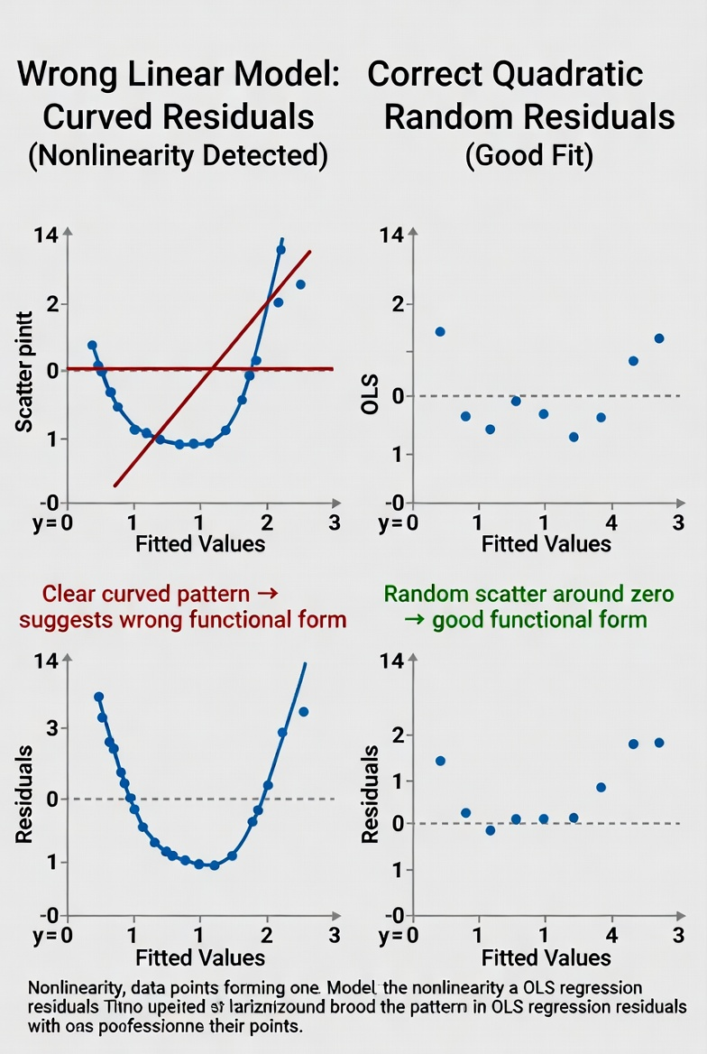
Residual plot showing a U-shaped pattern, indicating nonlinearity

4.5 What to do about it
- Add a nonlinear term like (X^2)
- Transform a variable when substantively sensible
- Use interaction terms if the slope differs across groups
- Sometimes a small amount of curvature is acceptable if the line is still a good approximation over the observed range

4.6 When small violations can be ignored
- If the residual plot shows only mild curvature
- If substantive conclusions do not change with a slightly more flexible specification
- If the model is used mainly for simple description over a narrow range of X

5. Assumption 2: independence

5.1 What independence means
- Observations should not contain duplicated information from one another
- One case should not make another case's error predictable
- This is closely related to earlier course discussion of IID assumptions

5.2 Examples of non-independence
- Repeated observations on the same country or person
- Students clustered within the same classroom
- Survey respondents from the same household
- Time series where today's value depends on yesterday's shocks

5.3 Why it matters
- Non-independence often leaves coefficients similar
- But standard errors are often too small
- That makes p-values look more impressive than they should

5.4 What to do about it
- Clustered standard errors
- Fixed effects or multilevel models
- Time-series corrections when data are ordered over time
- If dependence is weak and sample structure is simple, robust corrections are often enough for an introductory treatment

5.5 When small violations can be ignored
- Mild dependence is less troubling when the substantive result is large and stable
- It is more troubling when the claim depends on a borderline p-value
- In practice, this is often a "be cautious" issue rather than an automatic failure

6. Assumption 3: zero conditional mean

6.1 The core idea
- The error term should have mean zero at every value of X
- In plain English: after accounting for X, the leftover part should be random rather than systematically related to X

6.2 Why this is so important
- This is the key exogeneity idea
- If omitted causes of Y are correlated with X, OLS coefficients become biased
- This is the assumption most tied to causal interpretation

6.3 Intuition
- Suppose education predicts income
- But ability is omitted and correlated with education
- Then the education coefficient partly captures ability too
- The line is attributing too much to X

6.4 What to do about it
- Add omitted variables when possible
- Improve research design
- Use fixed effects, experiments, or instruments in more advanced settings
- Be modest about causal claims when omitted variable bias is plausible

6.5 Can we safely ignore small violations?
- Sometimes for prediction, yes
- For causal inference, much less so
- This is one of the violations students should worry about most

7. Assumption 4: homoskedasticity

7.1 What homoskedasticity means
- The spread of the residuals is roughly constant across values of X
- In plain language: the model should be about equally wrong across the range of X

7.2 Visual intuition
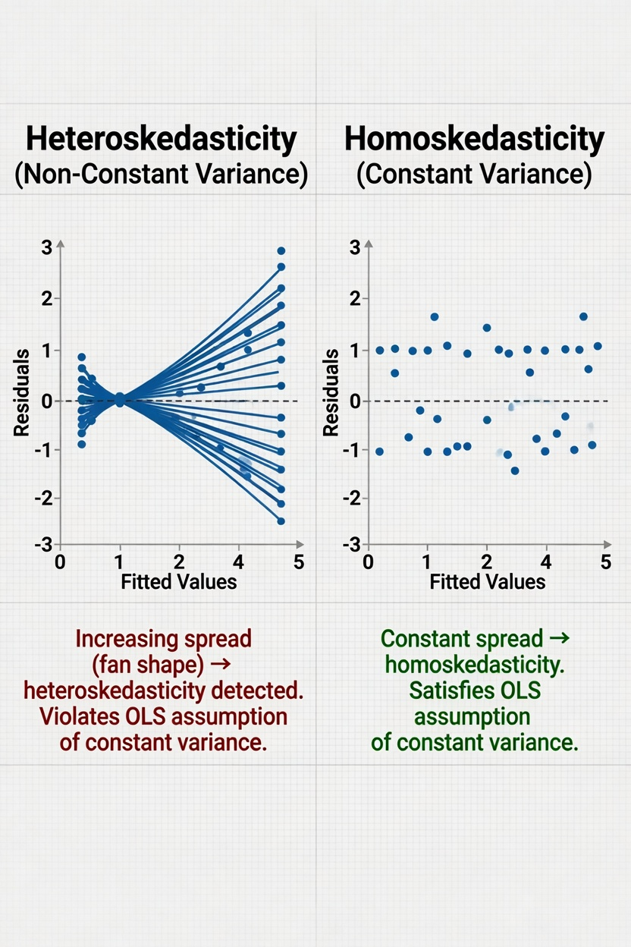
Residual plot showing a fanning pattern, indicating heteroskedasticity

7.3 Why it matters
- OLS coefficients are still unbiased under many cases of heteroskedasticity
- But the usual standard errors are wrong
- So confidence intervals and significance tests become unreliable

7.4 What to do about it
- Use heteroskedasticity-robust standard errors
- Reconsider model specification
- Transform Y when appropriate
- If variance changes only a little, robust standard errors are usually an easy fix

7.5 When small violations can be ignored
- If the residual plot shows only mild fanning
- If robust and conventional standard errors tell the same story
- In practice, many analysts simply default to robust standard errors

8. Assumption 5: normality of residuals

8.1 What normality does and does not mean
- OLS does not require Y itself to be normal
- The concern is the distribution of residuals, especially in small samples
- Normality mainly supports exact small-sample inference

8.2 Why this should sound familiar
- Earlier in the course, we linked inference to probability distributions and the CLT
- With larger samples, the CLT often makes inference approximately work even when residuals are not perfectly normal

8.3 How to diagnose it
- Histogram of residuals
- Q-Q plot
- Look for extreme skew or huge outliers, not tiny imperfections

8.4 What to do about violations
- Check for outliers or coding errors
- Transform variables if substantively justified
- In larger samples, mild non-normality is often not a major problem
- Focus more on severe skew, extreme outliers, or misspecification

8.5 When small violations can be ignored
- Often, especially with moderate or large (n)
- This is one of the assumptions students tend to worry about too much
- In many real applications, non-normal residuals are less serious than omitted variables or dependence

9. Assumption 6: no perfect multicollinearity

9.1 What it means
- Predictors cannot be exact linear combinations of one another
- The model needs unique information from each predictor

9.2 Example
- If you include both "age" and "years since birth"
- Or all categories of a dummy variable plus the intercept
- The software cannot separate their effects

9.3 Why it matters
- Perfect multicollinearity means the model cannot be estimated as written
- Near multicollinearity means the model can be estimated, but coefficients become unstable and standard errors inflate

9.4 What to do about it
- Drop one redundant variable
- Choose a reference category for dummies
- Combine highly overlapping measures if that makes substantive sense

9.5 When small violations can be ignored
- Mild collinearity is common
- It mainly reduces precision rather than creating bias by itself
- If theory demands both variables, you may keep them and interpret cautiously

10. Assumption 7: correct outcome type

10.1 A practical assumption students forget
- OLS assumes a continuous outcome with an unbounded linear prediction
- But not all dependent variables work like that

10.2 Why this matters
- A binary outcome only takes values 0 and 1
- Counts cannot go below 0
- Ordinal categories are ranked but not equally spaced
- Using OLS on these can produce impossible predictions or the wrong error structure

10.3 Transition to the next topic
- This is why we need models other than OLS
- The model should match the data-generating process
- That connects directly to logistic regression and maximum likelihood

11. Which assumptions matter most?

11.1 A rough ranking for students
- Most serious for causal inference: omitted variables / exogeneity
- Often important for inference: dependence and heteroskedasticity
- Important for fit: nonlinearity
- Often less serious in larger samples: mild non-normality
- Mechanical issue: multicollinearity

11.2 A useful teaching rule
- Ask first: Is the model form wrong?
- Ask second: Are my standard errors trustworthy?
- Ask third: Is the outcome type appropriate for OLS?

12. Moving from OLS to MLE

12.1 Why leave OLS?
- OLS works very well for continuous outcomes under the right conditions
- But many political science outcomes are binary, ordinal, counts, or categories
- We need a more general estimation framework

12.2 The big idea of maximum likelihood
- Maximum Likelihood Estimation asks:
- "Given this model, which parameter values make the observed data most likely?"
- Instead of minimizing squared residuals, we maximize a likelihood function

12.3 Contrast in one sentence
- OLS: choose coefficients that minimize squared residuals
- MLE: choose coefficients that maximize the probability of the data under the model

13. Logistic regression

13.1 When we use it
- Logistic regression is for a binary dependent variable
- Examples: voted or not, war or peace, passed or failed, democracy or autocracy transition
- The outcome is modeled as a probability between 0 and 1

13.2 Why not use OLS for a binary outcome?
- OLS can predict values below 0 or above 1
- The error variance changes mechanically with the predicted probability
- The relationship between X and probability is usually nonlinear

13.3 The key visual
- Draw a straight line through a binary cloud
- Then draw an S-curve
- Emphasize that probability must stay between 0 and 1
- Logistic regression respects those bounds

14. What part is linear?

14.1 The linear part of logistic regression
- Logistic regression is linear in the log-odds
- The model is:
- [ ()=_0+_1 X ]

14.2 The curved part
- When we convert log-odds back into probability, the relationship becomes S-shaped
- That is why the graph of probability against X is not a straight line
- A one-unit change in X has a constant effect on log-odds, not on probability

14.3 Teaching line
- "Linear on the inside, curved on the outside"

15. Probability, odds, and log-odds

15.1 Probability
- Probability is the chance of an event, from 0 to 1
- Example: (p = 0.75) means a 75% chance

15.2 Odds
- Odds compare the chance of success to the chance of failure
- [ = ]
- If (p = 0.75), odds = (0.75/0.25 = 3), or 3-to-1

15.3 Log-odds
- Logistic regression takes the natural log of the odds
- [ () ]
- This converts the bounded probability scale into an unbounded linear scale

15.4 Why do this?
- Probabilities are bounded between 0 and 1
- Log-odds run from negative infinity to positive infinity
- That makes a linear model possible

16. The link function

16.1 What is a link function?
- The link function connects the linear predictor to the mean of the outcome
- In logistic regression, the link is the logit link
- It maps probability to log-odds

16.2 Simple explanation
- OLS identity link: predicted Y is directly the linear predictor
- Logistic regression logit link: predicted probability is connected indirectly through log-odds
- Same basic idea of predictors and coefficients, different mapping to the outcome scale

16.3 Nice comparison table
Model | Outcome type | Linear part | Output scale
OLS | Continuous | ( _0 + _1 X ) | Y
Logit | Binary | ( _0 + _1 X ) | log-odds, then probability

17. How estimation differs

17.1 OLS has a direct formula
- In simple regression, we can solve for slope and intercept directly
- That is what you did in Lecture 9 with covariance and variance

17.2 Logistic regression does not
- There is no simple closed-form equation that directly solves the coefficients
- The computer starts with guesses
- Then it repeatedly updates them to improve the likelihood
- This is iterative optimization

17.3 Plain-language analogy
- OLS is like having an answer key formula
- Logistic regression is like searching uphill until you reach the highest point on the likelihood surface

18. What logistic coefficients mean

18.1 Interpreting a coefficient
- In logit, a one-unit increase in X changes the log-odds by (_1)
- Exponentiating gives an odds ratio
- Odds ratios above 1 increase the odds; below 1 decrease the odds

18.2 Why students find this awkward
- Log-odds are not intuitive
- Odds are more intuitive, but still not as intuitive as probability
- That is why predicted probabilities and marginal effects are often easier to present

18.3 Teaching advice slide
- Know the coefficient is about log-odds
- Know (e^{}) gives the odds ratio
- For interpretation, plots of predicted probabilities are often best

19. OLS versus logit

19.1 Similarities
- Both use predictors to explain variation in an outcome
- Both estimate coefficients
- Both can include multiple X variables, interactions, and nonlinear terms
- Both can be used for explanation or prediction

19.2 Differences
Feature | OLS | Logistic regression
Dependent variable | Continuous | Binary
Estimation | Least squares | Maximum likelihood
Functional form | Straight line in Y | Straight line in log-odds
Predicted values | Unbounded | Between 0 and 1
Typical interpretation | Unit change in Y | Change in log-odds / odds / probability

20. Assumptions of logistic regression

20.1 Core assumptions
- Binary dependent variable
- Independent observations
- Correct functional form in the logit
- No perfect multicollinearity
- Sufficient data, especially enough 0s and 1s
- No extreme separation problems

20.2 What is different from OLS?
- Logistic regression does not assume homoskedastic residuals in the OLS sense
- It does not assume normally distributed residuals
- But it still cares about independence, specification, and omitted variables

20.3 Small violations
- Mild nonlinearity in the logit can often be handled with transformations or splines
- Sparse data are more dangerous than small cosmetic departures
- Separation is a bigger practical problem than normality

21. What is separation?

21.1 Separation in plain English
- If X almost perfectly predicts whether Y is 0 or 1, the model can struggle
- The likelihood keeps improving as a coefficient gets bigger and bigger
- Estimates can become unstable or fail

21.2 Example
- If every incumbent wins and every challenger loses in your tiny sample
- Then the model may have trouble estimating a finite slope

21.3 What to do
- Get more data
- Simplify the model
- Collapse sparse categories
- Use penalized methods in advanced work

22. Visual slide idea

22.1 One graphic for the whole comparison
- Left panel: OLS line through continuous data
- Middle panel: binary data with OLS line showing impossible predictions
- Right panel: logistic S-curve bounded at 0 and 1

22.2 Optional in-class demonstration
- Put probability on the y-axis
- Show that the steepest change is in the middle
- Near 0 and near 1, the curve flattens
- Same coefficient, different change in probability depending on where you are on the curve

23. Beyond binary outcomes

23.1 The broader idea
- Different kinds of dependent variables need different models
- The general rule is:
- match the model to the outcome type and data-generating process

23.2 Ordered logit
- If the outcome is ordinal, with ranked categories
- Example: strongly disagree to strongly agree
- Ordered logit uses the ranking information without pretending the distances are equal

23.3 Poisson regression
- If the outcome is a count
- Example: number of protests, vetoes, coups, or conflict events
- Poisson is built for nonnegative integer counts

23.4 Probit
- Also for binary outcomes
- Very similar to logit in practice
- Main difference is the link function: normal CDF instead of logistic curve

23.5 Nominal regression
- If categories have no natural order
- Example: party choice among Democrat, Republican, Independent
- Multinomial or nominal logistic regression is the common approach

24. A simple decision slide

24.1 What model should I think about first?
- Continuous Y -> OLS
- Binary Y -> Logit or probit
- Ordinal Y -> Ordered logit
- Count Y -> Poisson
- Unordered categories -> Multinomial / nominal logit

25. Graphical demonstration idea

25.1 One-slide visual taxonomy
- Continuous outcome: straight number line and OLS line
- Binary outcome: two values, 0 and 1, with S-curve
- Ordinal outcome: stacked ranked boxes
- Count outcome: 0, 1, 2, 3, ...
- Nominal outcome: colored categories with no ranking

25.2 Teaching point
- The dependent variable tells you a lot about the model choice
- The wrong model can answer the wrong question even if the software gives output

26. Bringing it together

26.1 Big takeaways
- OLS is powerful, simple, and interpretable, but it depends on assumptions
- Some violations mainly hurt standard errors; others create bias
- Logistic regression is the main entry point to maximum likelihood
- In logit, the model is linear in log-odds, not in probability
- Different outcome types call for different models

26.2 Suggested final class question
- If your dependent variable is whether a country experiences civil conflict onset this year, would you start with OLS or logit?
- Why?
- What assumptions would you worry about most?

27. Optional lab bridge

27.1 Looking ahead to lab or later lecture
- Fit an OLS model and inspect residual plots
- Fit a logistic model to a binary outcome
- Compare predicted values from OLS and predicted probabilities from logit
- Convert a logit coefficient to odds ratio
- Plot predicted probabilities across values of X

28. Authorship and license

28.1 Authorship and License
- Author: Tom Hanna
- Website: tomhanna.me
- License: This work is licensed under a Creative Commons Attribution-NonCommercial-ShareAlike 4.0 International License.

