CSY-1018

Web Development:

Assignment 1

By Thomas Fletton ID: 16436545

<https://tomhas10.github.io/csy1018-cv/>

15/1/17

1. Introduction
2. Sketches
   1. Homepage
   2. CV
   3. About
   4. Contact
   5. Logo
3. Wireframes
   1. Homepage
   2. CV
   3. About
   4. Contact
4. Models of Good Practice
   1. Material Design
   2. Comparable Designs
   3. Validation
5. Conclusion

# Introduction

For my assignment, I have been given the task of creating a simple profile website consisting of a homepage, a bio, a Curriculum Vitae (CV,) and a contact page. This document will detail the designs for the website, explaining my thought process for each, as well as providing an overall detail of the good practices followed in my designs.

# Sketches

These are the basic ideas I had for the website, as well as some ideas I had for the logo that will be included on all the webpages. I designed the pages to fit in with the material design used throughout the web by having a layered nav and header bar at the top of the pages. The nav bar consists of a logo, my name, and links to all the pages, and the header has the page title in the bottom left. This is present on all the page

## Homepage

The homepage will consist of a background image with the three other page names written in the middle. These will be linked to the respective pages, and will glow or expand part of the background when hovered over.

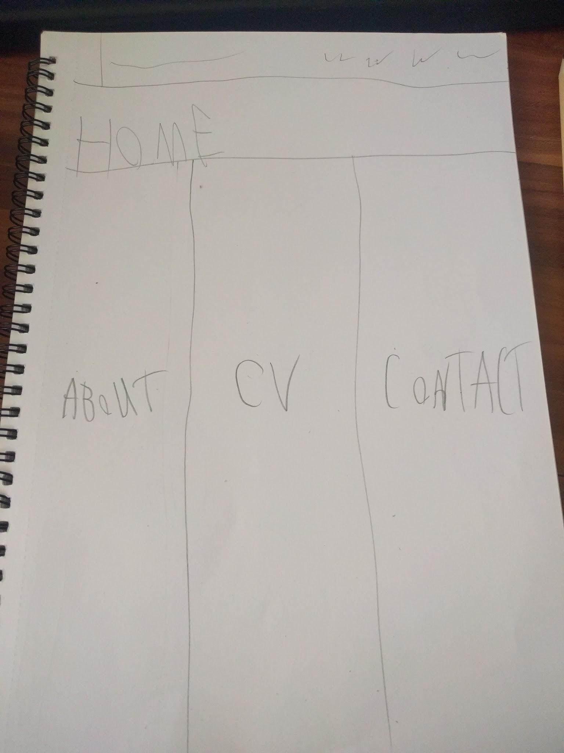

## CV

As the CV is more likely to be viewed by more professional visitors, I wanted the page to not seem too flashy. Therefore, it will consist of a large introductory paragraph, followed two lists on a single row for my computing and general skills. Below that is another list for my educational history.

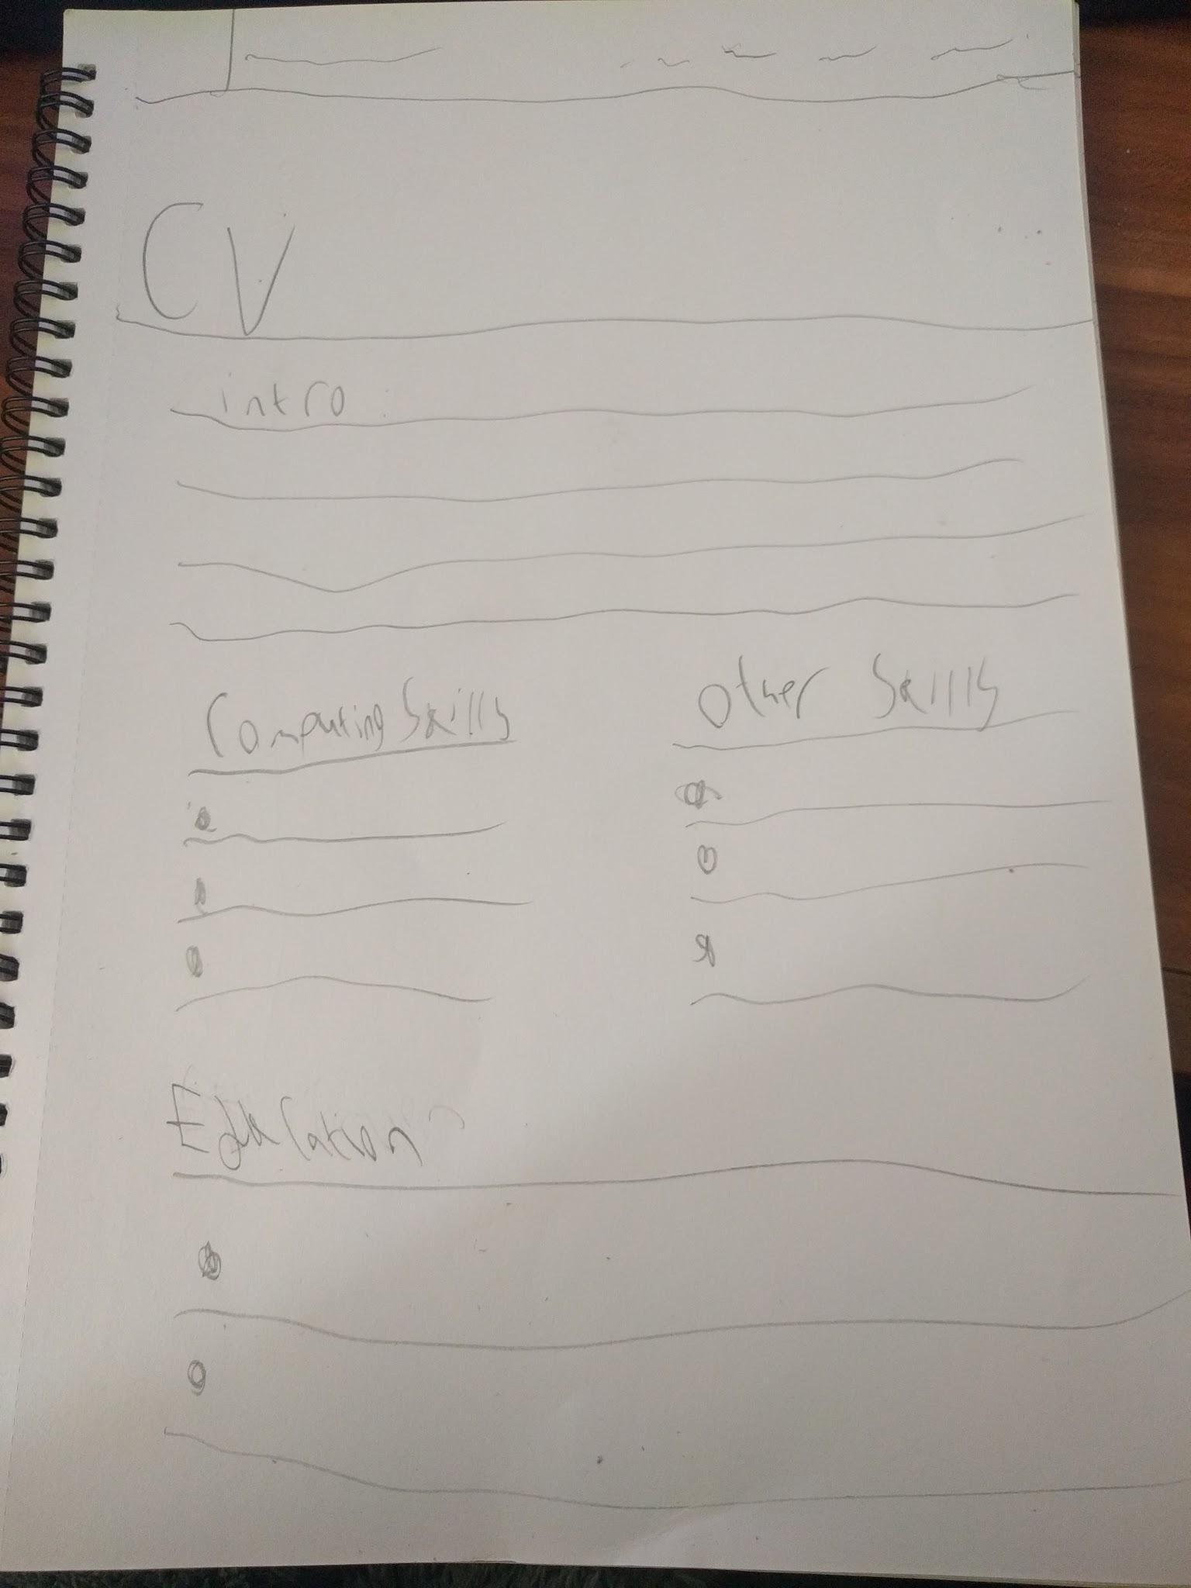

## 

## 

## 

## 

## Bio

The bio will contain a introductory paragraph explaining who I am, with two lists below describing my hobbies and interests. There will also be a photo of myself to the right of the introductory paragraph. Since the bio is more personal, the page should feel slightly more casual compared to the CV.

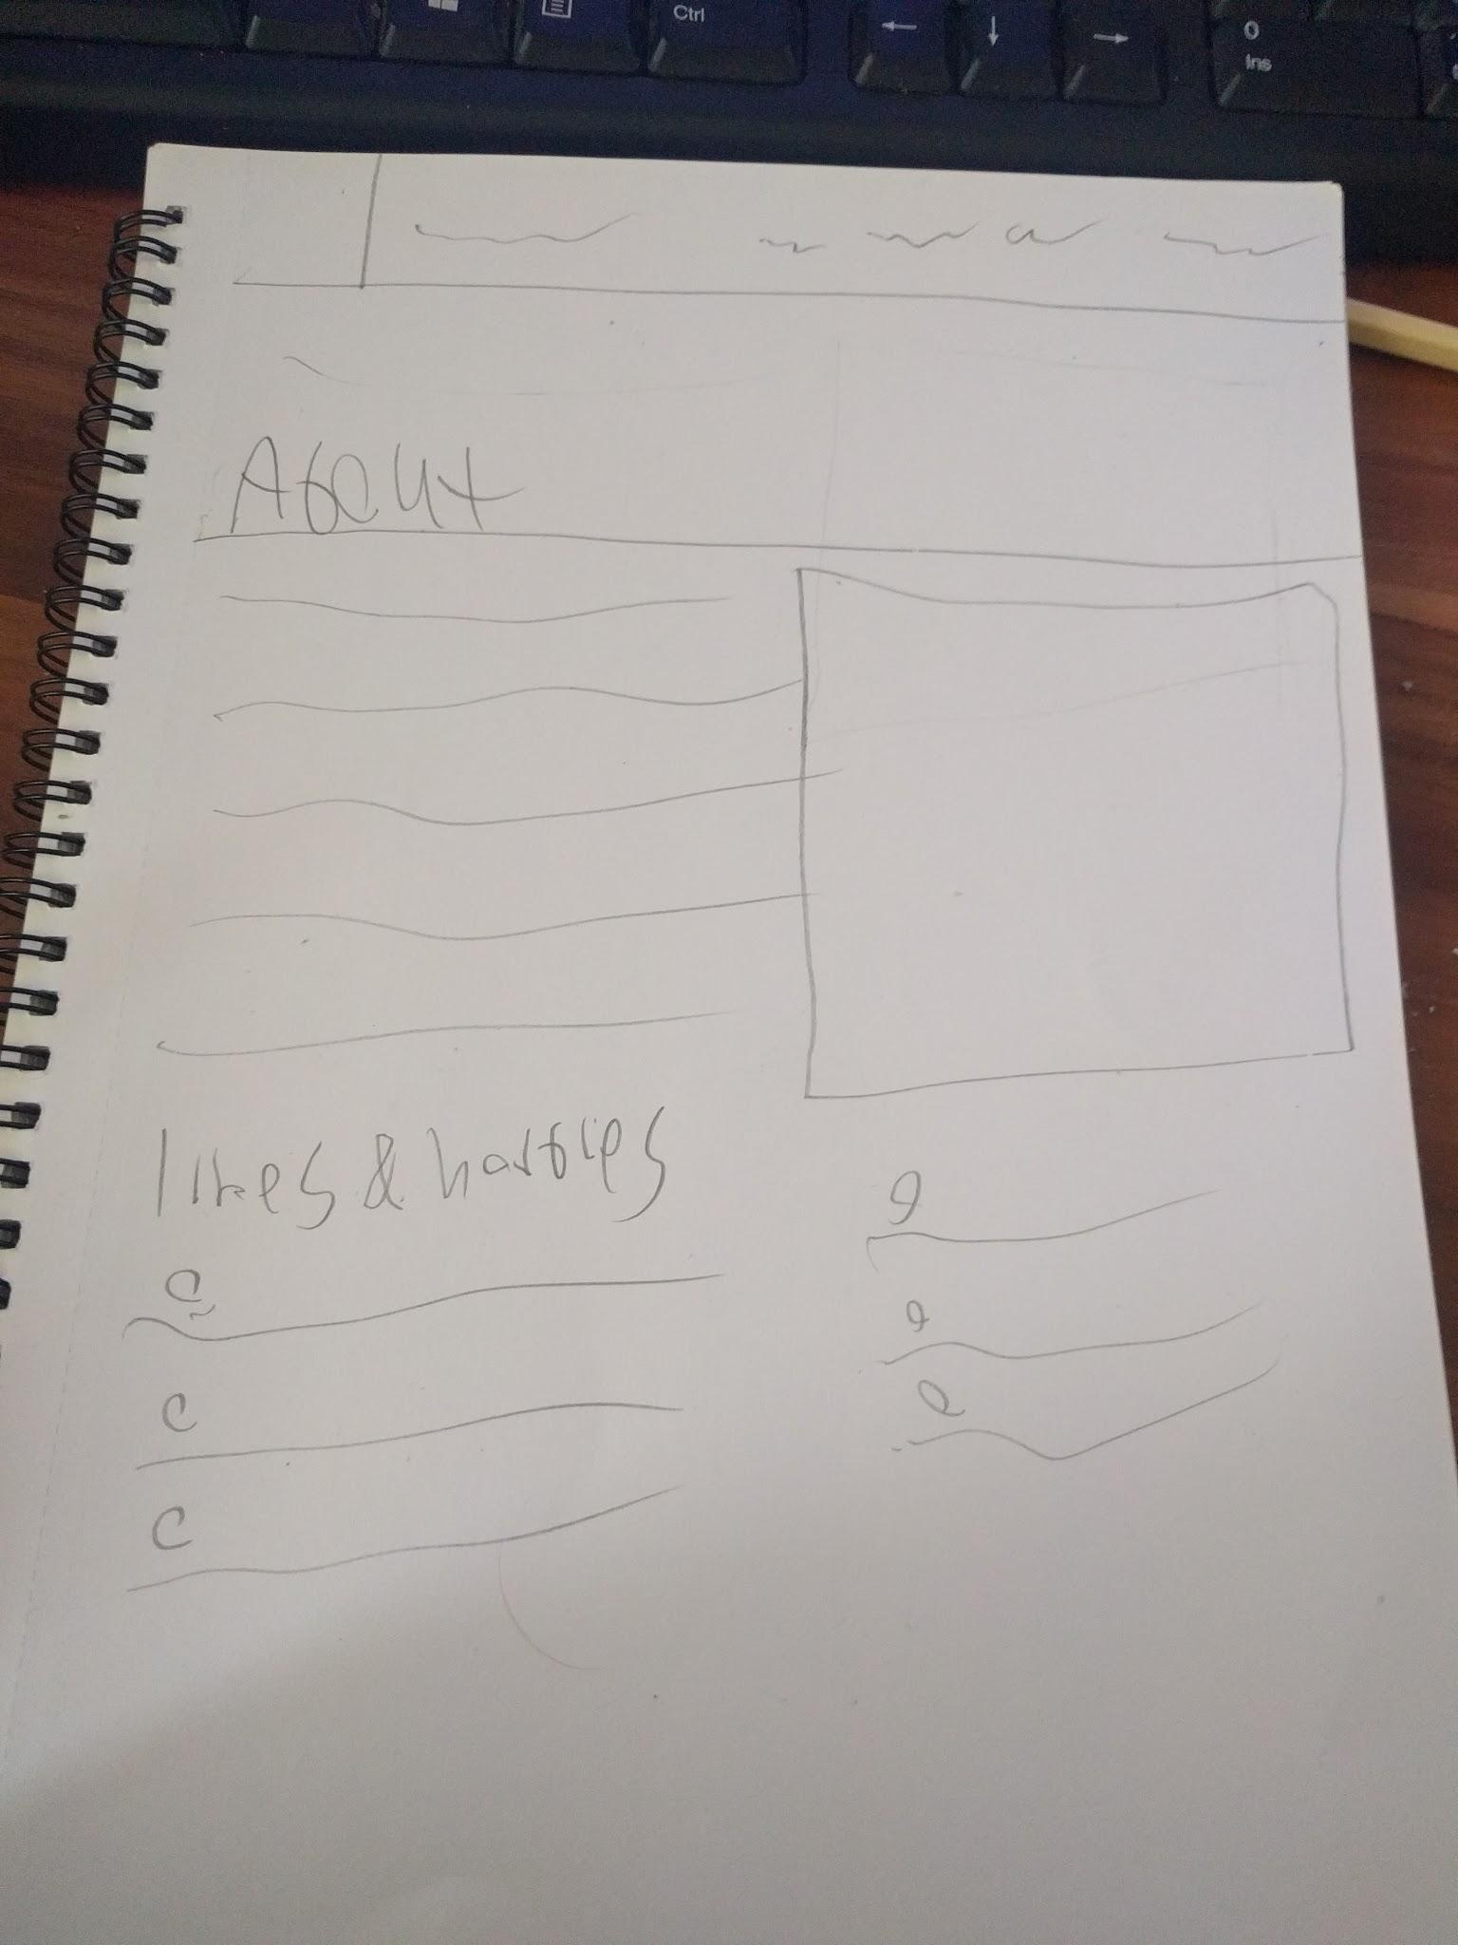

## Contact

Since the contact page doesn’t need to be too complicated, it will likely just consist a contact form asking for the name, email, and phone number, followed by a box for entering a message. A bit of text introducing the page may also be added above the form so people know what its for.

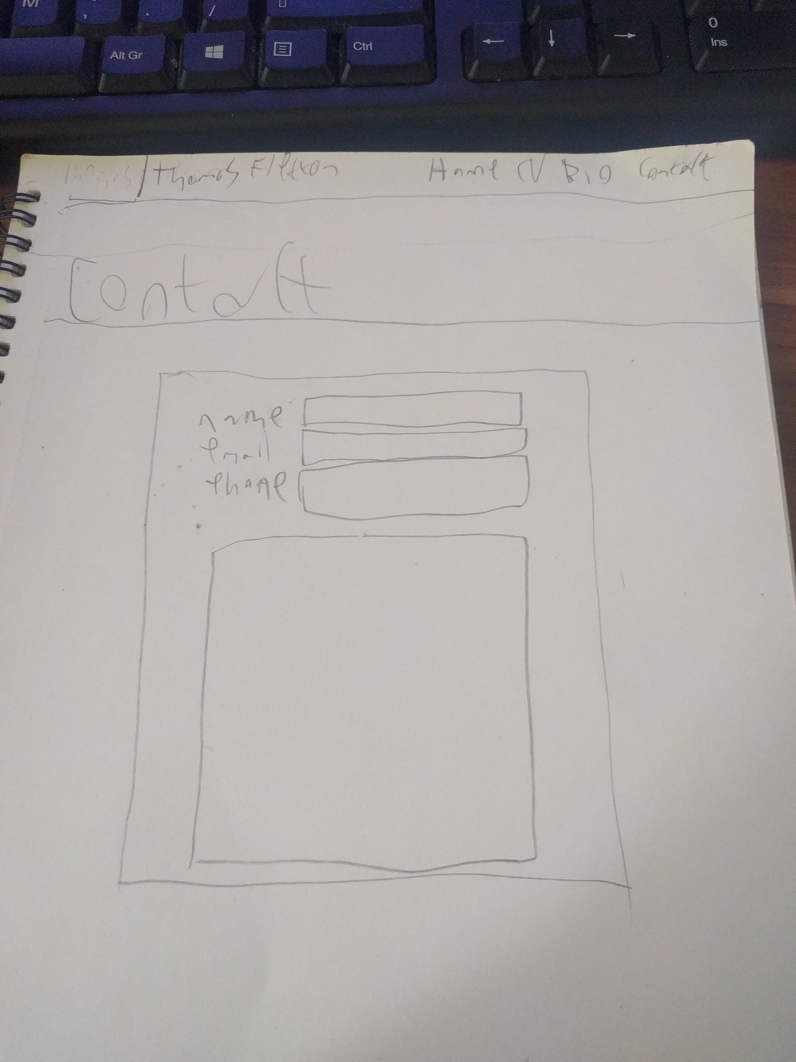

## 

## 

## 

## 

## Logo

Finally, I decided to make the logo something relatively simple. Since my two initials look similar, i decided the logo should incorporate that into the design by having them ‘merge.’ This logo will appear at the left of the navigation bar, and will link to the homepage when clicked.

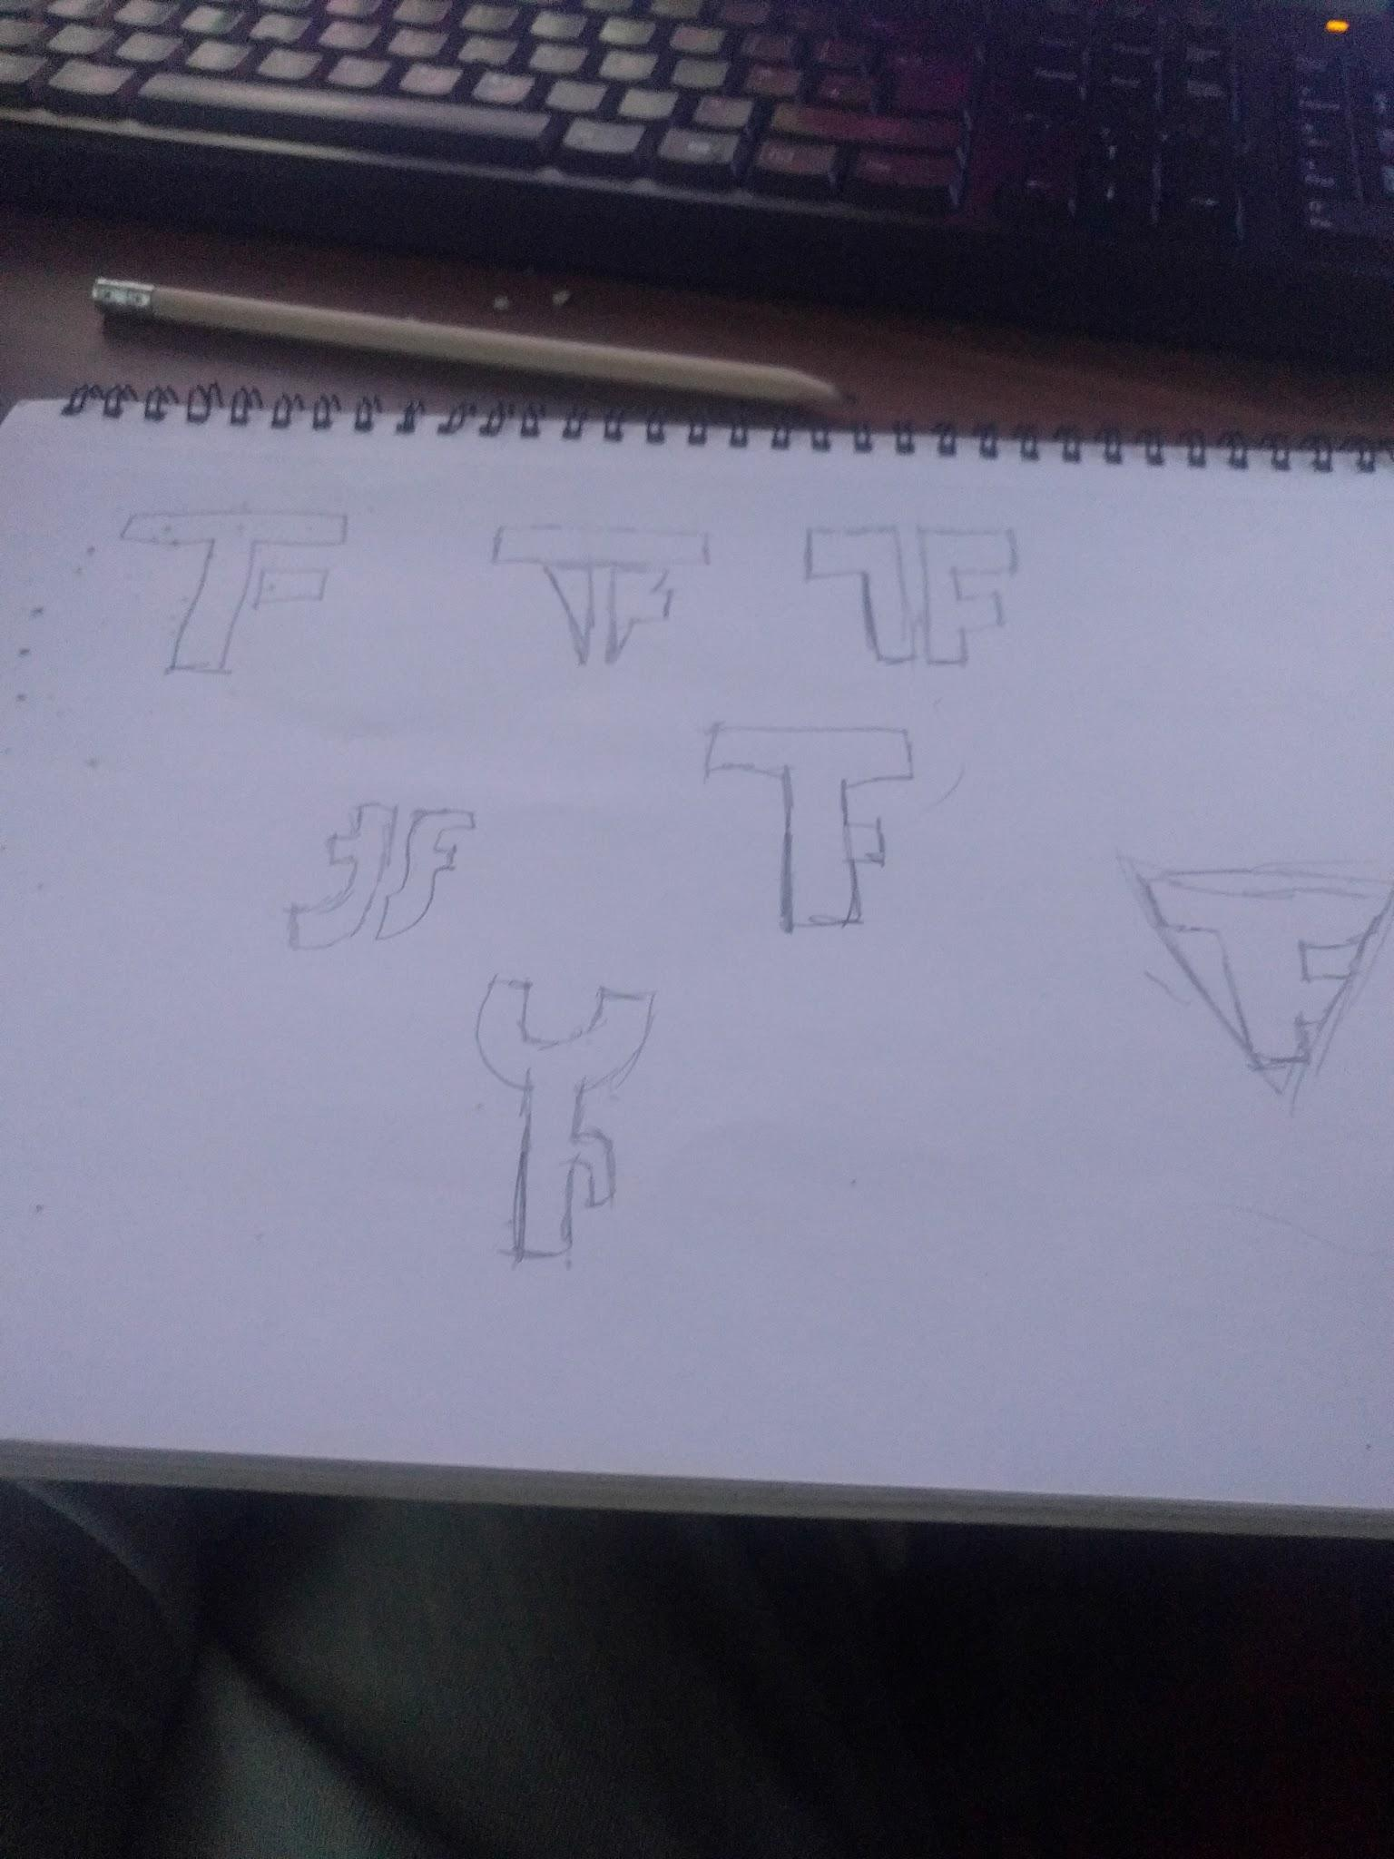

# Wireframes

Theses are the wireframes that I designed, which expand on the paper designs. I mostly stuck to what I drew in the sketches, as those designs fit with how I wanted it to look.

## Homepage

As you can see, nothing has really changed from the sketch design. I was considering having the link background be three separate images, but due to how the webpage will need to change size, the size of the boxes would be too thin for an image to fit, so I think a single image spanning all three boxes would work best.

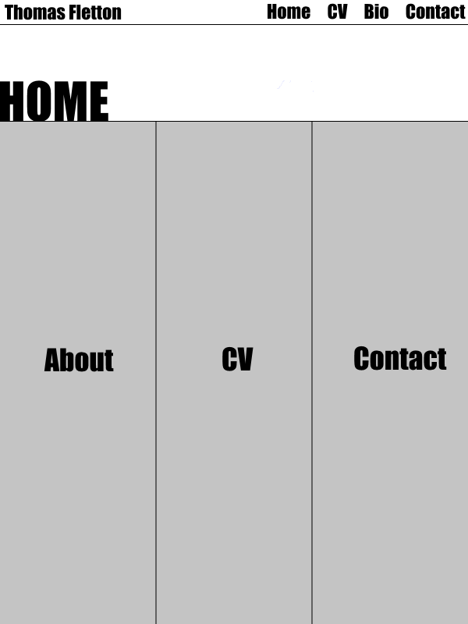

## 

## 

## 

## 

## 

## 

## Bio

Same with the homepage, nothing has really changed regarding the design. The bottom half will be an even divide when split, while the top half should have more room for the text, since it would be more important than the image.

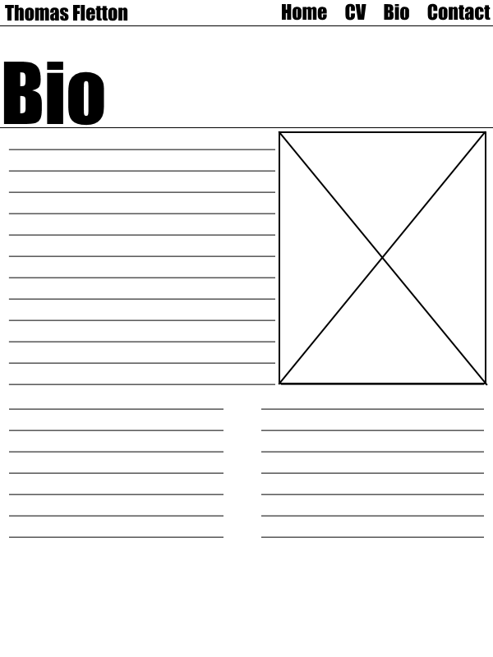

## Contact

I altered the design for the contact form slightly, so that it includes text above the form explaining the form below. Everything on the page should also be centered to make it seem more tidy, seeing how simple the page will be.

## 

## CV

Once again, not much has changed since the sketch designs. The split for the two tables will need to be evenly spaced when implemented.

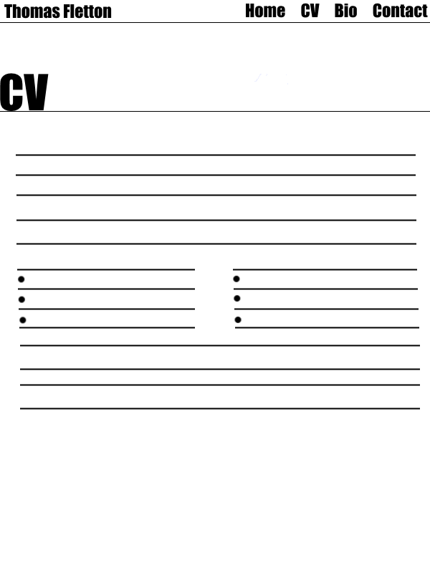

# Post production

The coding side of the website took approximately 20 hours to develop, including fixing bugs. Overall I think the website did well to stick with the designs I created, and it fits the general model of good practice used across the internet for web design.

# Good Practice

## Keeping to material design

Material design is a global design concept that “allows for a unified experience across platforms and device sizes.” Material design guidelines (2017). It essentially helps to describe how a website should be designed in order to work across multiple platforms and screen sizes, while also keeping website designs similar. It describes how the website should use specific color palettes, how “An emphasis on user actions makes core functionality immediately apparent and provides waypoints for the user.” Material design guidelines (2017), and how motions on screen should have a purpose.

My designs all kept to a similar colour palette, with the navigation bar and title box using shades of blue, and a red for highlighting areas being hovered over. This also ties into making it apparent what a user can interact with, as links to areas across the site all have a red highlight when hovered over; except the logo which plays an animation. Lastly, all pages play a short animation upon loading, indicating to the user that the page is ready for viewing.

## Comparable designs

Before I started designing the website, I did some research into what other portfolio website look like for reference. The one I particularly drew inspiration from was joel.sh. For the most part, these websites stick to a basic design, use fonts that stand out and fit the rest of the site, and only use photos where they are relevant. I took what I found during my research and incorporated it into my design, by making sure the website was mostly simple besides the homepage, I made the fonts stand-out and work well with each other, and I also kept the use of images to a small amount. By doing this, the website fits in with other websites of the same type, meaning it follows a uniformed design making it easier for people to use, as well as making it more presentable.

## Validation

Finally, I have ensured that the website I have developed is as fully validated as possible. What this means is that the code does not have any broken or redundant lines of code, meaning the website will load faster and result in less errors on the page. I managed to remove all errors from the CSS validation, meaning the stylesheet is perfect, and the same is true for the HTML validation. This means there are zero code related errors remaining, so the website is less likely to crash, load a false page, or hang due to bad coding.

# Conclusion

Having completed the final website design, I believe I have done a good job at creating something that is simple and easy to navigate, yet has its own flairs and manages to follow the good practices set in place. If i developed further, I would have added additional pages, such as a portfolio page with links to any work I’ve done. I might have also added a few more images across the pages, such as making the homepage use three images for the links rather than one full size images.

References

* Material design guidelines. (2017). Introduction - Material design - Material design guidelines. [online] Available at: https://material.io/guidelines/.
* Rose. T (2016) Forms [CodePen] Available at: <http://codepen.io/UoN-ThomasRose/pen/NbYrGjs>

#### W3schools.com. (2017). *CSS z-index property*. [online] Available at: <http://www.w3schools.com/cssref/pr_pos_z-index.asp>.

* Mozilla Developer Network. (2016). text-decoration. [online] Available at: https://developer.mozilla.org/en/docs/Web/CSS/text-decoration [Accessed 15 Jan. 2017].
* algi. (2012). How to outline text in HTML / CSS. [online] Stackoverflow.com. Available at: http://stackoverflow.com/questions/11323813/how-to-outline-text-in-html-css [Accessed 10 Jan. 2017].
* W3schools (2017).CSS Layout - Horizontal & Vertical Align. [online] Available at <http://www.w3schools.com/css/css_align.asp>. [Accessed 13 January 2017,]