**Agilent “SkillMatrix”** **Manual**

Introduction

The SkillMatrix is designed to search for products and engineers. Selecting an engineer will show the data of this engineer and the product he is trained for. The same goes for the product, where it will show the engineers trained for the selected product. This application has an admin page where you could manage the information provided in the SkillMatrix.Login

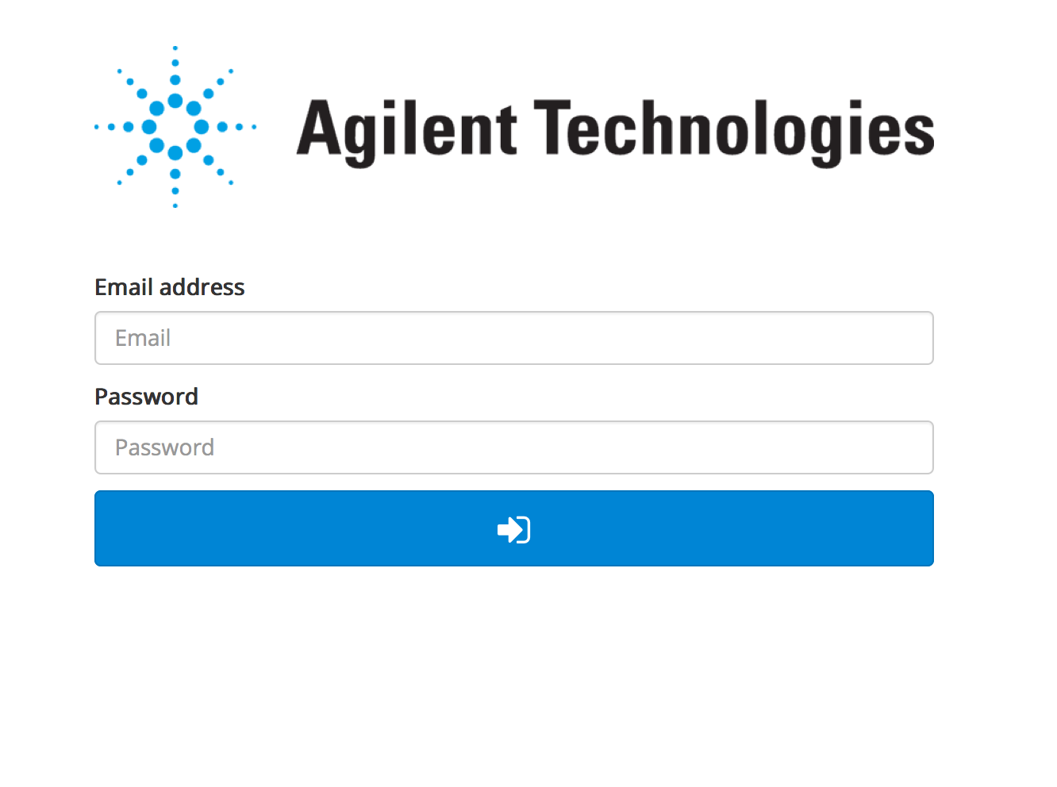

When opening the application, the first thing you will see is this login page. The login page has two input fields; Email and Password. Use your given Agilent email and password to login in the application. After filling out your email and password, press the blue button to continue to the next page.

SkillMatrix

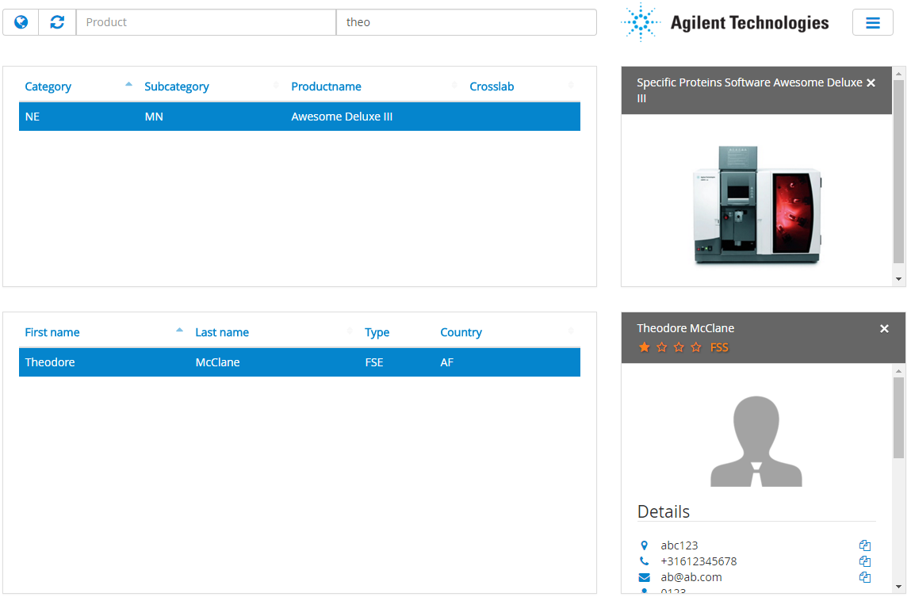

This is the page you will see after logging in. It is called the SkillMatrix. On this page you can search for engineers and products. After selecting the specific engineer or product, you will be able to see the information about them. You can also filter the results by clicking on the world icon in the top left. There you can select specific countries, then the application will filter the results based on that.

Search product

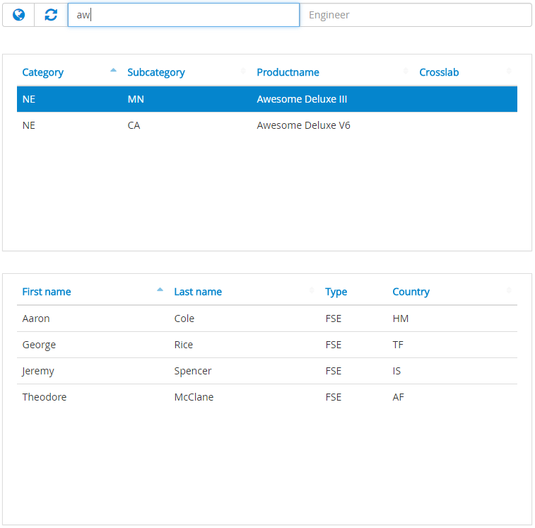

This part of the SkillMatrix is designed to search for a product. You do this by searching the name, an abbreviation or a part of its name in the ‘product’ search bar. The product table will narrow its result live to your search request as you type. After you click on a product the engineers trained for this product will appear on the second table.Search engineer

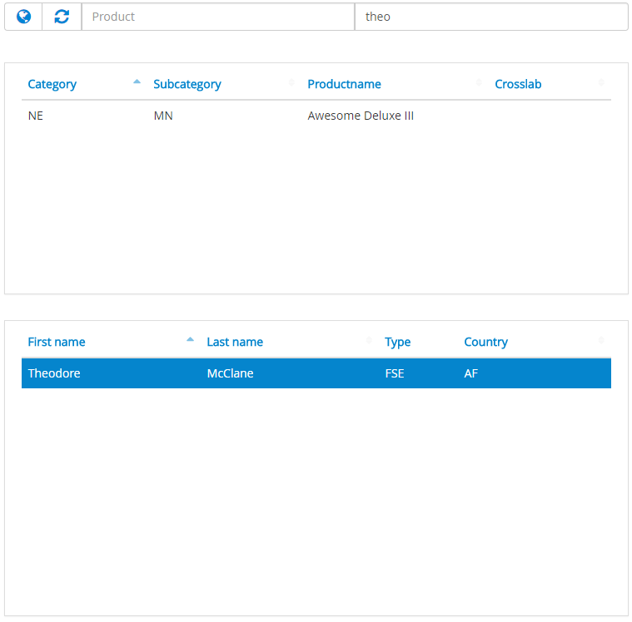

You could also search the other way around by searching for an engineer in the engineer search bar. To search for an engineer you type in the full name or a part of it. The engineer table will narrow its result live to your search request as you type. After you click on an engineer the product table will show the products this engineer is trained for.

Language preferences

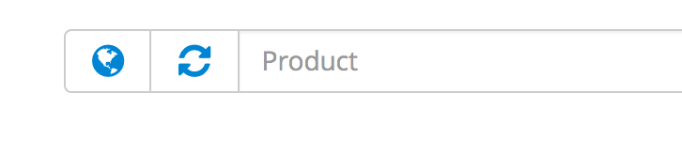 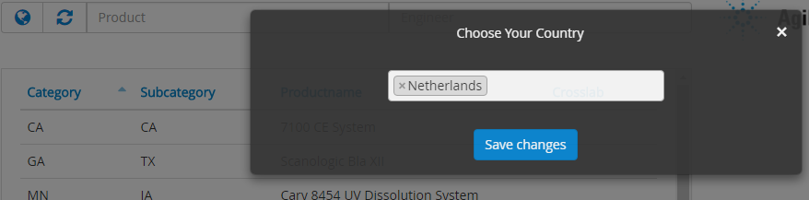

To filter your search result you can set the countries you want to include in the search bar. First you have to click on the globe icon next to the search bars that will open a pop-up window where you can add and remove the countries to include. You can save your preferences by clicking the ‘Save changes’ button. The system will remember your settings for the next visit.Engineer details

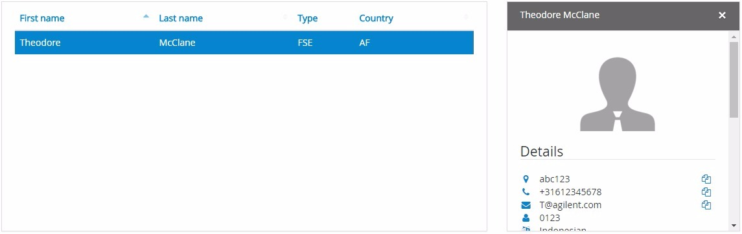

After you’ve searched for an engineer, you want to select an engineer. You do this by clicking on the row of the desired engineer in the engineers table. After clicking a window to the right of the engineers table will appear with its information. Here you will find information such as: The name and last name, the e-mail, the phone number, etc. This window is scrollable.

Engineers note

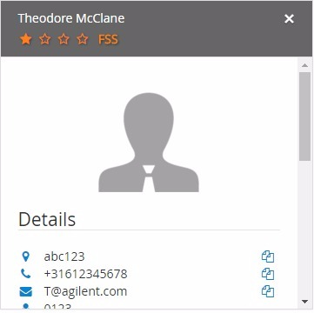 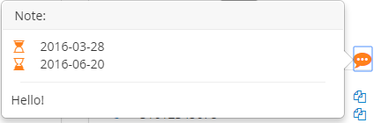

The note will only show when an engineer has been selected and the engineer details tab is showing the selected engineers information. It will also only show if a note has been made for this engineer. If this selected engineer has a note you will see an orange comment bubble icon next to details. When this icon is clicked it’s comment will show in a pop up. In this pop up you will see the starting date and ending date of this comment and the comment itself.

Important: The note will not show if the time selected is not your current time. For example, If you selected 2017-03-10 / 2017-05-23 and it is 2016-02-12 then it will not show up until the given date.Engineer’s skill



After selecting an engineer in the list and selecting a machine he is trained for, you can see the engineers skill level for this machine. The skill level is indicated by the amount of filled star icons. If this engineer is a FSS for this product the word FSS will appear next to the stars. Refreshing your search

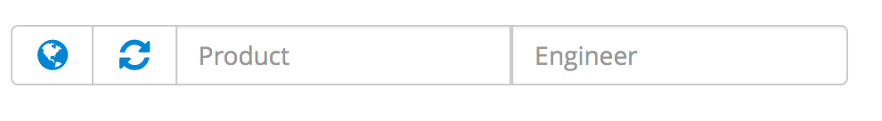

To refresh your search you will have to click on the refresh button recognizable by its two arrows pointing towards each other. Both engineer and product table will refresh and show all the data again.

Log-out

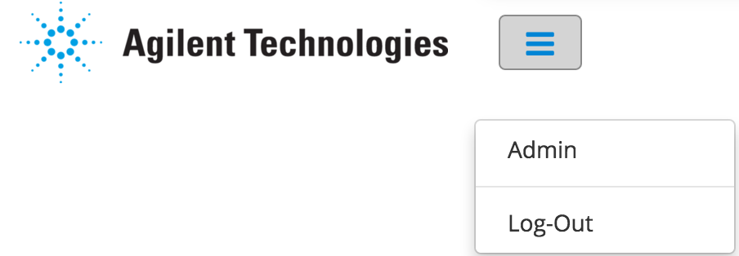

If you want to log out the current user you can click the ‘Hamburger’ next to the Agilent logo. A menu will appear. Log out by clicking on the log-out item in the menu.

Backend (Admin)



If you want to edit the information of an user or a product you will have to go to the ‘Admin’ page. You do this by clicking on the blue ‘hamburger’ next to the Agilent logo. A menu appears with two options. Click on admin to proceed to the admin page. You will be directed to the Admin page looking like the image below.

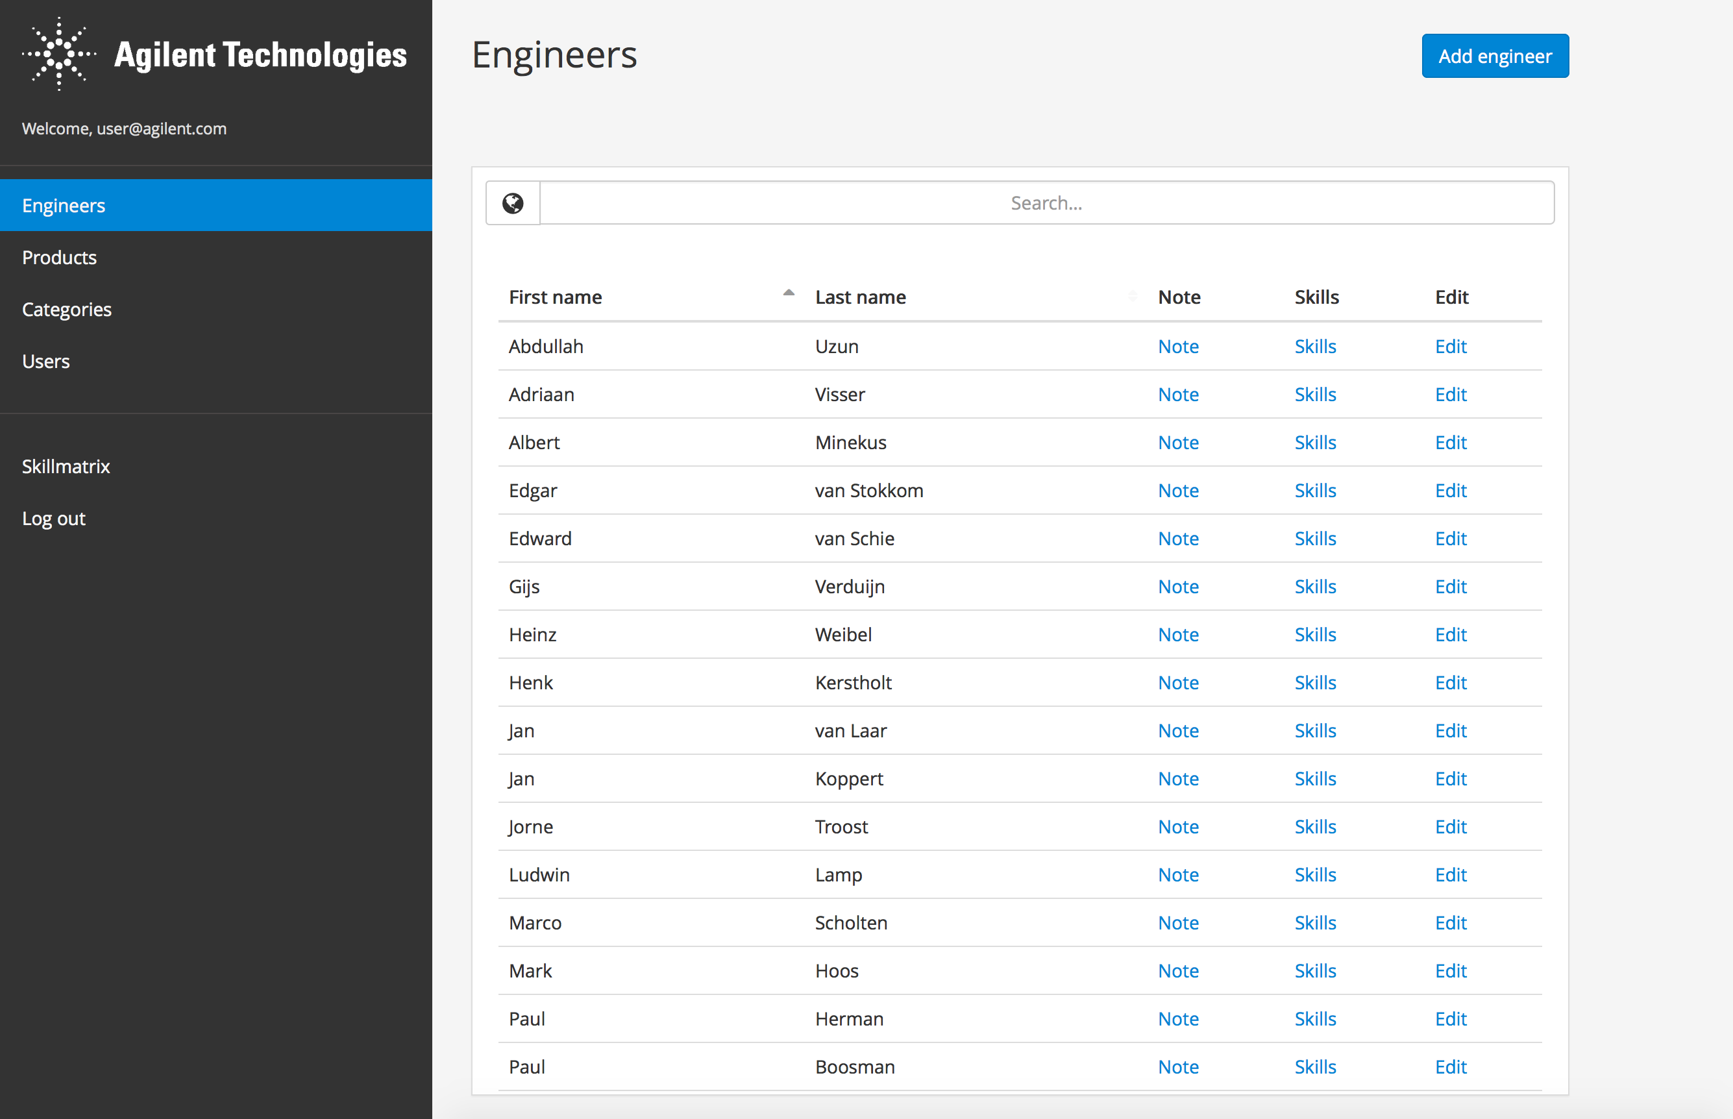

Add engineer

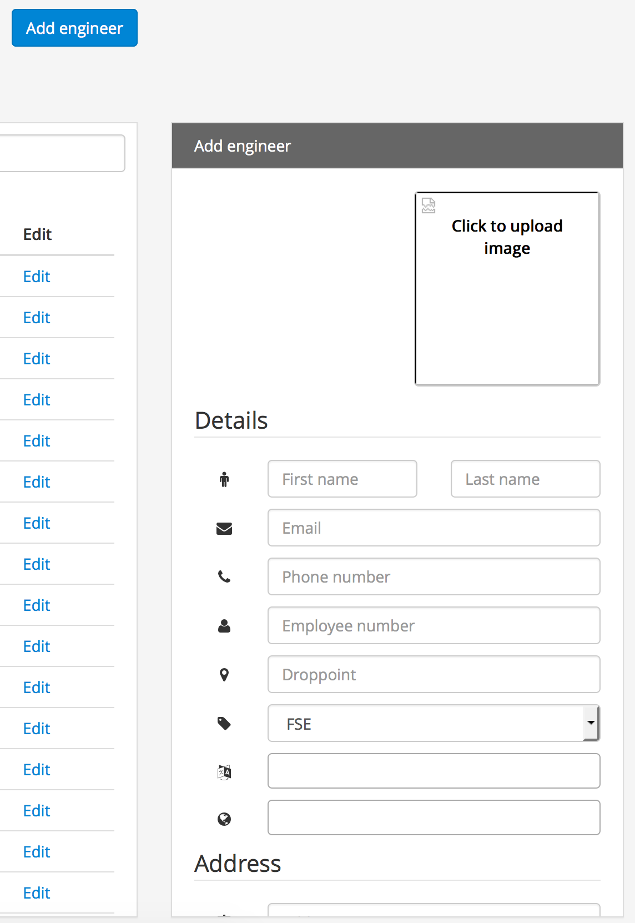

To add an new engineer to the system. Click the add engineer button to open the ‘Add engineer’ button. A new form will open on the right side of the page with fields required for this new engineer. If you are done filling in this form press the ‘submit’ button. The engineer will now be added to the system.

Edit engineer

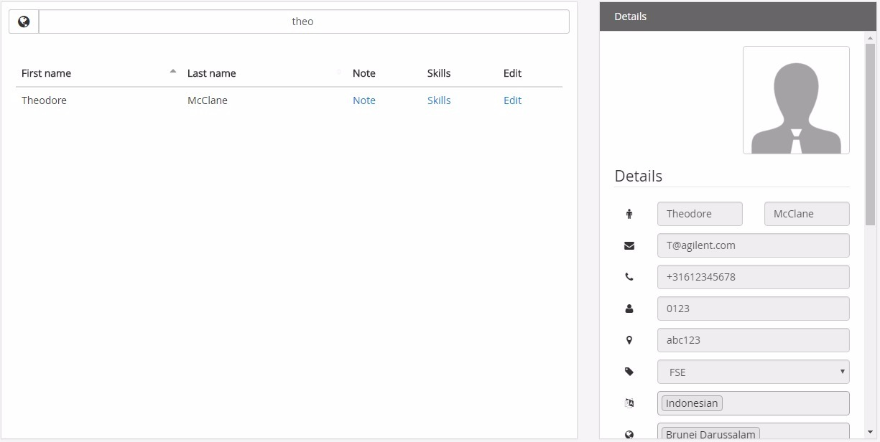

To edit an engineer click on the ‘Edit’ link in the desired engineer’s row. The right side of the screen will now change to the selected engineers data which you can edit. To save your changes press submit.

Edit skills

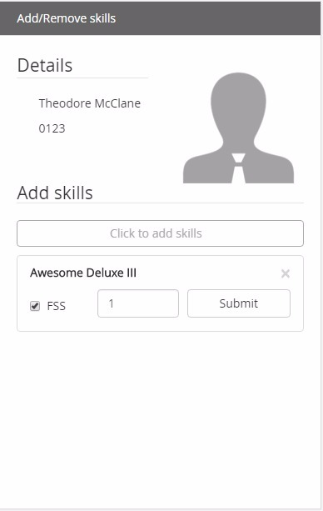

To edit the products an engineer is trained for you click on ‘Skills’ in the table. A window will open at the right side of the screen where you will be able to edit its skill. Click on the button and start searching for a product this engineer is trained for. This product will now appear below where you can edit its level. After you are done press submit to save your changes.Edit/edit note

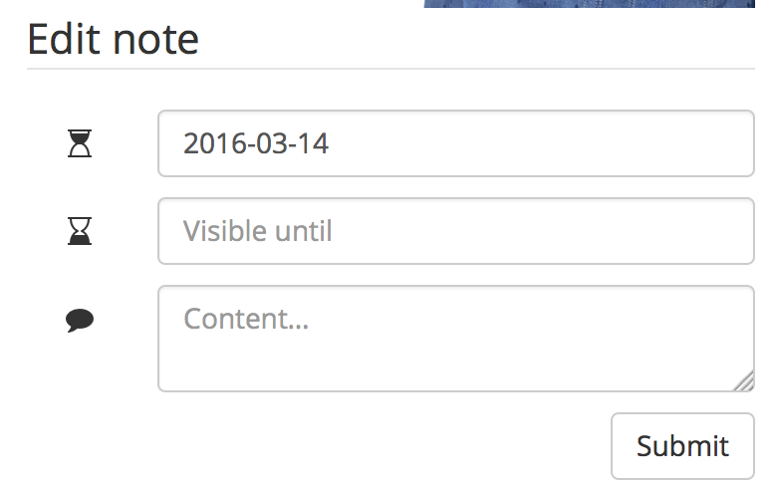

To edit a note of an engineer you click on ‘Note’ in the table. A window will open at the right side of the screen where you will be able to edit its data. Fill in the start date and end date of the comment and the comment of this engineer. After you are done press submit to save changes.

Add product

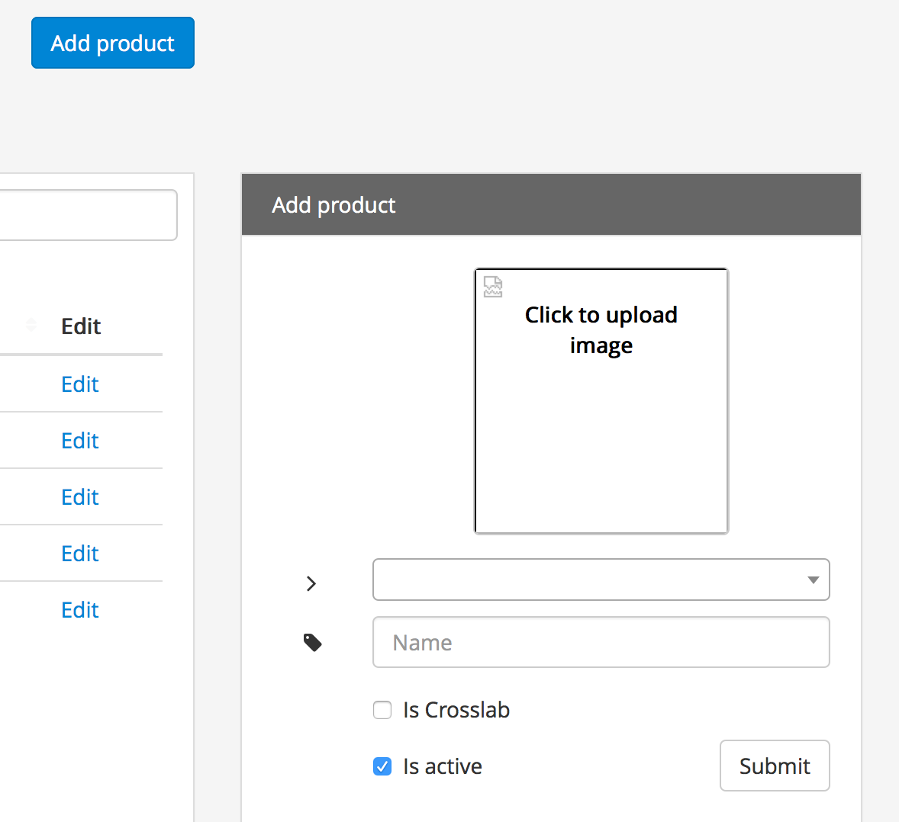

To add an product to the list, click on the blue ‘Add product’ button on the top-right side of the page. The right side of the screen will turn in to a blank form where you can add a picture of the product, its category in the first field and the product’s name. You can also select if the product is Crosslab. Click submit after you are done.Edit product

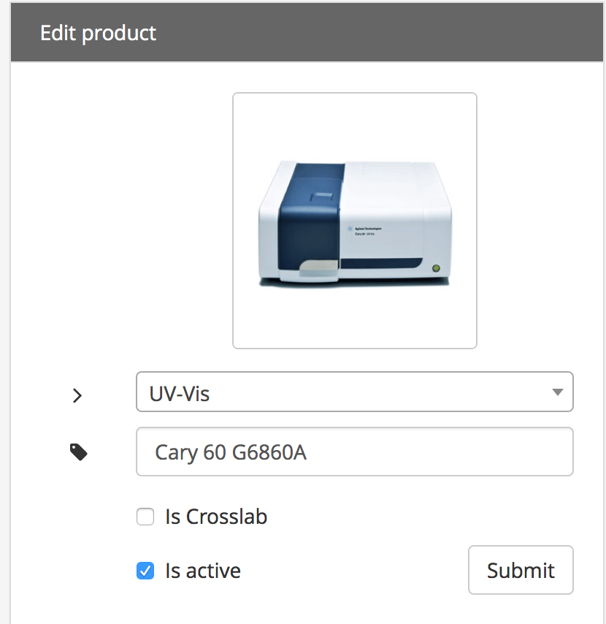

To edit a product, click on the Edit button next to the product you want to edit. The right side of the page will turn into this product’s information for you to edit. If you are done hit submit.Add category

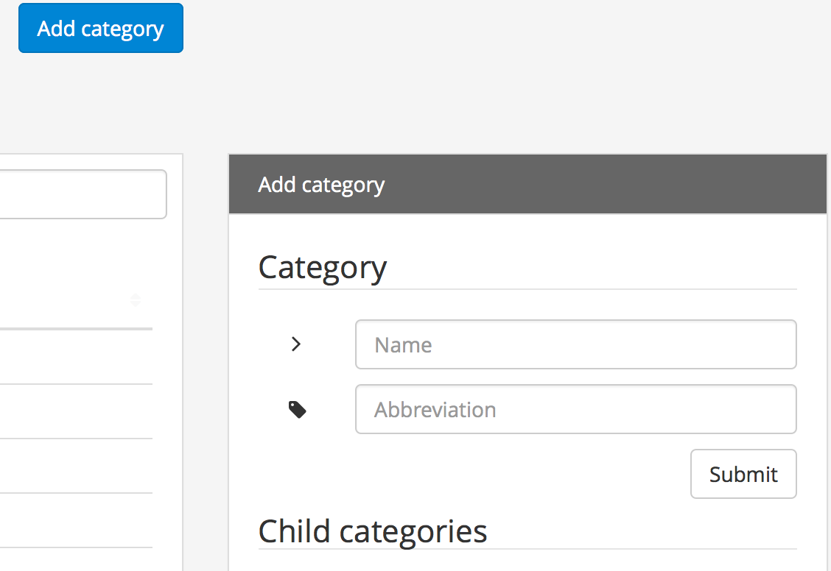

To add an category press on the blue ‘add category’ button. A empty form will open at the right side of the page. Here you can fill the name and abbreviation (Short code) of this category. This abbreviation will be searchable. You are also able to add Child categories, these will appear beneath your main categories. If you are done hit submit.Edit (sub)category

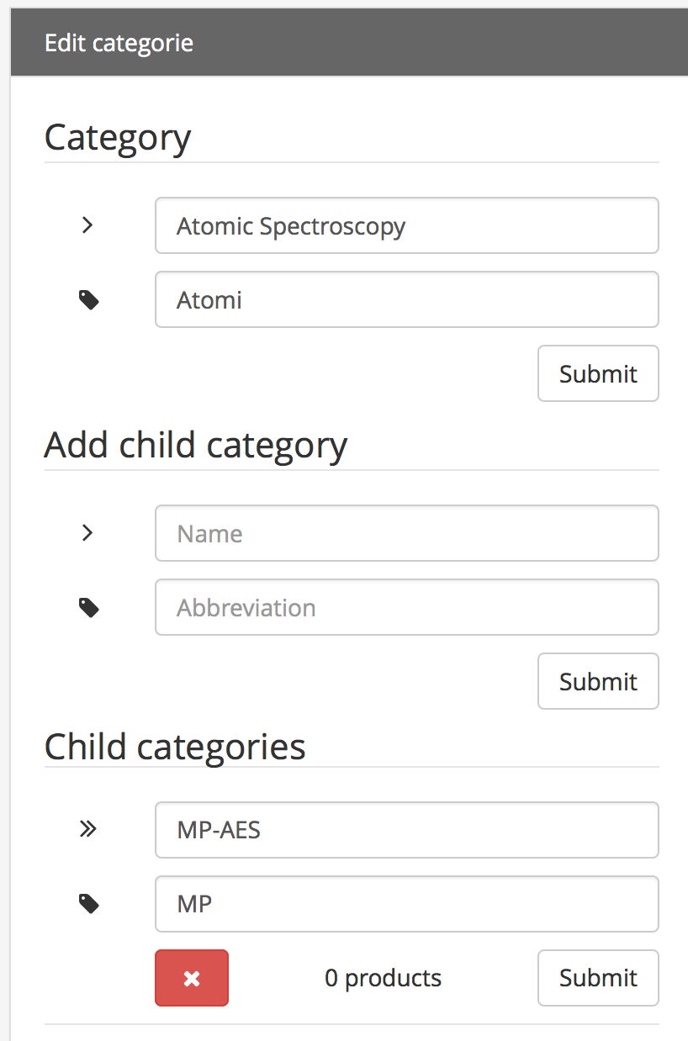

To edit and category click on the ‘Edit’ link next to the category name in the table. The right side of the page will turn into this category’s information. Here you can edit its name and add subcategories.Add User

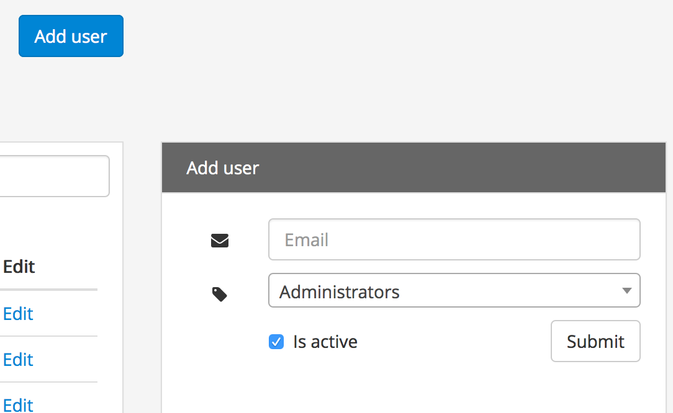

To add an user to the database click on the blue ‘Add user’ button. A form will appear on the right side of the page. Fill in an email address and an access level. Then when you are done, hit the submit button to save.Edit user

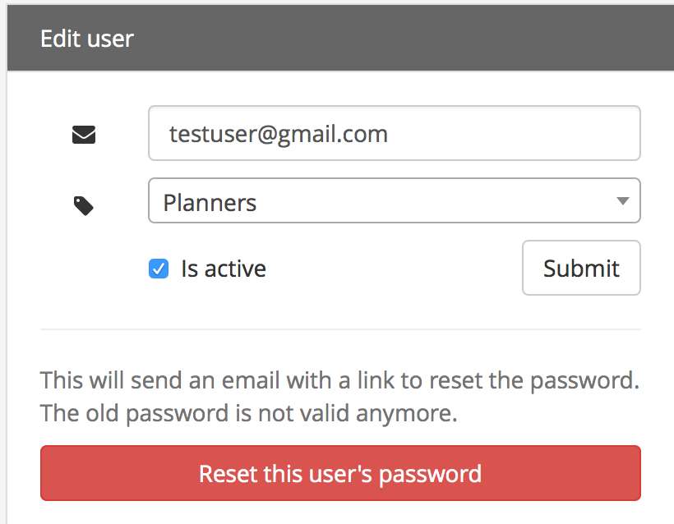

To edit an user, click on the ‘Edit’ link next to the users name. The right side of the page will change to this user’s information. Here you can edit its e-mail, access level and reset its password.Skillmatrix/Log-out

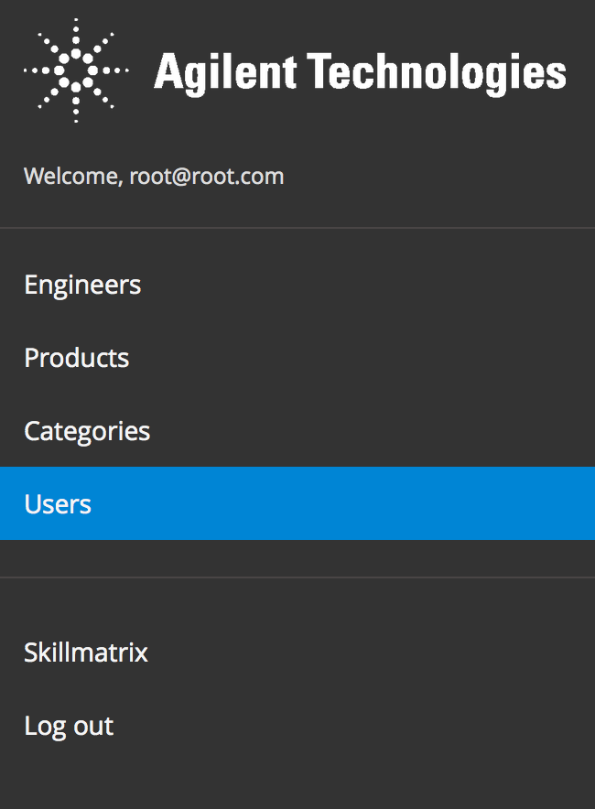

if you want to go back to the Skillmatrix or Log-out of the application entirely. Click on the link on the left side of the screen