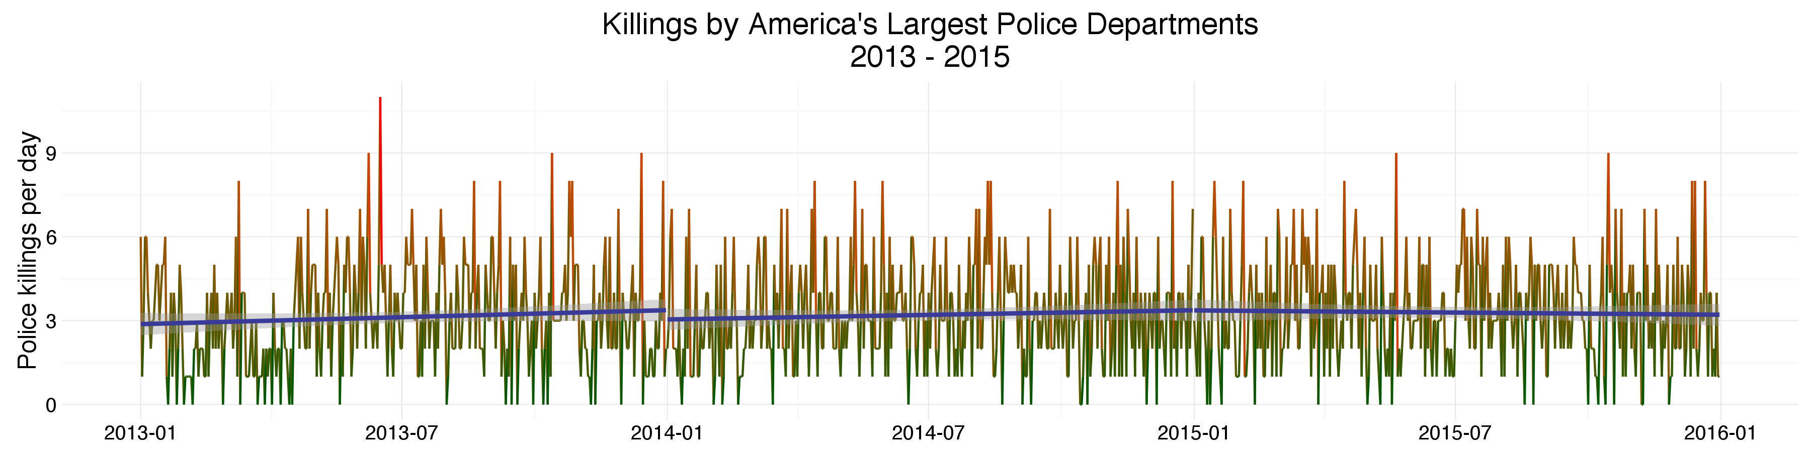
In America's 60 largest police departments, 2015 saw
1201  killings by police | 3  people per day |  | 80%  by gunshot
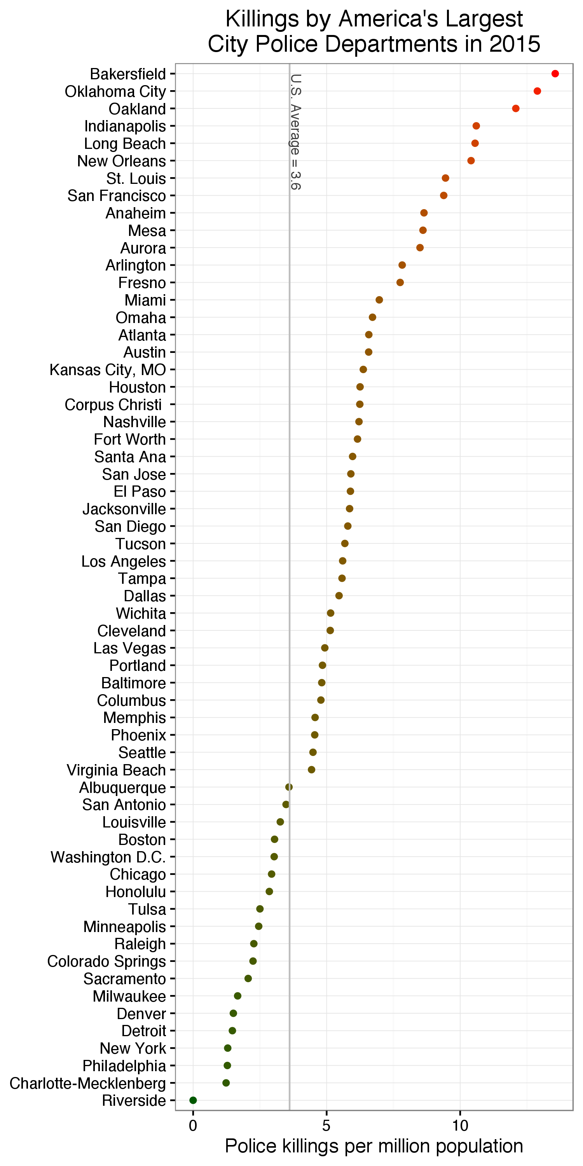 |  | 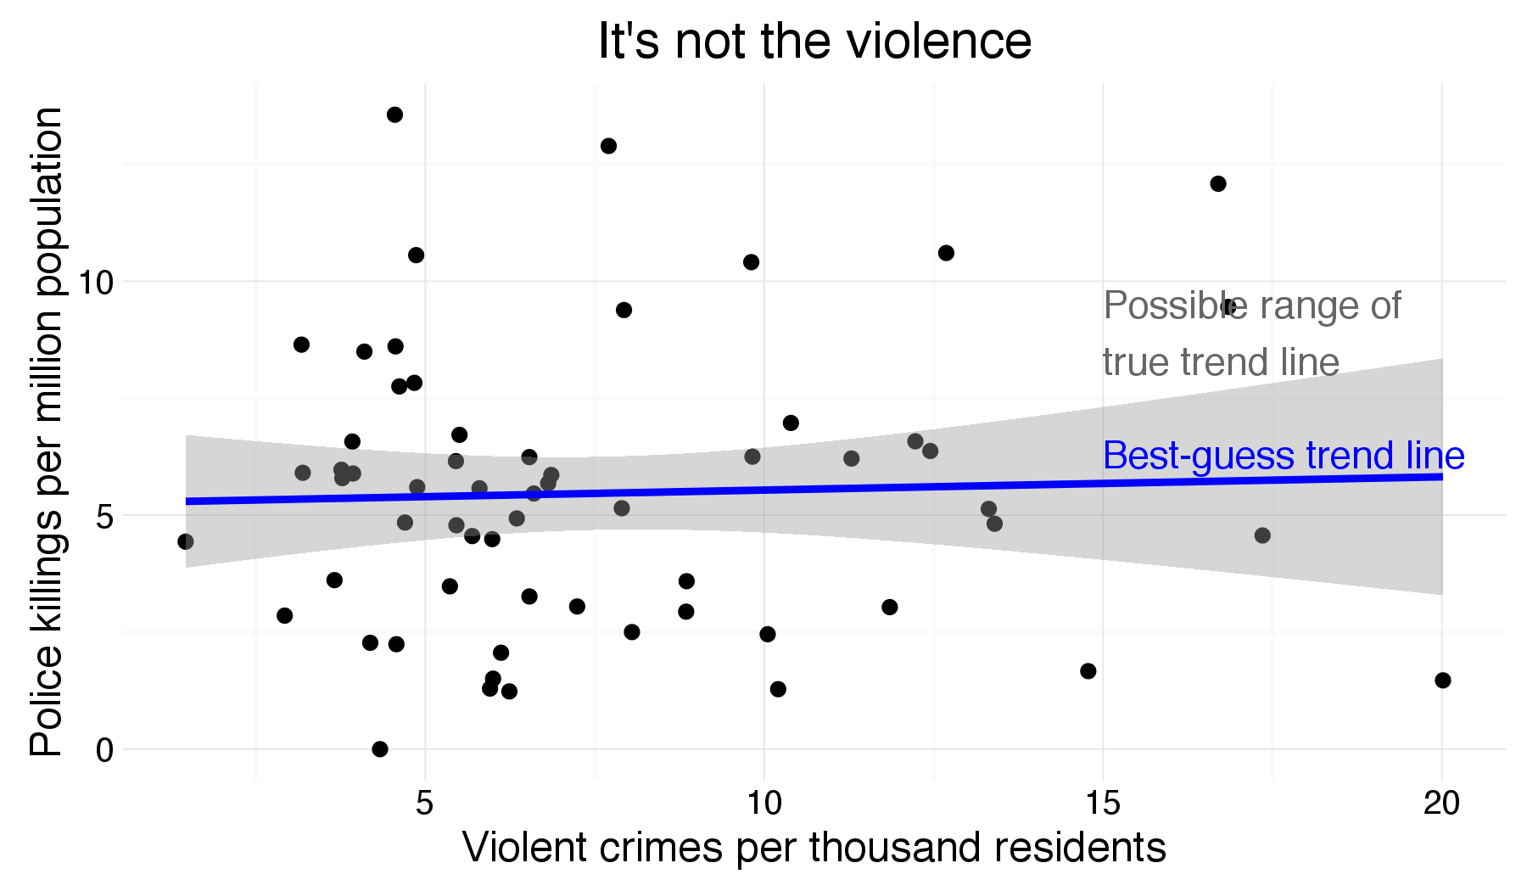
 |  | 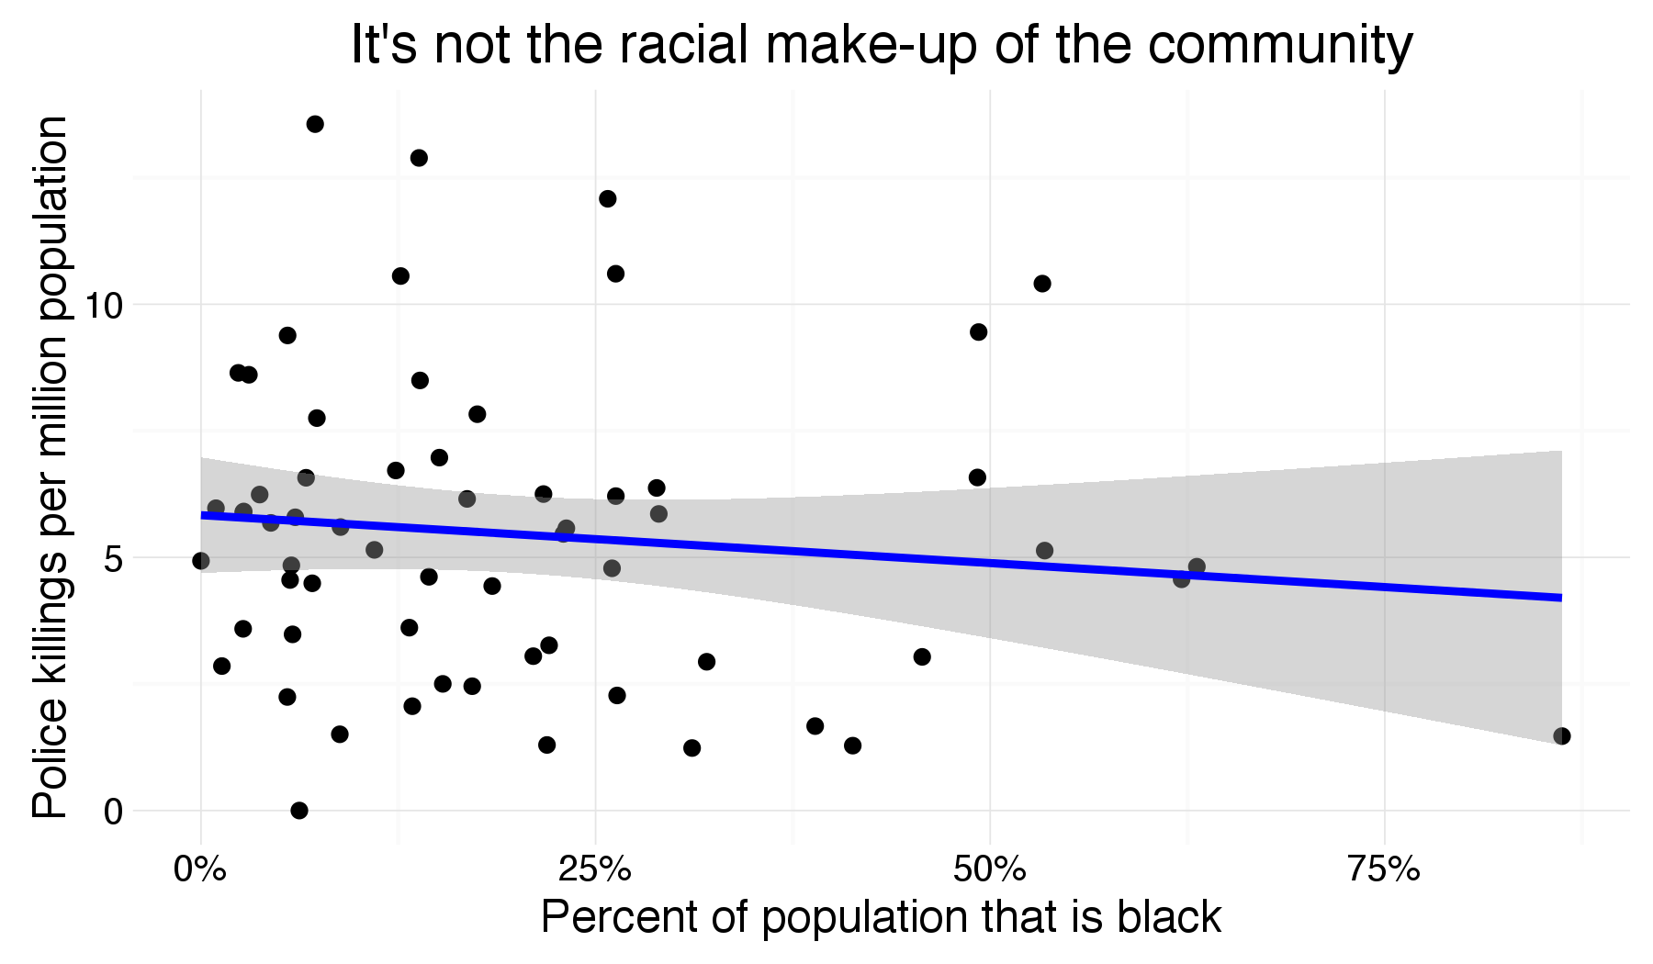
 |  | 