Nielsen’s Heuristics
Stacy Tomasi
60503 - Fundamentals of Interaction Design
Professor Andy Vitale
February 7, 2026

Introduction
This document is a heuristic analysis of the Starbucks and Phil's Coffee mobile apps, using Jacob Nielsen's 10 Usability Heuristics. It identifies interaction design strengths and weaknesses in each app and provides some recommendations for improvement.
Visibility of System Status
  - Starbucks: Makes good use of loading indicators by showing the item being added to the cart (pictured). Could improve visibility of real-time order status and inform users of delays, offering the option to cancel their order.
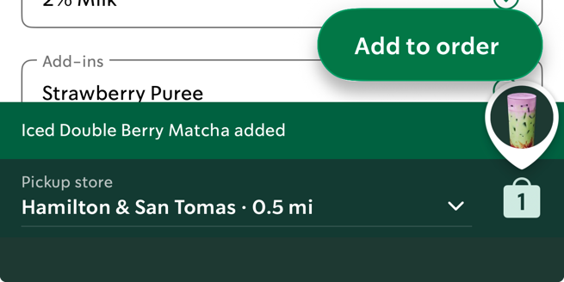
  - Philz Coffee: Provides excellent, immediate feedback. Button text changes dynamically (pictured), and the interface updates in real-time, effectively keeping users informed.
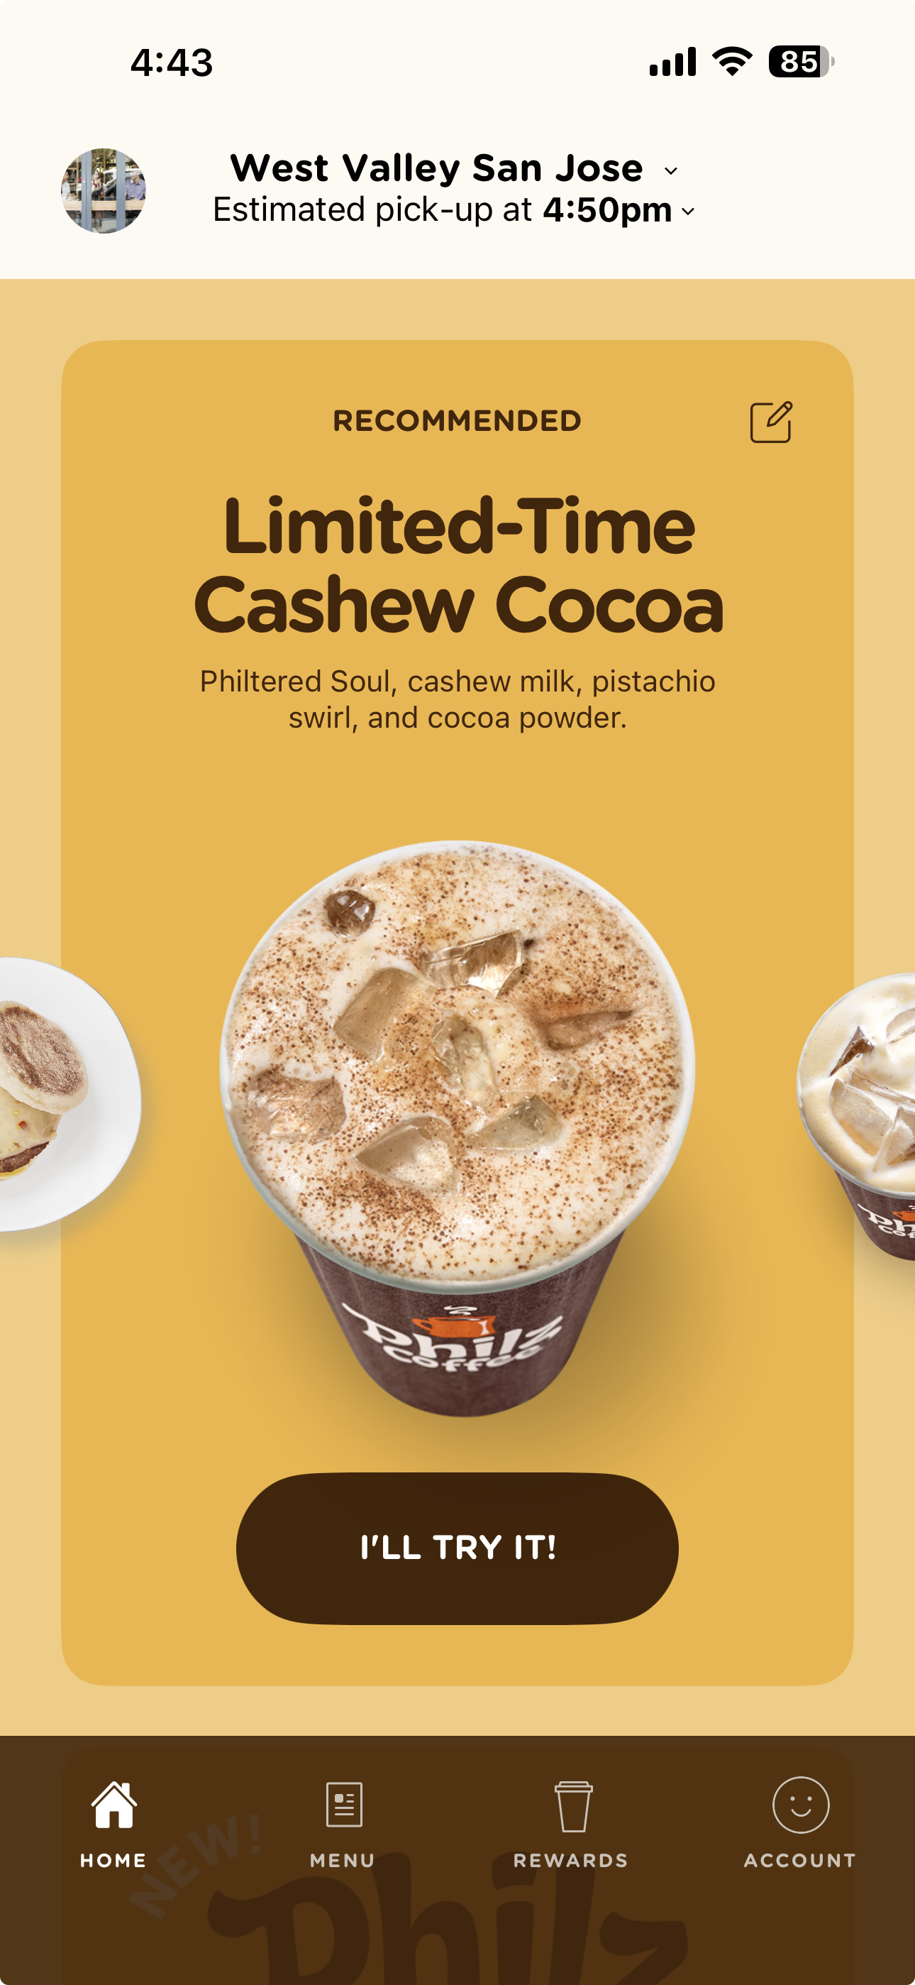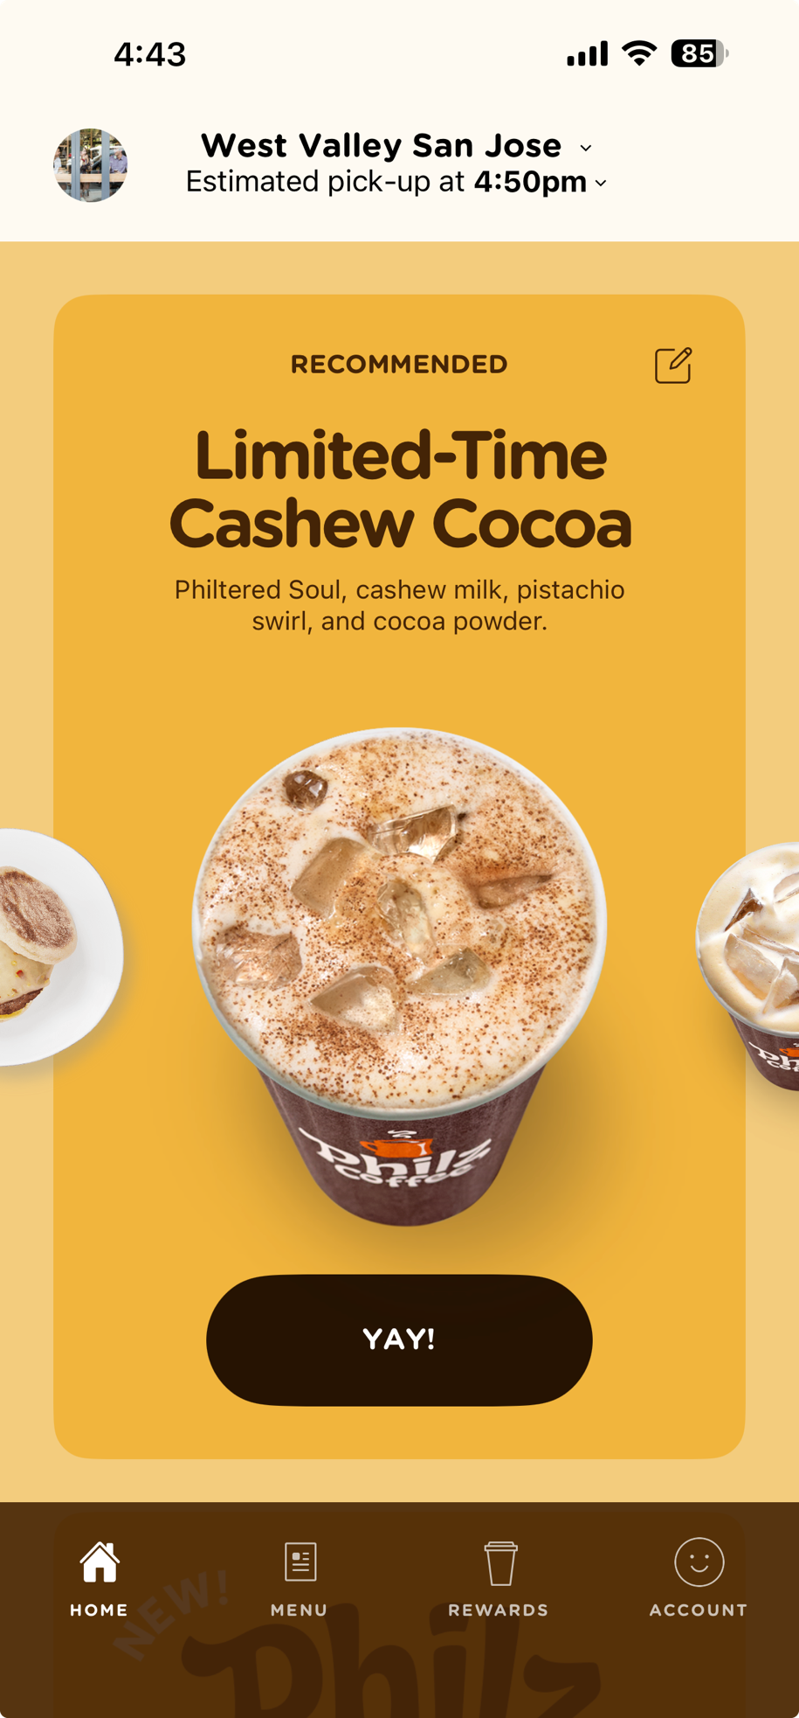
Match Between System and the Real World
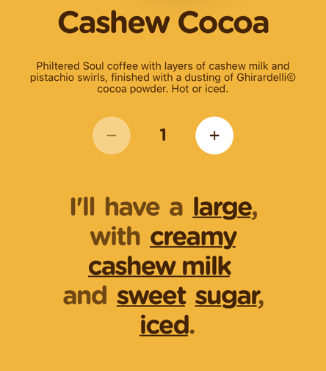
  - Starbucks: Uses familiar language (“Choose a Store”) and universal icons. The app’s workflow mirrors real-world ordering, making it intuitive.
  - Philz Coffee: Employs conversational language (pictured) and clear icons. The menu and customization process feel like talking to a barista, creating a natural user experience.

User Control and Freedom
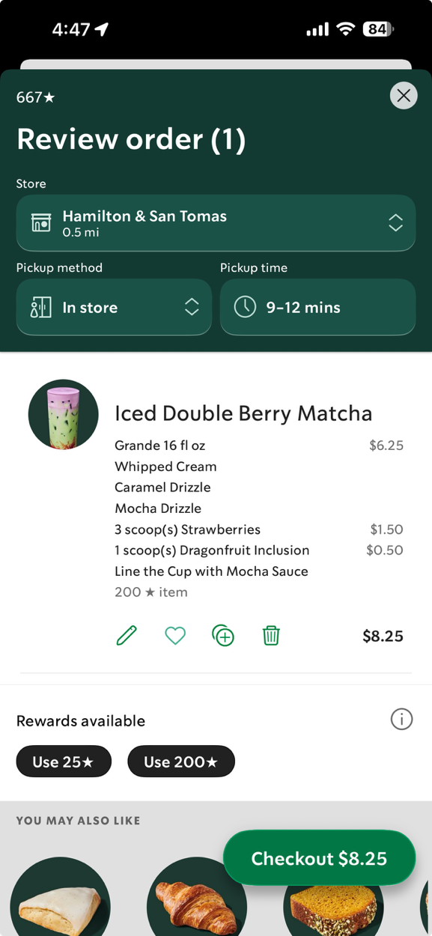
  - Starbucks: Offers great order personalization abilities (pictured) but lacks an order cancellation feature after placement, reducing user control. The detailed order summary before confirmation helps prevent errors.
  - Philz Coffee: Allows users to easily edit cart items and customizations. However, reordering the same drink with minor modifications is difficult because users must restart the process from the main menu.
Consistency and Standards
  - Starbucks: Maintains a consistent design language (colors, fonts, icons) and follows platform navigation standards. Minor inconsistencies in non-core sections, such as help articles, could be improved.
  - Philz Coffee: Has strong visual and interaction consistency with a clear navigation bar and uniform language. Minor refinements, like standardizing button colors, notably on the checkout page (black button, should be brown or orange), could enhance this further.
Error Prevention
  - Starbucks: Indicates sold-out items with red text and clear language (pictured), as well as guides users step-by-step through the ordering process to reduce errors.
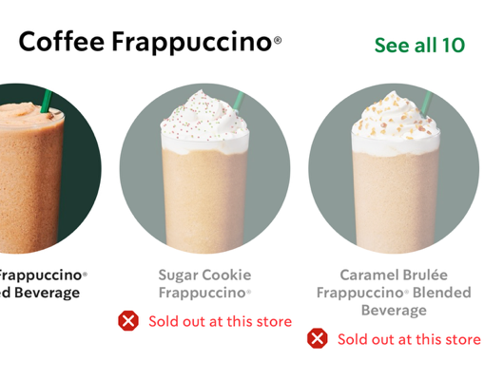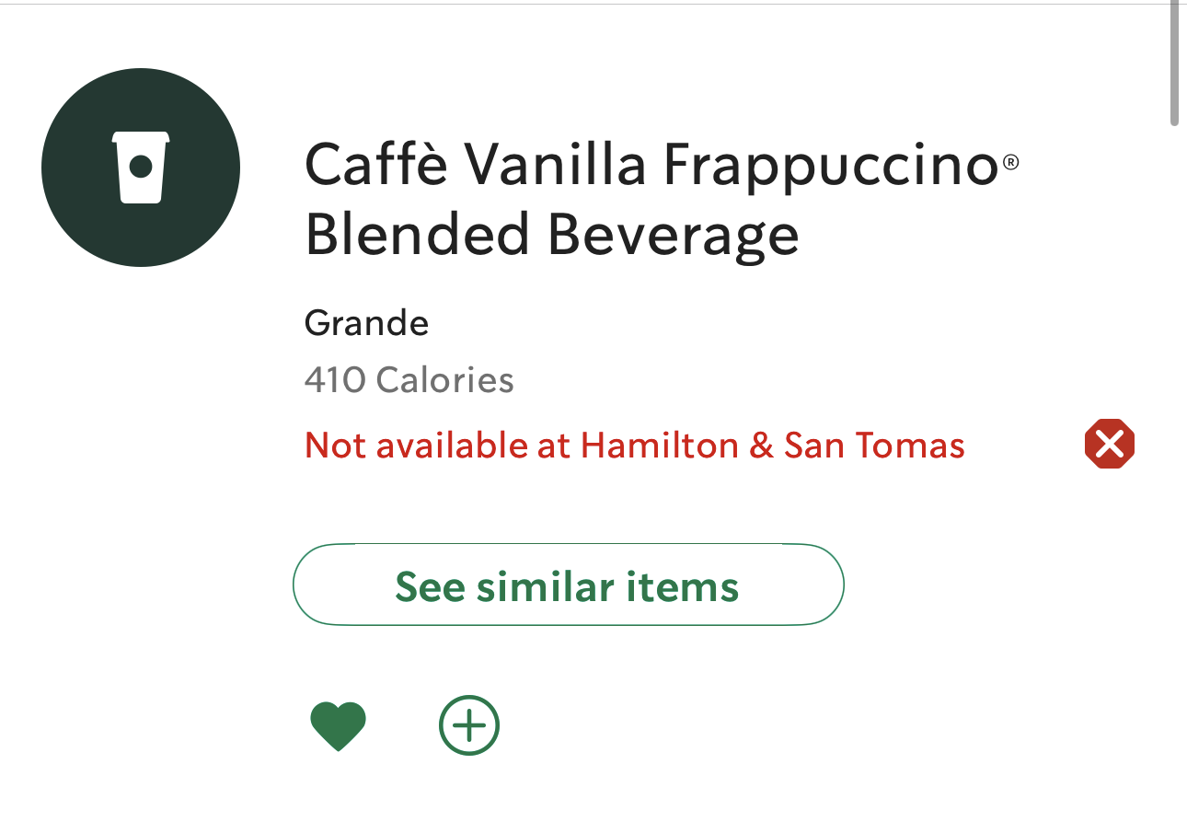
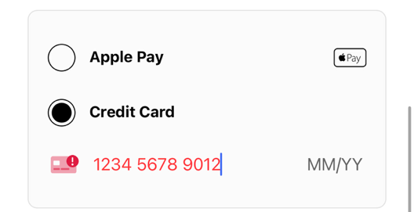
  - Philz Coffee: Uses constraints and real-time feedback to prevent mistakes. For example, payment entry errors are immediately flagged with red icons (pictured), guiding users to correct them.

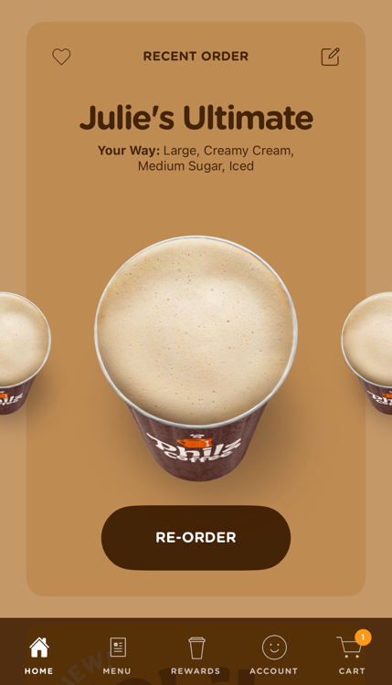
Recognition Rather than Recall
  - Starbucks: Reduces memory load by keeping features like “Favorites” visible. However, some support tools are buried in menus. This forces the user to recall the specific path or search for them, rather than recognizing them at a glance.
  - Philz Coffee: Exhibits a strong recognition-based design. The cart icon always shows item counts, and shortcuts on the home menu to re-order recent orders are readily available (pictured), minimizing user memory demands.
Flexibility and Efficiency of Use
  - Starbucks: User-friendly for all users, but could be more efficient for power users. A one-tap reorder feature would streamline the process for frequent customers.
  - Philz Coffee: Caters to various user needs with features like recent orders. However, customization is limited, and special requests must be typed into a box, which is less convenient.
Aesthetic and Minimalist Design
  - Starbucks: Features a clean, visually appealing interface. However, supplementary content, such as featured articles, can sometimes create unnecessary clutter on the home page.
  - Philz Coffee: Prioritizes a clean layout with large, touch-friendly buttons in plain language. The design is focused and user-friendly.
Help User Recognize, Diagnose, and Recover from Errors
  - Starbucks: Uses clear, actionable pop-up messages (pictured) to help users resolve errors without technical jargon.
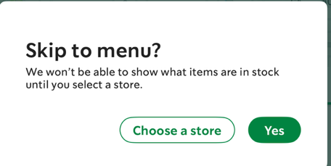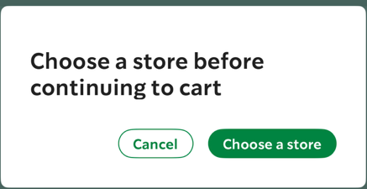
  - Philz Coffee: Error handling is direct. For example, invalid credit card information is immediately flagged, guiding users to a solution.
Helpful Documentation
  - Starbucks: The help section is somewhat hidden. While it offers searchable FAQ's, making live support options more prominent would improve the experience.
  - Philz Coffee: The app is mostly self-explanatory. Adding an easily accessible help section would ensure all users can confidently place orders.
Recommendations
Heuristic evaluations of the Starbucks and Philz Coffee apps reveal distinct approaches to user experience in the coffee retail space. Both apps adhere strongly to core usability principles, yet each faces unique challenges that affect overall efficiency and user satisfaction. Some recommendations include:
- Starbucks excels in consistency and standards, offering a polished, reliable interface that users navigate intuitively. It’s strengths lie in simplicity and efficiency, allowing users to quickly access the vast menu and order customized drinks. However, the app could benefit from refining User Control and Freedom by allowing users to cancel or modify an order after it’s been placed.
- Philz Coffee does a great job at Matching between the System and the Real World with its use of familiar language that reflects a coffeehouse experience, bridging the gap between the physical store and digital platform experience. The app could stay on the product page after adding the item to the cart, allowing the user to decide if and when they are done with that product page. This would enhance the users Control and Freedom.
Both apps do a great job of delivering a user-centric design, and with a few minor adjustments, their user experience could be further enhanced.

References
Nielsen, J. (2024, February 20). 10 Usability heuristics for user interface design. Nielsen Norman Group. https://www.nngroup.com/articles/ten-usability-heuristics/

